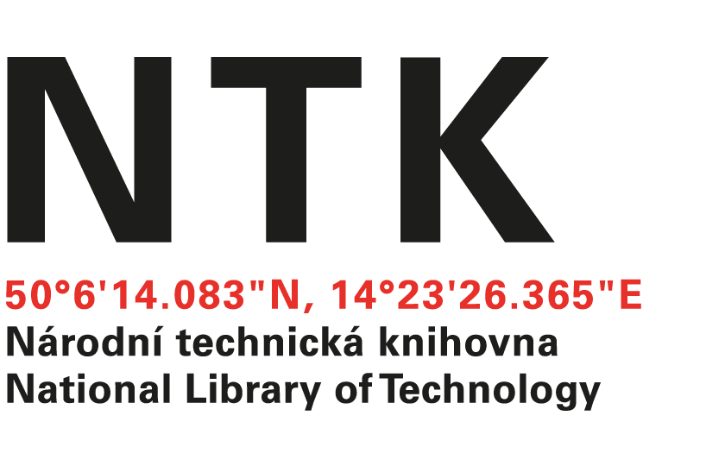
Order

No. 141/EIZ/2024/NTK

Customer: | Supplier:
National Library of Technology | Encylopaedia Britannica (UK) Ltd.
Technická 6/2710 | 2nd Floor, Unity Wharf
160 80 Prague 6 – Dejvice | Mill Street
Czech Republic | London  SE1 2BH  UK
ID: 61387142
VAT: CZ61387142

Dear xxxxxxx,

based on your renewal quote from 29. 10. 2024 we order:
Britannica Academic 1.1.2025 - 31.12.2025 - £3390
ImageQuest 1.1.2025 - 31.12.2025 - £1971
Total : £5361

Kind regards

xxxxxxxxxxxxxxx
electronic resources librarian

Date of issue: 27. 11. 2024
Issued:
xxxxxxxxxx
email: eiz@techlib.cz
Order accepted by:

