|  |  |  |  |  |
| --- | --- | --- | --- | --- |
| **INTERNATIONAL ADVERTISING SERVICES ORDER (“ORDER”)** |  | |  | |
| **SPECIFIC TERMS** | **“Discovery”** | **“Client”** | | | |
| **Agreed between** | **Discovery Communications Europe Limited** | **Česká centrála cestovního ruchu – CzechTourism** | | | |
| **Established in** | **England & Wales** | **Czech Republic** | | | |
| **Company number** | **05039068** | **49 27 76 00** | | | |
| **Full postal address** | **Chiswick Park Building 2, 566 Chiswick High Road, London W4 5YB, United Kingdom** | **Štěpánská 567/15, Praha 2 – Nové Město 120 00** | | | |
| **Contact person**  **name / title** | **XXX** | **XXX, Marketing Manager** | | | |
| **Telephone** | **XXX** | +420 XXX | | | |
| **E_mail** | **XXX** | XXX | | | |
| **Term** | **1st December_31st December 2024** | | | | |
| **Advertiser** | **Czech Tourism** | **Campaign Period** | | **01/12/24 – 31/12/241/12/2401/12/24 – 31/12/24** |
| **Sector of Activity** | **Tourism** | | | |
| **Price of Services** | **Net Budget: € 100.000 (One hundred thousand euro)**  The total cost will be equally divided among individual spots see Annex 2 (Media Plan).  One invoice shall be sent on the 16th of December 2024.  The detailed schedule of broadcasted spots will be attached to the invoice.  Eurosport will state the number of the purchase order on the invoice.  All payments shall be made by bank transfer within 30 days after receiving of the original invoice. | | | |
| **Campaign type** | **TV spot**  **TV sponsorship** | | | |
| **Applicability of Clause 10 (Use Of Olympic Properties)** | **Yes  No** | | | |
| **Campaign Particulars** | See Annex 2 (Media Plan) | **Production required?** | | N |
| **Creative Agency** |  | **Telephone** | |  |
| **Contact person**  **name / title** |  | **Email** | |  |
| **Special Requests** | The Parties hereby agree that clause 8.1. of the General Terms and Conditions of Annex 1 shall be deleted and replaced by the following:  *“8.1.1 Either Party may immediately terminate this Agreement on written notice to the other in the event that:*  *- the other Party commits any non-remediable breach of the terms or conditions of this Agreement; or*  *- the other Party becomes insolvent, is placed in receivership, liquidation or bankruptcy, or communicates to Discovery that it is unable to pay its debts.*  *8.1.2. Discovery may immediately terminate this Agreement on written notice to Client in the event that:*  *- Clients fails to pay any sums due to Discovery pursuant to this Agreement; or*  *- Discovery becomes unable to continue the broadcast or publication of any applicable Media for any reason whatsoever.”*  The rest of clause 8 shall remain unchanged.  The Parties hereby agree that clause 12.7. of the General Terms and Conditions of Annex 1 shall be deleted and replaced by the following:  *“12.7. Each party undertakes that it shall not at any time during this Agreement, and for a period of two (2) years after expiry hereof, disclose to any person any confidential information concerning the business, affairs, customers, clients or suppliers of the other party, except:(a) to its or its affiliates’ employees, officers, representatives or advisers who need to know such information for the purposes of exercising the party's rights or carrying out its obligations under or in connection with this Agreement. As an exception, the Parties agree with the publication of the Agreement by Client in accordance with § 219 of Act No. 134/2016 Coll. Public Procurement Act, as amended. Client shall publish the Agreement within 30 days from its conclusion.* | | | |
| **Annexes incorporated in this Order** | Annex 1: General Terms and Conditions  Annex 2: Media Plan | | | |
|  | | | | |
| **AGREED BY CLIENT:**  **Signature:**  **Authorised signatory name/title:**  **Česká centrála cestovního ruchu-CzechTourism**  **František Reismüller, Ph.D.**  **CEO** | | **Date:** | | |
| **AGREED BY DISCOVERY:**  **Signature:**  **Authorised signatory name/title: Mike Rich, GSVP Sales** | | **Date:** | | |

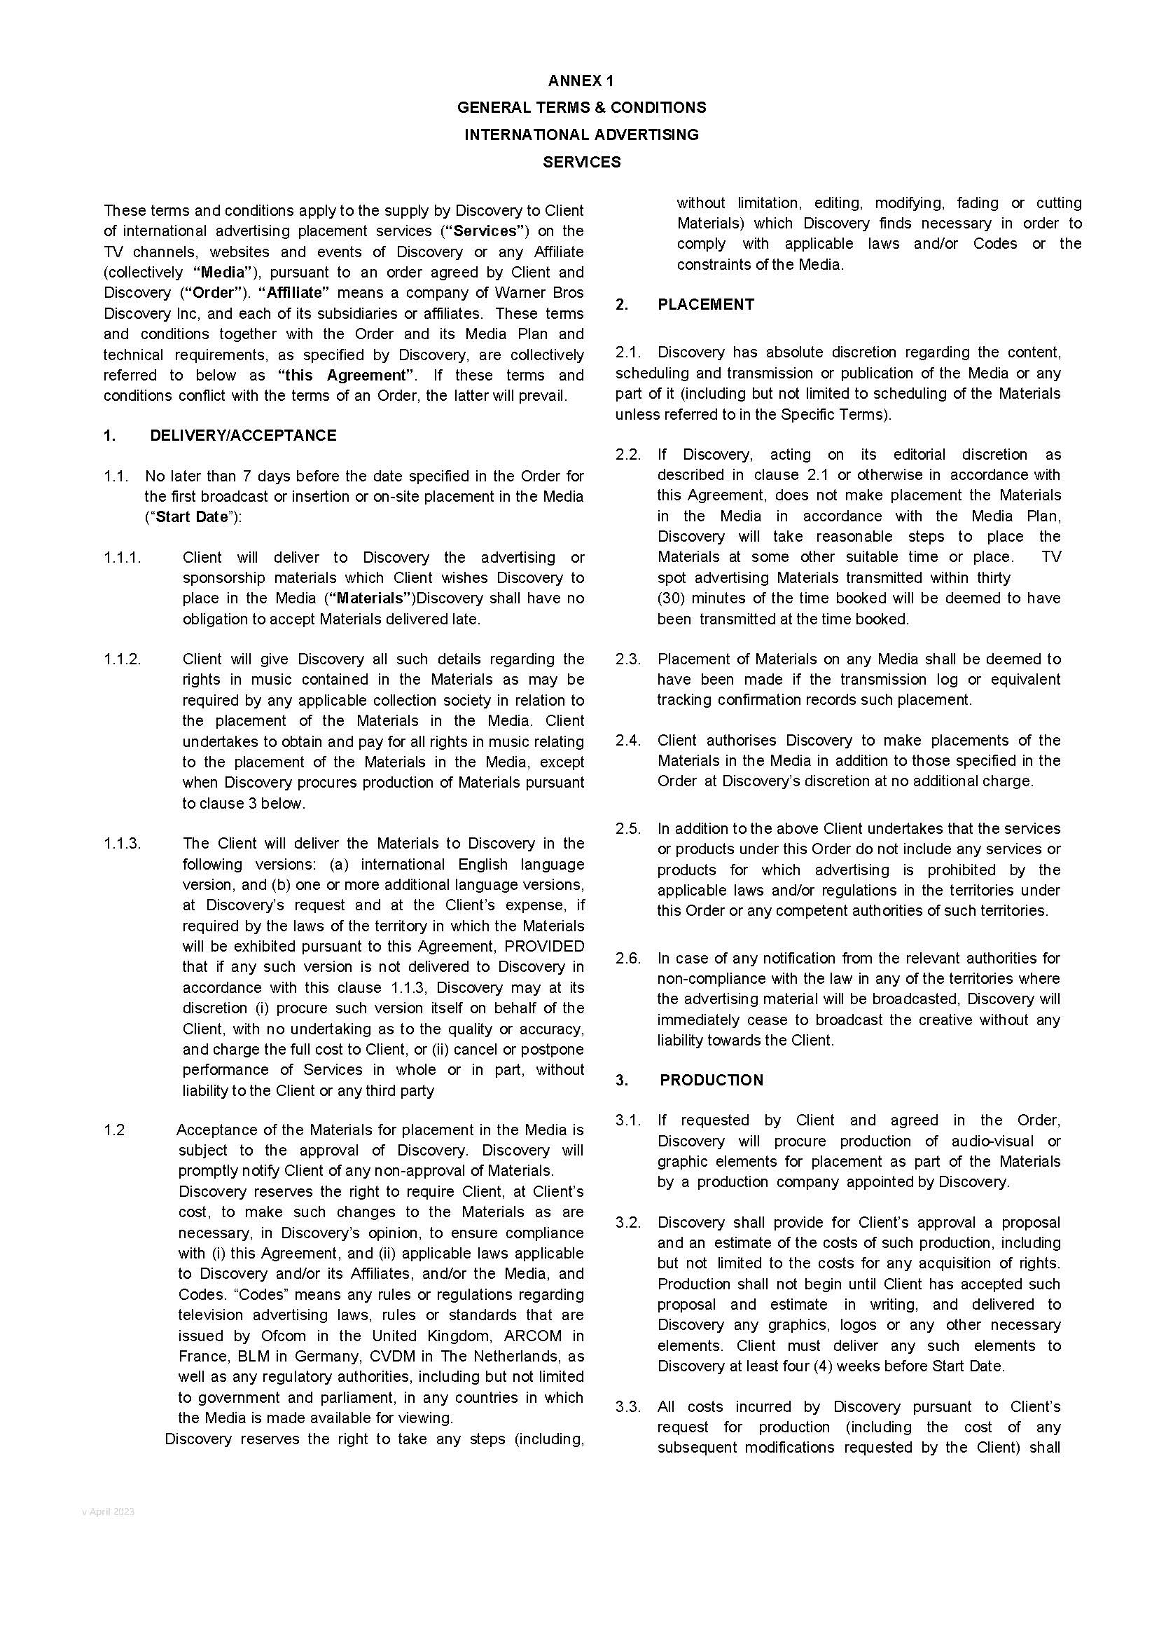

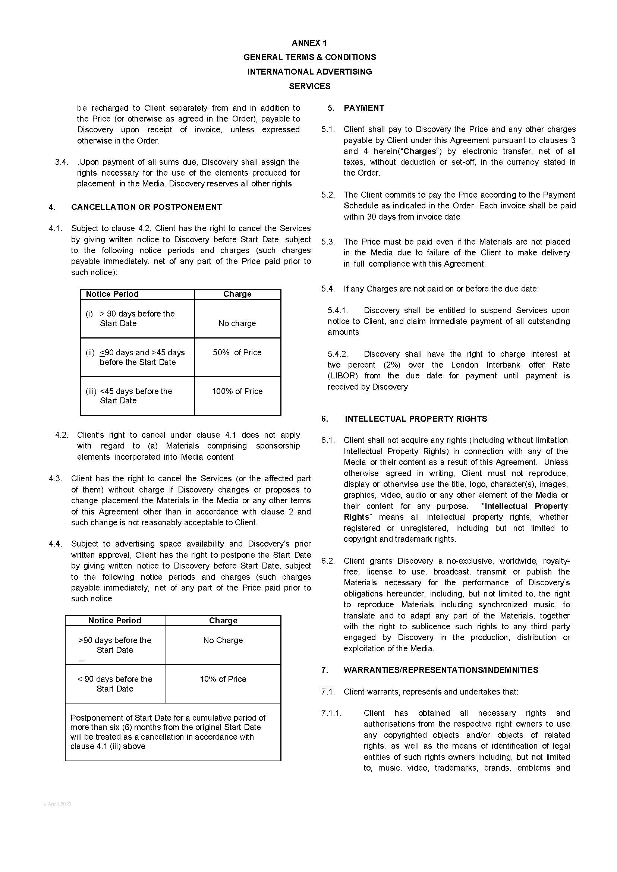

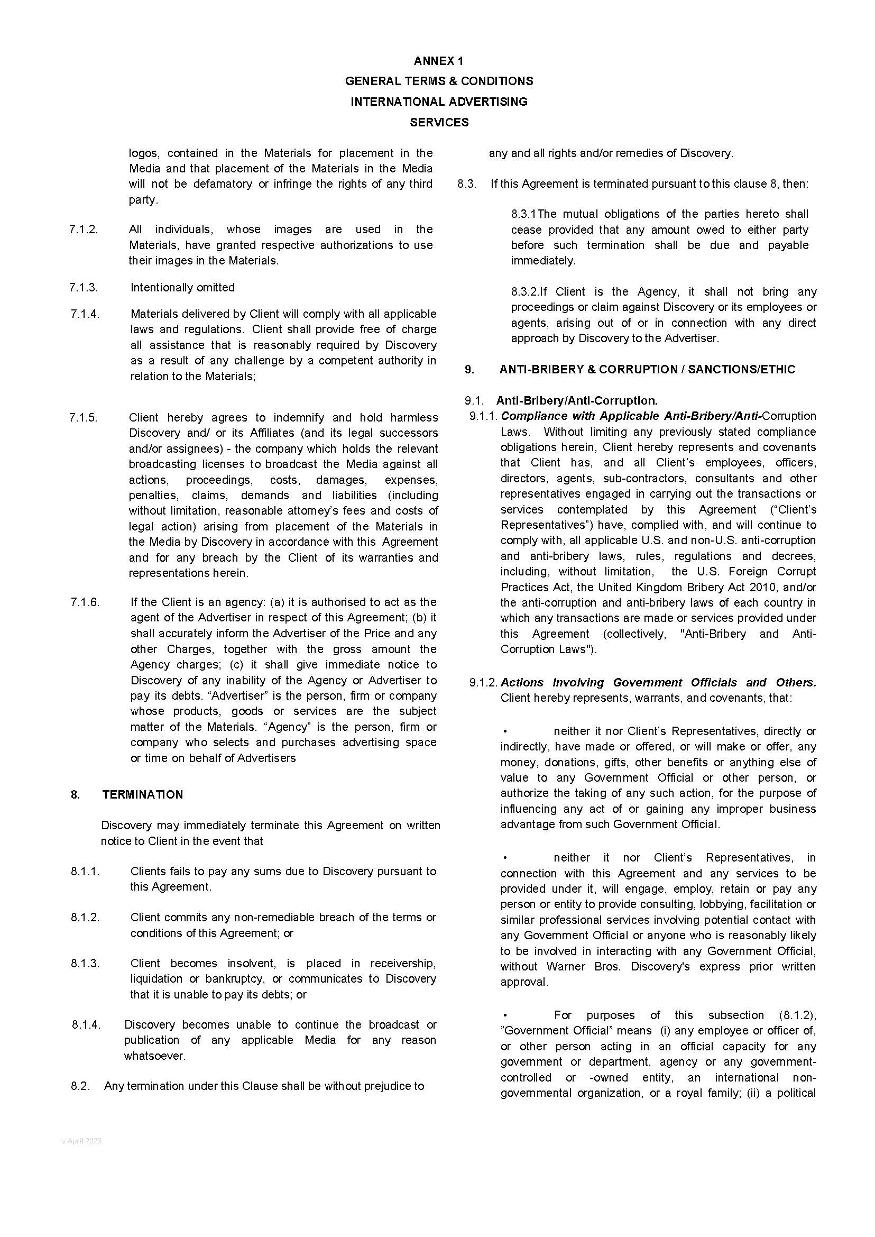

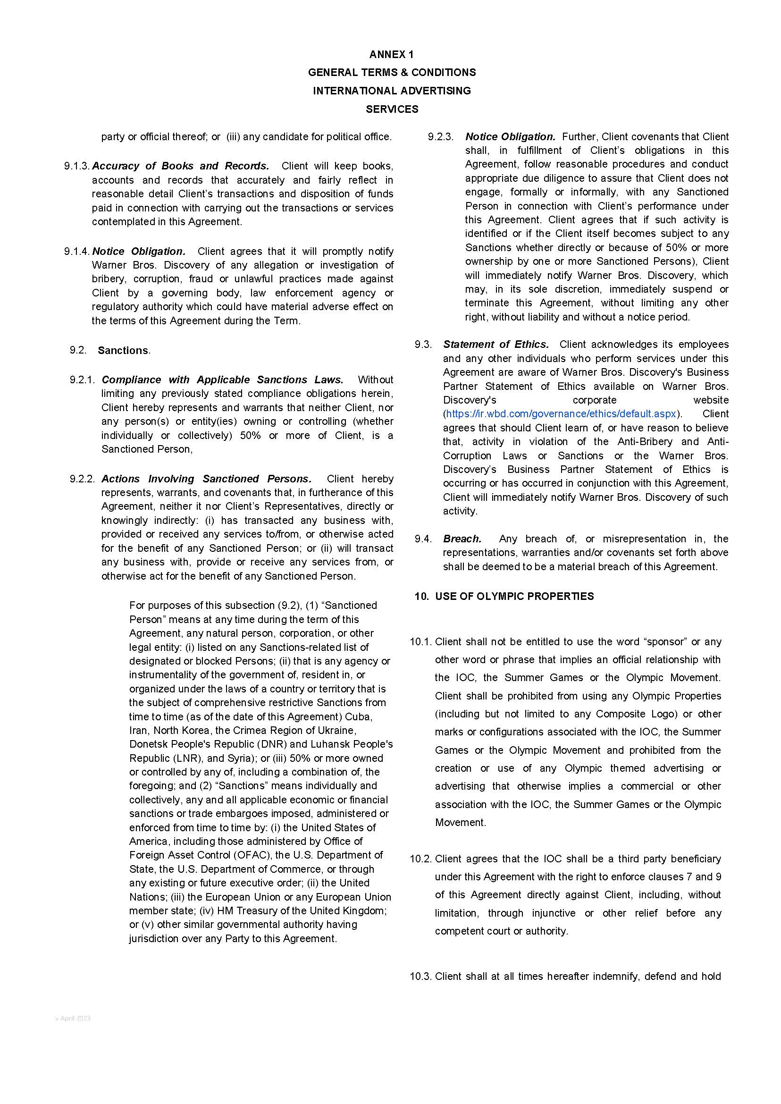

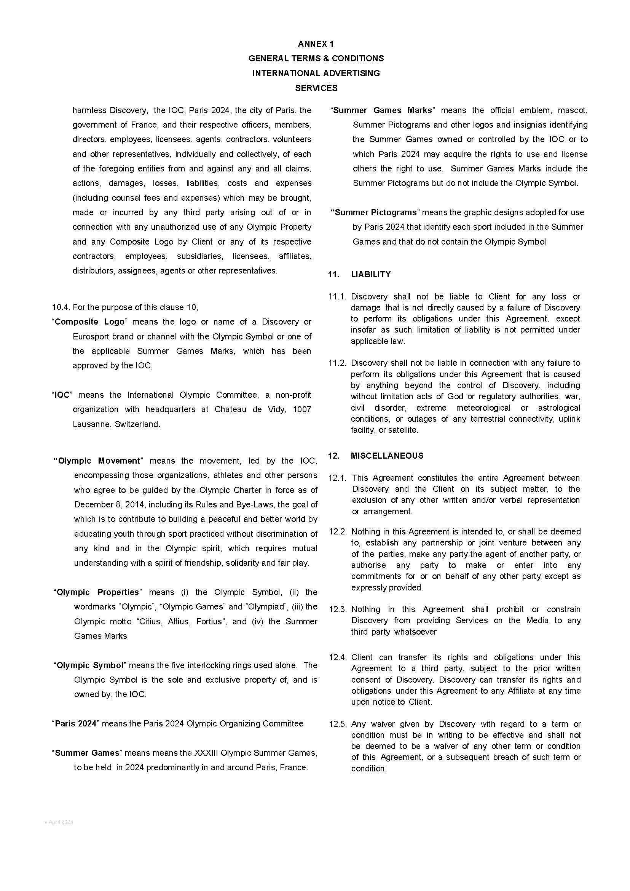

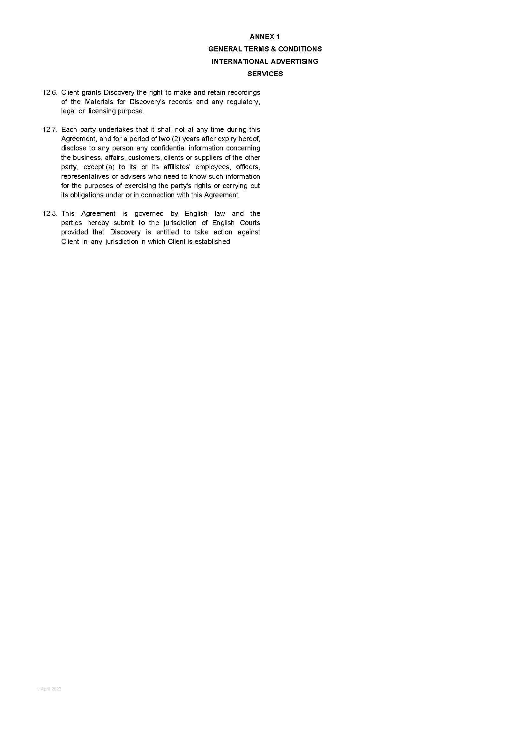

ANNEX 2

MEDIA PLAN



1. We would have 50% of the spots in prime time (means between 1700 and 2400 from Monday to Friday and from 1200 to 2400 on Saturdays and Sundays) and 50% on day time (means from 0800 to 1700 from Monday to Friday and from 0800 to 1200 on Saturdays and Sundays).
2. Spots will be placed around winter sports mainly (*e.g.*, biathlon, cross country, alpine skiing, ski jumping, etc. world cup and/or magazines), subject to legal, regulatory and contractual restrictions/requirements.