DODATEK O HOSTOVÁNÍ KE SMLOUVĚ O ÚČASTI NA PROGRAMU MERIT

mezi

Středočeské inovační centrum, spolek
a

Astronomický ústav AV ČR, v. v. i.

Tento DODATEK O HOSTOVÁNÍ KE SMLOUVĚ O ÚČASTI NA PROGRAMU MERIT
uzavřené dne 13. dubna 2023 (dále jen „Dodatek o hostování“) uzavřely následující smluvní strany:

- Středočeské inovační centrum, spolek
se sídlem Strakonická 3367,150 00 Praha 5
IČO: 042 28 235
zastoupený XXXXXXXXX
(dále jen „Koordinátor“)
- Astronomický ústav AV ČR, v. v. i.
se sídlem Fričova 298, 251 65 Ondřejov
IČO: 67985815
Zastoupená XXXXXXXXX
č.ú. (CZK) 35-5478690277/0100 vedený u Komerční banka, a.s. (EUR) 35-5478700287/0100 vedený u Komerční banka, a.s.

(dále jen „Partner“)
(Koordinátor a Partner společně jako „Strany“)

PREAMBULE
- Strany uzavřely Smlouvu o účasti na programu MERIT (dále jen „Smlouva“), na jejímž základě je realizována jejich spolupráce při realizaci Programu a upraveny podmínky vzniku práva na poskytnutí Podpory.
- Realizace Projektu postoupila do další fáze, pročež Koordinátor vyzval Partnera k uzavření tohoto Dodatku o hostování.
- Partner v postavení Implementující organizace má zájem nabýt účinností tohoto Dodatku o hostování postavení Hostující organizace, se všemi právy a povinnostmi příslušejícími k tomuto postavení.

Strany v souladu s článkem 9 Smlouvy přistupují k uzavření Dodatku o hostování o následujícím znění:

  - Definice a výkladová pravidla
    - Není-li v tomto Dodatku o hostování uvedeno jinak, uplatní se v plném rozsahu definice a výkladová pravidla převzatá Stranami v článku 1 Smlouvy.

  - Předmět a prohlášení stran
    - Strany prohlašují, že
      - Výzkumník předložil Projekt, jehož specifikace tvoří přílohu č. 1 Dodatku o hostování;
      - Projekt předložený Výzkumníkem splňuje požadavky Programu;
      - Výzkumník má zájem realizovat Projekt u Partnera;
      - Výzkumník byl vybrán v rámci výběrového procesu Programu a jeho výběr, včetně přiřazení k Partnerovi, byl oficiálně schválen Řídicím výborem (Steering Committee) – Protokol o výběru Výzkumníka a jeho přiřazení k Partnerovi tvoří přílohu č. 2 Dodatku o hostování.

    - Partner se zavazuje nejpozději do 1. května 2025, od uzavření Dodatku o hostování uzavřít s vybranou výzkumnicí, XXXXXXXXX, Pracovní smlouvu svým obsahem odpovídající Pokynům k Pracovní smlouvě (viz Příloha č. 3 Smlouvy). Nebude-li Pracovní smlouva dle předchozí věty v daném termínu uzavřena, pozbývá tento Dodatek o hostování účinnosti a Partner ztrácí postavení Hostující organizace.
    - Partner se dále zavazuje poskytnout Vybranému výzkumníku Spolufinancování za podmínek a v rozsahu stanoveném Smlouvou.
    - Partner bere na vědomí, že účinností tohoto Dodatku o hostování nabývá postavení Hostující organizace s právy a povinnostmi příslušejícími tomuto postavení. Tím nejsou dotčena další práva a povinnosti plynoucí Partnerovi ze Smlouvy.
  - Ostatní a závěrečná ustanovení
    - Tento Dodatek o hostování nabývá účinnosti dnem jeho zveřejnění v registru smluv.
    - Ve zbytku zůstávají ustanovení Smlouvy nedotčena.

V dne 4.9.2024 V dne 2.9.2024

el. podpis el. podpis

Koordinátor XXXXXXXXX
Partner
XXXXXXXXX

Příloha č. 1 – Specifikace Projektu
Příloha č. 2 - Protokol o výběru Výzkumníka a jeho přiřazení k Partnerovi (Zápis z jednání Steering Committee)
Obě přílohy jsou součástí Dodatku.

CORUS - CORonal magnetic field diagnostics Using Spectropolarimetry

EXCELLENCE

Quality and pertinence of the project’s research and innovation objectives (and the extent to which they are ambitious, and go beyond the state-of-the-art).
The solar corona is our local plasma laboratory, where we can study the physics of plasma and magnetic fields which can then be applied to other astrophysical environments. The corona is composed of highly ionized plasma with
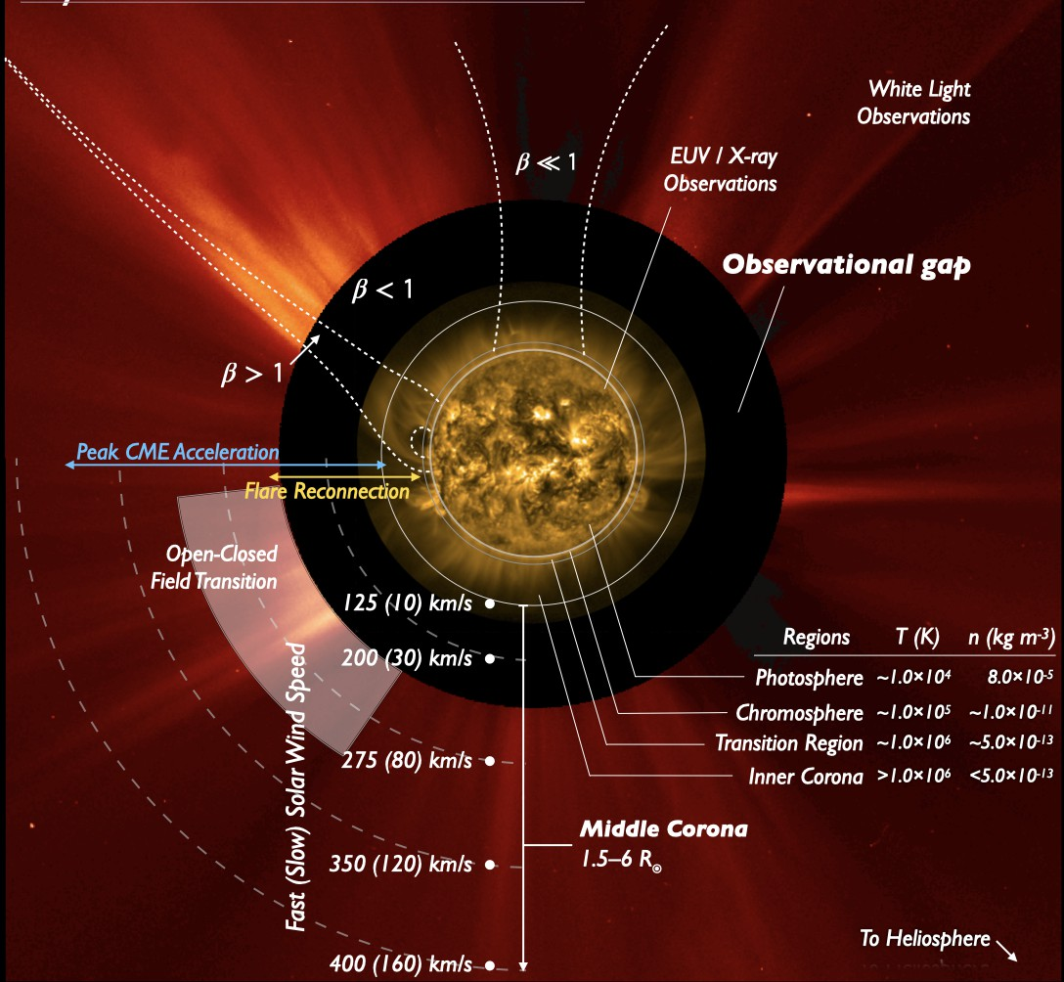
temperatures ranging from one to a few million degrees. Although there has been progress on the observational and theoretical side, it is still unclear which mechanisms are responsible for the heating of the solar corona and for the creation and acceleration of the solar wind and space weather events such as coronal mass ejections. It has long been known that the plasma in the corona is frozen in with the coronal magnetic field B, which therefore dominates the dynamics of the gas (see the illustration in Figure 1). The magnetohydrodynamic properties of the corona are complex, with many types of waves and magnetic processes that can store and release energy to heat the plasma. We now have plenty of theories but virtually no observations of B in the corona. This is generally only estimated by extrapolating the magnetic field measurements at the photosphere. As outlined below, we are finally entering a new era where the magnetic field of the outer corona could be measured with spectropolarimetry, a remote sensing technique based on spectral lines sensitive to the magnetic field (cf. the review by XXX, 2022). Coronal spectropolarimetry can be carried out in a range of emission lines from the far ultraviolet (FUV) up to the near-infrared (NIR). These lines can be broadly classified as allowed and forbidden. Typically, the allowed lines are in the FUV, while the forbidden lines lie in the visible and NIR wavelengths (see the review by XXX, 2018). Even without magnetic fields, the calculation of a spectral line profile and intensity is complex, as the ion excitation
Figure 1: A composite image highlighting the physical transition between different layers of the solar atmosphere. Understanding the dynamics in the solar corona which extends up to heliospheric distances is the crucial challenge to be addressed. Figure courtesy, XXX et al., 2023 where they define and discuss different
aspects of the middle corona.
in the corona is due to collisions by the local free electrons and the photons originating from the solar disk (called resonant excitation, RE). Hence the observed intensity depends on the distribution of the disk intensity, the distance, and the plasma state (the local velocity, electron energy distribution, as well as distributions of density and temperature, etc). In addition, as the corona is optically thin, the signal is the integral along the line-of-sight.
The presence of the magnetic field alters the signal in different ways depending on the type of transition. The magnetic sensitivity in solar spectral lines is commonly studied using the Zeeman effect which generates circularly polarized light whose circular polarization degree is proportional to the line-of-sight oriented magnetic field. The linear polarization signals in the corona are predominantly caused by scattering processes (RE), and in the presence of a magnetic field, they are modified by the Hanle effect. The linear polarization of forbidden lines can be used to infer the

orientation of B in the plane of the sky and the circular polarization to measure the magnetic field strength along the line-of-sight. The allowed transitions are in contrast mostly sensitive to the so-called unsaturated Hanle effect, causing the linear polarization signals to vary with both magnetic field strength and orientation. A sensitivity study by the researcher (XXX et al., 2021) for the H I Lyman-α at 1215 Å and He II Lyman-α at 304 Å showed various advantages and limitations in the possible diagnostics. The allowed He I 10830 Å line is a promising NIR line for coronal diagnostics, although its formation process is highly complex, as discussed in XXX et al. (2020), where the first coronal model of the He emission is proposed. In summary, obtaining information on the magnetic field is difficult and complex. It is best carried out with a 3D forward modelling accounting simultaneously for multiple spectral lines differently sensitive to different physical mechanisms.
In terms of observational infrastructure, the main facility that has recently become operational is the Cryo-NIRSP spectropolarimeter on DKIST, the first large-scale ground-based solar telescope (XXX et al., 2023). The instrument is regularly observing out to a distance of 1.5 R⊙ allowed and forbidden lines in the NIR, the main ones being currently the forbidden Fe XIII lines and the He I 10830 Å line, plus lines from Fe XI, Fe XIV, Si IX and Si X. The other main upcoming facility is the Visible Emission Line Coronagraph (VELC, XXX et al., 2017) onboard the
first dedicated Indian solar space mission - the Indian Space Research Organization (ISRO)’s Aditya-L1, which was launched in September 2023. VELC has imaging capability from 1.05 to 3 R⊙ and a slit spectrometer in forbidden lines and white light continuum, in addition to spectropolarimetry in Fe XIII to measure the magnetic field. The researcher plans to collaborate with the Principal Investigator (PI)’s of VELC. Furthermore, the Coronal Spectropolarimeter for Airborne Infrared Research (CORSAIR) will be tested on a balloon flight in 2024 and with later plans to perform
measurements with an Antarctic circumpolar flight. Several other facilities are (or will soon be) providing invaluable routine observations of the corona: the Upgraded Coronal Multi-channel Polarimeter (UCoMP) instrument; the Association of Spacecraft for Polarimetric and Imaging Investigation of the Corona of the Sun (ASPIICS) coronagraph onboard PROBA-3 (to be launched in 2024), providing routine imaging in forbidden lines and the continuum from 1.1 to 3 R⊙; the coronagraph METIS and extreme ultraviolet (EUV) imager (EUI) onboard Solar Orbiter, among others.
The above missions are filling the observational gap in the lower corona and also in a virtually unexplored region of the
middle corona shown in Figure 1. Apart from these, in the low corona, a promising new diagnostic for active regions is a magnetically-induced transition (MIT) in Fe X, observed by Hinode EIS. The researcher plans to request further combined DKIST and Hinode observations to compare the results of the two very different diagnostics.
Though these solar missions will result in a plethora of exciting research prospects, they probe unexplored diagnostics in an area, the spectropolarimetry of the corona, where there is little expertise around the world, despite being the new frontier in measuring the coronal magnetic field. One of the aims of the European Research Council (ERC) Advanced Grant POLMAG (http://research.iac.es/proyecto/polmag/, awarded to Prof XXX) was to bridge this gap. The researcher was hired in 2018 as a post-doctoral fellow for this project to develop P-CORONA (XXX et al., 2021). P-CORONA is a new code for calculating the intensity and polarization of coronal lines using 3D models of the solar corona, taking into account the scattering of anisotropic radiation and the Hanle and Zeeman effects. It can be applied to model the off-limb polarization of visible/IR forbidden lines, as well as the off-limb polarization of the allowed coronal lines, taking into account the effects of non-radial velocities. All the relevant atomic data are taken from the CHIANTI database (XXX et al., 2021), used by the entire solar physics community. Using P-CORONA as a tool I propose, through CORUS, to build computationally efficient and accurate atomic models for the diagnosis of the coronal plasma parameters and to constrain them using the upcoming coronal observations.
In this context MERIT provides an ideal opportunity to integrate the researcher’s knowledge in spectropolarimetric modelling of solar coronal lines with the expertise available at the host institute - Astronomical Institute of the Czech Academy of Sciences (ASU CAS) in atomic modelling and spectral analysis in executing the proposed project - CORUS (also see Section 1.3). Modelling the coronal lines, especially with the inclusion of the magnetic field is challenging but is urgently needed now for the science exploitation of the above missions. There is great interest in the solar physics community in this area of research. As a testimony of this importance, an international ISSI team led by Dr. XXX has recently been approved, see https://teams.issibern.ch/middlecorona/. The researcher is one of the experts on the team along with Dr. XXX at the host institute. If CORUS is funded, this research will provide

important contributions to the work of the ISSI team. The idea behind the ISSI international program is to bring together a group of international experts in a field by providing a platform (through funding for local facilities) to hold two dedicated collaborative sessions each for one week in 2024 and 2025.

Soundness of the proposed methodology (including interdisciplinary approaches, consideration of the gender dimension, and other diversity aspects if relevant to the research project).
CORUS will deepen our knowledge and provide a framework for coronal plasma diagnostics, a key step in addressing the coronal heating problem. To achieve this, a comprehensive understanding is essential, spanning across diverse fields such as plasma physics, quantum mechanics, atomic modelling, and spectral analysis. Within the framework of the MERIT program, CORUS will foster a collaborative environment where my research goals to explore the solar corona can be combined with the expertise at the host institute, especially with Dr. XXX and Dr. XXX. Moreover, the inclusion of secondment through MERIT will significantly support the proposed objectives. The main goals of CORUS are:
WP1: to improve the forward modelling tools developed by the researcher by first running a series of sensitivity studies using different atomic models for the critical ions producing observed lines and varying atmospheric models (mainly electron densities and temperatures);
WP2: benchmark the tools against other methods;
WP3: test the tools against available observations and to obtain and analyse new observations based on the conclusions of the forward modelling efforts in the previous steps.
WP4: improve the forward modelling using P-CORONA by including and studying the effects of non-Maxwellian (accelerated) particles on the coronal forbidden lines.
The first step WP1 is fundamental, as it is essential to assess the accuracy of the various approximations that need to be made. The original diagnostic methods developed for DKIST coronal magnetometry in a series of forbidden lines were based on a very limited atomic model with a few states. Whereas the one developed by XXX (2012) for Fe XIII has several thousands of states, many of which are affected by cascading the populations of the levels, significantly changing the predicted intensities of the forbidden lines, an issue confirmed by XXX (2020). Since calculations using P-CORONA with such large atomic models are computationally prohibitive, it is first necessary to run sensitivity studies to scale down or modify the models without compromising critical information of the predicted profiles. During this assessment, the tools developed by Dr. XXX to estimate uncertainties on the line intensities will be modified to add such estimates to the spectropolarimetry results. Execution of WP1 would be the primary objective of the first secondment period. The researcher will also run sensitivity studies to assess which atmospheric parameters are most critical. We will start with NIR coronal forbidden lines from Fe XIII, Fe XI, Fe XIV, Si IX, and Si X, and the complex He I 10830 Å line, all primary DKIST targets.
The numerical code P-CORONA, development of which was led by the researcher, is made open source (https://gitlab.com/polmag/P-CORONA). The atomic and atmospheric models developed through the proposed studies will also be made available to the scientific community with the aim of having a user-friendly theoretical tool.
The WP2 will involve a benchmark comparison between results obtained using simplified P-CORONA models developed as a part of WP1 with the results of other available codes for different coronal models. Among them, there is a suite of codes recently developed by XXX et al. (2020) for the calculation of line intensities, those included in FORWARD (XXX et al. 2016) which were based on older (limited) atomic data, and other codes that have been developed by different groups. This WP will be carried out in collaboration with ISSI team members who have either developed codes (XXX) or have provided to the community 3D MHD models of the solar corona (XXX). In executing both WP1 and WP2, the researcher will continue her collaborations with the POLMAG team led by XXX at Instituto de Astrofísica de Canarias, Spain (the planned second secondment period). The results of WP1 and WP2 will be disseminated to the community

by organizing dedicated workshops to train young students/researchers. The researcher is a female from India. By participating in this high-profile research and these training workshops, she will be an inspiration and mentor to others, hence encouraging more diversity in the STEM community. The research proposal itself does not specifically require considerations of gender.
The WP3 will involve using the improved atomic models thus developed to simulate the coronal emission and compare it to specific observations. The researcher will take advantage of the secondment (for the planned third period) and collaborate with Dr. XXX who is involved in several ongoing (e.g. Hinode, IRIS, Solar Orbiter, Chandrayaan-2, DKIST) and upcoming missions. He obtained what may be the first DKIST observations of He I (and Fe XIII) line intensities, which we plan to use to test the new tools. He is also co-I of Airborne Coronal Emission Surveyor (ACES; PI: XXX, CFA, Harward University, one of the ISSI team members), which will perform the first-ever survey of all the NIR lines during the next total solar eclipse in April 2024. The researcher therefore also plans to apply the tools to these observations, in collaboration with XXX. The researcher will also test the tools with spectropolarimetric DKIST and UCoMP measurements when they become available along with those from ASPIICS (in collaboration with XXX, who is one of the ISSI team members and has carried out the calibration of this instrument).
Measurements of densities and temperatures will be combined with extrapolations of the magnetic field B to forward-model the spectropolarimetry signal in the IR lines of Fe XIII, Fe XI, Fe XIV, Si IX, and Si X, to assess how reliably magnetic fields can be measured. Such comparison may allow us to differentiate amongst plausible coronal models (e.g. XXX et al., 2018; XXX et al., 2023) while enabling us to recognize the sensitivity of the various spectral lines to different coronal features or magnetic fields associated with them. As a last part of WP3 of CORUS, the researcher will apply for DKIST time and coordinate observations with different instruments, with particular attention to Hinode/EIS and Aditya-L1 VELC. One important benchmark that will be carried out is a comparison between the results obtained from the NIR forbidden lines (e.g. DKIST or Aditya-L1/VELC) with those obtained from Hinode/EIS in the EUV using the Fe X MIT diagnostic. The study will hopefully validate these new diagnostics. The work on Aditya-L1/VELC will be carried out in collaboration with Prof. XXX (ARIES, India), a member of the ISSI team and a leading scientist on the VELC instrument.
The WP4 involves improving the existing forward modelling tools in the context of P-CORONA by examining other proven physical mechanisms that contribute to the process of coronal spectral line emission. The key mechanism we plan to investigate is the influence of the non-Maxwellian electron distributions, the presence of which is indicated by both the coronal emission lines (e.g., XXX et al. 2022) as well as in situ measurements in the solar wind (see the review by XXX et al., 2017). The studies by XXX et al. (2014) have shown their significant contribution to the intensity of the forbidden lines of Fe IX - Fe XIII. However, their influence on the polarization profiles of these lines is still unknown. By leveraging a forward modelling tool such as P-CORONA, along with Dr. XXX expertise at ASU CAS in studying non-Maxwellian electron distributions and Dr. XXX in atomic physics, the researcher aims to use MERIT as an ideal platform for addressing this knowledge gap. In executing the WP4, new spectral synthesis calculations using the KAPPA package developed at ASU CAS XXX et al. 2023) under the assumption of κ-distribution of electron energies will be incorporated into computations from P-CORONA. This will be then used to forward model the coronal forbidden and EUV lines to understand their impact in the final polarization signatures. These studies will help us refine the diagnostic tools capable of identifying and quantifying deviations from the traditional Maxwellian electron energy distributions, which are fundamental to understanding the complex environments of the solar corona.

Quality of the two-way transfer of knowledge between the researcher and the host.
The Solar Physics Department at ASU CAS excels in studying the solar corona and plays a crucial role in the Solar Orbiter mission, with Prof. XXX serving as the co-PI of the onboard METIS coronagraph (e.g., XXX et al. 2020). It hosts experts like Dr. XXX in spectropolarimetric studies, especially in employing the scattering polarization and Hanle effect for probing magnetic fields on the Sun, and Dr. XXX in atomic modelling and spectral analysis accounting for non-Maxwellian contributions in the coronal line formation. Through CORUS, the

researcher aims to integrate these so far separate research groups in using the spectropolarimetric methods for coronal diagnostics and building efficient atomic models for better forward modelling of coronal lines.
Dr. XXX involvement in the POLMAG project as an external member, alongside the researcher's past work there, effectively connects past experiences with the current project's objectives. The WP4 of CORUS is specifically designed keeping Dr. XXX expertise in studying the effects of non-Maxwellian particles on the coronal forbidden lines and incorporating such effects in the researcher’s forward modelling efforts using P-CORONA. In this collaborative endeavor through CORUS, the synergy between individual expertise and institutional capabilities would facilitate the Solar Physics Department at ASU CAS to expand its research topics and at the same time enabling the researcher to advance her academic career. Additionally, the researcher plans to foster collaboration between the department and India's solar community, aiming to achieve the proposal's specific observation goals with India's solar mission, Aditya-L1.
By the end of the fellowship, we would have not only advanced in our understanding of the solar coronal magnetic fields but we would have also provided an open-source theoretical tool to the community that can be used for future coronal observations. The above experience is crucial for the researcher's career, as it will enable her to advance her research methodologies and position her as a world leader in measurements of the coronal magnetic field via SP, at a time when numerous ground and space solar missions are starting to provide a wealth of new observations. The career skills gained will enable the researcher to have the opportunity to progress in a solar physics career as an independent scientist and obtain a permanent academic position.

Quality and appropriateness of the researcher’s professional experience, competences and skills.
The researcher specializes in studying the coronal vector magnetic fields which is one of the key ingredients in interpreting the plasma dynamics of the upper atmosphere of the Sun. The Hanle effect acts as an important diagnostic tool in this process. To this end, the researcher has led the development of an efficient code, namely P-CORONA as a part of the ERC Advanced grant project POLMAG since 2018. The intended studies of CORUS will primarily rely on P-CORONA as its key theoretical framework. P-CORONA computes the Stokes profiles of any coronal spectral line (allowed and forbidden) that emerge from a given three-dimensional magneto-hydrodynamic coronal model taking into account the symmetry-breaking produced by the presence of magnetic fields (both Hanle and Zeeman effect) and non-radial solar wind velocities along with anisotropic illumination. A plasma diagnostic tool of this nature was indeed developed for the kind of studies proposed in CORUS with the aim of doing theoretical predictions as well as interpreting spectro-polarimetric observations that we expect from the many promising coronal missions.
P-CORONA was first applied to investigate the linear polarization of the Lyman-alpha lines of H I and He II, due to the resonance scattering of solar-disk Lyman-alpha photons by residual neutral hydrogen and residual ionized helium atoms in the million-degree solar corona. This investigation led to a detailed paper in The Astrophysical Journal by the researcher (see XXX et al. 2021). Continuing from this point, the researcher took up a more complex challenge of expanding the capabilities of P-CORONA. This involved the incorporation of abilities for computing the intensity and polarization characteristics of coronal forbidden lines originating from highly ionized ions—examples being Fe X, Fe XIII, Si X, and others-within the context of 3D coronal models. To the best of our knowledge, P-CORONA is the only code available in the community for this kind of computation of both the forbidden and allowed coronal lines (see sample computations in Figure 2) which makes the researcher’s expertise in the field unique and appropriate for the goals proposed in CORUS. The researcher, along with her POLMAG team, has made this unique code available to the community and has also designed a graphical user interface for making P-CORONA a user-friendly code. Through CORUS, the researcher aims to take forward the same approach in making all the atomic and atmospheric models resulting from the project open source. Apart from this, the researcher has extensive experience in the numerical modelling of the generation and transfer of polarized radiation in 1D models of the solar chromosphere, which led to several publications during her Ph.D. During this journey, the researcher has also gained a better grasp of the atomic processes involved in studying various spectral lines. This understanding will form the foundation of the proposed project, CORUS, where the aim is to conduct sensitivity studies using different atomic models for the key ions in the solar corona.

IMPACT

Credibility of the measures to enhance the career perspectives and employability of the researcher and contribution to his/her skills development.
The research outlined in CORUS will only be possible thanks to MERIT. This project is marked by innovation and interdisciplinary collaboration, offering the applicant a chance to develop a diverse set of skills. It serves as a platform for engaging with exceptional scientists across various fields within solar coronal physics, thereby expanding her knowledge horizon and networks. By bridging the work groups at the Astronomical Institute of the Czech Academy of Sciences, Czech Republic, Instituto de Astrofísica de Canarias, Spain, the University of Cambridge, and India, the researcher will become a link that facilitates broader interdisciplinary expertise. CORUS significantly enhances her profile, elevating her visibility through expected publications in reputable journals resulting from the project. Additionally, involvement in meetings (such as the ISSI workshops) and collaborations with the host’s contacts and India's Aditya-L1 holds promising prospects for presenting her work internationally.
CORUS also sets the stage for her to establish a wider network through secondment, conference interactions, cultivating global collaborations for tackling future challenging research endeavors. This isn't limited to research alone but extends to engagement within the larger European solar community. Beyond integrating her into existing networks, CORUS empowers her to forge her own connections, thereby strengthening the ties between EU and non-EU countries. Furthermore, CORUS enhances her adaptability to function effectively within international and interdisciplinary settings, ultimately contributing to her mobility in the coming years. The training in proposal writing and fellowship management equips her to pursue independent funding avenues such as an ERC Grant. Her aspirations for a grant/tenure-track position and eventual permanent role receive substantial support from MERIT, laying a robust foundation for her scientific career.

Suitability and quality of the measures to maximise expected outcomes and impacts, as set out in the dissemination and exploitation plan, including communication activities.
The underlying atomic data are already widely available via the CHIANTI database, maintained by Dr. XXX. The non-Maxwellian calculations are publicly available through the KAPPA package based on CHIANTI (maintained by Dr. XXX). The methods and codes are made available via the POLMAG framework. Any new codes or data developed during the MERIT fellowship will be published and made available via ZENODO so that they are versioned, citable, and accessible. ZENODO currently has a limit of 500 GB per dataset which we expect to be more than sufficient for our needs. The outcomes of the research will be initially shared with the international ISSI team. The results of this and the ISSI teamwork will be widely disseminated at international conferences. As the topic of the ISSI teamwork is original, the results are expected to become a reference work for the future. Apart from this, we plan to organize workshops to train young researchers on the above-mentioned codes and data that will be made open source.
In addition to disseminating research through publications and meetings within the scientific community, the findings from CORUS will be effectively communicated to policymakers and taxpayers via targeted outreach initiatives both at and beyond the Czech Republic. The researcher has actively engaged in outreach activities, having been a prominent member of the outreach committees at both the Indian Institute of Astrophysics in Bangalore and the Udaipur Solar Observatory in Udaipur. These committees were dedicated to raising awareness and promoting physics and astronomy among students in urban and rural areas alike. The researcher played a role in developing a range of educational resources, including astronomy talks, physics experiments, and demonstrations, all aimed at fostering greater understanding and interest in these fields.
Furthermore, she took part in outreach programs that introduced the observational facilities available at these institutes, while also organizing quiz programs during the Indian National Science Day. Her contributions extended to designing educational posters displayed at institutions like the Evershed Museum in Kodaikanal Solar Observatory, Tamil Nadu, and the Udaipur Solar Observatory, Udaipur. With her wealth of outreach experience, the applicant is a natural fit for

the ongoing outreach programs at the host institute, including the popular “Chat with Astronomer” featuring female astronomers. She also intends to contribute popular science articles to local newspapers in India, focusing on disseminating knowledge about Sun-Earth connections, particularly among young and talented researchers, with a specific emphasis on encouraging girls to engage in science – an area where they are often underrepresented. She is a member of the recently formed community of solar physicists from India - INDUS (https://sites.google.com/view/indus-solphys/home) and Cosmology and Astronomy Researchers of Indian Nationality and Sisters - CARINAS (https://carinas.co.in/).
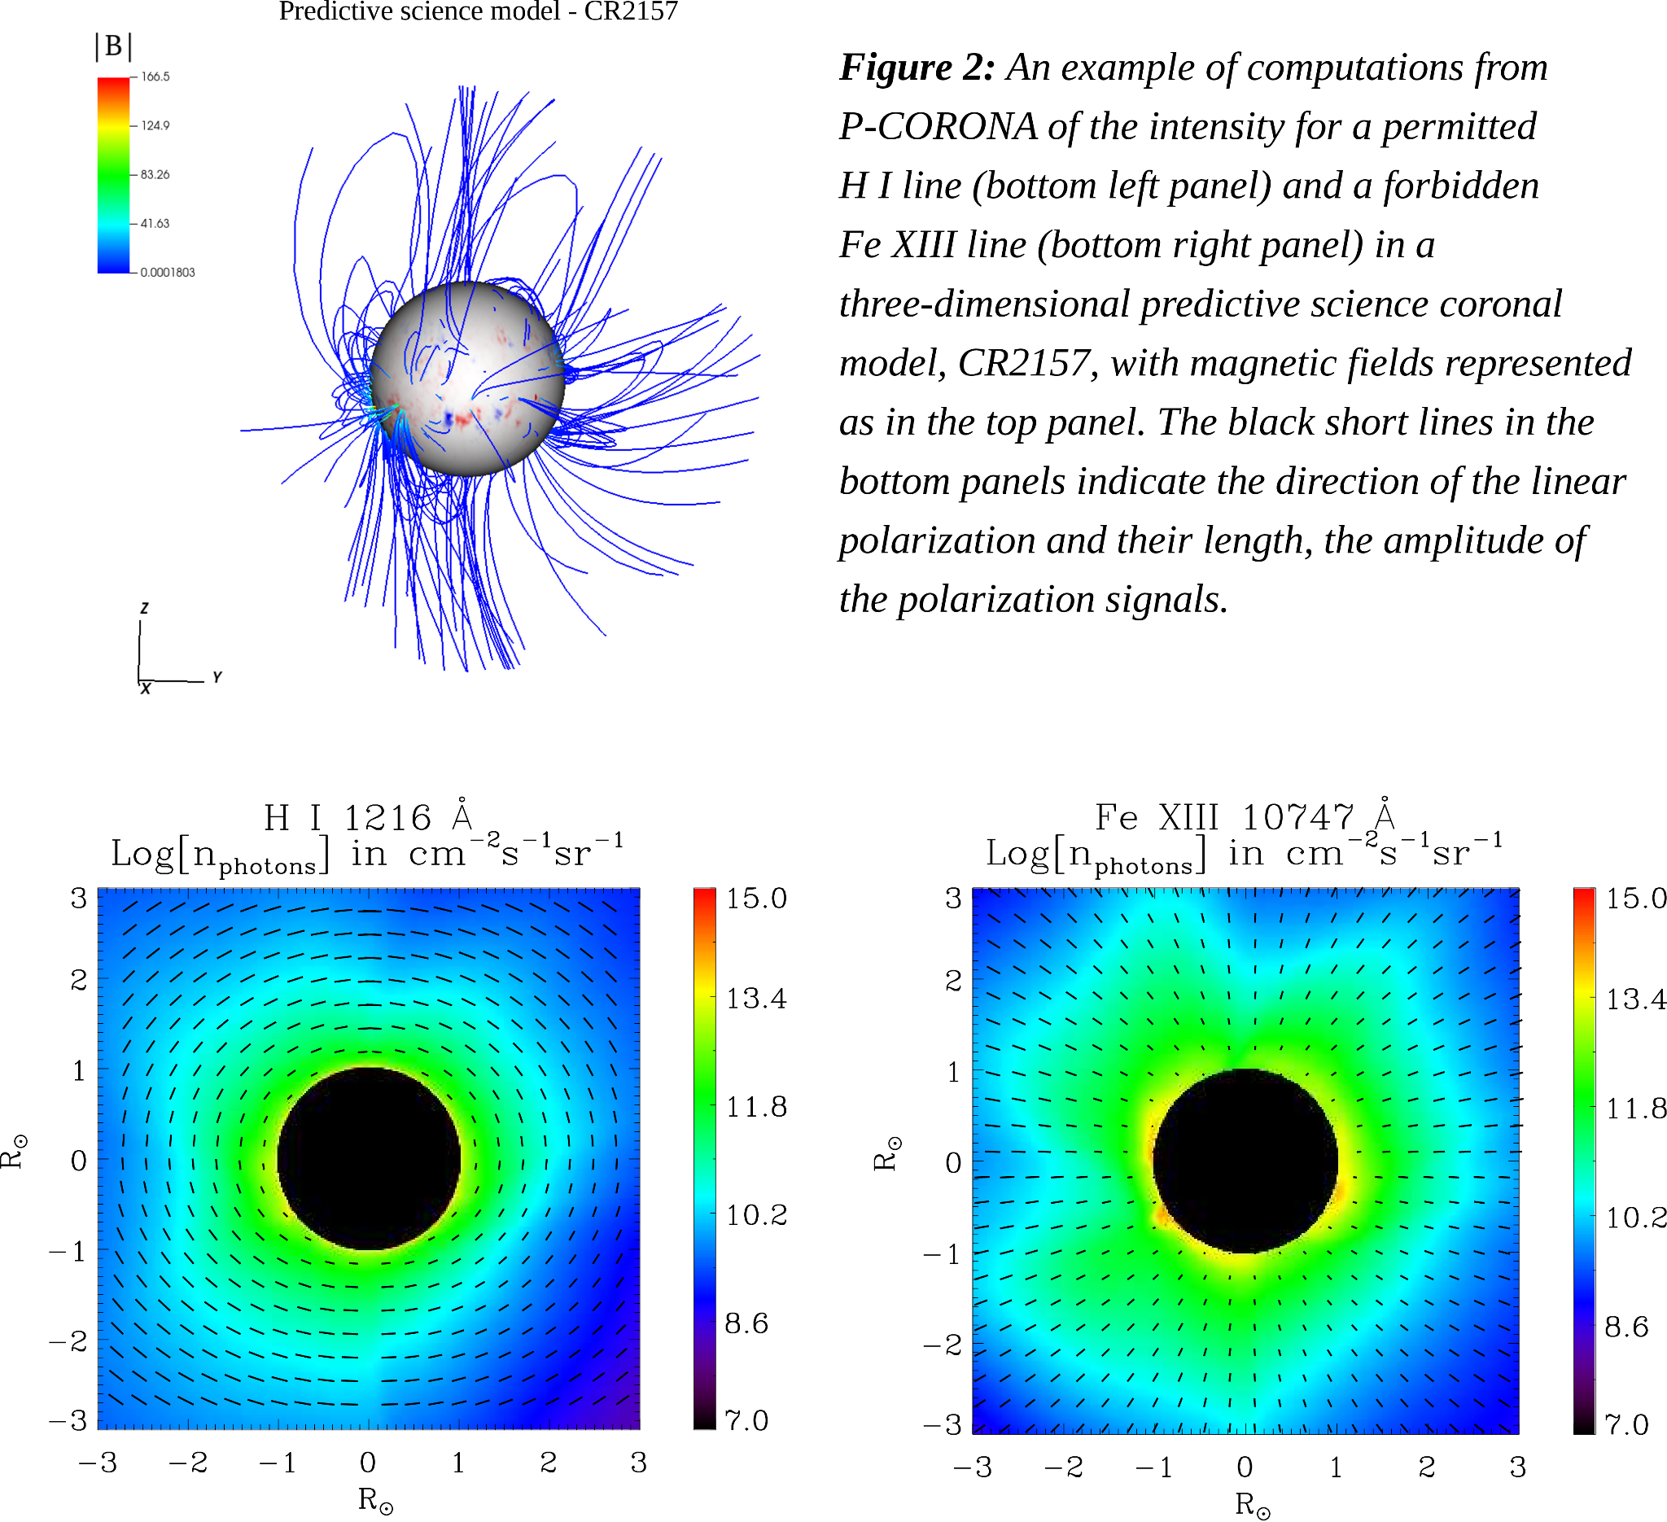

Sustainability of the candidates’ research project in the Region (Central Bohemia/Czech Republic). Opportunities to continue the research through regional/international collaboration with relevant industry or academic sectors.
CORUS will create several new benefits for the Czech Republic solar physics community: bringing key new expertise into the country; maximizing the scientific return of Hinode, DKIST, and Solar Orbiter; advancing applications of atomic data for astrophysics; and seeding further international collaborations. The solar department of the host institute is especially involved in the Solar Orbiter project. Analysis of the data from this mission will greatly substantiate the scientific goals of this mission and also pave way for the advances in the future regarding coronal spectropolarimetry.

Through MERIT, CORUS will open up many collaborations not just between EU countries but also with EU and non-EU countries. CORUS will also bring benefits to Spain, as the POLMAG group invested several years, with EU funding, developing the framework on coronal spectropolarimetry, and its use on actual solar observations will be fundamental. The assessment of the atomic models will also be of great benefit to the team.
The planned collaboration through CORUS will also bring great benefits to India, the researcher’s home country. India is a country that is currently investing significantly in the design and building of new space-borne instruments, several of which are in solar physics (e.g. the Aditya-L1 solar satellite, and the Chandrayaan-3 solar X-ray monitor). The models developed by POLMAG and refined through this fellowship are much needed for the analysis of the Aditya-L1 VELC spectropolarimetric observations. The country also needs to further increase the training of bright young researchers in the various areas of space physics. This can subsequently turn to long-term benefits for space research, as the newly trained researchers will contribute to the formation of new groups and in turn train a new generation of students. We expect Aditya-L1 to bring a new generation of researchers into solar physics, similar to the impact that SOHO had in the 1990s in the USA and Europe.

IMPLEMENTATION

Quality and effectiveness of the work plan and assessment of risks.
During the first year, the applicant will familiarize with the atomic rates and their uncertainties, and then run the goals illustrated in WP1 and WP2. During this year the proposals for coordinated observations with DKIST, VELC, Hinode, etc. will also be written for the work planned in WP3. The second year will be devoted to goals in WP3 and the organization of the three workshops. The last six months will be used for executing WP4.
List of major deliverables: 1.1 A technical report summarizing the benchmark results from initial tests will be circulated. 1.2 A manuscript presenting the optimal configuration of atomic levels in different coronal lines and their sensitivity to electron density and temperature, which provides a better insight into the overall importance of using forbidden lines for coronal diagnostics, will be submitted to ApJ or A&A. 2.1 Presentation of the work till date at ISSI workshop 2.2 A technical report presenting the results from our benchmarking of the results obtained using simplified P-CORONA models developed in WP1 with the results of other available codes for different coronal models will be made publicly available. 2.3 First annual project review and a seminar summarizing the work carried out in the first year. 3.1, 3.3, and 3.4 A workshop will be organized to train young students/researchers about the newly developed tools in WP1 and WP2 for coronal diagnostics. 3.2 Presentation of results at the ISSI workshop. 4.1 A manuscript presenting the results from our comparisons of numerical results with observations and its deductions will be submitted to ApJ or A&A. 4.2 Second annual project review and a seminar to summarize the work carried out during the fellowship till date. 4.3 A manuscript detailing the results from WP4 from the studies including the effects of non-Maxwellion electron distribution in forward modelling using P-CORONA. Outreach activities will be carried out throughout the course of the fellowship.
List of major milestones: M1 Completion of the data sets for atomic levels and lines lists, by testing their sensitivity to different coronal parameters. M2 Completion of benchmarking the results from P-CORONA using the atomic models developed in WP1. M3 Completion of the data reduction from DKIST, ADITDYA-L1 for the comparison with theoretical results. M4 Validation of the theoretical data against observations and deduction of information about magnetic fields, electron density, and temperature in the solar corona. M5 Completion of the new observing proposals based on the results obtained in the previous step. M6 Completion of including the new atomic data accounting for non-Maxwellian electron distribution into P-CORONA. The research tasks for CORUS have been carefully drawn up keeping in mind the accessibility to the resources needed to ensure its timely and successful implementation.
Risks that might endanger reaching the action objectives: The implementation of the research objectives proposed in CORUS within the duration of the fellowship is not entirely free of risks due to unforeseen delays or complications, like in any other innovative research project.

Figure 3: A Gantt chart showing the work breakdown structure of the proposed action. The deliverables and milestones within a given work package bear the same color. Time allocation for participation in conferences and seminars are tentative (actual times may differ). Public engagement will be a regular activity during the project.

Month | 1 | 2 | 3 | 4 | 5 | 6 | 7 | 8 | 9 | 10 | 11 | 12 | 13 | 14 | 15 | 16 | 17 | 18 | 19 | 20 | 21 | 22 | 23 | 24 | 25 | 26 | 27 | 28 | 29 | 30
Work Package | WP1 |  |  |  |  |  | WP2 |  |  |  |  |  |  |  | WP3 |  |  |  |  |  |  |  |  |  | WP4
Secondment
Deliverable |  |  |  |  | 1.1 | 1.2 |  | 2.1 |  |  |  | 2.2 | 2.3 |  |  | 3.1 | 3.2 |  | 3.3 |  |  | 3.4 |  |  | 4.1 |  | 4.2 |  |  | 4.3
Milestone |  |  |  |  |  | M1 |  |  |  |  |  |  | M2 |  |  |  |  |  | M3 |  |  | M4 |  | M5 |  | M6
Training | Training activities and progress monitoring
Conference
Seminar
Dissemination
Public Engagement | Outreach Activities
The implementation of work packages (WP1 and WP2) which are all computationally intensive may take a little longer than projected in Figure 3, due to possible limitations of computational resources. Such hurdles will be overcome by seeking additional computing resources like in Piz Daint, a supercomputer in the Swiss National Supercomputing Centre. The applicant was a part of three successful joint proposals to Piz Daint in the past three years with the POLMAG group. WP3 focuses on validating the tools developed in WP1 and WP2 by comparing them with existing data and collecting and assessing new data based on the insights gained from previous modelling efforts. This aspect of CORUS is thoughtfully designed to not rely solely on a single set of observations but rather on a diverse array of operational facilities, including both currently functional (DKIST) and upcoming (ACE, UCOMP, ASPIICS, and ADITYA-L1/VELC) ones. This diversified reliance helps mitigate risks associated with potential project failures or delays. Some of the suitable DKIST observations for our planned studies have already been acquired by Dr. XXX Additionally, the DKIST observations that have been published or will be in the future are available to the wider scientific community through the National Science Foundation's open data and access policy. In case these new observations are not available for unforeseen reasons, we plan to advance our theoretical investigations by expanding upon the studies described in WP1, particularly focusing on the UV and EUV lines of the solar corona. WP4 involves incorporating data from the KAPPA package into P-CORONA, a process we anticipate will be straightforward. Should we encounter unforeseen difficulties, we plan to estimate the differences in line intensities caused by non-Maxwellian electron distributions and subsequently incorporate these estimates into the spectropolarimetric computations performed with P-CORONA

3.2. Relevance, feasibility, and benefit for the research project objectives of the planned temporary placement in academic or non-academic sector (secondment), (NOTE: secondment is not the fellowship). Quality of the secondment choice in terms of at least one of the following principles: intersectorality, interdisciplinarity, or international mobility.
The secondments for CORUS are planned at the University of Cambridge, United Kingdom with Dr. XXX and at the Instituto de Astrofisica de Canarias, Spain with Prof. Trujillo Bueno. The Atomic Astrophysics group at the University of Cambridge is now led by Dr. XXX and has a world-class international reputation in the field of

atomic data for astrophysics and spectroscopic diagnostics of the solar corona. The Atomic Astrophysics group has been leading the worldwide reference atomic database CHIANTI (www.chiantidatabase.org) for the analysis of astrophysical spectra. Dr. XXX is also an expert on DKIST coronal spectroscopy his review, XXX (2018), is being used as a reference for the planning of DKIST observations. He is co-I of several of the instruments, aimed at coronal studies, mentioned in section 1.1. The researcher’s collaboration with Dr. XXX and his extensive experience will be key in executing WP1 and WP2. This secondment would provide an ideal opportunity to integrate the researcher’s knowledge in spectropolarimetric modelling of solar coronal lines with Dr. XXX experience in atomic modelling and spectral analysis in executing the proposed project - CORUS.
The researcher worked as a post doctoral fellow with Prof. XXX from 2018 till 2023 and continues the collaboration. During this period Prof. XXX led the project POLMAG funded by Euopean Research Council advanced grant. The project addressed multiple problems aiming at understanding the solar dynamics in a better way. P-CORONA, the main theoretical tool for CORUS, was developed under this project by the researcher with the POLMAG team members. Spectropolarmetric studies of different solar lines is one of the key expertise of Prof. XXX. His inputs as a part of secondment would significantly contribute in addressing goals described in WP1 and WP2. This secondment would facilitate the researcher to continue the long term strong collaboration with Prof. XXX. Both the planned secondments would further increase the researchers exposure to the international community in the field bringing together the various experts in the field in executing CORUS. This would not only strengthen the researcher’s profile in terms of future employability but also strengthen the existing collaborations of the Solar Department of the ASU CAS with these research groups.
References:
XXX

Zápis z jednání Steering Committee MERIT dne 25.07.2024

Přítomni:
- XXX
- XXX
- XXX
- XXX
- XXX
Omluvena:
  - XXX

Program schůze:
- Představení stavu probíhajících výzkumných projektů po ukončení prvního reportovacího období
- Schválení vyplacení dotace hostujícím organizacím na základě zaslaných žádostí o platbu
- Představení výsledků druhé výzvy
- Schválení projektů vybraných v druhé výzvě

Návrh usnesení: Řídicí komise MERIT bere na vědomí program jednání.
Výsledky hlasování Pro: 4 ; Proti: 0
Přijaté usnesení: Řídicí komise MERIT bere na vědomí program jednání.

- Představení stavu probíhajících výzkumných projektů po ukončení prvního reportovacího období

Návrh usnesení: Řídicí komise MERIT bere na vědomí stav probíhajících výzkumných projektů po ukončení prvního reportovacího období.
Pro: 4 Proti: 0
Přijaté usnesení: Řídicí komise MERIT bere na vědomí stav probíhajících výzkumných projektů po ukončení prvního reportovacího období.

- Schválení vyplacení dotace hostujícím organizacím na základě zaslaných žádostí o platbu

Návrh usnesení: Řídicí komise MERIT schvaluje vyplacení dotace hostujícím organizacím na základě zaslaných žádostí o platbu 9 projektů viz příloha č 1), jejichž realizace probíhala v období od ledna do června 2024.
Pro: 4 Proti: 0

Přijaté usnesení: Řídicí komise MERIT schvaluje vyplacení dotace hostujícím organizacím na základě zaslaných žádostí o platbu 9 projektů (viz příloha č 1), jejichž realizace probíhala v období od ledna do června 2024.

- Představení výsledků druhé výzvy

Návrh usnesení: Řídicí komise bere na vědomí informaci o průběhu hodnocení druhé výzvy.
Výsledky hlasování Pro: 4 ; Proti: 0
Přijaté usnesení: Řídicí komise bere na vědomí informaci o průběhu hodnocení druhé výzvy.

- Schválení projektů vybraných v druhé výzvě

Návrh usnesení: Řídicí komise MERIT schvaluje seznam předložených podpořených a rezervních projektů. Komise schvaluje celkem 24 projektů druhé výzvy programu MERIT (viz příloha č. 2), z nichž 16 projektů, které získaly v hodnocení nejvyšší skóre, budou podpořeny, a 8 rezervních projektů může být podpořeno v případě, že některý z podpořených projektů nebude realizován.
Výsledky hlasování Pro: 4; Proti: 0
Přijaté usnesení: Řídicí komise MERIT schvaluje seznam předložených podpořených a rezervních projektů. Komise schvaluje celkem 24 projektů druhé výzvy programu MERIT (viz příloha č. 2), z nichž 16 projektů, které získaly v hodnocení nejvyšší skóre, budou podpořeny, a 8 rezervních projektů může být podpořeno v případě, že některý z podpořených projektů nebude realizován.

Řídíce komise stanovila termín na příští setkání k prvnímu reportovacímu období dne 29.1.2025 ve 14:30 hodin.

Zapsala: Zápis ověřil:
XXX XXX
Programová manažerka MERIT Předsedající Steering Committee

Příloha č. 1
Seznam probíhajících projektů

Jméno kandidáta | Instituce | Název projektu
XXX | Národní ústav duševního zdraví | Rozluštění osy střevní mikrobiom- mikroglie v progresi nemocí
XXX | Astronomický ústav AV ČR | Zkoumání kompaktních hvězdných pozůstatků a jejich vliv na evoluci  hvězdokup
XXX | ELI Beamlines | Laserem urychlené protony (LDP) a jejich zvýšená účinnost pro použití v protinádorové terapii
XXX | HiLASE, Fyzikální ústav AV ČR | Vývoj laserového systému s vlnovou délkou 2 µm a CPA (chirped pulse amplification) založeného na Ho tenkodiskovém regenerativním zesilovači
XXX | Ústav živočišné fyziologie a genetiky AV ČR | Vzory genomové rediploidizace u neopolyploidů parmičkovitých,  sekavcovitých a kaprovitých ryb
XXX | Výzkumný ústav geodetický, topografický a kartografický | Výzkum, plánování a realizace měřicích činností k zajištění metrologické návaznosti Státního  etalonu délky od 25 m do 1450 m
XXX | Výzkumný ústav geodetický, topografický a kartografický | Výhody integrovaného GNSS pro geodézii, geofyziku a geodynamiku
XXX | Univerzitní centrum energeticky efektivních budov ČVUT | Hodnocení pasivních strategií pro udržitelnou výstavbu budov v České republice z hlediska energetické náročnosti. Zkoumání dlouhodobých vzorců klimatických změn a  extrémních podmínek.
XXX | Ústav termomechaniky AV ČR | Prostorově-časová evoluce znečišťujících látek ve vzduchu v blízkém poli: aplikace nástrojů z výpočetní geometrie

Příloha č. 2
Seznam 16 kandidátů s nejvyšším skóre

Jméno kandidáta | Instituce | Oblast | Finální skóre
XXX | Národní ústav duševního zdraví | Biotechnologie a Biomedicína | 95,4
XXX | Astronomický ústav AV ČR | Vesmírné technologie | 94,4
XXX | Biotechnologický ústav AV ČR | Biotechnologie a Biomedicína | 93,4
XXX | Astronomický ústav AV ČR | Vesmírné technologie | 93

XXX | Mikrobiologický ústav AV ČR | Biotechnologie a Biomedicína | 92,8
XXX | Fyziologický ústav AV ČR | Biotechnologie a Biomedicína | 91,7
XXX | Botanický ústav AV ČR | Digitalizace a AI | 90,3
XXX | Česká zemědělská univerzita | Digitalizace a AI | 89,8
XXX | HiLASE | Laserové technologie | 89,7
XXX | Fakulta strojní ČVUT | Laserové technologie | 89
XXX | Univerzitní centrum energeticky efektivních budov ČVUT | Udržitelná energetika a materiály | 88,9
XXX | HiLASE | Laserové technologie | 88,8
XXX | Mikrobiologický ústav AV ČR | Biotechnologie a Biomedicína | 88,4
XXX | Fakulta biomedicínského inženýrství ČVUT | Biotechnologie a Biomedicína | 87,8
XXX | Ústav živočišné fyziologie a genetiky AV ČR | Biotechnologie a Biomedicína | 87,5
XXX | Biotechnologický ústav AV ČR | Biotechnologie a Biomedicína | 86,9

Seznam 8 rezervních kandidátů

Jméno kandidáta | Instituce | Oblast | Finální skóre
XXX | Astronomický ústav AV ČR | Vesmírné technologie | 93,2
XXX | Národní ústav duševního zdraví | Biotechnologie a Biomedicína | 86,9
XXX | Česká zemědělská univerzita | Digitalizace a AI | 82,8
XXX | Ústav termomechaniky AV ČR | Udržitelná energetika a materiály | 80,6
XXX | Česká zemědělská univerzita | Digitalizace a AI | 79,7
XXX | Ústav jaderné fyziky AV ČR | Udržitelná energetika a materiály | 78,8
XXX | ELI Beamlines | Laserové technologie | 78,1
XXX | Fakulta strojní ČVUT | Laserové technologie | 77,3

