•
Erasmus+ Programme

Key Action 1
- Mobility for learners and staff - Higher Education Student and Staff Mobility

Inter-institutional agreement 2016/17-2020/21
between programme countries

The institutions named below agree to cooperate for the exchange of students and/or staff in the context of the Erasmus+ programme. They commit to respect the quality requirements of the Erasmus Charter for Higher Education in all aspects related to the organisation and management of the mobility, in particular the recognition of the credits awarded to students by the partner institution.

- Information about higher education institutions

Name of the institution Erasmus code Contact details Website
(and department, where (email, phone) (eg. of the course relevant) catalogue)
lnst. Coordinator

Reidun Sundstr0m
Institutional lnternational Office
Coordinaror Postboks 6050 Langnes
9037 Troms0, Norway
e-mail: international@uit.no
UiT The Arctic University N TROMSO0l https://en.uit.no/startsida
HSL-fakultetet Universitetet i Troms0 9037 Troms0

of Norway
Departmental Contact

Erasmus Office
lnternational@uit.no
lnstitutional Coordinator
TECHNICAL UNIVERSITY OF CZ LIBERECOl lnst1tutional http_:LLwww.tul.czLen

LIBEREC Coordinator:

Studentská 2, 46117, Liberec, Czech Republic erasmus@tul.cz

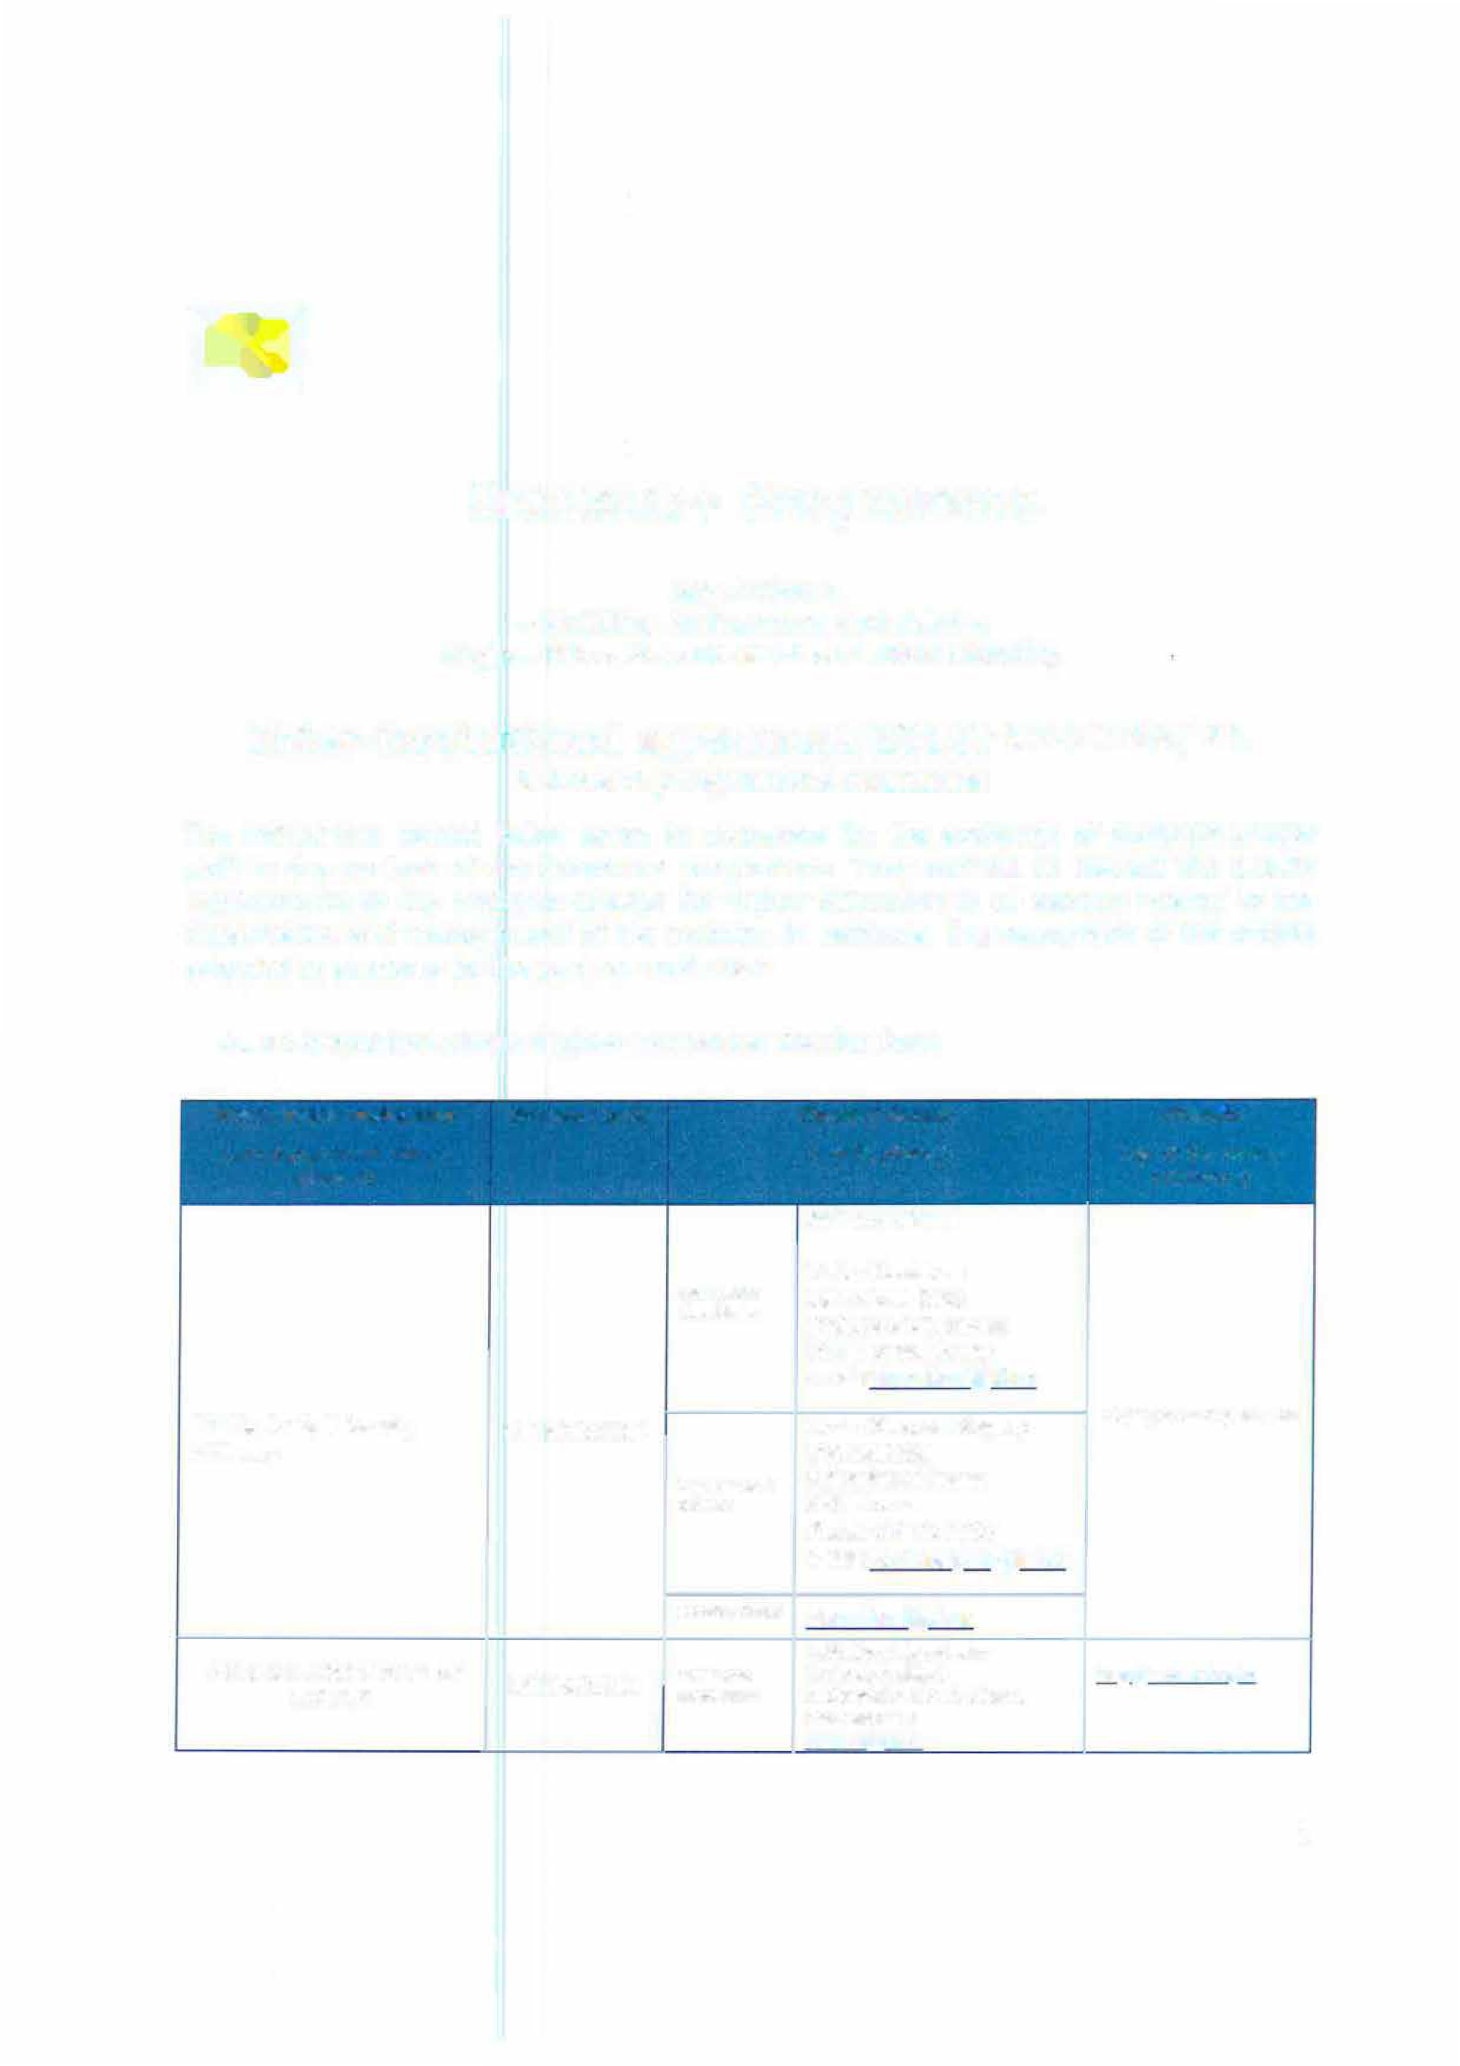

1

Faculty
Erasmus+
I
Coordinator:
Faculty of Sicence, Humanities and Education

List of ECTS Coordinators and Course Catalogue: http://www.tul.cz/en/erasmus/incoming- internationa1-students/course-catalogue

Mobility numbers per academic year

The partners commit to amend the table below in case of changes in the mobility data by no later than the end of January in the preceding academic year.

011 Education
023 Languages
N TROMSO01 CZ LIBEREC0l 022 Humanities 1", 2nd 4 students x * Optional
S months =
224 History 20 months
Philosophy and Ethics
226

CZ LIBEREC0l N TROMSO01
011 Education
023 Languages
022 Humanities

1",2nd

4 students x S months =

* Optional

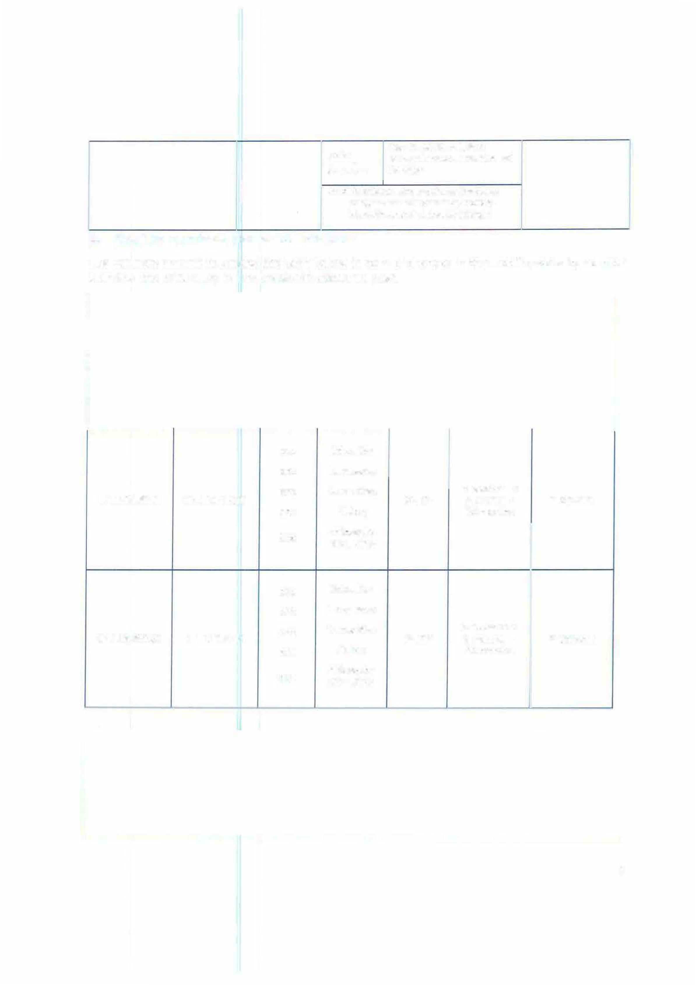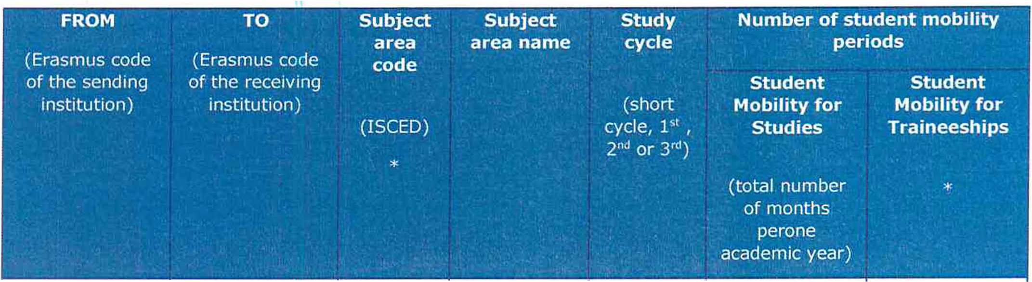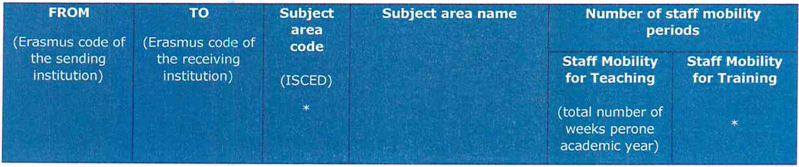224 History 20 months
Philosophy and Ethics
226

2

011 Education
023 Languages

N TROMSO01 CZ LIBEREC0l
022
Humanities
3 weeks for 3 2 weeks for 2 Teaching Staff staff

224 History (min.S hours)
226 Philosophy and Ethics

CZ LIBEREC0l N TROMSO01
011 Education
023 Languages

3 weeks for 3 Teaching Staff (min.S hours)

2 weeks for 2 staff
022 Humanities
224 History
226 Philosophy and Ethics

- Recommended language skills
* Opt1onal

The sending institution, following agreement with the rece1v1ng institution, is responsible for providing support to its nominated candidates so that they can have the recommended language skills at the start of the study or teaching period:

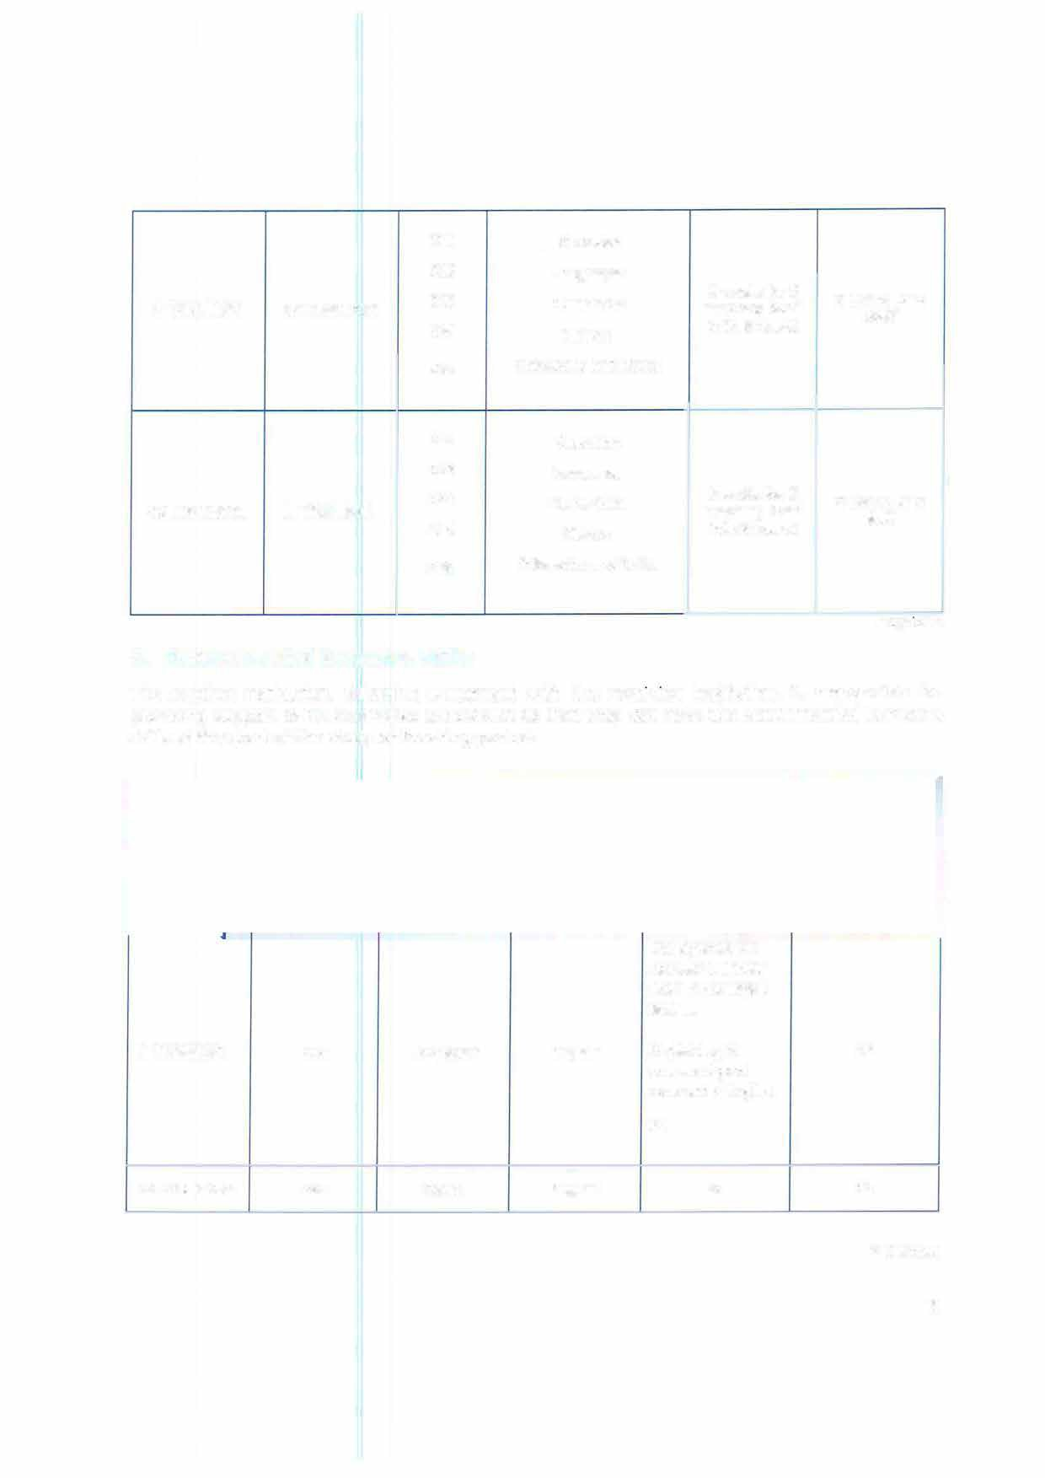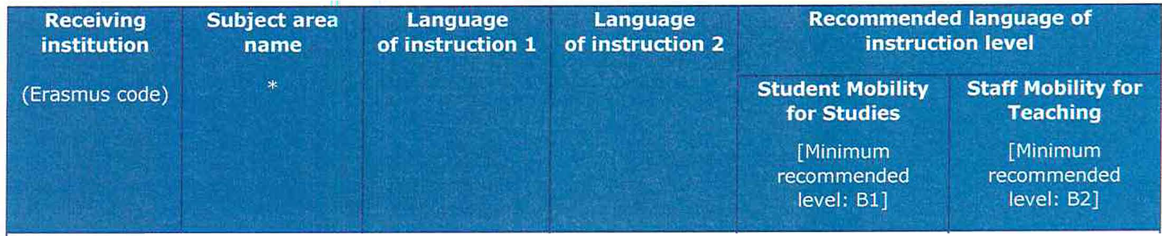

N TROMSO01 XXX Norwegian English

CZ LIBEREC0l XXX Czech English

Norwegian taught courses: University exam in Norwegian, level Ill.

English taught courses: A good command of English.
B1

B1

B2

B2

* Optional

3

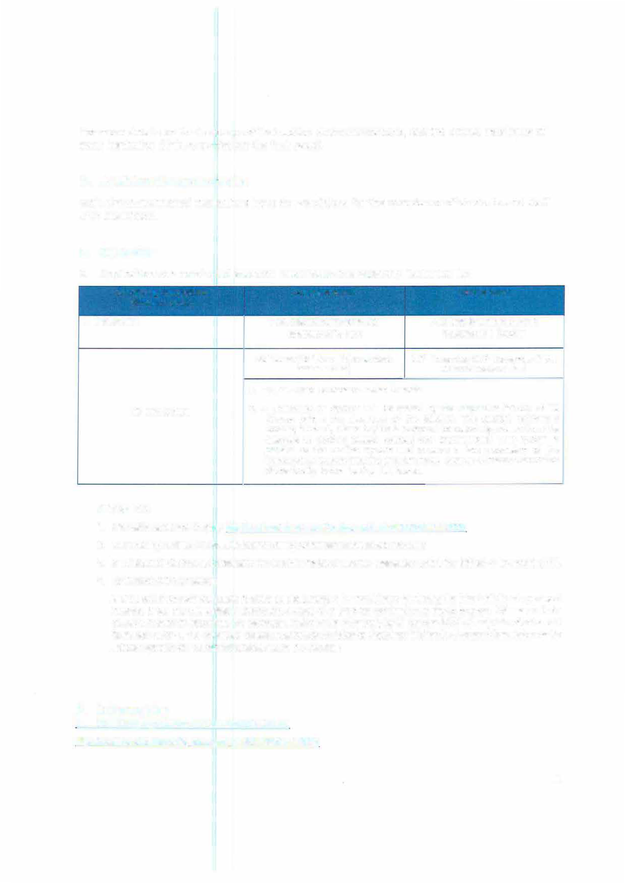

For more details on the language of instruction recommendations, see the course catalogue of each institution (links provided on the first page).

O. Additional requirements
Both above mentioned institutions have the conditions for the acceptance of students and staff with disabilities.

- Calendar
  - Applications on nominated students must reach the receiving institution by:

Receiving institution Autumn term Spring term
(Erasmus code)
N TROMSO01 Fina! date for nominations and Final date for nominations and applications: 15 Apríl applications: 1 October

30th June (15 'h June if the student 30th November (15th November if the needs a Visa) student needs a Visa)
    - TUL will send its decision within 6 weeks
CZ UBERECOl 2. A Transcript of Records will be issued by the respective Faculty at TU
Liberec before the departure of the student. The student receives a booklet, "Index", where he/she is supposed to collect signatures from the teachers to confirm passed courses and examinations. This system is
parallel to the on-line system and ensures a fast processing of the
transcript of records that the student should pick up at the student Office of the faculty before leaving TU Liberec.

NTROMSO01:
- lnformation about how to apply: http://en.uit.no/utdanning/art?p document id=342479&dim=179005
- The receiving institution will send its decision durinq November/December and May/June
- A Transcript of Records will be issued by the receiving institution after the assessment period has finished at the receiving HEi.
- Termination of the agreement
fit is up to the invo/ved institutions to agree on the procedure for modifying or terminating the inter-institutional agreement. However, in the event of unilateral termination, a notice of at least one academic year should be given. This means that a unilateral decision to discontinue the exchanges notified to the other party by 31 October 20XX wi/1 only take effect as of 1 September 20XX+1. The termination clauses must include the following disclaimer: "Neither the European Commission nor the National Agencies can be held responsible in case of a conflict. '1

Information

Grading systems of the institutions
https://en.uit.no/education/art?p document id= 352142&dim=179005

4

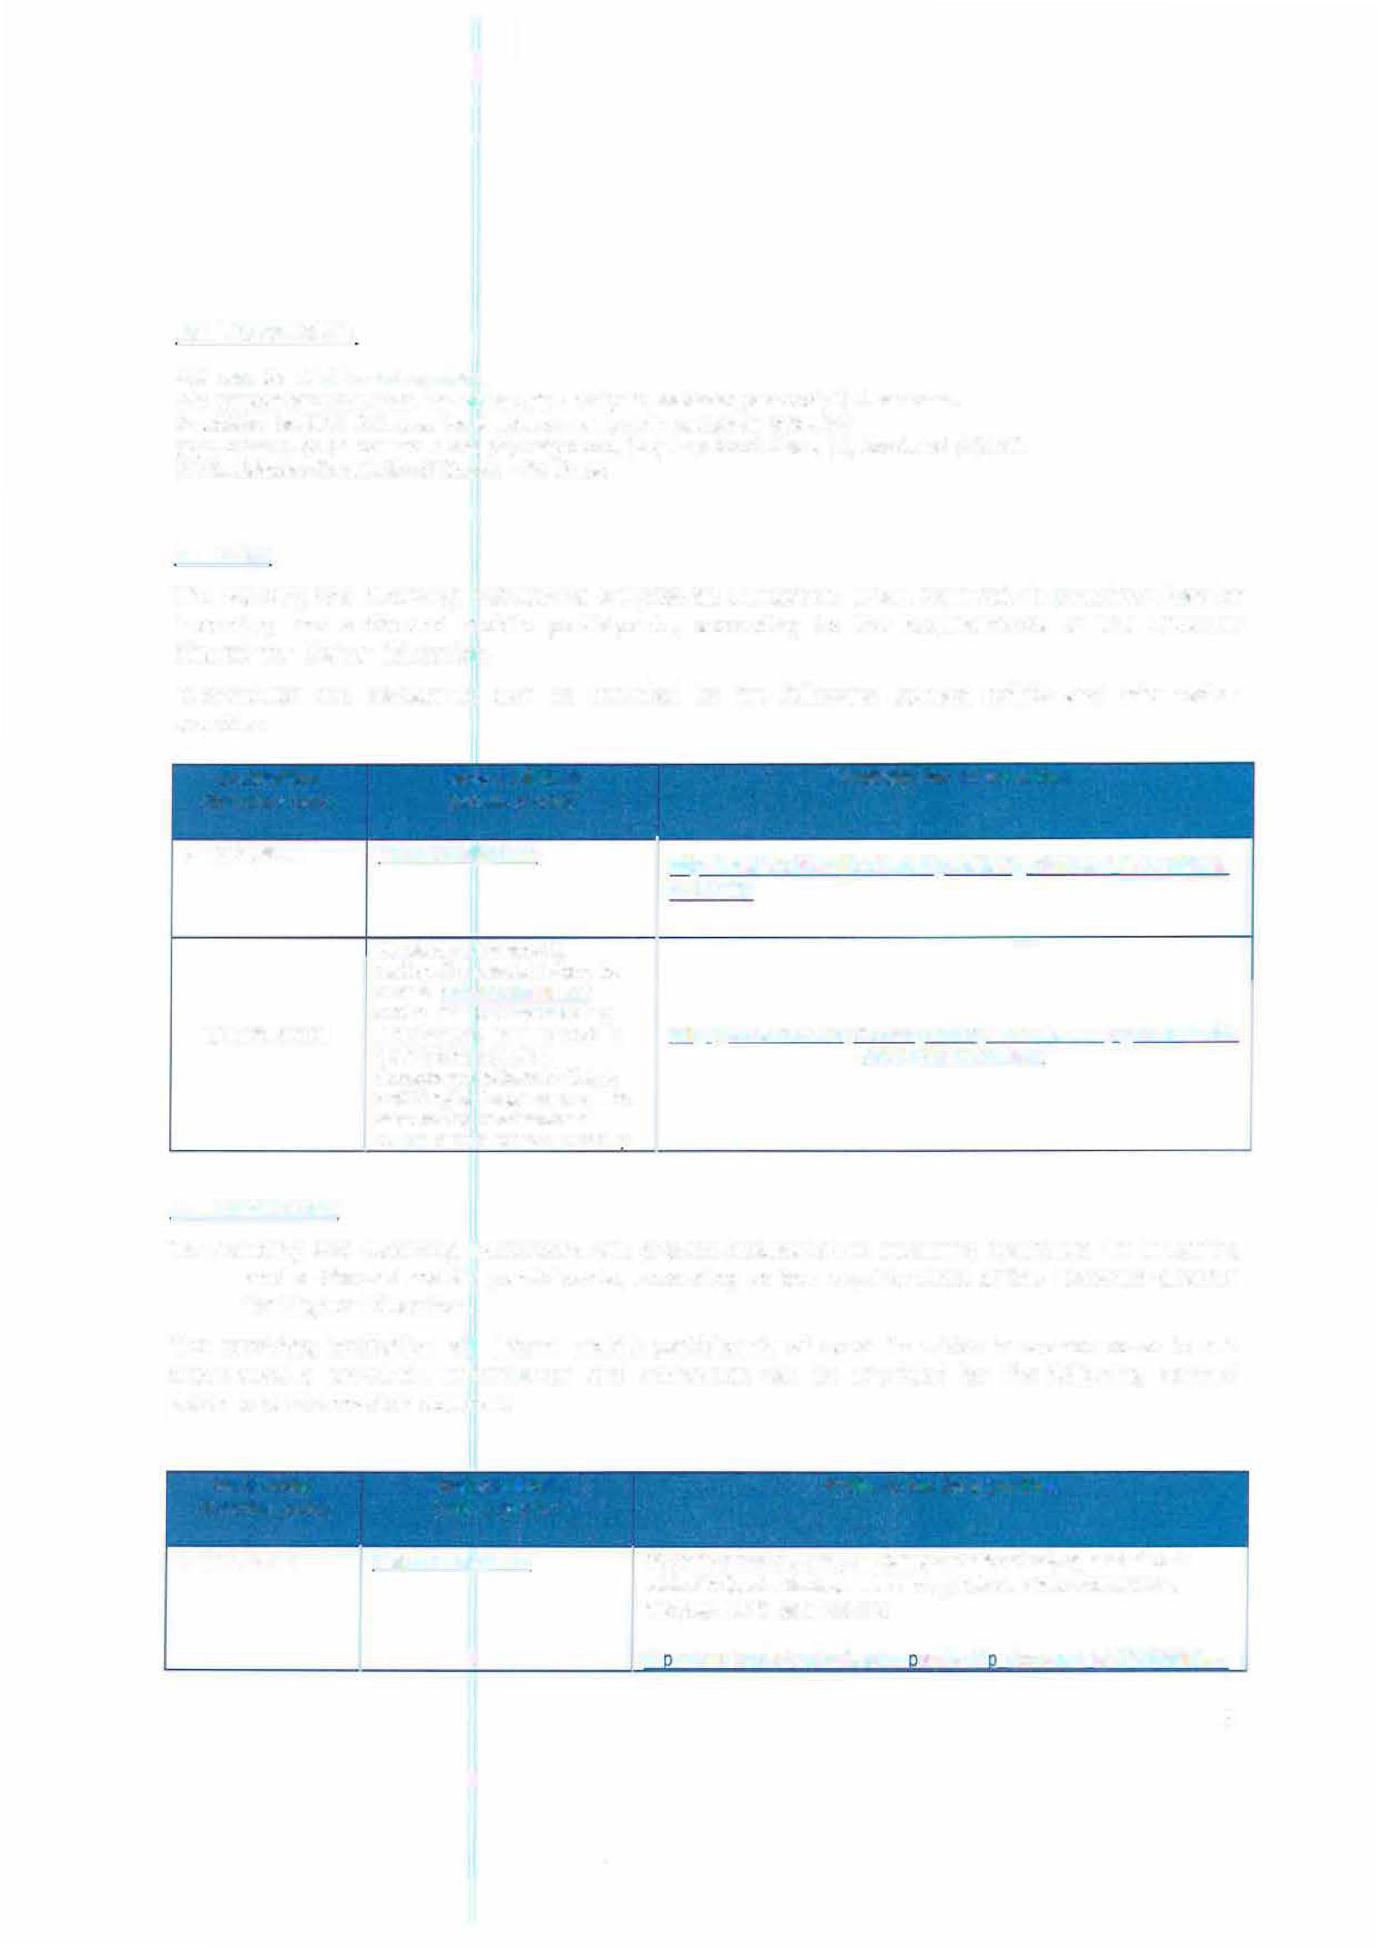li

CZ LIBEREC01:
TUL uses the ECTS credit system.
The symbols of course unit duration: (Y) 1 fu/I year academic year and (S) 1 semester. In addition to ECTS, TUL uses the local numera/ grade system as following:
(1) Excellent, (1-) Excellent Minus, (2) Very Good, (2-) Very Good Minus, (3) Good and (4) Fail.
(R) SatisfactoryCompletion of Course - No Grade.

Visa

The sending and receiving institutions will provide assistance, when required, in securing visas for incoming and outbound mobile participants, according to the requirements of the Erasmus Charter for Higher Education.
Information and assistance can be provided by the following contact points and information sources:

Institution Contact details Website for information
(Erasmus code) (email, phone)

N TROMSO01 lnternational@uit.no httQs://en.uit.no/education/studentQortal/art?Q document id=373688&di m=191028

Students with non-EU nationality should inform by e-mail (erasmus@tul.cz) about the town where they
CZ LIBERECOl have applied for the VISA in http: LLwww. mvcr .czlmvcrenLarticleLa-visa-for-a-stay-of-over-90- their home country. days-long-term.aspx
Acceptance letters in Czech and English languages will be sent to the International Office of the home universitv.

Insurance

The sending and receiving institutions will provide assistance in obtaining insurance for incoming and outbound mobile participants, according to the requirements of the Erasmus Charter for Higher Education.
The receiving institution will inform mobile participants of cases in which insurance cover is not automatically provided. Information and assistance can be provided by the following contact points and information sources:

Institution Contact details Website for information
(Erasmus code) (email, phone)

N TROMSO01 lnternational@uit.no Students at the University of Troms0 are insured only against student
related incidents. Students MUST bring their own insurance and/or a European health card. See also
li htt s://en.uit.no/education/student ortal/art? document id=374656&dim=
s
li

We accept EU health insurance card, students with non-EU nationality should show their insurance contract at arrival.
CZ LIBEREC0l
191037

httQ:L[www.mzcr.czl12revencelukLuk.html

  - Housing
The receiving institution will guide incoming mobile participants in finding accommodation, according to the requirements of the Erasmus Charter for Higher Education.
Information and assistance can be provided by the following persons and information sources:

Institution Contact details Website for information
(Erasmus code) (email, phone)
N TROMSO01 Teorifagsbygget hus 2,
Universitetsveien 29, 9037 http:/ /www.samskipnaden.no/en /housing

Troms0
+47 77 64 90
30 Please apply immediately after nomi nation.

tromso bo1tg@samsk1pnaden.no
Accommodation is booked at Harcov Residence Halls by TU Liberec Erasmus
CZ LIBEREC0l Office upon acceptance of To inform about the time of arrivat: us.koleje@tul.cz
the student. There is no
need to send a special application form or to reaister.

SIGNATURES OF THE INSTITUTIONS (legal representatives)

Institution Name, function
(Erasmus code)

Date
Signature

N TROMSO01

Reidun Sundstn�m Institutional Erasmus Coordinator

07.04.2017

PhDr. Lucie Koutková, Ph.O.
CZ LIBERECOl Head of the International office
/1.(p. w1;

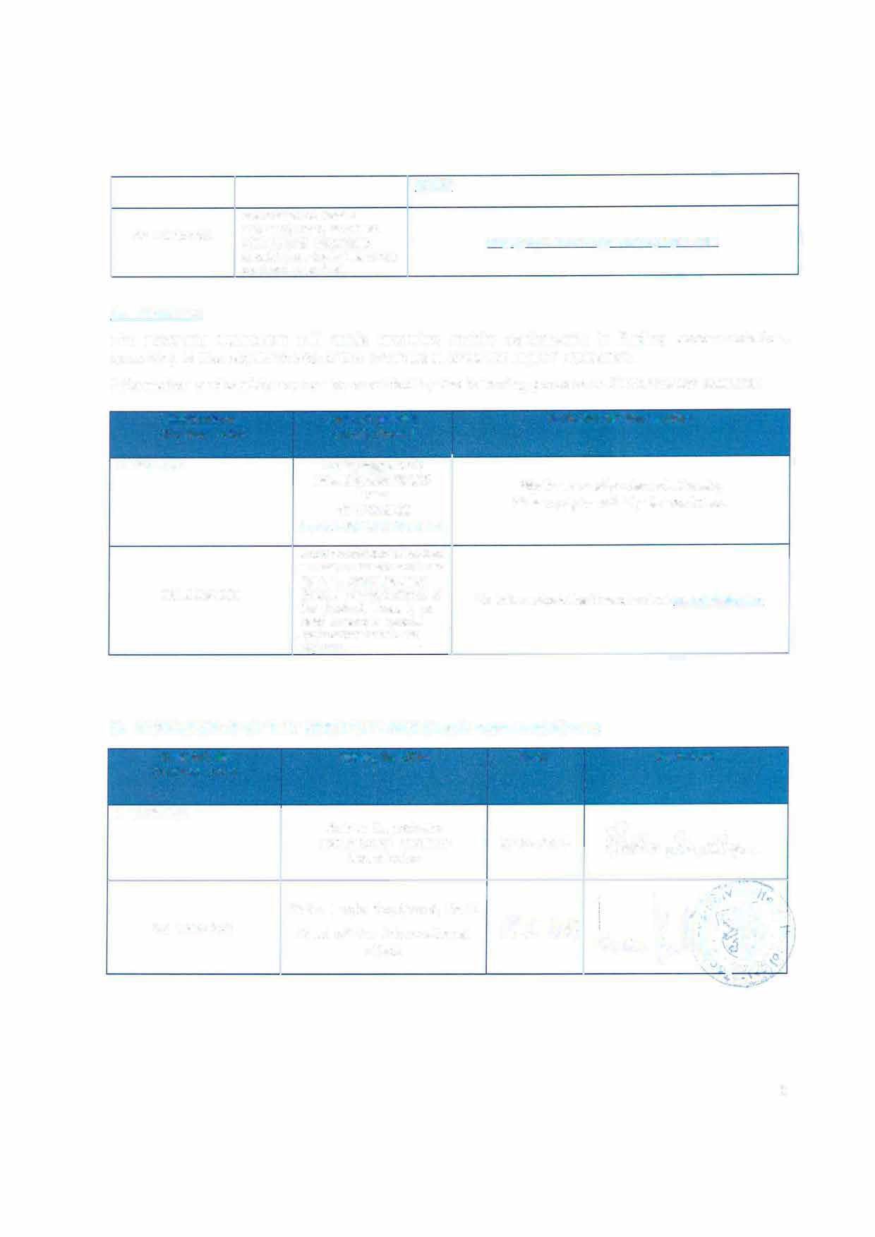

6

