Erasmus+ Programme

Key Action 1 - Mobility for learners and staff Higher Education Student and Staff Mobility

Inter-institutional agreement 2017/18 2020/21
between programme countries

The institutions named below agree to cooperate for the exchange of students and/or staff in the context of the Erasmus+ programme. They commit to respect the quality requirements of the Erasmus Charter for Higher Education in all aspects related to the organisation and management of the mobility, in particular the recognition of the credits awarded to students by the partner institutíon.

Information about higher education institutions

Name of the institution Erasmus code

Universidad de Cantabria (CIESE, Comillas)
E SANTAND0l

Contact detaíls
Institutional Coordinator
Teresa Susinos Rada
Vicerrectora de Internacionalización y Cooperacion
Facultad CC. Económicas
Avda. de los Castros s/n 39005 Santander (Cantabria) vr.internacional@unican.es
Website

Incoming Exchange Student:
httQ:[Lweb.unican.eslenlS tudlingladmissionLexchan ge-students

Technical University of Liberec CZ LIBEREC01 Institutional Coordinator
Studentská 2, 461 17, Liberec, Czech Republic.

erasmus@tul.cz
http:ljwww.tul.cz/en

International Affairs List of ECTS Coordinators and Course Catalogue:

Academie Contact http://www.tul.cz/en/erasmus/incoming-international- students/course-catalogue

Mobility numbers per academic year
FROM TO Subject area [ISCED] Cycle Number of student mobility periods
code name Studies Traineeships
-
CZ LIBEREC01 E SANTAND01
!51, 2nd  1st, 2nd | 4 x S months
 | 2 x 10 months

023 Languages

E SANTAND01 CZ LIBEREC01
-
023 Languages

FROM TO Subject area [ISCED] Number of staff mobility periods code name Teaching Training

CZ LIBEREC01 E
SANTAND01
023 Languages

2 x 5 days (8 hours)

E SANTAND01 CZ LIBEREC01 023 Languages

2 x S days (8 hours)

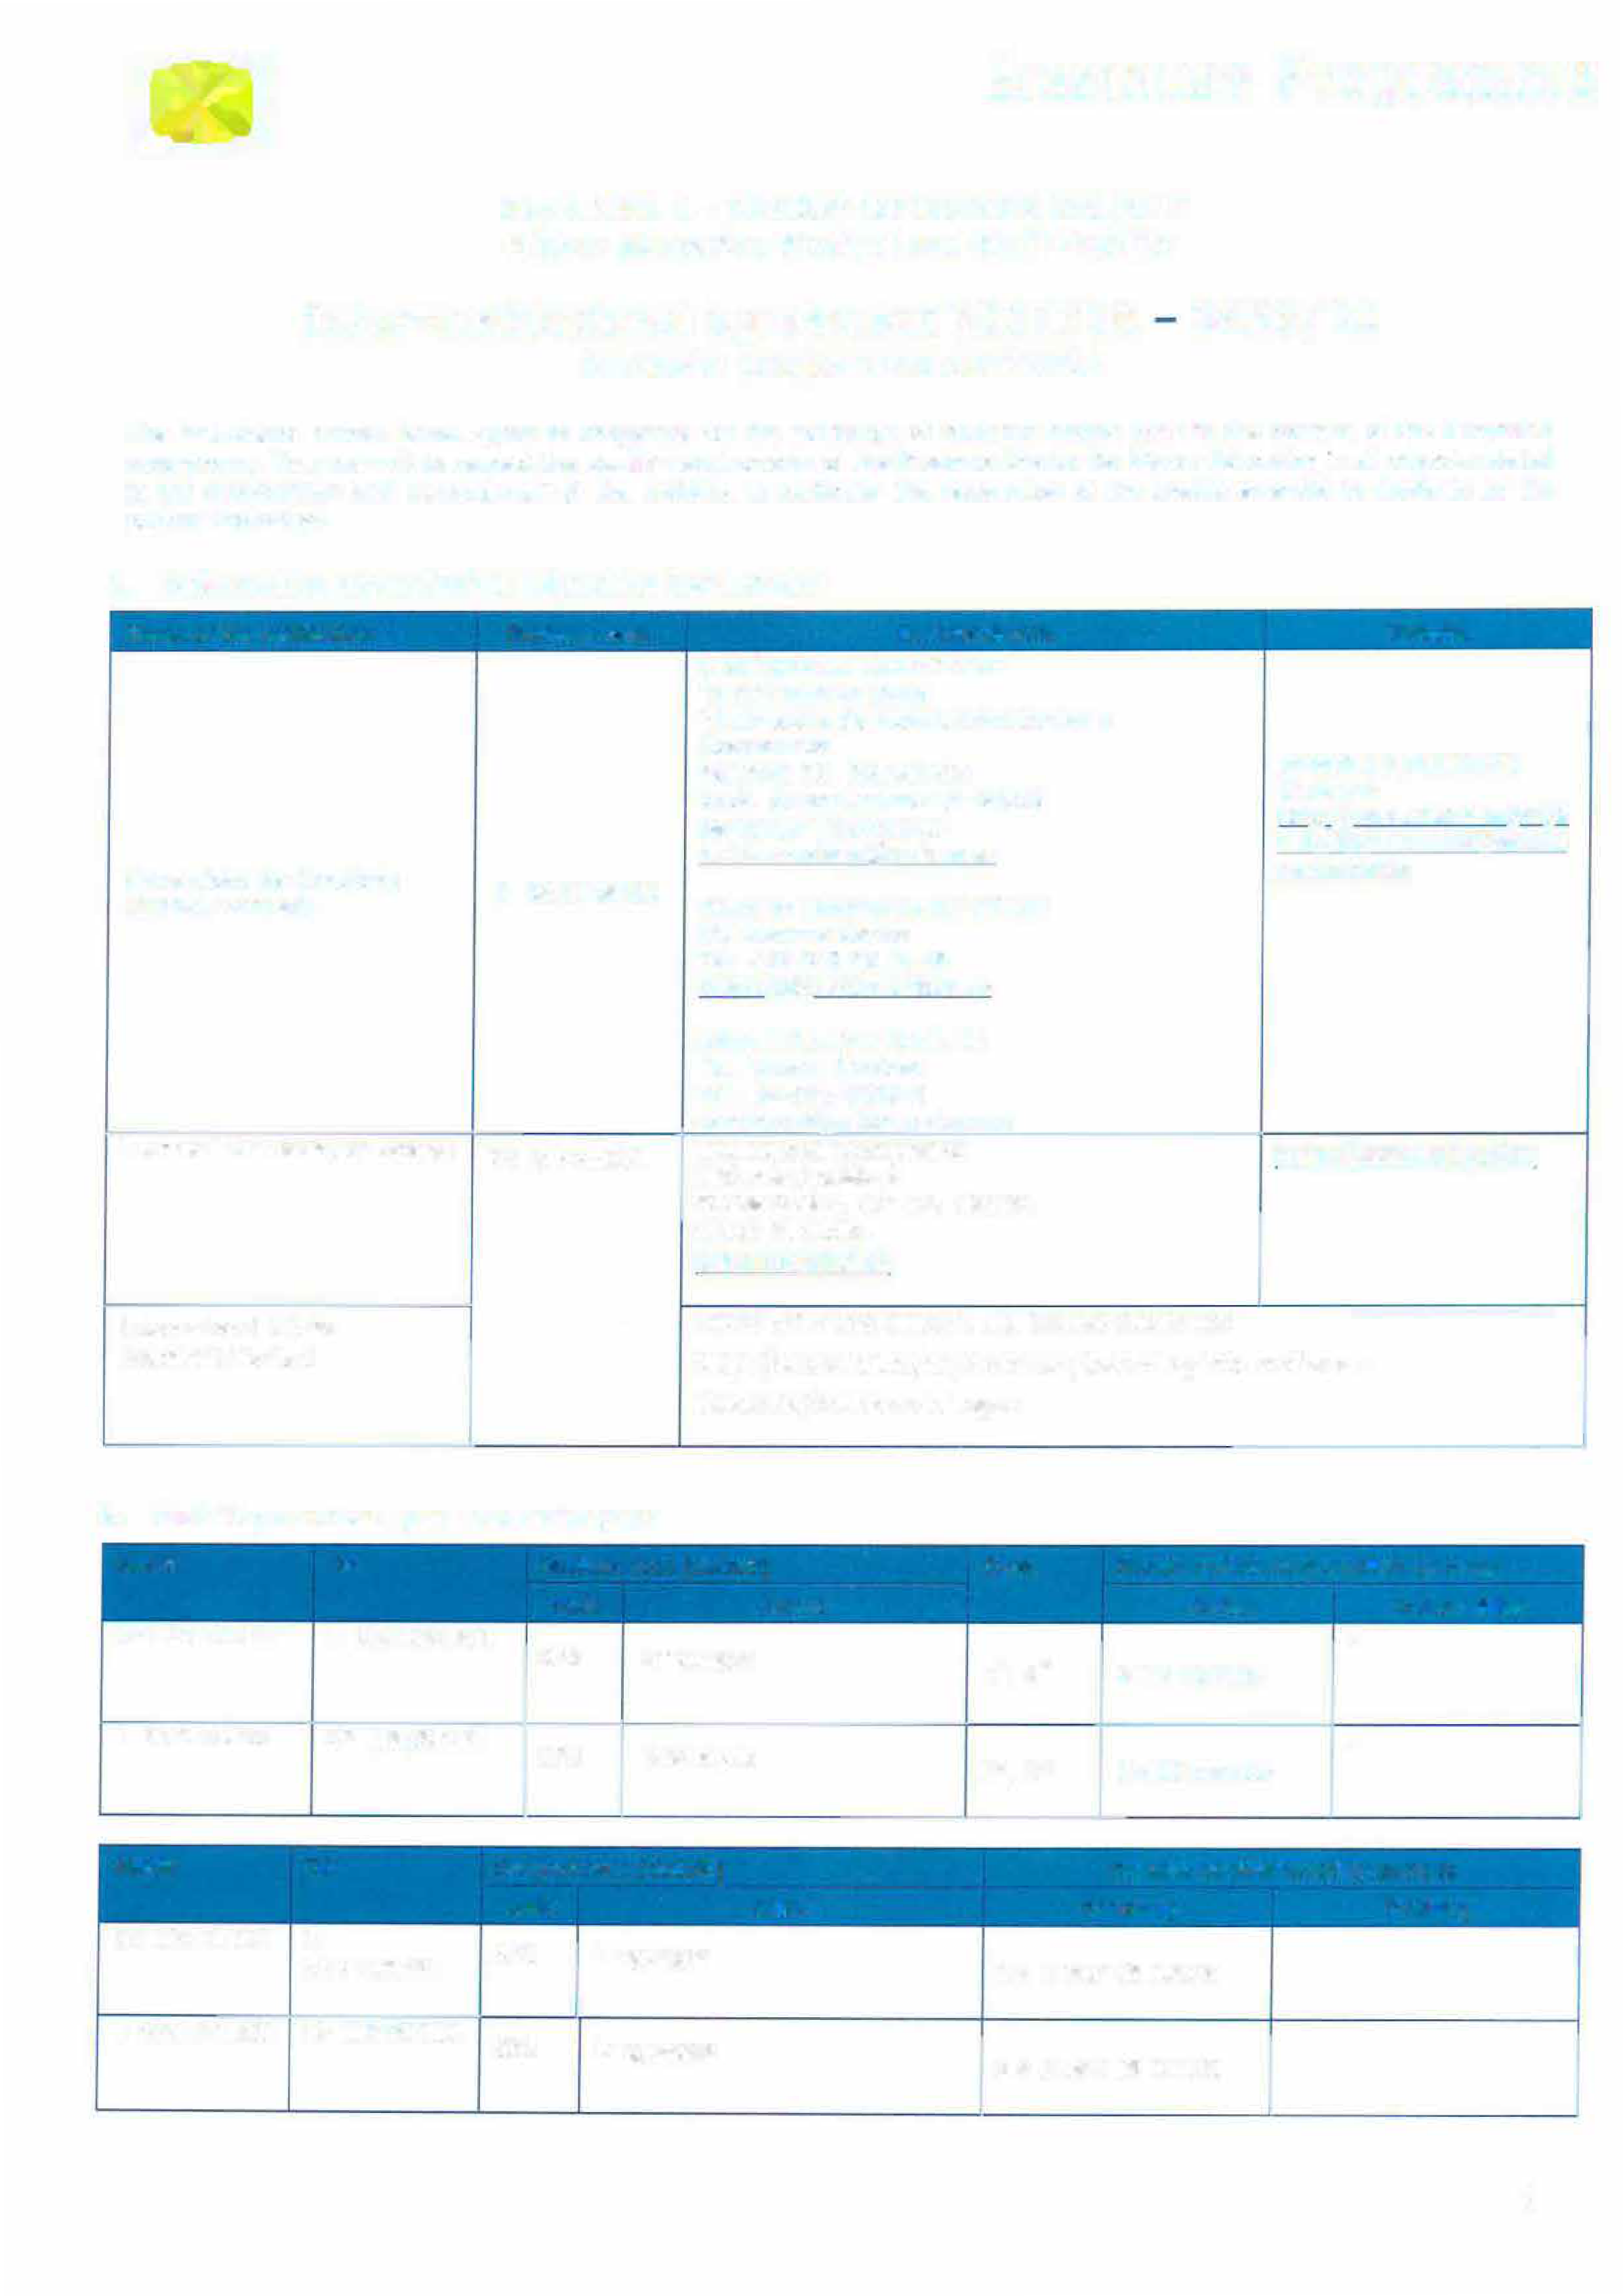
•

1

Recommended language skills
The sending institution is responsible for providing support to its nominated candidates so that they can have the recommended language skills at the start of the study or teaching period:
Receiving institution Language (s) For more details Recommended language of instruction of instruction Student Mobility Staff Mobility
CZ LIBEREC0l | Czech/English | English | B1
E SANTAND0l | Spanish |  | B1  Recommended  B2  Recommended
E SANTAND0l | English

Additional requirements

CZ LIBERECOl In case of additional requirements of academic, organisational or other aspects (e.g. students with special needs), please consult our website: http://www.tul.cz/en/erasmus/incoming-international-students or contact the Erasmus Office: erasmus@tul.cz.
E SANTANDO1 * Support is offered to students and staff with special needs or disability; the lnternational Office should be contacted in the first place. http://web.unican.es/en/Studying/Pages/The-UC-1 nternationa1-Relations-office.aspx.
- lntegration of mobile students: http://web.unican.es/en/Studying/admission/exchange-students
- For further details please refer to the UC information sheet:
http://www.unican.es/NR/rdonlyres/24E37B6B-D8F0-46C2-862B­ A5945E4EASF9/0/UClnformationSheet2014.pdf

Calendar
Receiving institution Autumn term Spring term
l
CZ LIBEREC0l 30th June (15 th June if the student needs a Visa) 30th November (15th November if the student
needs a Visa)

  - TUL will send its decision within 6 weeks
  - A Transcript of Records will be issued by the respective Faculty at TU Liberec before the departure of the student. The student receives a booklet, "Index", where he/she is supposed to collect signatures from the teachers to confirm passed courses and examinations. This system is parallel to the on-line system and ensures a fast processing of the transcript of records that the student should pick up at the student Office of the faculty before leaving TU Liberec.
E SANTANDOl 30th June (deadline for online aoolication) I 1st November (deadline for online aoolication)
- The receiving institution will send its decision within 5 weeks.
- A Transcript of Records will be issued by the receiving institution no later than 5 weeks alter
the assessment oeriod has finished at the receiving HEL
The present bilateral agreement will be valid during the academic years 2017/18 - 2020/21, unless either side terminates the agreement in writing at the !atest by September 30th for activities taking placing during the next (n+l) academic year. Additional activities, cancellations or new subject areas are to be communicated by the same deadline.

Information
About

CZ LIBEREC0l

E SANTAND0l

(for up to date contact details, see web pages)

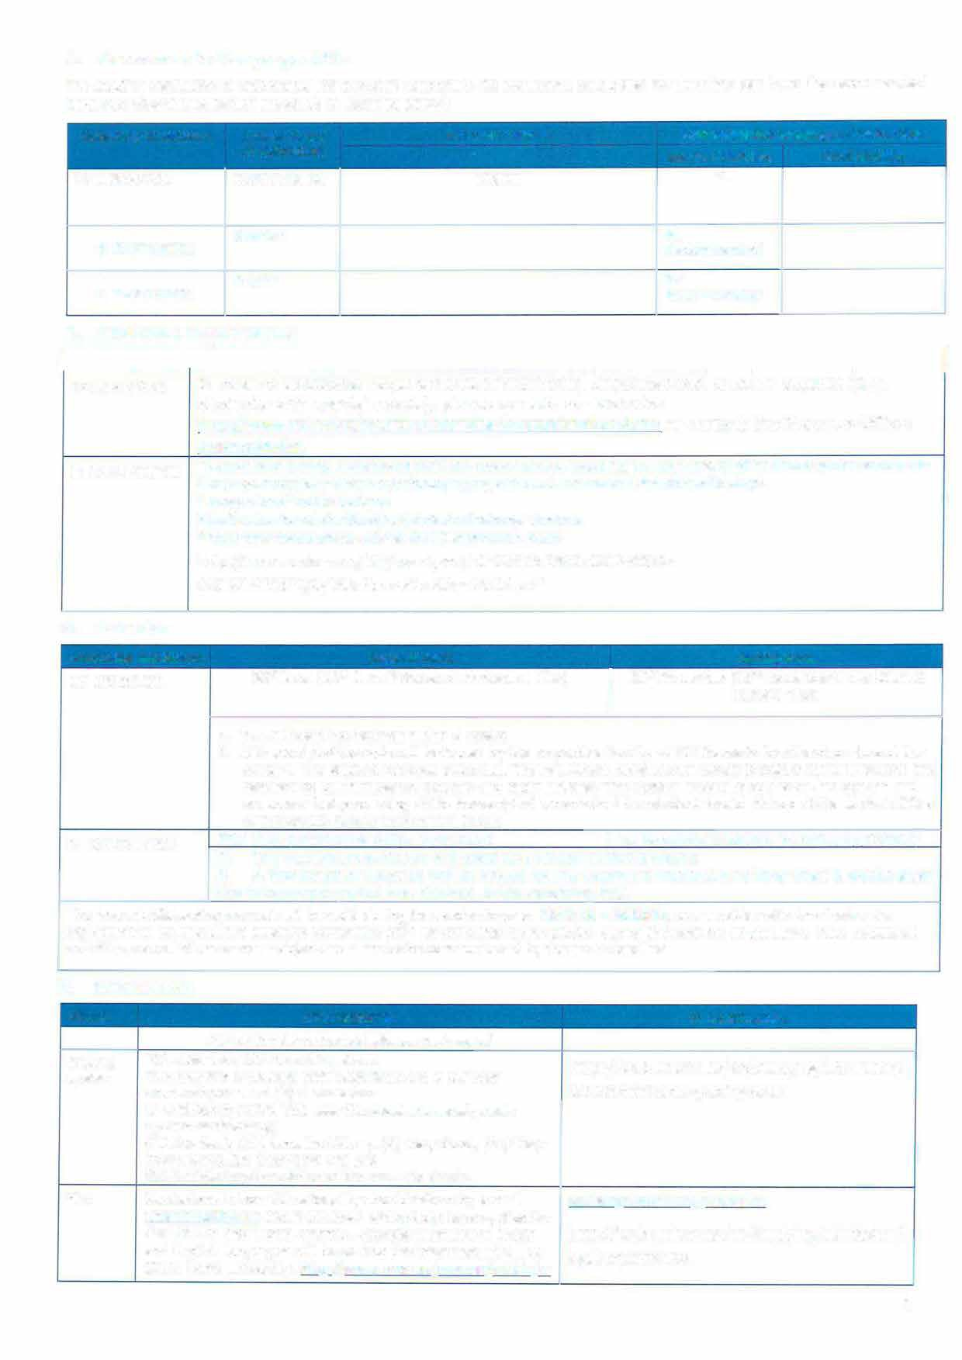Grading system

Visa
TUL uses the ECTS credit system.
The symbols of course unit duration: (Y) 1 fu/I year academic year and (S) 1 semester.
In addition to ECTS, TUL uses the loca/ numera/ grade
system as following:
- Excellent, (1-) Excel/ent Minus, (2) Very Good, (2-) Very Good Minus, (3) Good and (4) Fail.
(R) SatisfactoryCompletion of Course - No Grade.
Students with non-EU nationality should inform by e-mail (erasmus@tul.cz) about the town where they have applied for the VISA in their home country. Acceptance letters in Czech and English languages will be sent to the International Office of the home university. httQ:LLwww.mvcr.czLmvcrenLarticleLa-
http://web.unican.es/en/Studying/admission/ assessment-and-grading-scale

exchange.students@unican.es
http://web.unican.es/en/Studying/admission/l egal-aspects-visa

2

visa-for-a-stay-of-over-90-days-long-term.asgx
Insurance We accept EU health insurance card, students with non-EU nationality should show their insurance contract at arrival. httQ:LLwww .mzcr.czLQrevenceLukLuk.html

Housing Accommodation is booked at Harcov Residence Halls by TU Liberec Erasmus Office upon acceptance of the student. There is no need to send a special application form or to register. To inform about the time of arrival:us.koleje@tul.cz

Special The facilities of the university are accessible for handicapped needs persons. There is also a centre for guidance and support:
httQ:Uwww. tuI.czLakademicka-goradna-a-centrum- QOdQO[Y 82
Academie Winter Semester: Beginning of OCTOBER - Mid FEBRUARY Calendar Summer Semester: Mid FEBRUARY - End of JUNE
httQ:LLwww.tul.czLenLerasmusLincoming-international-
studentsLacademic-calendar

exchange.students@unican.es http://web.unican.es/en/Studying/admission/hea1th
-insurance
info@accommodationunican.com
+34 648 100 288
www.accommodationunican.com/

http://web.unican.es/unidades/oficina-relaciones- internacionales/Documents/Key_dates_Next_Year.p df

SIGNATURES OF THE INSTITUTIONS
Institution Name, function Date Signature

CZ LIBEREC0l
PhDr. Lucie Koutková, Ph.O.
Head of the International office

E SANTAND0l
Teresa Susinos
Vice-Rector for Internationalisation and Cooperation
14-06-2017

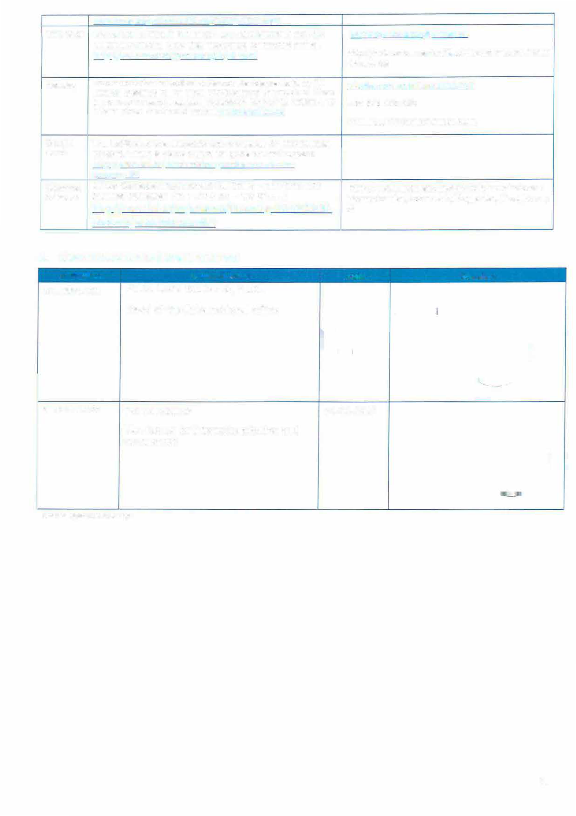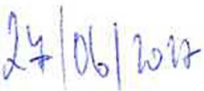

scanned signatures are accept

3

