KOREA ZNOVUNALEZENÁ – příloha č. 1

Boseong Kim, Bowl, xxxxxx Kč

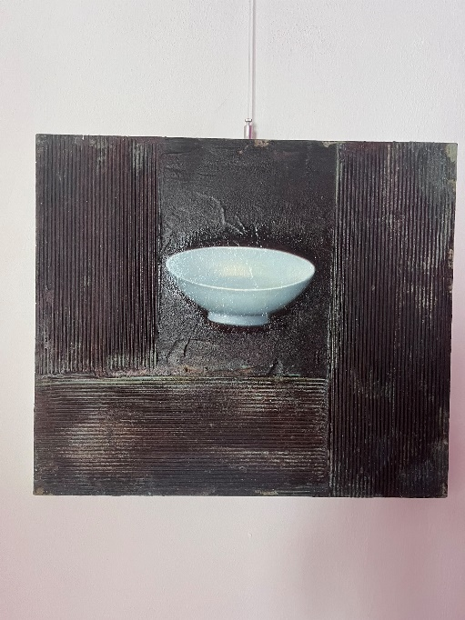

Boseong Kim, Bowl II, xxxxxx Kč

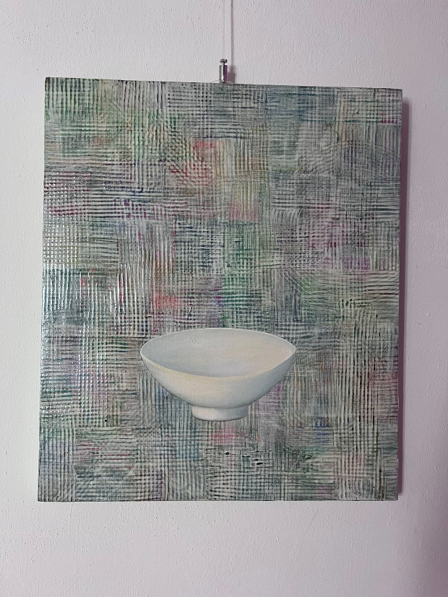

Boseong Kim, Vaze, xxxxxx Kč

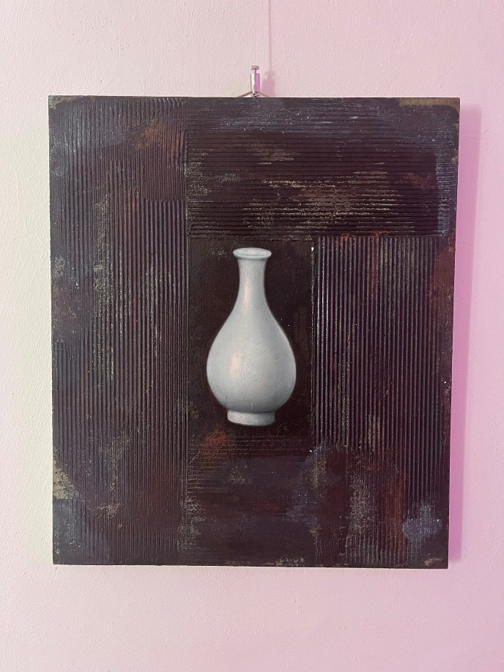

Jaehak Rho, Dancheong I, xxxxxx Kč

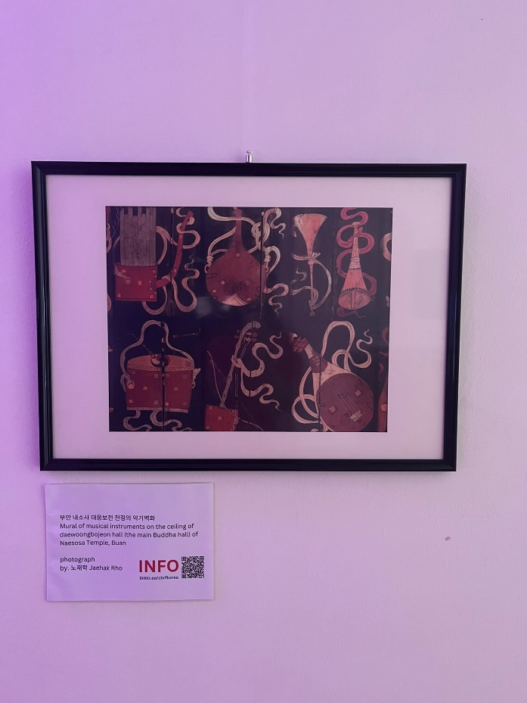

Jaehak Rho, Dancheong II, xxxxxx Kč

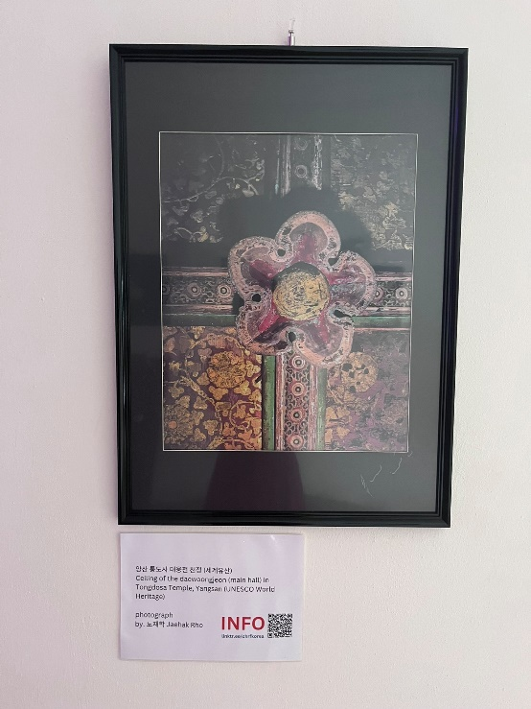

Jaehak Rho, Dancheong III, xxxxxx Kč

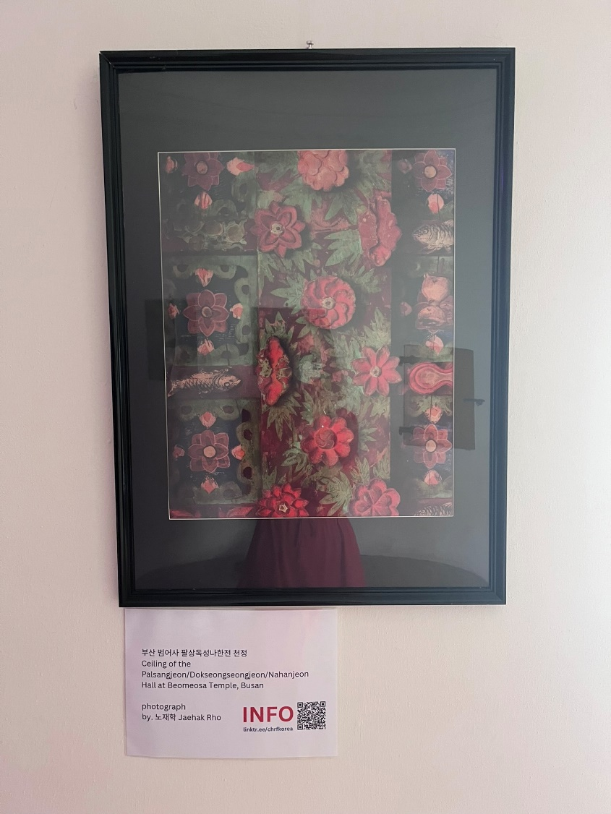

Jaehak Rho, Dancheong IV, xxxxxx Kč

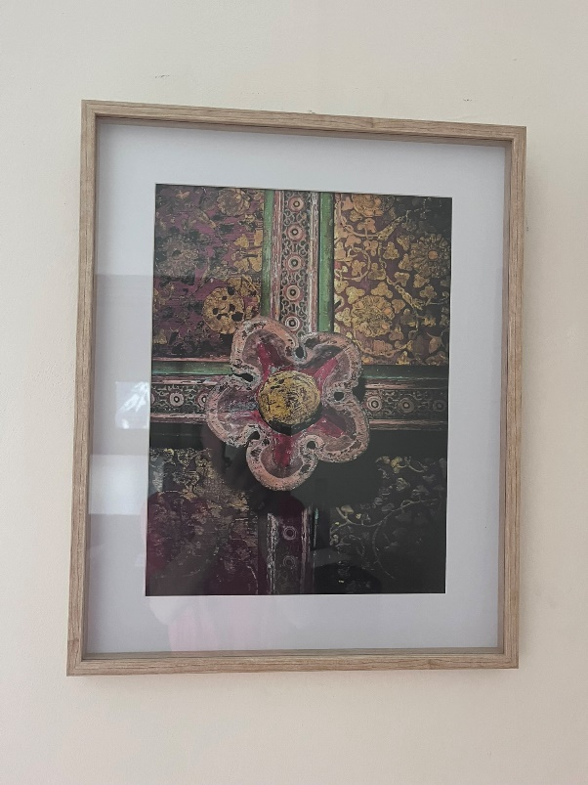

Jaehak Rho, Dancheong V, xxxxxx Kč

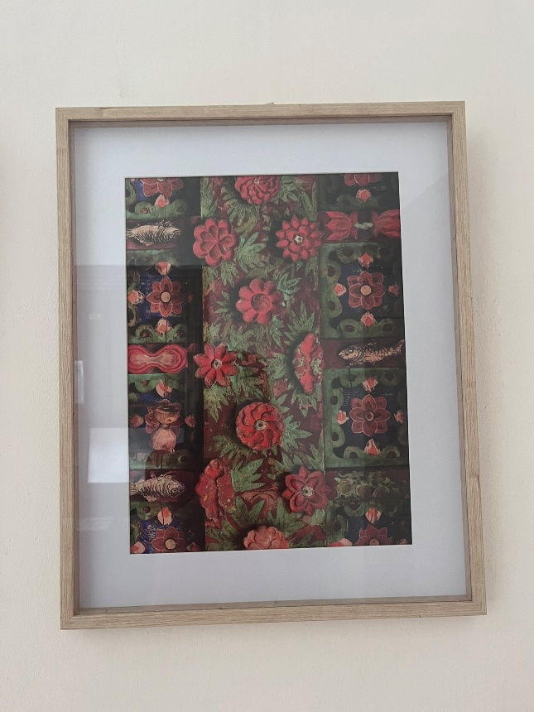

Jaehak Rho, Seonamsa Temple, xxxxxx Kč

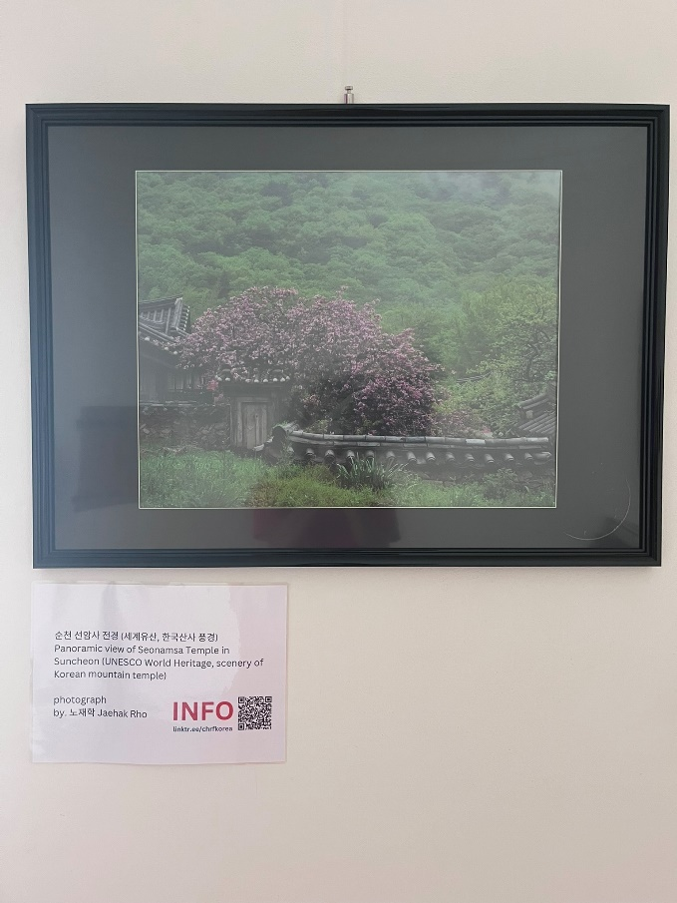

Jaehak Rho, Tongdosa Temple, xxxxxx Kč

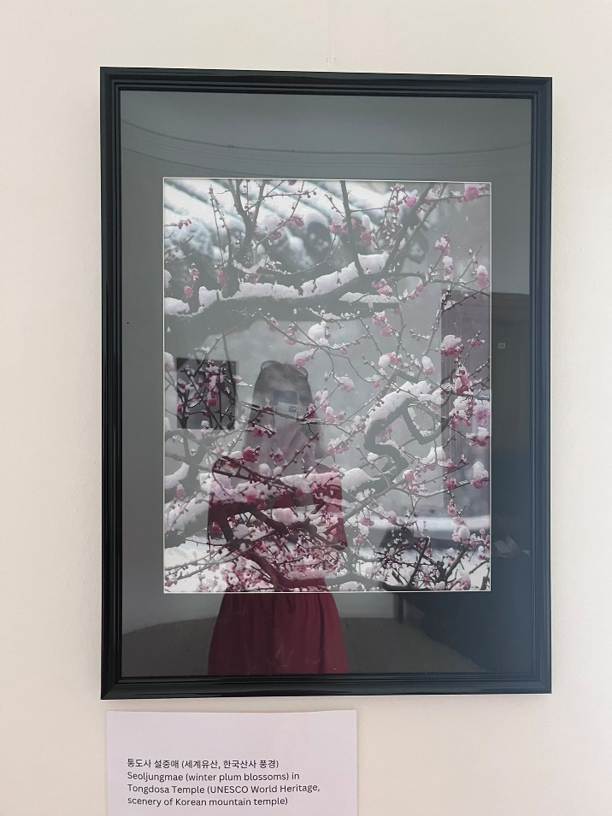

SAMSUNG TV 65 2x

2x TV 65":

|  |  |  |
| --- | --- | --- |
| Control No | Serial Number | Model code |
| C101536848 | 0K0J3HTT500149 | GQ65S95BATXZG |
| C010730975 | 0H3T3HIR300758 | QE65QN85AATXXH |

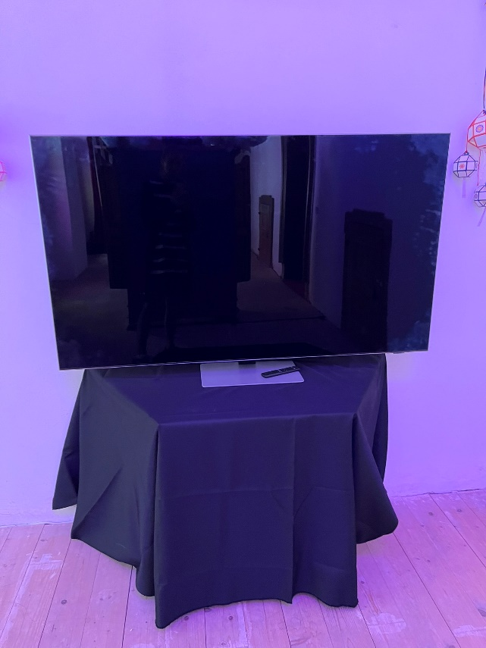

Samsung monitor 27": 3x

|  |  |  |
| --- | --- | --- |
| Control No | Serial Number | Material |
| C006053533 | 0RGQHTHJB00857 | LC27FG73FQUXEN |
| C006053540 | 0RGQHTHJB00849 | LC27FG73FQUXEN |
| C006056058 | 0RGQHTHJC00546 | LC27FG73FQUXEN |

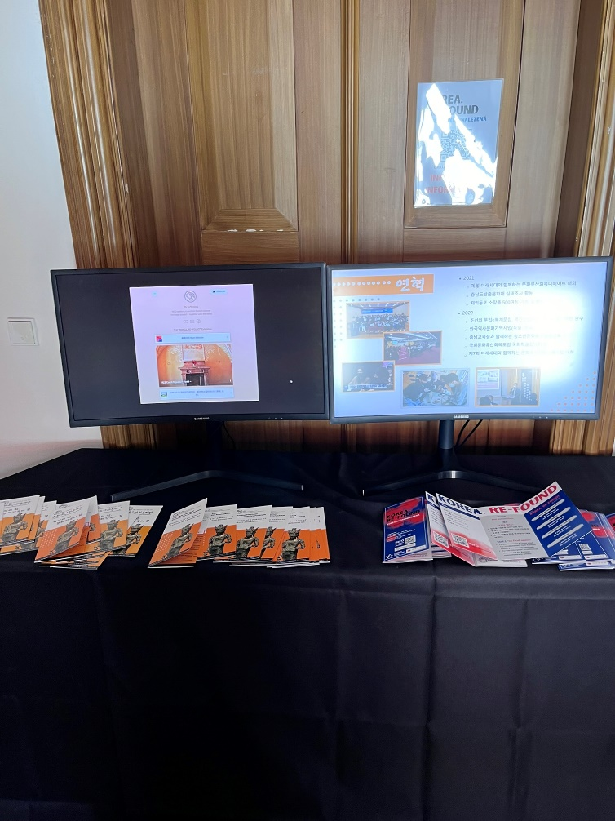

Projektor JOABEAM

JD720B 3x

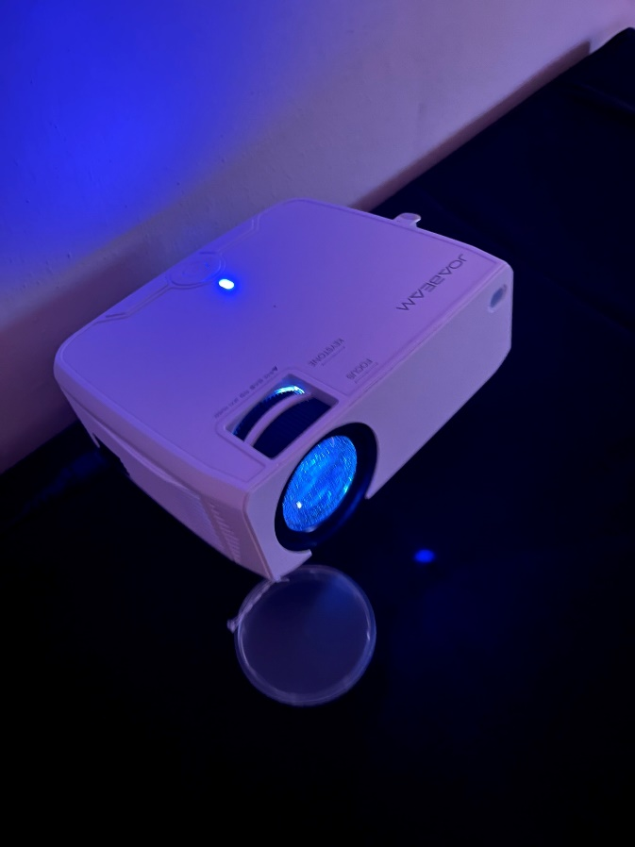

- Semin Cho, video, xxxxxxKč

- Donah Lee, video, xxxxxxKč

- Leenam Lee, video, xxxxxxKč

- Sangkyum Kim, video, xxxxxxKč

- Jongho Lee, video, xxxxxxKč