Příloha č. 1

[[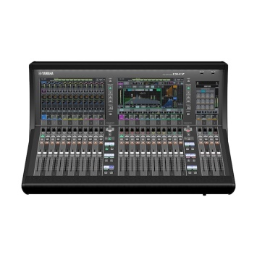](https://europe.yamaha.com/en/files/DM7-front-4000_a97d7650fd0462238a6621b6bc51faad.jpg?impolicy=resize&imwid=4000&imhei=4000)](https://europe.yamaha.com/en/files/DM7-front-4000_a97d7650fd0462238a6621b6bc51faad.jpg?impolicy=resize&imwid=4000&imhei=4000" \o "Yamaha Digital Mixing Console DM7)

DM7 Digital Mixing Console

The DM7 is a Dante-equipped versatile digital mixing console with unparalleled sound quality, ease of operation, and high reliability that make it perfect for a wide range of applications. The DM7 is configured with 24 + 4 faders and a 2 x 12” + 1 x 7” multi-touch screen.

* Input mixing channels: 120 mono
* Buses: 48 Mix + 12 Matrix + 2 Stereo
* Display: 12.1" multi-touch screen x 2, 7" multi-touch screen x 1
* Faders: 28 (12 + 12 + 4)
* Analog I/O: 32 inputs / 16 outputs
* Dante: 144 in / 144 out
* AES/EBU: 2 in / 2 out (with SRC)
* Slot: PY Slot x 1
* USB Audio Interface: 18 in / 18 out
* Power supply: Redundant power supply built-in
* Power consumption: 240 W
* Dimensions (W x H x D): 793 mm x 324 mm x 564 mm (31.3" x 12.8" x 22.2")
* Net Weight: 23.5 kg (51.8 lb)

Software Package

[[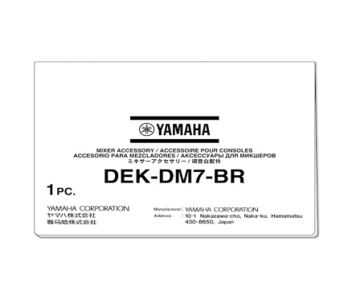](https://europe.yamaha.com/en/files/DEK-DM7-BR-package_eea6ff91a3900d58a88008e3d3d54bea.jpg?impolicy=resize&imwid=2000&imhei=2000)](https://europe.yamaha.com/en/files/DEK-DM7-BR-package_eea6ff91a3900d58a88008e3d3d54bea.jpg?impolicy=resize&imwid=2000&imhei=2000" \o "Yamaha Broadcast Package (DEK-DM7-BR))

Broadcast Package (DEK-DM7-BR)

The Broadcast Package (DEK-DM7-BR) is a software package that adds broadcast functionality to the DM7 series.

* Functions: Mix Minus, Fader Cue Release, Back Stop PFL, Audio Follow Video, Source Selection Mix Mode, Loudness Meter, Meter Scale, 5.1 Surround (Future Update)

[[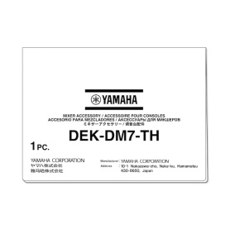](https://europe.yamaha.com/en/files/DEK-DM7-TH-package_80e6b7fd2c0dea53de154af2bce6a751.jpg?impolicy=resize&imwid=2000&imhei=2000)](https://europe.yamaha.com/en/files/DEK-DM7-TH-package_80e6b7fd2c0dea53de154af2bce6a751.jpg?impolicy=resize&imwid=2000&imhei=2000" \o "Yamaha Theatre Package (DEK-DM7-TH))

Theatre Package (DEK-DM7-TH)

The Theatre Package (DEK-DM7-TH) is a software package that adds theater functionality to the DM7 series.

* Functions: 4 Bank EQ/DYN, Actor Library, DCA Preset, DCA Scene Grid, MIDI Output Event on Scene, AFC Image Control (Future Update)

PY Card

[[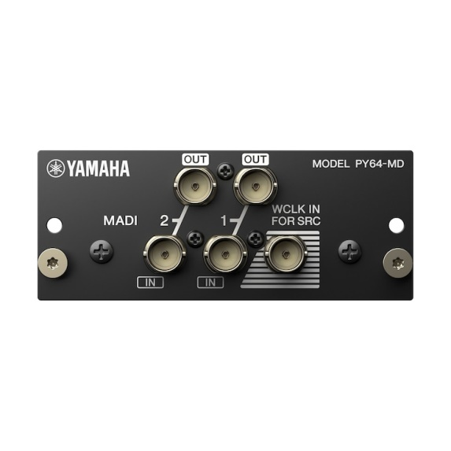](https://europe.yamaha.com/en/files/PY64-MD_4c195ed92692aa3889f9d1166d34d0b1.jpg?impolicy=resize&imwid=2000&imhei=2000)](https://europe.yamaha.com/en/files/PY64-MD_4c195ed92692aa3889f9d1166d34d0b1.jpg?impolicy=resize&imwid=2000&imhei=2000" \o "Yamaha Audio Interface Card PY64-MD)

PY64-MD Audio Interface Card

The PY64-MD audio interface card provides MADI connectivity, handling up to 64 input and 64 output channels of 96 kHz / 24-bit digital audio. The onboard sample rate converters allow interconnection between devices operating at different sampling rates.

* Number of Channels: 64 in / 64 out
* MADI input: 2 BNC connectors with SRC (Up to 64 channels on each terminal)
* MADI Output: 2 BNC connectors with SRC (Up to 64 channels on each terminal)
* Dimensions (W x H x D): 100 mm x 40 mm x 141 mm (4.0" x 1.6" x 5.6")
* Net Weight: 0.2 kg (0.5 lb)

AC Adaptor for external power supply of DM7 Control

[[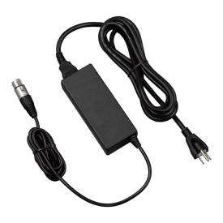](https://europe.yamaha.com/en/files/pa-700_index_61735b21528fcd126a97d04299433342.png?impolicy=resize&imwid=4000&imhei=4000)](https://europe.yamaha.com/en/files/pa-700_index_61735b21528fcd126a97d04299433342.png?impolicy=resize&imwid=4000&imhei=4000" \o ")

PA-700 AC Adapter

AC adapter for providing redundant power supply for SWP1, SWP2, RSio64-D, and DM7 Control.

* Input power voltage: AC100-240V
* Output power voltage: DC24V
* XLR4-11C type connector
* Dimensions: 139.0(W) x 31.3(H) x 58.2(D) mm *without cables