# Contract on the Provision of Financial Resources from the International Visegrad Fund's

**Visegrad Grant No. 22410207**

(hereinafter only the "Contract")

### CONTRACTING PARTIES

#### lnternational Visegrad Fund

Address : Hviezdoslavovo nám. 9, 811 02 Bratislava,

**SK**

ID No.:

Bank name: Bank seat: IBAN: SWIFT/BIC:

36060356

Tatra banka, a.s. Bratislava

SK29I I 000000002936000250 TATRSKBX

Represented by: **Maja Wawrzyk,** Deputy Executive Director hereinafter referred to as the "Fund"

and

#### Západočeská univerzita v Plzni

Name: Address:

Correspondence address:

ID No.:

Bank details:

Registered VAT Payer:

University of West Bohemia Univerzitní 2732/8, Plz eň, 301 00, CZ Univerzitní 8, Plzeň, 30 I 00, CZ

49777513

IBAN: CZ040 I 000000004845500267; SWIFT/BIC: KOMBCZPPXXX; bank

nam e: Komerční banka, a.s.; bank seat: Na Příkopě 969/33, 114 07 Praha 1,

Czechia yes

Represented by: **Miroslav Lávička**

hereinafter referred to as the "Grantee"

* 1. The Fund and the Grantee are hereinafter jointly referred to as only "Contracting Parties".
  2. The Contracting Parties enter into this Contract on the Provision of Financial Resources from the Intemational Yisegrad Fund under the conditions and with the subject matter stipulated belo w.

### SUBJECT OF THE CONTRACT

* 1. The subject of this Contract is the definition of the conditions for the payment of financial support from the Fund to support the activities of the Grantee within the project named **"Innovation of the education process towards implementing Al tools" ,** on the basis ofthe Grantee's proposal in the application submitted via the Funďs Online System as defined below (the "Application") under serial No. **22410207** (the "Project"). To avoid any doubts , Contracting Parties declare and agree that after the Application 1s submitted via the Online System, it cannot be changed by either Contracting Party.

*'ťl*

*{b*

.. I of I O

- -

* 1. The Grantee specified the following project partners for the implementation ofthe Project:

#### Partner No. 1.

|  |  |  |  |  |  |  |
| --- | --- | --- | --- | --- | --- | --- |
| Name ofthe organization in its native language: Slovenská pol'nohospodárska univerzita v Nitre | | | | | | |
| Name ofthe organization in English: Slovak University of Agriculture in Nitra | | | | | | |
| Address: Tr. A. | Hlinku | 2, Nitra, 949 76 , **SK** |  |  |  | JsK |
| Statutory representat ive: Klaudia Halászová | | | | | | |
| BIN: 00397482 |  |  | JRegis tered | VAT | payer: yes |  |

**Partner No. 2.**

|  |
| --- |
| Name of the organization in its native language : Eotvos Loránd Tudományegyetem |
| Name ofthe organization in Englis h: Eotvos Loránd University |
| Address: Egyetem tér 1-3 , Budapes t, I 053, HU !HU |
| Statutory representative: László Borhy |
| BIN: 15308744-2-41 JRegis tered VAT payer: yes |

**Partner No. 3.**

|  |  |  |  |  |  |  |  |  |  |
| --- | --- | --- | --- | --- | --- | --- | --- | --- | --- |
| Name ofthe organization in its native language: Uniwersytet Jagiellonski w Krakowie | | | | | | | | | |
| Name ofthe organization in English: Jagiellonian University in Kraków | | | | | | | | | |
| Address : ul. Golybia | 24, | Kraków, | 31-007, | PL |  |  |  | I P | L |
| Statutory representative: Jacek Popiel | | | | | | | | | |
| BIN: 000001270 |  |  |  |  | IRegis tered | VAT | payer: yes |  |  |

**Partner No. 4.**

|  |
| --- |
| Name ofthe organization in its native language: Vysoká škola ekonomická v Praze |
| Name ofthe organization in English: Prague University ofEconomics and Business |
| Address: nám. W. Churchilla 193 8/4, Praha, 130 67, CZ J e z |
| Statutory representative: Petr Dvořák |
| BIN: 61384399 JRegis tered VAT payer: yes |

Ail ofthe above-mentioned partners are hereinafter jointly referred to only as the "Project Partners" .

* 1. The subject of the Project shall be supported by the Fund with an amount of up to **€9,990.00** under conditions set forth below in this Contract (the "Grant").
  2. The Grantee is obliged to implement the Project in compliance with the time frame and financial and other conditions stipulated in the Contract.
  3. The Grantee is obliged to keep the Fund updated with regard to the Project via the grant management online system available at h tt p:/fnl\'.v isegradfund .org/ (the "Online System"). The Grantee is also obliged to submit requests for budget changes and extensions of the implementation period of the Project through the Online System as further specified in the Grant Guideli nes . Requests for substantial changes must be submitted to the Fund in writing and approved by the Fund as further specified in the Grant Guidelines. The Grantee is obliged to inforrn the Fund with no delay (max. within IO calendar days from such a change) in writing of any interna) changes of the Grantee, such as changes of the Grantee 's official name , registered seat, statutory representatives , registration for VAT, etc.

### IMPLEMENTATION OF THE PROJECT

* 1. The Contracting Parties agree that the Project shall last from **01/06/2024** to **30/06/2025** (the "Implementation Period").
  2. Particular stages ofthe Project implementation are specified in Attachments No. I and 2 hereof("List ofOutputs" and "Calendar

, of Events"). The Grantee is obliged to maintain an up-to-date Calendar of Events. Any change in the dates, venues and details of events originally stipulated in the Calendar of Events must be updated and confirmed in the Online System within 30 to I O calendar days prior to the planned date. The Grantee is allowed to modify the Calendar of Events without the Funďs prior approval to the extent specified in the Grant Guideli nes . Unconfirmed events and/or unauthorized modifications in the List of Outputs and/or Calendar of Events will be disregarded during the evaluation of the lnterim/Final Report and their related costs will not be reimbursed.

1. **GRANT PAYMENT**
   1. The Grant shall be paid to the Grantee under the conditions set forth in Section 4.2 hereof in 2 installments as follows:
      * the 1st installment in the amount **of€7,992.00** within 15 working days after the delivery ofthe valid and effective Contract by the Grantee to the Fund (the "First lnstallment"); Contracting Parties agreed that the Grantee is obliged to deliver to the Fund a final report, the contents and requisites of which are set forth in the Grants Guidelines published and available on the Funďs website, in the period under Artic le 6, section 6.2 ofthe Contract (the "Final Report");
      * the 2nd (and final) installment in the amount of **€1,998.00** within 15 working days after the Final Report and Financial Statement are approved by the Fund according to Article 6 hereof (the "Final lnst allment") . Parties agreed that the Final lnstallment must be pre-financed by the Grantee and, if duly approved under the conditions set forth hereof , the Fund reimburses the due amount ofthe Final lnstallment.
   2. The Grantee shall be entitled to the 2nd lnstallment and Final Installment of the Grant solely upon the approval of the Fund provided (i) the relevant reports relating to the particular installment were delivered by the Grantee to the Fund within the periods stated in Article 6 hereof and in the Calendar of Events/Outputs as specified in Attachment No. 2 hereto and (ii) such reports were approved by the Fund pursuant to Article 6 hereof .
   3. The Fund reserves the right to deny the disbursement of the Grant or any part of it, in case the Grantee does not comply either with the Grant Guidelines mentioned in 4.4 and applicable at the time of the App lic ation's submissi on, or the provisions of the present Contract. ln such case, the Grantee shall not be entitled to any dis bursement . The Fund also reserves the right to reduce the Grant or any part of it, in case the Grantee is entitled for any tax (VAT) refund from local authorities.
   4. The Grantee declares that prior to signing this Contract they have made themselves familiar with the Grant Guidelines of the Fund which are applied by the Fund for the organization and treatment of the grants, including the Grant provided to the Grantee under this Contract, and which are published on the website of the Fund (www.visegrad fund.or g). The Grantee shall be obliged to accept all such rules and principles ofthe Fund.
   5. The Fund is entitled to unilaterally change and/or amend the Grant Guidelines even through validity ofthe Contract and is in such case obliged to make the valid version thereof available at the Funďs website (www.v is egradfu nd. org). The Grantee is obliged to comply with the updated Grant Guidelines after receiving a notification about changes and/or amendments by the Fund.

## GRANT UTILIZATION

* 1. The Grant shall be used by the Grantee only to cover the direct expenses of the Project during the lmplementation Period of the Project according to the budget pian which forms Attachment No. I hereof (the "Budget"). Up to 15% of the Grant may be used to cover Project overhead costs (operating costs directly Iinked to the Project).
  2. The expenses required for the Project from the Grant cannot exceed the approved amount.
  3. The Grant may only be used during the contracted lmplementation Period. The part of the Grant not used during the lmplementation Period sha ll be retumed by the Grantee to the Fund upon request within 15 working days.
  4. The Grantee shall use the Grant according to the Budget in an efficient and cost-effective way.

"

* 1. Any change in the qualified expenses as stated in the Budget exceeding the amounts in individual budget categories as specified

in the Grant Guidelines requires the prior approval of the statutory representative of the Fund. For such approval to be granted šl­ request must be submitted in the Online System with proper justification. Without the Funďs approval, the Grant may not be used to cover such changed expenses exceeding the amount qualified in the Budget.

* 1. The financial resources ofthe Grant other than overhead costs cannot be used for:

|  |
| --- |
| a) capital investments (tangible/in tangible assets); |
| b) VAT refund for Grantees who request VAT compensation from local authori ties; |
| c) the Grantee 's own indirect costs (elec trici ty/gas/water/telephon e bills, etc.); |
| d) intemal costs or invoices (rent of one's own prem is es, one's own accommodation and board); and |
| e) Grantee's own work-e.g. coordination ofthe Project, salaries, financial remuneration ofemployees (or any expenses related to employment based on the Labour Code, including daily allow ances, part-time work, etc.). |

## REPORTING OBLIGATIONS AND RELATED CONTRACTUAL TERMS

* 1. The Grantee shall immediately inform the Fund in writing of any circumstance which may affect the realization of the Project or of any changes in the contractual conditions. The statutory representative of the Fund shall decide upon such circumstances and changes.
  2. The Grantee shall deliver to the Fund:

|  |  |  |
| --- | --- | --- |
| *l?eporl:* | *Covering lhe period from- 10:* | *la1es1 delivery of reporl:* |
| Fin a! Repon | O I /06/2024- 30/06/2025 | 28/07/2025 |
| Fin ancial Statement | O I /06/2024- 30/06/2025 | 28/07/2025 |
| Copie s of all project-related in voices and bank  transcripts | 01/06/2024- 30/06/2025 | 28/07/2025 |

* 1. The reports under this Article hereof shall be drawn up in the qualified fonns and according to the requirements and instructions published on the website ofthe Fund , mainly in the Grants Guidelines. The Fund reserves the right to deny any Report failing to meet this requirement.
  2. Ali the reports shall be prepared and separately signed by an authorized representative ofthe Grantee.
  3. The Financial Statements shall conform to the budget and shall mention expenditures related to the Project and shall comply with financial documents evidencing the utilization of the Grant. Ali financial documents (receipts, bills , contracts and invoices, etc.) related to a project must be kept for a period of at least I O years and copies thereof delivered to the Fund upon request.
  4. The Fund has the right to verify any data provided by the Grantee to the Fund. The Grantee hereby grants the Fund authorization to carry out any acts necessary for verifying any data provided by the Grantee to the Fund.
  5. ln case of any reservations of the Fund to the provided reports or any documentation attached thereto, the Grantee shall be obliged to revise such reports or documentation according to the requirements ofthe Fund within the period stated by the Fund.
  6. The Fund reserves the right to detennine the eligibility of each cost to be covered by the Fund.
  7. The Grantee shall infonn the Fund with no delay (max. within I O calendar days from such a change) in writing of any intemal changes of the Grantee, mainly but not limited to changes of the Grantee's official name, registered seat, statutory representat ives, registration for VAT, etc.

## OTHER CONTRACTUAL TERMS

* 1. Ali fonnal communication with the Fund must be conducted in English.

_,

* 1. The Grantee is obliged to specify a bank account for the purposes ofthe grant disbursements realized by the Fund. Ail Project

, payments must be carried through the bank account owned by the Grantee .

* 1. The Grantee shall conduct bank transfer (non-cash) transactions only.
  2. The Grantee is obliged to acknowledge the Funďs support ofthe Project (i) on all prem is es where events take place as part ofthe Project (in the form of a banner or flag), (ii) in all printed materials distributed as part of the Project, (iii) in all public statements and presentations and (iv) on all web pages connected with the Project. Ali acknowledgements must visibly carry the current version of the Funďs logo and, if onli ne, must be directly linked to [www .visegradf und .org.](http://www.visegradfund.org/) Acknowledgements in event venues must be present for the duration of the events; acknowledgements online must remain active for the whole Contractual Period of the Project, at a minimum . The Grantee shall ensure that any of its Project Partners acknowledge the Funďs support for the Project to the same extent that the Grantee is obliged under this Contract. Further obligations of the Grantee regarding the acknowledgement of the Funďs support ofthe Project are specified in the Logo and Acknowledgement Manual (annex to the Grant Guidelines) ofthe Fund published on the Funďs website and the Grantee declares that prior to signing this Contract they have made themselves familiar with the Grant Guidelines and shall abide by this policy.
  3. The Fund reserves the right to carry out monitoring visits of the Project and implementation thereof and carry out financial inspection of the Project and, if necessary, request additional documentation regarding the Project. The Grantee is obliged to allow visits from the Funďs staff or from personnel authorized by the Fund to make such visits, allow financial inspections and provide any materials related to the Project upon request.
  4. The Fund (or person authorized by the Fund) is entitled to carry out an audit ofthe Grantee during the Contract validity and for three additional years after providing the final installment of the Grant to the Grantee based on this Contract. The Grantee is obliged to bear such an audit and provide the Fund with any accounting and other documents related to the Grant, and make and deliver the Fund copies therefrom.
  5. The Fund undertakes to extend to the Grantee necessary co-operative suppo rt.
  6. Both Contractual Parties may disclose information on the Project and enable access ofthe public to participate in the Project.
  7. The Grantee takes note ofthe fact that the Fund accepts no responsibility for any contents of any Project outputs.

7. I O The Grantee declares that he shall be the bearer of all intellectual property rights and/or copyrights to any outputs of the Project or any part thereof (the "Outputs"). The Grantee hereb y grants to the Fund under provisions ofthe Act No. 185/2015 Coll. Copyright Act (the "Copyright Act") a non-exclusive royalty free lic ense, without territorial, time , material and technological limi tations , to any Outputs ofthe Project or part thereof, so the Fund shall have mainly right to:

|  |
| --- |
| a) publicly disclose the Outputs and publish the Outputs in any way, e.g. on the Funďs website, in any Funď s mater ials , etc.; |
| b) alter and process the Outputs, mainly use the Outputs to create new work, according to the needs of the Fund; |
| c) include the Outputs to a database under *§* 131 ofthe Copyright Act; |
| d) merge the Outputs with any other outputs or work; |
| e) make copies ofthe Outputs; |
| f) publicly distribute the Outputs ; |
| g) to deal with the Outputs in any other way that is attributable to the author under the provisions ofthe Copyright Act. |

7.11 The Parties agreed to adhere to the principles of enviro nmenta l sustainability by all means possible in relation ' to the Project (saving electricity, water and other resources, preferring local goods and services and printing only if necessary and on bot sides ofthe paper, etc.).

## CONTRACTUAL SANCTIONS

* 1. The Fund shall be entitled against the Grantee for a contractual penalty in the amount of 20% of the amount of the Grant (the "Contractual Penalty"), if :

1. any data provided by the Grantee tums out to be false or not up-to-date , or
2. the Grantee fails to deli ver to the Fund any of the reports according to this Contract in time, or
3. the Grantee fails to observe the Budget or the Grant or any part of it is used in conflict with the terms stipulated in this Contract, or
4. the Grantee breaches any of its obligations arising from Article 7 hereof.
   1. The Contractual Penalty shall be paid by the Grantee within 15 working days from the written notice of the Fund. The Contractual Penalty payment shall not affect the Funďs right to request a damage compensation for any damages caused to the Fund.
   2. The Fund shall be entitled to withdraw from the Contract , in case:

|  |
| --- |
| a) any kind of false / i ncorrect data/ info rmation is provided by the Grantee, or |
| b) any of the contractual requirements are not met by the Grantee or breached by the Grantee and the Grantee shall not remedy such deficiency or breach within an additional reasonable period provided by the Fund in the written call for the remedy, or |
| c) deficiencies are determined that could in a significant way affect the result or approved schedule during the implementation ofthe Project, main ly, but not limited to, the Project Outputs not meeting the requirements under this Contract and its attachments, or |
| d) the good reputation of the Fund is damaged by the Grantee, or |
| e) the Fund leams about a misuse of any funds granted to the Grantee by the Fund or the funds provided by the Fund are used , intentionally or neg ligentl y, for any other purposes than those specified in the Project. |

* 1. The notice of withdrawal shall be delivered in writing in person or by registered mai l to the address of the relevant Contract ing Party stated in this Contract. The notice of withdrawal shall be considered received on the date of its delivery. If the delivery of the withdrawal notice is rejected by the relevant Contracting Party, the rejection date shall represent the date of delivery. In the case of postal deliveries , the withdrawal notice shall be considered received on the third day of its postal depos it, irrespective of the addressee ' s knowledge of such deposit.
  2. If the Contract is terminated upon the withdrawal of the Fund therefrom , the Grantee shall automatically be obliged to return to the Fund the amount of the paid Grant within 15 working days.
  3. In case the Grantee fails to observe the Budget or the Grant or any part of it is used in contlict with the terms stipulated in this Cont ract, the Grantee shall be obliged to return the amount of the paid Grant to the Fund within 15 working days at the call of the Fund.
  4. When the Fund determines deficiencies that could significantly affect the result or approved schedule during the imp le mentation of the Project , the Fund reserves the right to suspend the payment of the Grant or any part of it for a definite period.
  5. !fat any time (i.e., also after implementation ofthe Project) the Fund learns about a misuse ofany funds granted to the Grantee by the Fund , and/or about unann ounced and/or unauthorized changes within the Project and interna) changes ofthe Grantee affecting the utilization of the provided Grant (mainl y, but not limited to, changes ofthe Grantee ' s name , registered seat, statutory representatives , registration for VAT, etc.), the Grantee shall be obliged to return the full granted amount to the Fund within 15 working days at the call ofthe Fund.

## FINAL PROVISIONS

* 1. 1 This Contract shall be govemed by Slovak law. Relevant provisions of the Civil Code of the Slovak Republic and other relat e d regulations ofthe Slovak Republic shall apply to the relations regulated in this Contract, resulting from it and related to it.
  2. Any disputes resulting from this Contract which could not be settled by mutual agreement of the Contracting Parties shall be

, resolved by Slovak courts.

* 1. This Contract shall enter into force on the day of its signing by both Parties . This Contract is concluded for a definite time period until 08/09/2025 (i.e., the implementation per io d + 50 working days), except the stipulations in Section 8.8 hereofwhich shall remain valid and effective for an indefinite time period.
  2. Both Contracting Parties declare that they conclude this Contract of their free will, they have read its content and as evidence of their consent to its wording they voluntarily sign it as correct.
  3. The Contract is drawn up in two identical counterparts in Englis h. Each Contracting Party shall receive one counterpart of the Contract.

Done in Bratislava. on 09/05Qez

S-1gnature otthe ·ún.d' slatuto htoresentative Signatµre ofthe Grantee's statutory representative

# Attachment 1

to the Contract on the Provision ofFinancial Resources from the Intemational Visegrad Funďs Visegrad Grant No. **22410207**

## List of Outputs:

Tota! approved sum: **€9,990.00**

I Conference Busines s Trends, section focused on **Al** tools, F2F team meeting (Event-Public), Pilsen, CZ 20/ l l /2024- 22/11 / 2024

lntemational conference in Pilsen , Business Trends, section focused on Al (21 / 11 / 2024), meeting of project team, cooperation with subjects from business pract ice . Key stage of the project, sharing of experience among partners and experts from practice . Disseminat ion of results from first stage and piloting process at universitie s. Team meetings (20/11 and 22/11/2024) - meet in g minutes .

Direc .t target groups:

Experts from business and education institutions focused on Al : 15

Selec tion/outreach: Cooperating experts from busin ess, participants of sections, other partners focusing on the project topic . C onference participants. Academics (university teachers and researchers, Ph.D. studen ts) : 12

Se lec tion/outreach : Target group of the project includes academics (teachers and researchers,Ph.D. students) from the participating institutions directly involved in research ( inc lu din g young researchers ). Responsibili ty - applicant and partners .

Med ia, journ alis t: 3

Selecti on/outreach: Press release and invitation to the co nference. Selection will be based on professional contacts and regional availabili ty. Dissem in at ion/prom otion

Conference and project www pages, social media of WBU and Faculty of Economics. National project www pages. The contributions from the section will be published as papers in the journal Business Trends (open access). The joumal is available on www and in dexed in DOAJ. These outputs are published in English. Press release

Role of the applicant and project partners

Applicant and the partner from the Czech Republic are respons ible for the management of the conferen ce section and subsequen t editing of the outputs for journal Business Trends. Applicant is also responsible for media contact. Each partner will make at least two presentations in the sessio n. Applicant is responsible for meeting minute s .

------"

2 Workshop in Brno, project team cooperation and sharing experience with experts from practice (Event-Private), Brno, CZ I 9 /03/2025- 21/03/2025

Workshop in Brno (for all project partici pants), cooperation with experts from business and education practice, sharing information about implementation of Al ( round table) , feedback from practice . Presentation of national outputs and evaluation of achieved resu lts. Updating materials for workshops with teachers at universities and for activities with students in the educational process. The output will be recommendations for the implementation of innovative training and educational activities at national level. Meeting minutes, list of recommendation, new li s t of available and useful Al tools for innovation ofteaching and learning process.

**Direct target groups:**

Academics (university teachers and researchers, Ph.D. students) : 18

Selec tion/outreach: Target group of the project includes academics (teache rs and researchers, Ph. D. students) from the participating institutions directly in volved in research (including young researchers ). Respons ibility - applicant and partners.

Experts from business and education institutions focused on Al : 8

Sele ction/outreach : Cooperating experts from busines s, participants of round table , other partners focusing on the problematics.

**Dissemin atio n/promotion**

This event will be presented on the project websites of the applicant and partners and on the social media of the universit ie s . The emphasis of the media message will be on collaboration with practice .

**Role of the applicant and project partners**

The outputs will be used for innovation of training (workshop) for teache rs at universities and for ne w activities for students in the education al process, see th e following products. The applicant and all of involved project partners are involved in the prepa ratio n, implementation and/or dissemination of this output.



## Budget

|  |  |  |
| --- | --- | --- |
| Accommodation and board | 5,600.00 | |
| Promotional costs | 250.00 | |
| Rent and related technical services | 800.00 | |
| Transportation and postage | 2,640.00 | |
| Project overhead costs | 700.00 | |
| Total | | 9,990.00 |

Done in Bratisl ava, on 09/05/2024

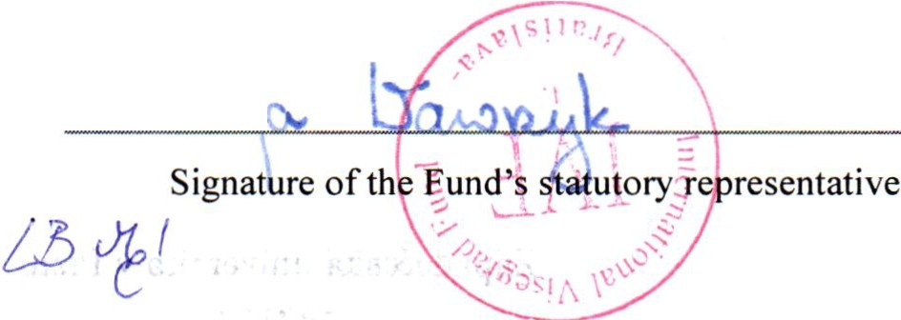

v(;

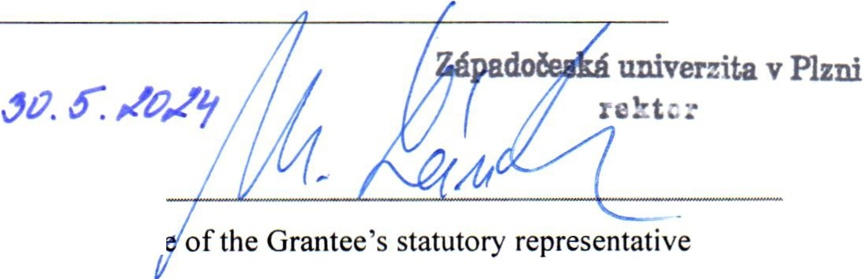

Signatur

# Attachment 2

to the Contract on the Provision of Financial Resource s from the lntemational Yisegrad Funďs Yis egrad Grant No. **22410207**

## Calendar of Events:

lmplementation period : from **01/06/2024 to 30/06/2025**

|  |  |  |  |  |  |
| --- | --- | --- | --- | --- | --- |
|  | **Event** | Cit y | Countr y | From | Until |
| I . ' | Conference Business Trends, section focused on Al tools , F2F team meeti ng | Pils e n | cz | 20/11/2024 | 22/11/2024 |
| .,  2 | Workshop in Brno, project team cooperatio n and sharing experie nce with experts from practice | Brno | cz | 19/03/2025 | 21/03/2025 |

,

Fin ancial Statement and Fina! Report deadline : 28/07/2025

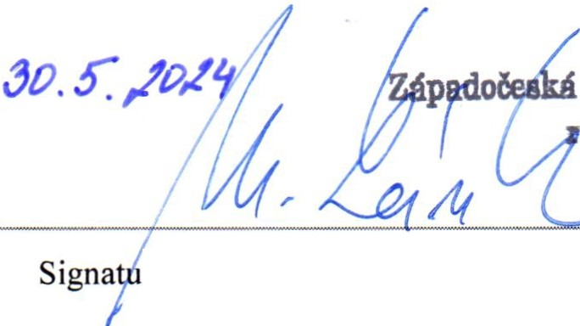

**univerzita v Plzni**

**e tcr**

re ofthe Grantee's statutory representat ive

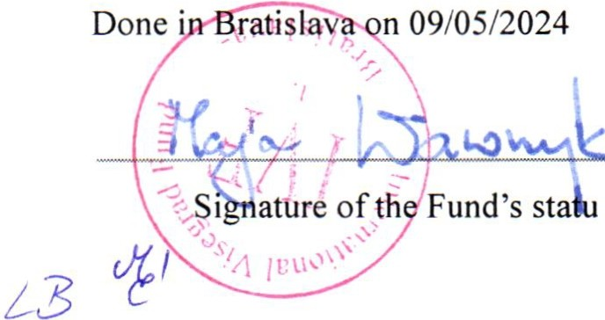

tory representat ive