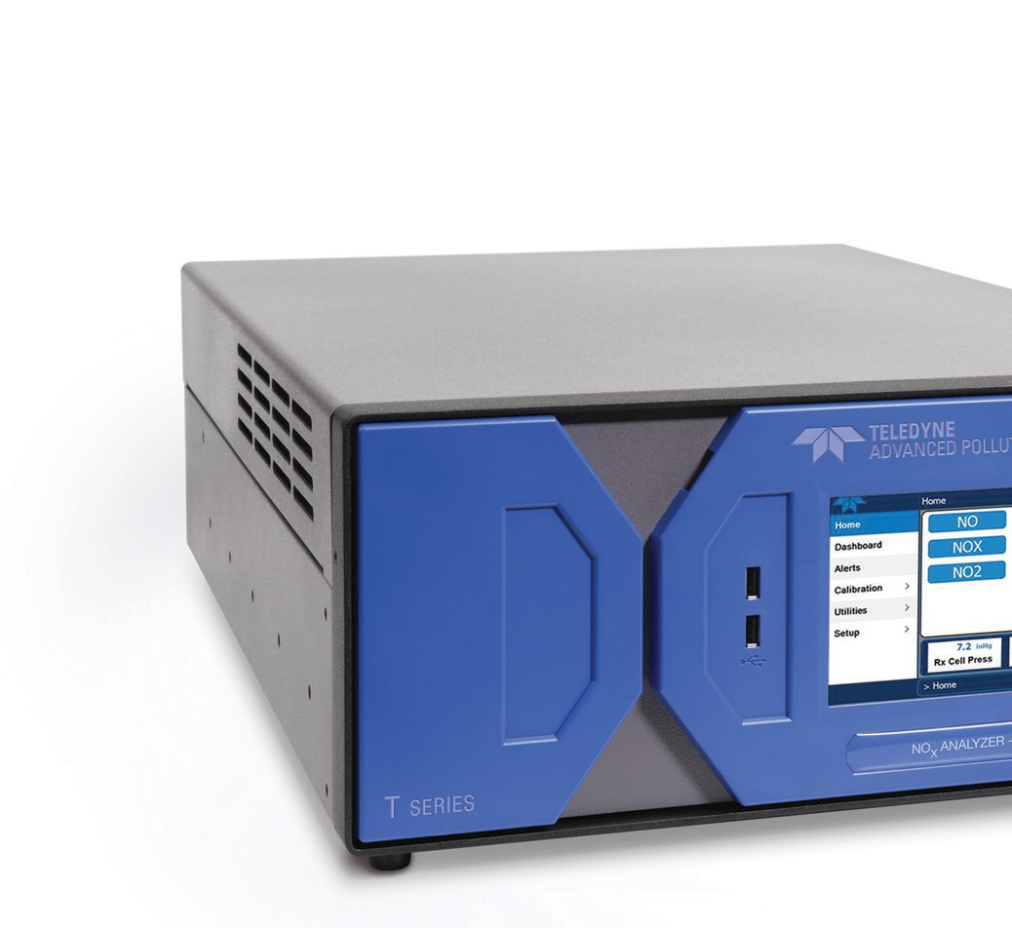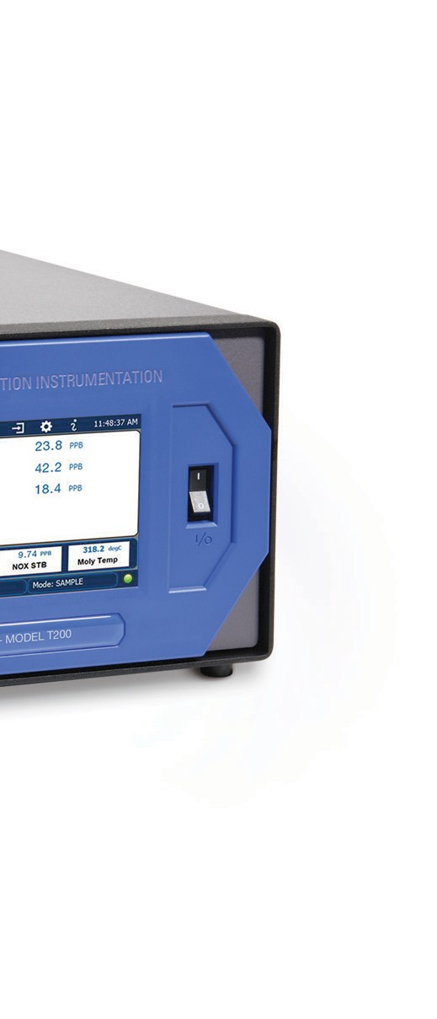The Model T200 Chemiluminescence NO/ NO2 / NOx Analyzer

The Model T200 NO / NO2 / NOx analyzer uses the proven chemiluminescence detection principle and advanced electronics to allow accurate, dependable, continuous measurements for ambient air quality, stack gas monitoring and other applications.
— With NumaView™ premium T Series software —

Large, vivid, and durable color touchscreen display All other T Series instrument platform features
Lifetime technical support by phone and email
Standard two-year warranty

T200 Speciﬁcations

Ranges | Min: 0 - 50 ppb full scale  Max: 0 - 20,000 ppb full scale (selectable, dual-range supported)
Measurement Units | ppb, ppm, μg/m3, mg/m3 (selectable)
Zero Noise | < 0.1 ppb (RMS)
Span Noise | < 0.2% of reading (RMS) above 50 ppb
Lower Detectable Limit | < 0.2 ppb
Zero Drift | < 0.5 ppb/24 hours
Span Drift | < 0.5% of full scale/24 hours
Response Time | < 80 seconds to 95%
Linearity | 1% of full scale
Precision | 0.5% of reading above 50 ppb
Sample Flow Rate | 500 cc/min ±10%
Power Requirements | 100V-120V, 220V-240V, 50/60 Hz, Typical power 110W
Analog Output Ranges | 10V, 5V, 1V, 0.1V (selectable)
Recorder Oﬀset | ±10%
Included I/O | - x Ethernet: 10/100Base-T  2 x RS232 (300-115,200 baud)  - x USB device ports  8 x opto-isolated digital outputs 6 x opto-isolated digital inputs 4 x analog outputs
Optional I/O | 1 x USB com port 1 x RS485  4 x digital alarm outputs Multidrop RS232  3 x 4-20mA current outputs
Operating Temperature Range | 5 - 40ºC (with US EPA approval)
Dimensions (HxWxD) | 7” x 17” x 23.5” (178 x 432 x 597 mm)
Weight | Analyzer: 40 lbs (18 kg)  External pump: 22 lbs (10 kg)
Certiﬁcations | US EPA: RFNA-1194-099  EU: EN14211 TÜV Rheinland QAL1 Certiﬁed: EN15267 MCERTS: Sira MC 050068/12  CNEMC: 质(认)字 No. 2018-209 Report
Speciﬁcations subject to change without notice.
All speciﬁcations are based on constant conditions.

T200

9970 Carroll Canyon Road  San Diego, CA 92131 Ph. xxx Fax xxx
Email xxx
For more information about the Teledyne API family of monitoring instrumentation products, call us or visit our website at:
www.teledyne-api.com
© 2021 Teledyne API
Printed documents are uncontrolled. SAL000046J (DCN 8464) 11.04.21

