Národní divadlo Brno, příspěvková organizace, Dvořákova 589/11, 602 00 Brno
e-mail: stepankova@ndbrno.cz, tel. +420 606 917 904
Contract on the staging of a theatre performance
concluded pursuant to § 1746 par. 2 of Act No. 89/2012 Coll., the Civil Code

Contracting parties:

Company: Teatr Studio im. Stanislawa Ignacego Witkiewicza
Registered office: Pałac Kultury i Nauki, Plac Defilad 1, 00-901 Warszawa
Represented by: Roman Osadnik – General Director
countersigned by Jadwiga Jaworska - Chief Accountant
VAT number: PL525 000 97 89
Legal form: public institution - a municipal cultural institution of the Capital City of Warsaw with legal personality
Bank details:
Account Holder: Teatr Studio im. Stanislawa Ignacego Witkiewicza
Name of bank: Bank Gospodarstwa Krajowego, I Oddział w Warszawie
Bank address: Warszawa
IBAN: PL6811301017002006210320 0010
SWIFT: BIC (SWIFT) code: GOSKPLPW
(hereinafter “the Theatre”)
and
Národní divadlo Brno, příspěvková organizace
registered office: Dvořákova 589/11, 602 00 Brno
represented by: MgA. Martin Glaser, director of the NDB
IČO: 00094820

DIČ: CZ00094820
Commercial Register of the Regional Court in Brno, section Pr, entry 30
Account no..: UniCredit Bank 2110126631/2700
(hereinafter “the organizer”)

- Subject of the Contract
- The Theatre undertakes to give two performances of “Employees“, on 27. 5. 2023 at 19:00 and 28. 5. 2023 at 20:30 on the stage of BVV BRNO, hall G2, addresse: Veletrhy Brno, a.s.
Výstaviště 405/1, 603 00 Brno.
- The organizer undertakes to pay the Theatre remuneration for the aforementioned staging in accordance with this contract.
- The Theatre provides the discharge of obligations arising from this contract at its own expense and responsibility.

- Price and Payment Terms
- The fixed price for the staging and the discharge of obligations in accordance with article I point 1 of this contract is set at 48 449,28 EUR net, e. i. 56 239,45 EUR gross:

- Fee for the performance (includes per diem, travel, royalties):44 144,28 EUR net, i. e. 51 934,45 EUR gross,
- Other production costs (set and costumes transport): 4 305 EUR net, i. e. 4 305 EUR gross.

- The royalties, music and artistic rights are included in the fee for the performance, except of 4 musical works that need to be reported to collecting societies (DILIA).
- The Organizer will pay music rights through the local Copyright Association DILIA. The organizer will conclude a separate contract with DILIA in this connection. List of music is integral part of this contract, Appendix No.2.
- Taxation of the remuneration will be carried out in compliance with the applicable regulations of the Czech Republic (CR), and if the Theatre provides the Organizer with the original and valid certificate of their tax residence to confirm tax liabilities in Poland, the Organizer shall deduct the income tax in the amount provided for in the double taxation treaty concluded between the Czech Republic and the Republic of Poland.
- The Organizer obliges to pay the Theatre the fee as follow:
- The Organizer will pay the Theatre at latest 14 days from the signing the contract 50% of the fee for the staging according Artc. II. 1. 24 224, 64 EUR net, i. e. 28 119, 73 EUR gross. The payment will be paid on the basis of an invoice in gross amount issued by the Theatre with a due date of 14 days from the date on which the invoice is delivered to the organizer, into the account specified in the heading of this contract, however, not earlier than the next working day following the entry into force of the contract.
- Organizer will pay the Theatre remaining 50 % of the fee for the staging according
Artc. II. 1. 24 224, 64 EUR net, i. e. 28 119, 73 EUR gross via Bank Transfer. The payment in the net amount, after deduction of the income tax, shall be paid following the public performance of the performance on the basis of an invoice issued by the Theatre with a due date of 14 days from the date on which the invoice is delivered to the Organizer, into the account specified in the heading of this contract, however, not earlier than the next working day following the entry into force of the contract.
- Both parties have agreed on the application of SHA (shared) bank fees to all payments arising from this contact made to accounts outside the CR.
- The Organizer, as the purchaser of cultural service, shall undertake to settle the value added tax (VAT) against the gross remuneration, according to the rate applicable as of the date on which the tax liability arose. The value added tax (VAT) shall not encumber the remuneration payable to the Theatre in any way.
- By signing this document, the Theatre confirms to be a public art institution of the Capital City of Warsaw entered into the register of cultural institutions of the Capital City of Warsaw under number RIK/6/2005. It is financed by the Capital City of Warsaw and its operations are not profit-oriented.
- On signature The Theatre provides to the organizer the confirmation of the actual tax domicile – the certificate of tax residence.
- The receipts from the staging are the property of the organizer.

- Obligations of the Contracting Parties
- The organizer’s obligations:
- The ORGANIZER:
- will ensure the organizational and technical conditions for technical preparation, rehearsal and execution of the performance in the premises of BVV BRNO, hall G2.
- ensures the agreed Schedule:
23/05/2024 arrival of equipment
24/05/2024 (technical preparation) – according to TR (technical rider), technical preparation incl. breaks according to the Labor Code
25/05/2024 (technical preparation) – according to TR (technical rider), technical preparation incl. breaks according to the Labor Code, arrival of the ensemble
26/05/2024 rehearsals on stage
27/05/2024 (performance) – technical preparation, rehearsal, first performance at 7:00 p.m.
28/05/2024 (performance) – second performance at 20:30, after the show taking down the performance set
29/05/2028 departure
- Provides space capable for production including stage and dressing rooms.
- Provides parking space for the truck for the purpose of stay and loading and unloading set and costumes needed for staging and cover any parking cost if it applies.
- Provides lighting and stage requirements, in accordance with the provided TR (technical rider) by the Theatre.
- Provides the necessary number of persons for the stage technology operation, as required by the Theatre, specified in TR.
- The organizer will arrange and pay for accommodation with breakfast in the contract hotel of the DSB festival according to the Rooming list in Appendix No. 3. The possible cancellation fees will be charged to the Theatre. The same applies for booking and payment of accommodation in case of the additional the Theatre requirements. The organizer will pay the accommodation based on an invoice issued by the hotel.
- The ORGANIZER will arrange and pay for the Theatre transportation between the airport and the hotel.
- The organizer undertakes to carry out the promotion of the aforementioned staging. The Theatre will provide materials to be used in this promotion as soon as possible upon the request of the organizer.
- The organizer reserves the right to use its own visual style in promoting the staging in keeping with the National Theatre Brno marketing strategies and plans.
- The organizer will provide the Theatre with 10 complimentary tickets for the staging specified in Art. I.
- The organizer will provide at its own expenses the translation of the surtitles, subtitling equipment in the given format of the Theatre. The Theatre will provide relevant documents for the translation and subtitling program. The Theatre provides a staff member for running the subtitles at the rehearsal and performance.

- The Theatre’s obligations
- The Theatre undertakes to perform the staging on the agreed date at the venue in accordance with Art. I of the contract.
- The Theatre undertakes to ensure that all members of the traveling group, including technical staff and external staff involved in performance specified in Art. I., will have a form A1 valid on the date and place of performance.
- The Theatre is obliged to ensure the safety of items which will be brought onto the organizer’s theatre premises in connection with the staging and acknowledges that the organizer is not liable for any damage to these items unless this is incurred in connection with the activities of the organizer.
- The Theatre is obliged to comply with safety and fire regulations associated with the operation of the organizer’s building and allocated facilities and thus avoid any injuries or damage to property. These regulations form an integral part of this contract as appendix
no. 1.
- The Theatre agrees to use the photographs and audio/video recordings (max. 3 minutes) of the performance for promotional and archival purposes free of charge.
- The Theatre will provide the Technical Rider to the organizer. Contact person of the organizer: Silvie Zeinerová Sanža, sanza@ndbrno.cz, contact person for the Theatre: Anna Lewanowicz anna.lewanowicz@teatrstudio.pl

- Non-performance or Cancellation of the Staging
- Failure by the Parties to perform the obligations referred to in this agreement as a result of force majeure (i.e. an external event beyond the control of the parties which could not be predicted or prevented despite the exercise of due diligence, in particular war, unpredictable natural disaster, official ban, serious illness, epidemics, etc.) gives both parties the right to withdraw from the contract if it is impossible to determine by the Parties for a different date for staging the performance, without any claim to financial compensation for damages.
- If the ORGANIZER cancels the staging (except for the reasons specified in paragraph 1), according to Art. I. contract, it is obliged to pay the Theatre demonstrable costs and damages associated with the preparation of the staging. The Theatre is obliged to prove these costs. These proven costs will be credited to the advance payment already provided to the Theatre.
- If the staging is cancelled by the Theatre (except for the reasons specified in paragraph 1), according to Art. I. contract, it is obliged to pay the organizer demonstrable costs and damages associated with the preparation of the staging. Theatre must reimburse documented costs incurred related of the Organizer, refund his damage and has to return the provided advance payment to the Organizer.

- Final Provisions
- This contract enters into force and effect on the date of signing by both contracting parties.
- The contract can be modified and supplemented only through written, sequentially numbered amendments.
- This contract has been drawn up in 2 copies, and each contracting party will receive one copies.
- The contracting parties affix their signatures as proof of agreement with the content of this contract.
- The Contracting Parties declare that they have complied with the terms of this Agreement by mutual agreement since the date of signature of this Agreement and, in the event that the Agreement is published in the Register of Contracts, consider all their reciprocal services provided from the date of signing of this agreement until the date of entry into force of this contract as discharge of obligations provided under this contract.
- The contracting parties agree with the publication of this contract in full version in the register of contracts pursuant to the Act no. 340/2015 Coll. (Law of the contracts registry).

Appendix No. 1: Training in fire safety and occupational safety
Appendix No. 2: Music works list
Appendix No.3: Rooming list

Brno, ……. Warszawa, ……

……………………………………… ………………………………………….
on behalf of the organizer on behalf of the performer
Martin Glaser, Director Roman Osadnik, General Director

………………………………………………
Jadwiga Jaworska - Chief Accountant

Annex No.1
BINDING RULES FOR OCCUPATIONAL SAFETY AND FIRE PREVENTION
To ensure personal safety of contractors of National Theatre Brno at the premises of Veletrhy Brno, a.s. (Brno Exhibition Grounds), Výstaviště 1, Brno (hereinafter referred to as BVV)

- The work activities related to assembly and disassembly may be performed always only in compliance with valid labour-law, safety and trade regulations, including fire prevention regulations, sanitary regulations, occupational safety regulations, and with the valid law on waste disposal.
- Electrical installations for the stage, which is to be connected to the distribution network of the BVV premises, have to fully comply with the requirements of valid Czech electrical engineering norms (ČSN 34 1090 Regulations for temporary electrical devices, mainly ČSN 33 2000-4-41 ed. 2 Protection from injuries caused by electric shock, and ČSN 33 2000-7-711 Single-purpose devices and devices in special buildings – expositions, shows, and booths).
- The entrances and gates to the premises to be used during working on the stage, rehearsals, performances, and disassembly are described in the Organization Instructions issued for individual events.

Fire Prevention
- Smoking is forbidden in all the exhibition pavilions as well as in the inner areas open to the public, applying to electronic cigarettes as well. This ban fully applies to the preparation (assembly), performances, disassembly as well as to all the events held in the exhibition pavilions located at the exhibition grounds premises.
Smoking is allowed only at designated outdoor areas and at designated structurally-separated areas equipped with non-flammable ashtrays and marked by clearly visible graphical signs “Smoking allowed” at the entrance.
- It is forbidden to park vehicles equipped with a combustion engine inside the pavilions.
- It is forbidden to use heating appliances inside the pavilions unless approved by the Fire Prevention and Occupational Safety departments of BVV in advance.
- The fire hydrants, tools in fire cabinets, portable fire extinguishers, fire alarms, etc. installed in the premises may be used only in case of fire. Any use, damage to or any other handling has to be immediately reported to the designated representative of National Theatre Brno.
- It is necessary to keep free access to all the electrical switchboards, main switches and valves, electronic fire protection system alarms, fire hydrants, fire extinguishers etc. In case any such device is accessible but not visible, its position has to be marked by a corresponding safety sign.
- Any fire safety defects that cannot be removed by means and efforts available shall be immediately reported to the designated representative of National Theatre Brno or fire patrol and at the pavilion reception. Any fire safety defects caused by third parties need to be reported as well.
- Emergency exists and routes are marked with green safety signs and have to be permanently kept free and unobstructed.
- Fire regulations have been created for the BVV buildings and are visibly posted there; all the contractors of National Theatre Brno who access the BVV premises shall be obligated to get familiar with them and follow their provisions. If there are no fire regulations in the area, follow the instructions included in attachment No. 1 to these Binding Rules.

Occupational Safety
Occupational safety needs to be ensured according to Act No. 262/2006 Coll. of the Labour Code, as amended, and Act No. 309/2006 Coll., providing for further requirements of occupational safety, and Government Decree No. 101/2005 Coll. on more detailed requirements for working sites and working environments.
- Basic instructions
- Enter only the working sites, areas and facilities you have been sent to work at.
- Use only marked routes. Keep left where there is no pavement.
- Be careful not to hit or trip over any stored material or tools.
- Do not enter switch rooms, transformer stations, and natural gas regulation stations.
- Do not work with any mechanical, electrical or any other equipment unless authorized to.
- Follow the instructions of transportation, safety, and fire prevention signs.
- Respect audio signals produced by vehicles transporting material.
- Do not enter the BVV working site under the influence of alcohol. It is forbidden to consume alcohol at or bring alcohol to the working sites.

- Transportation at the premises
When driving at the premises it is necessary to follow common valid legal regulations (Act No. 361/2000 Coll., as amended, on traffic, as well as Regulation No. 30/2001 Coll., on traffic regulations) and valid BVV Traffic Regulations.
Speed limit:
- 30 kph/19 mph⁻¹ (for all the vehicles at the BVV premises, unless there is a traffic sign showing a different speed limit);
- 5 kph/3 mph⁻¹ in the pavilions, warehouses and other buildings.

The drivers are obligated to observe the above-stated speed limits and adjust their speed to the nature of their load, visibility, conditions of the surfaces or current traffic.
In order to ensure safety of the visitors during trade fairs and exhibitions the traffic is substantially limited at the premises. If it is absolutely necessary to drive at the premises during these events, the drivers are obligated to give way to pedestrians and slow down to ensure their maximum safety.

- Assembly and disassembly
During assembly, disassembly and any construction works performed at the BVV premises it is necessary to respect safety regulations for construction works according to Government Decree No. 591/2006 Coll. on minimum safety requirements and health protection during work at construction sites and Government Decree No. 101/2005 Coll. on more detailed requirements for working sites and environments.

- Cables and technical cabling
All the cables and technical cabling have to be put into technical shafts; wherever a cable leads from a technical shaft to an exhibition it is necessary to prevent it from getting loose, e.g. by a cable duct or a cable protector. Neither cables nor technical cabling can be located on roads, routes or emergency exits. It is forbidden to pass electrical cables through doors or gates, as they could get cut off or damaged; the cables must always be secured by a protective lath.

- Job-related injury
In case a third-party employee or a visitor of a legal or natural person working at the BVV working sites suffers an injury, the tenant is obligated to immediately report the injury to the designated representative of National Theatre Brno; if needed, the first aid shall be called and medical treatment ensured. The first-aid kit is located at the pavilion reception and with the designated representative of National Theatre Brno. A doctor shall be present during each performance.

- Information on other potential risks
Other potential risks related to our activities are as follows:
- Falling down the stairs due to wet shoes or outsoles;
- Slipping on muddy or icy surfaces, dangerous hollows and uneven terrain;
- Hitting or tripping over stored material or tools;
- Unauthorized entry to the working site or to a designated area when working at heights;
- Material falling down from certain height when transported vertically or upwards;
- Material or tools falling down from certain height due to careless handling;
- People falling down from certain height due to failure to observe safeguarding;
- Risk of emergence of dust, noise or vibrations;
- Getting burnt by fragments of metal during cutting, welding, etc.;
- Electric shock suffered when driving over incorrectly covered cables;
- Injury suffered when driving over inlets of compressed air;
- Injury and subsequent fire caused by driving over inlets of technical gases used for welding;
- Fire caused by insufficient removal or covering of highly inflammable substances;
- Vehicles transporting material;
- Failure to respect sound signals produced by the vehicles or some other designated signals;
- A hanging object falling down and causing injury to the person below or dangerously close to it;
- Getting hit by a moving or manually controlled mechanism due to failure to observe the safety distance, i.e. at least 2 metres from its maximum reach, or at a place the person cannot see and does not leave even after a sound signal is produced;
- Injury suffered at a place where vehicles turn, reverse or move forward;
- Injury caused by unauthorized use of tools, machines, devices, when removing covers, etc.;
- Performing any personal activities;
- Failure to report an imperfection or defect;
- Injury or burns caused by failure to follow safety or fire prevention instructions;
- Failure to observe restrictive or informative traffic signs;
- Injury suffered when getting off/on a vehicle in a dangerous way;
- Injury suffered upon unauthorized entry to an electrical switch room, transformer station, natural gas regulation station, boiler room or heat exchanger station.

Attachment No. 1
What to do in case of fire?
Every person who spots or causes a fire is obligated to:
- take necessary measures to save people in danger;
- extinguish the fire using suitable available means, if possible, or take necessary measures to prevent it from spreading (e.g. remove flammable substances and objects, close the doors and windows, etc.);
- start a fire alarm and inform the people around in case the fire is too serious to extinguish on his/her own or using the means available.

FIRE ALARM IS ACTIVATED:
- automatically by a sensor of the electrical fire prevention system
- manually by switching the button
- by calling “FIRE, FIRE!” (“HOŘÍ! – HOŘÍ!“ in Czech)

- immediately report the fire or make sure it is reported at 112 emergency number while giving following information: place of fire, what is on fire, who is calling, and where s/he is calling from.
Never hang up first; always wait for potential questions asked by the operator.
Then report the fire to the designated representative of National Theatre Brno.

Evacuation shall take place according to the evacuation plan. All the people shall assemble at a designated area and wait for further instructions.

Other important telephone numbers:
First aid: 112
Firemen: 112
Police: 112

Attachment No. 2
Safety signs
Restrictive signs – round signs with a black pictogram on a white background with a red edge, crossed out.

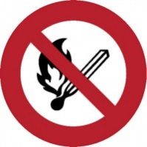 | 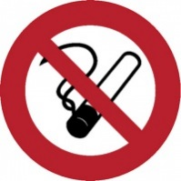 |  |  | 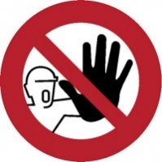 | 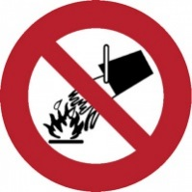 | 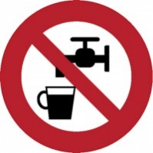
No naked flames | No smoking | Do not pass | No unauthorised entry |  | Do not extinguish with water | Water not suitable for drinking

Warning signs – triangular signs with a black pictogram on a yellow background with a black edge.

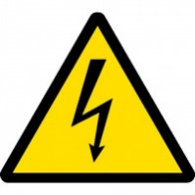 | 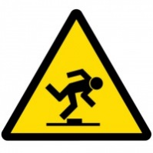 | 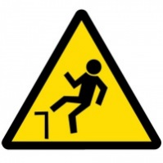 | 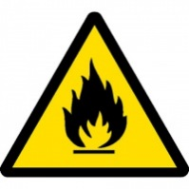
Danger – electricity | Tripping hazard | Fall hazard | Danger! Flammable material | Watch out! Forklift trucks | Warning, alert, risk, general danger

Regulatory signs – round signs with a white pictogram on a blue background

Wear safety goggles | Wear helmet | Wear ear protection | Wear face protection | Wear protective gloves | General command

Signs showing a risk of hitting obstacles or falling

When red and white colours are used | When black and yellow colours are used

Informative signs
Informative signs marking emergency exits and routes or first-aid station and devices to call the first aid are of a rectangular or square shape with a white pictogram on a green background.

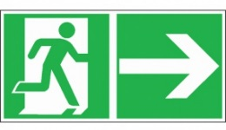 | 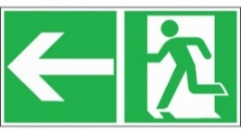 | 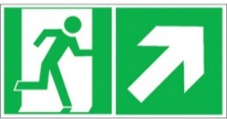 | 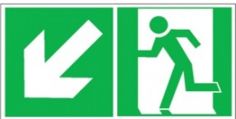
To emergency exit | To emergency exit | To emergency exit | To emergency exit | To emergency exit
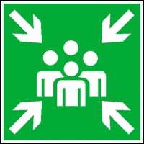
Assembly point | First aid | Automated external defibrillator

Informative signs to mark fire protection means and fire prevention devices

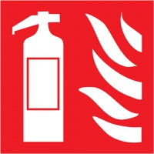 | 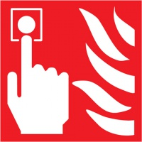 | 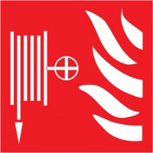
Fire extinguisher | Fire alarm call point | Fire hose | Fire emergency phone

Warning symbols – marking chemical substances and mixtures
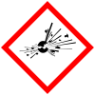
GHS01 – explosive | GHS02 – flammable | GHS03 – oxidizing | GHS04 – gas under pressure | GHS05 – corrosive

