sherrards
solicitors

JEAN-PAUL da COSTA

NOTÁRY PUBLIC

7 Swallow Pláce London W1B 2AG ENGLAND

Tel: +44(0)20 74789018

Email: jeanpaul.dacosta@sherrards.com

BE IT KNOWN THAT, I Jean-Paul da Costa of Sherrards Solicitors LLP, 7 Swallow Place, London, W1B 2AG, England duly admitted and sworn DO HEREBY CERTIFY that:-

Simon David Bedson (UK Passport Number 801093933) acting in his capacity as a duly appointed and authorised director of Vertex Pharmaceuticals (Europe) Limited; (Company number 02907620) did appear before me on the 6th day of October 2015 and did sign the attached Power of Attorney in my presence authorising Medasol, s.r.o to participate in meetings with Czech Republic authorities on behalf of Vertex Pharmaceuticals (Europe) Limited.
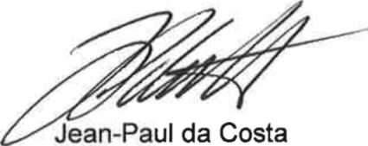
Notáry Public In and for London, England My commission is for life

IN FAITH AND TESTIMONY whereof I the said Notáry have subscribed my name and set and affixed my Seal of Office at 7 Swallow Pláce, London, W1B 2AG this 6th day of October 2015.

APOSTILLE
(Convention de La Haye du 5 octobre 1961)

1. | Counry  Pays/Pais United Kingdom of Great Britain and Northern Ireland
This public document
Le présent acte public / El presente documento público
2. | Has been signed by  a été signé par ha sido firmado por | Jean-Paul da Costa
3. | Acting in the capacity of  agissant en qualité de quien actúa en calidad de | Notary Public
4. | Bears the seal/stamp of  est revétu du sceau / timbre de y está revestido del sello / timbre de | The Said Notary Public
Certified
Attesté / Certificado
5. | at London  á / en |  | 6. the 09 October2015  le / el dia
7. | by Her Majesty's Principal Secretary of State for Foreign and  par /por Commonwealth Affairs
8. Number  sous no / bajo el numero |  |  | K707686
9. Seal / stamp:
Sceau / timbre: Sello / timbre:
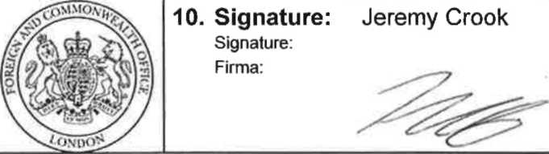
This Apostille is not to be used in the UK and only confirms the authenticity of the signatuře, seal or stamp on the attached UK public document. It does not confirm the authenticity of the underlying document. Apostilles attached to documents that have been photocopied and certified in the UK confirm the signatuře of the UK public official who conducted the certification only. It does not authenticate either the signatuře on the originál
document or the contents of the originál document in any way. If this document is to be used in a country which is not party to the Hague Convention of 5th October 1961, it should be presented to the consular section of the mission representing that country. To verify this apostille go to www.verifyapostille.service.gov.uk

Power of Attorney

Vertex Pharmaceuticals (Europe) Limited, of 2 Kingdom Street, London W2 6BD, United Kingdom, with company number: 02907620, which is the holder of the Marketing Authorisation (MA) for Kalydeco™ (Ivacaftor) with the following EU MA number: EU/1/12/782/001-002;

Hereby authorizes:

Medasol, s.r.o., of U Poštovky 1269/2, Praha 5, 150 00 Czech Republic, with company number: 242 17 867;

During the period from 21 August 2015 until 31 December 2016;

To represent it and submit and receive documentation in relation to Czech authorities responsible for medicinal products, in the administrativě proceeding related to application for establishment of maximum price and reimbursement of the above mentioned product and regarding Czech Republic scientific information services, for the purposes of: (1) obtaining reimbursement for Kalydeco™ (Ivacaftor) in the Czech Republic, (2) establishing blue box labeling and sampling for Kalydeco™ (Ivacaftor) in the Czech Republic, and (3) establishing and maintaining a compassionate use program for Kalydeco™ (Ivacaftor) in eligible patients in the Czech Republic.

On behalf of Vertex Pharmaceuticals (Europe) Limited,

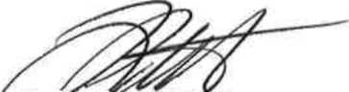
Date
Je£n-P^3sHÍ6sta NOTÁRY PUBLIC Sherraro íolicitors LLP 7 Swallow Pláce Lof.au/ W1B2AGEngland My Coniínission Is For Life
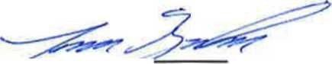
Simon Bedson Director, Vertex Pharmaceuticals (Europe) Limited

Accepted by Cecilia Marinová,

MUDr. Cecilia Marinová,
Date 6 October 20. 10. 2015
Praha

