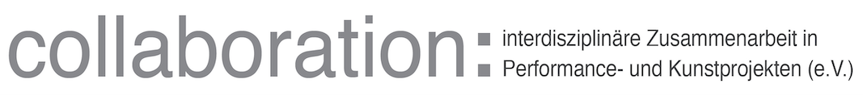

From:
Collaboration: interdisziplinäre Zusammenarbeit
in Performance- und Kunstprojekten (CPAP)
Telefonweg 213
1220 Vienna, Austria
To:
Mgr. Ondřej Zatloukal (director)
Muzeum umění Olomouc státní příspěvková organizace
Denisova 824/47
771 11 Olomouc
SUBJECT of this AGREEMENT:
Transmission of the assigned grant amount to Olomouc Museum of Art, collaboration partner in the COLLABORATION GRANT CONTRACT CHCG_02_04 of “Culture Helps / Культура допомагає”, for collaborating in “Розповіді Присутностей | Narrative Presences”
The Main Grant receiver CPAP forwards the assigned budget to Olomouc Museum of Art.
Olomouc Museum of Art is responsible for keeping original bills and sending copy of bills and/or invoices in the amount of the respective transmission to CPAP after the project-phase realization is over (during June, latest July 2024).
Number of Culture Helps Grant: CHCG_02_04
Transmission of assigned grant amount consisting of:
1) 1400,00 Euros (one thousand four hundred euros)
2) 720,00 Euros (seven hundred tweny euros)
3) 600,00 Euros (six hundred euros)
4) 200,00 Euros (two hundred euros)
Total SUM of transmission: 2.920,00Euros (two thousand nine hundred twenty euros)
Time Frame and Description:
1) Co-Producing and Financially Covering (Administration and Organization, Planning, Documenting, Materials, Fees) for the Workshop Phases (May and June 2024) and Final Event (27.6.2024).
2) Organizing and Inviting a Ukraine speaking Psychotherapist who accompanies on several days the two intensive Workshop Series between 30.5.2024 – 26.6.2024.
3) Organizing, Administrating, and Financing Lunches for all Workshop Participants during the Workshop Series on several days between 30.5. – 26.6.2024
4) PR, Printing and Distributing Posters and Flyers for the Workshops and the Performative Event at the SEFO 2024 Triennial.

Where:
Realization in Spaces of Olomouc Museum of Art, Olomouc, Czech Republic
Transmission to bank account of:
Name of the account holder: Muzeum umění Olomouc, státní příspěvková organizace
IBAN: CZ69 0710 0345 3401 9793 7621
Abbreviated name: Muzeum umění Olomouc
Address: Denisova 824/47
771 11 Olomouc

This project is a collaboration between "Collaboration: interdisziplinäre Zusammenarbeit in Performance und Kunstprojekten" - CPAP, MetaLab, collaborating project Muzeum umění Olomouc (MUO) and Co-Haty (UA), in the framework of the project “Culture Helps / Культура допомагає”. (Time period of Grant: 15 December 2023 - 31 August 2024, Amount of entire collaboration Grant: 30.000,00 EUR)

16.4.2024, Vienna,AT Date.............., Location, Olomouc CZ
CPAP Project Manager, Jasmin Schait Olomouc Museum of Art Director,
Mgr. Ondřej Zatloukal


 

