AGREEMENT BETWEEN

-European Organisation for Astronomical Research in the Southern Hemisphere

And

- Asociacioo Argentina de Astronomía
- Kommission tur Astronomie der Osterreichischen Akademie der Wissenschaften
- Belgian Federal Ministry of Science Policy
- The Institute of Astronomy and National Observatory of the Bulgarian Academy of Sciences
  - Sociedad Chilena de Astronomía
- The Astronomical Institute of the Academy of Sciences of the Czech Republic
- University of Zagreb, Faculty of Geodesy
-Instrument Center for Danish Astrophysics (IDA), Aarhus University, Institute for Physics and Astronomy
- Tartu Observatory
-Finnish National Committee for Astronomy
- Centre National de la Recherche Scientifique
- Bundesrninisterium fí.ir Bildung und Forschung
- Hellenic Astronomical Society
  - Hungarian Acaderny of Sciences
- Institute Nazionale dí Astrofisica (INAF)
- Lithuanian Astronornical Society
- Nederlandse Onderzoekschool voor Astronomie
- Polish Academy of Sciences
-Sociedade Portuguesa de Astronomia
- Astronomical Institute of the Slovak Academy of Sciences
-Secretaria General de Ciencia, Tecnología e lnnovación
-The Swedish Research Council
- Swiss Acaderny of Sciences

CONCERNING THE PUBLICATION OF THE SCIENTIFIC JOURNAL ASTRONOMY & ASTROPHYSICS

The European Organisation for Astronomical Research in the Southern Hemisphere, having
its Headquarters at Karl-Schwarzschild-Strasse 2, D-85748 Garching bei Munchen (Germany), hereinafter referred to as "ESO"
I

and on the one hand,

Asociación Argentina de Astronomía, having its registered office at Observatorio Astronomico, Paseo del Bosque sin La Plata, Buenos Aires, Argentina represented by
Kommission fi.ir Astronomie der Osterreichischen Akademie der Wissenschaften
having its registered office at Dr. lgnaz Seipel-Platz 2, 1010 Vienna, Austria represented by
I
the Austrian Academy of
Belgian Federal Ministry of Science Policy, having its registered office at North Galaxy­ Avenue Roi Albert 1133 bte 01, 1030 Brusse!, Belgium represented by
The Institute of Astronomy and National Observatory of the Bulgarian Academy of Sciences, having its registered office at Bulgarian Academy of Sciences 72, Tsarigradsko Blvd.1784 Sofia, Bulgaria represented by
-
Sociedad Chilena de Astronomfa (SOCHIAS). having its registered office at Camino el Observatorio 1515, Las Condes, Santiago, Chile represented by

The Astronomical Institute of the Academy of Sciences of the Czech Republic, having its registered office at Fricova 298,251 65 Ondrejov. Czech Republic represented by-
University of Zagreb, Faculty of Geodesy, having its registered office at University of Zagreb, Faculty of Geodesy, Kaciceva 26, 10000 Zagreb, Croatia represented by-
-;
Instrument Center for Danish Astrophysics (IDA), Aarhus University, Institute for Physics and Astronomy, having its registered office at Ny Munkegade 120 DK-8000 Aarhus, Denmark, represented by
Tartu Observatory, having its registered office at Tartu Observatory, Observatooriumi 1, Toravere, 61602 Tartumaa, Estonia represented by
Finnish National Committee for Astronomy, having its registered office at Tuoria Observatory, Vaisalantie 20, Fl-21500 Kaarina, Finland represented by
-;
Centre National de la Recherche Scientlfique. having its registered office at Institut National des Sciences de l'Université, 3 rue Michel-Ange, 75794 Paris Cedex 16, France represented by

Bundesministerium fur Bildung und Forschung, having its registered office at Europaische Forschungsorganisationen, Heinemannstrasse 2, D-53175 Bonn, Deutschland represented by „GroBgerate und
Grundlagenforschung, Sonderaufgabe ESFRI";
Hellenic Astronomical Society, having its registered office at University of Athens
Dept of Physics, Section of Astrophysics, Astronomy and Mechanics, Zografos, GR-15784, Greece represented by
Hungarian Academy of Sclences, having its registered office at Szecheny lstvan ter 9,
Budapest, 1051 Hungary represented by
lnstituto Nazionale di Astroflsica (INAF), having its registered office at Viale del Parco Mellini 84, 00136 ROMA, represented by
Lltuanian Astronomical Society, having its registered office at A. Gostauto 12, Vilnius LT-01108 lithuania, represented by
Nederlandse Onderzoekschool voor Astronomie, having its registered office at Niels Bohrweg 2, 2333CA Leiden, The Netherlands, represented by its
-I;
Polish Academy of Sciences, having its registered office at PkiN Plac Defilad 1, 00-901, Warszawa represented by
Socledade Portuguesa de Astronomia, having its registered office at Centro de Astrofisica
da Universidade do Porto, Rua das Estrelas, 4150-762 Porto represented by i_ts :,
Astronomical Institute of the Slovak Academy of Sciences, having its registered office at the Tatranska Lomnica 18, 05960 Vysoke Tatry, Slovakia, represented by_,
-·;
Secretaría General de Ciencia, Tecnología e lnnovación (MINECO), having its registered office at Paseo de la Castellana 162 - pi. 4, 28046 Madrid, Spain, represented by 1111
Swedish Research Council, having its registered office at Box 1035, SE-101, 38 Stockholm, represented by
Swiss Academy of Sciences, having its registered office at Akademie der Naturwissenschaften SCNAT, Haus der Akademien, Postfach 3001 Bern, Switzerland represented by
For the purpose of this Agreement, hereafter cotlectively referred to as the "Sponsoring Bodies".
on the other hand.

PREAMBLE

NOTING the Statement of astronomers from France, the Netherlands, Denmark, Norway, Sweden, Finland, Belgium and Germany concerning the creation of the European Journal of Astronomy and Astrophysics, of its Board of Directors and the relation of these to ESO dated
2 December 1968 and that on 5 December of 1968 an Agreement was concluded between ESO and the Board of Directors of Astronomy and Astrophysics with the aim to merge five of the principal existing astronomical journals into a new to be created Astronomy and Astrophysics Journa/, hereinafter referred to as "the Journal";

CONSIDERING that since the creation of the Journal on 1 January 1969 high quality international papers on all aspects of astronomy and astrophysics (theoretical, observational, and instrumental) have been published independently of the techniques or facilities used to obtain the results;

WHEREAS several ether Sponsoring Bodies have joined the 1968 Agreement, bringing the current number of Sponsoring Bodies to 23;

NOTING that since the creation of the Journal the policy-making body for the Journal has been the A&A Board of Directors, consisting of senior astronomers representing the Sponsoring Bodies;

CONSIDERING that from the beginning ESO has acted on behalf of the A&A Board of Directors in contractual matters and in making available to the A&A Board of Directors its legal and administrative services, however, with the restriction that ESO would neither commit itself with regard to any direct financial sponsorship for the Journal, nor interfere in the scientific policy of the Journal. ln return, ESO has had one representative on the A&A Board of Directors;

CONSIDERING that neither the network of Sponsoring Bodies nor the A&A Board of Directors are legal entities of their own which could perform the legal or administrative acts necessary for the publication of the Journal and noting ESO's willingness to perform such acts;

NOTING that with the accession of numerous Sponsoring Bodies to the Journal a renewal of the terms of the Agreement of 1968 has become necessary;

CONVINCED that since 1968 the Journal has substantially contributed to fostering international collaboration among the astronomical community;

DESIROUS to continue promoting co-operation in astronomical research;

ESO AND THE SPONSORING BODIES HAVE AGREED AS FOLLOWS:

ART/CLE 1: PURPOSE

The purpose of this Agreement is to establish the new terms and conditions for the continuous publication of the Joumal, as agreed between ESO and the Sponsoring Bodies.

ARTICLE 2: A&A BOARD OF DIRECTORS

- The governing body of the Journal is the A&A Board of Directors (hereinafter referred to as "A&A Board"). The A&A Board shall be composed of one member from ESO and of one member appointed from each Sponsoring Body. Ali the members shall be astronomers.

- The A&A Board shall:
  - Define the long-term scientific policies, including the general guidelines for publishing, and the priorities for the Journal;
  - Define the scientific editorial policy of the Journal;
  - Appoint the Scientific Editors;
  - Recommend the ESO Council to approve the budget of the Journal, which shall be prepared by ESO in consultation with the Chair of the A&A Board, including an estimate of income and expenditure on A&A operations within a financial year, by simple majority plus weighted voting as approved by the A&A Board;
  - Approve, by a two-thirds majority, the accession of new Sponsoring Bodies under a procedure to be defined by the A&A Board;
  - Support ESO for administrative matters, as required;
  - Assess the compliance of the bids in the tendering process for publishing agreements;
  - Authorise the Editors ofthe Journal with the right to waive publication charges, under the conditions to be set up by the A&A Board.
  - Be vested with the authority to take the measures necessary for the publication of the Journal in accordance with this Agreement.

- The A&A Board shall meet at least once a year. lt shall decide on the venue of its meetings.

- Each member of the A&A Board shall have one vote in the A&A Board.

- The decisions of the A&A Board shall be binding only if at least one half of the members are present.

- Unless otherwise provided for in this Agreement, decisions of the A&A Board shall be taken by simple majority of the members present and voting.

- The A&A Board shall determine its own rules of procedure, subject to the provisions of this Agreement.

- The A&A Board shall appoint a Chairperson and a Vice-Chairperson from among its members for a term of office of three years. The Chairperson and the Vice-Chairperson may not be re-elected more than once consecutively.

- The A&A Board may set up auxiliary bodies as may be necessary.

ARTICLE 3: FINANCIAL CONTRIBUTIONS OF THE SPONSORING BODIES

- The Sponsoring Bodies shall share the costs for the operations of the Journal which shall be met by annual contributions in accordance with an annual scale of contributions which shall be recommended by ESO and approved by the A&A Board by simple majority plus weighted voting as approved by the A&A Board. The scale of contributions shall be calculated on the basis of the average Gross Domestic Product published by the World Bank (hereafter "GDP") of each country where the Sponsoring Bodies are located for the years n-2 to n-4 (including), whereof "n" shall be the year of budget preparation. ln the absence of a regular publication by the World Bank of the GDP for the country where a Sponsoring Body is located, the figures for that Sponsoring Body shall be estimated by ESO by continued application of the last available growth rate.

  - A minimum contribution shall apply, as approved by the A&A Board within the budget.
  - The A&A Board may decide, by a unanimous decision, to take into account
any special circumstances of a Sponsoring Body and adjust its contribution accordingly for a limited period of time.
  - The A&A Board may decide, by a two-thirds majority, that new Sponsoring
Bodies that have acceded in accordance with the procedure established under Article 2.2.e above can be exempted from the obligation to make a financial contribution for a maximum of two years following the accession.

- Annual contributions shall be called up and credited in EUR. They shall be due in one instalment payable not later than 1 Apríl, unless decided otherwise by the A&A Board.

- Upon approval of the budget and the annual scale of contributions ESO shall notify the Sponsoring Bodies of the amounts of their contributions and of the dates by which payments are due.

- Payment of contributions from the Sponsoring Bodies shall be acknowledged by ESO immediately upon receipt.
- lf a Sponsoring Body fails to pay the contributions due within 90 days of the due date, ESO shall inform the A&A Board.

- Any remaining budget surplus shall be considered as advance payment of contributions, which shall be attributed to the Sponsoring Bodies according to the Scale of Contributions applicable to the year of surplus.

ARTICLE 4: EXEMPTION OF PUBLICATION CHARGES

- Except for the provisions of Article 7.2 below, astronomers who are employed by an organisation with headquarters located within a country where one of the Sponsoring Bodies is located or who have a place of residence in such a country shall enjoy free publication of articles in the Joumal, unless they are employed by an organisation with headquarters located outside a country in which one of the Sponsoring Bodies is located.

- ESO personnel shall enjoy free publication of articles in the Journal.

ARTICLE 5: ROLE OF ESO

- ESO shall perform, in accordance with ESO rules, all executive functions necessary for the publication of the Journal consistent with this Agreement, in particular, the collection and administration of the contributions from the Sponsoring Bodies, the conclusion of the publishing agreement, the conclusion of the contract with the editors, the preparation of the budget of the Journal, the accounting, and all other legal and administrative functions, considering that neither the Sponsoring Bodies collectively nor the A&A Board have the legal personality to perform such tasks.

- Ali costs associated with these functions shall be compensated to ESO as part of the operational costs of the Journal according to Article 3.1.

- ESO shall keep the funds pertaining to the Journal on separate accounts and will provide the A&A Board with all the documents referring to it, if so required by the A&A Board.

- The budget and the Financial Statement of the Journal are consolidated in the ESO Budget and Financial Statements. For financial procedures not specified in this agreement the respective ESO rules shall apply.

- ESO shall own the copyright of the Journal in all forms and media, for the full term of copyright.

ARTICLE 6: LIABILITY

- The liability among the Parties arising out of or in connection with this Agreement shall be limited to the annual contributions as defined in Article 3 of this Agreement, of each and every Sponsoring Body. ESO's liability in this respect shall be limited to an amount calculated as the average of the annual contributions of all Sponsoring Bodies.

- The liability of the Sponsoring Bodies and ESO for any damage caused to third parties shall be unlimited and joint and several.

ARTICLE 7: FAILURE TO FULFILL OBLIGATIONS

- lf the A&A Board has been notified by ESO that the amount of the arrears due from a Sponsoring Body equals or exceeds the contribution due from that Sponsoring Body for the preceding full year, the A&A Board may decide by simple majority plus weighted voting as approved by the A&A Board to suspend the right of the Sponsoring Body in arrears to vote in the A&A Board until ESO has notified the A&A Board that the amount of the arrears has been fully paid.

- ln case the amount of the arrears due by a Sponsoring Body is equal or exceeds five annual contributions from that Sponsoring Body, such Sponsoring Body will automatically lose its status and will no longer be a Sponsoring Body of A&A, unless otherwise decided by the A&A Board. ESO will inform the Chair of the A&A Board thereof.

- ln the case of repeated failure of the Sponsoring Body to fulfil its obligations or if the Sponsoring Body withdraws or is expelled following Article 7.2, the A&A Board may decide to revoke the right for free publication of articles in the Journal for the astronomers employed by an organisation with headquarters located within a country where the Sponsoring Body concerned is located or with a place of residence in this country.

ARTICLE 8: WITHDRAWAL OR REPLACEMENT OF SPONSORING BODIES

- Any Sponsoring Body may notify the Chair of the A&A Board in writing of its withdrawal from this Agreement. Such withdrawal shall take effect at the end of the second financial year following that in which notification of withdrawal is given. The withdrawing Sponsoring Body shall continue to be fully bound by its obligations under this Agreement, in particular to pay the contributions due, as specified in Article 3 to this Agreement, until the withdrawal takes effect.

- A Sponsoring Body as a party to this Agreement may be replaced by a new Sponsoring Body from the same country as the original Sponsoring Body and acting on behalf of the astronomical community of this country, by giving one month notice from the original Sponsoring Body to ESO and the A&A Board. With the replacement, the new Sponsoring Body shall be placed on the same footing as the original Sponsoring Body with regard to decisions, rulings, resolutions or any other act under this Agreement and shall assume all ríghts and obligations of the original Sponsoring Body. The notice shall be accompanied with a confirmation of the replacing Sponsoring Body that it accepts these conditions. The replacement shall take effect on the date as specified in the notice.

ARTICLE 9: TERMINATION OF THIS AGREEMENT

- This Agreement may be terminated at any time by a decision adopted by two-thirds majority of the members of the A&A Board appointed by the Sponsoring Bodies. The termination of the Agreement shall take effect at the end of the second financial year following in which the decision on the termination is adopted.

- This Agreement may also be terminated at any time by a unilateral decision of ESO. The termination of the Agreement shall take effect at the end of the second financial year following that in which notification of termination is given by ESO to the Chair of the A&A Board.

- ln case of termination as described in paragraphs 1 or 2 above, net assets or net liabilities (assets less liabilities and obligations) shall be distributed among the Sponsoring Bodies still party to this Agreement at the time of the termination in proportion of their 3 years average share of contributions prior to the year of termination. Any unpaid contribution shall be either deducted from any net assets amounts due to, or added to any net liabilities due from the Sponsoring Bodies according to the above.

ARTiCLE 1O: RESOLUTION OF DISPUTES

- ln case of a dispute between ESO and one or more Sponsoring Bodies, both ESO and the pertinent Sponsoring Bodie(s) shall agree and engage to enter into negotiations with the aim to reach an amicable settlement. Failing such an amicable settlement, the parties shall resort to private arbitration under the conditions described in Chapter VIII, paragraph 29 of the "General Conditions of ESO Contracts" (Annex 1).

- The status of ESO and the applicable law are described in Chapter VIII, paragraph 30 and 31 of the "General Conditions of ESO Contracts" (Annex 1).

ARTICLE 11: ENTRY INTO FORCE

- This Agreement shall enter into force on the date on which at least 15 Sponsoring Bodies have signed the Agreement provided that the total annual contributíons committed amount to at least 50% of the total scale of contributions as calculated according to Article 3.1 for the year of signature of the last Sponsoring Body required to meet the above conditions. As for the date of its entry into force, this Agreement constitutes the entire agreement between ESO and the Sponsoring Bodies in relation to the subject matter of the Agreement and replaces and supersedes all other agreements, rules, bye­ laws, communications and understandings of any kind, either written or oral, between the parties in this respect, in particular the agreement between ESO and the A&A Board of Directors dated 05 December 1968 and the Standing Rules and Bylaws of the A&A Board of Directors effective as of May 2010.

- Wrth respect to any Sponsoring Body joining this Agreement after the date of entry into force provided for in paragraph 1 of this Article, the Agreement shall enter into force on the date of the signature of the Accession Agreement between the acceding Sponsoring Body and ESO, who shall be acting on behalf of the Sponsoring Bodies.

- Any modification of this Agreement requires the same level of approval as for its conclusion.

ARTICLE 12: TRANSITION

- Contributions of a Sponsoring Body budgeted under the previous A&A agreement and the Standing Rules and Bylaws of the A&A Board of Directors which have not been paid by the time of the entry into force of this Agreement shall be paid by the Sponsoring Body of the respective country at the latest within twelve months after entry into force of this Agreement.

- Ali rights and obligations of the Sponsoring Bodies created under the previous A&A agreement until the entry into force of this Agreement shall be transferred to the Sponsoring Bodies unless otherwise agreed upon in this Agreement.

- Notwithstanding Article 11.1 above, alt decisions of the A&A Board taken in accordance with the previous A&A agreement and the Standing Rules and Bylaws of the A&A Board of Directors shall remain valid unless explicitly otherwise agreed upon in this Agreement or until and unless otherwise decided by the A&A Board in accordance with this Agreement.

- The Chairperson andthe Vice-Chairperson of the A&A Board of Directors elected before the entry into force of this Agreement shall continue their terms according to Article 2.8 of this Agreement, unless the A&A Board decides to elect a new Chairperson and Vice­ Chairperson at its first meeting upon entry into force of this Agreement.

- ln case this Agreement enters into force after the approval of the A&A budget by the A&A Board for a subsequent year, but before the approval of the ESO budget by the

ESO Council for the same year, the approval by the A&A Board shall be considered to constitute the recommendation of the A&A Board according to Article 2.2 d) of this Agreement.

ARTICLE 13: ANNEXES

The following Annex 1 is an integral part ofthis Agreement: Chapter VIII, paragraphs 29, 30 and 31 of the "General Conditions of ESO Contracts", version applicable as of June 2013.

Done in twenty-four originals.

For the European Organisation for Astronomical Research in the Southern Hemisphere (ESO)
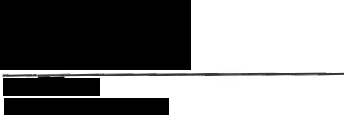

oate: 12..01.1{>

For the Asociación Argentina de Astronomía
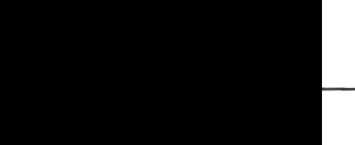
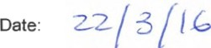

For the Kommission fur Astronomie der Osterreichlschen Akademie der Wissenschaften


Date: 3,1. '.> • Zo/6

For the Belgian Federal Ministry of Science Palicy


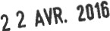
Date:

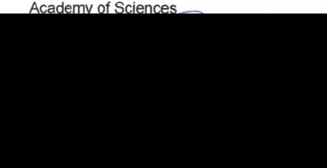
For the Institute of Astronomy and National Observatory of the Bulgarian

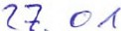
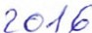
Date:

For the Sociedad Chilena de Astronomía
{SOCHIAS)


Date: 23-03-2016

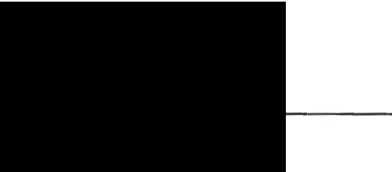
For the Astronomical Institute of the Academy of Sciences of the Czech Republic

Date: 1 8 -01- 2016

For the University of Zagreb

Date: O : -OZ- 2016

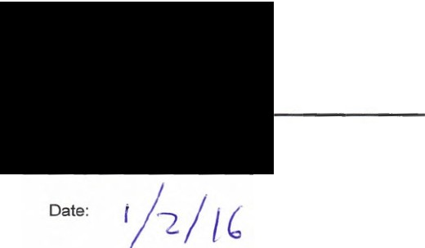
For the Instrument Center for Danish Astrophysics (IDA)

For Tartu Observatory
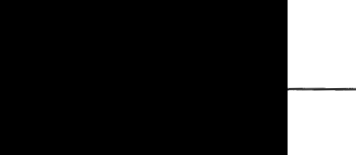
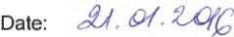

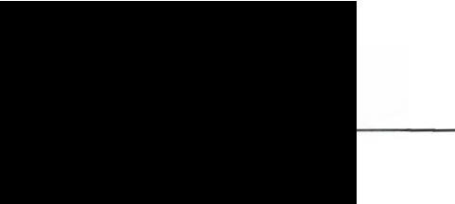
For the Finnish National Committee for Astronomy

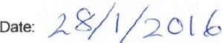

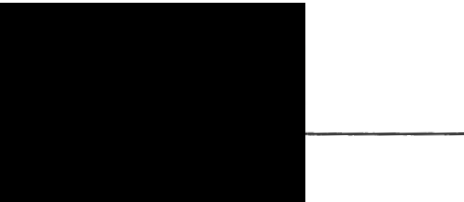
For the Centre National de la Recherche Scientifique

Date: le e>'.?. o '2.. l b


For the Bundesministerium fOr Bildung und Forschung

Date: J["" /OA/2DAÓ

For the Hellenic Astronomical Society


For the Hungarian Academy of Sciences

Date: 10 February 2016

For the lstituto Nazionale dí Astrofisica (INAF)

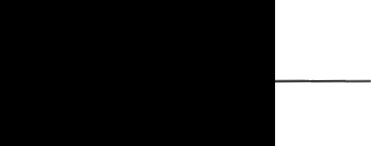
Date:

For the Lithuanian Astronomical Society
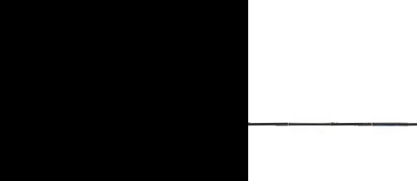

Date: c,I6•Wf-./

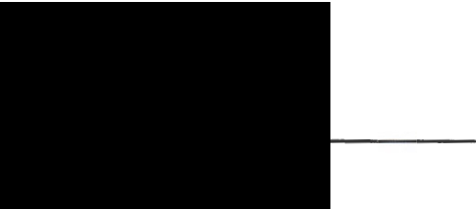
For NOVA: Nederlandse Onderzoekschool voor Astronomie
Date:
21 JV---- 2..•I l

For the Polish Academy of Sciences


Date:

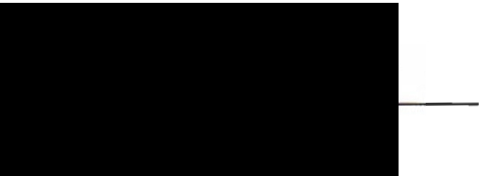

Date:

29

For the Sociedade Portuguesa de Astronomia

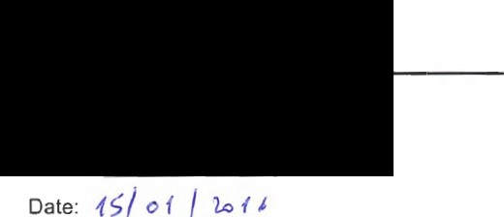

30

For the Astronomical Institute of the Slovak
--
Academy of Sciences l"/r. v ,•c1r


Date:
19. JAN. 2016

31


For the Secretaría de Estado de lnvestigación,
Desarrollo e lnnovación

Date:

32

For the Swedish Research Council
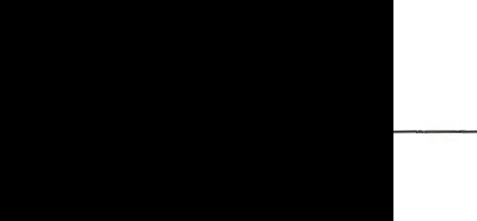
Date: -<-O I6 - O2. --{))._

For the Swiss Academy of Sciences
