SO03
SO02
SO01
PS01
VON
-119 299,04
577 400,00
-489 007,33
175 877,00
99 900,00
175 632,77
577 400,00
3 661 968,60
175 877,00
99 900,00
-294 931,81
0,00
-4 150 975,93
0,00
0,00
2
44 870,63
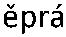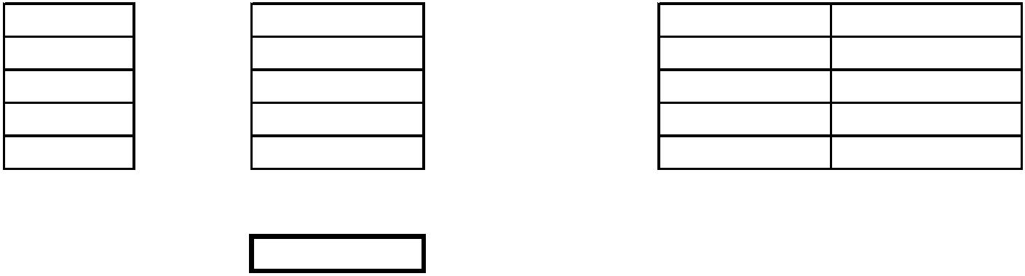

TV
Popis
MJ
J. cena
K
25
39
5938100R
kus
-3
2 664,00
-7 992,00
K
91952118R
M
-14
6 050,00
-84 700,00
K
K
40
47
59222003
M
T
-15,4
4 200,00
384,00
-64 680,00
-52 695,94
998323011
-137,229
K
K
3
4
334323418
334351112
m3
m2
0,96
5,4
5 770,00
1 230,00
5 539,20
6 642,00
K
K
16
1
334351211
334361412
m2
t
5,4
98,4
531,36
0,076
40 200,00
3 055,20
K
K
2
5
348171111
R1
m
7
728
158
5 096,00
kg
105
16 590,00
K
K
6
421321128
421351111
m3
m2
4,2
4,2
5 760,00
523
24 192,00
2 196,60
11
K
K
12
22
421351211
421361226
m2
t
4,2
92,4
388,08
0,758
58 200,00
44 115,60
K
K
7
8
962051111
963051111
m3
m3
0,96
4,2
9 390,00
9 390,00
9 014,40
39 438,00
K
15
997211611
t
12,384
143
1 770,91
9
9701360R.1
Odvoz suti
t
12,384
1377,86
17 063,42
-42 934,50
6
0556101
M3
-1,363
31500
7
7
7
62211140
62215812
62295001
M
M
-10,1
-10,1
414
170
630
-4 181,40
-1 717,00
-780,57
M3
-1,239
vruty
9
1
1
98762101
19003223
19003224
T
-1,09
-225
-225
1810
91
-1 972,90
-20 475,00
-12 802,50
M
M
56,9
Celkem
-119 299,04
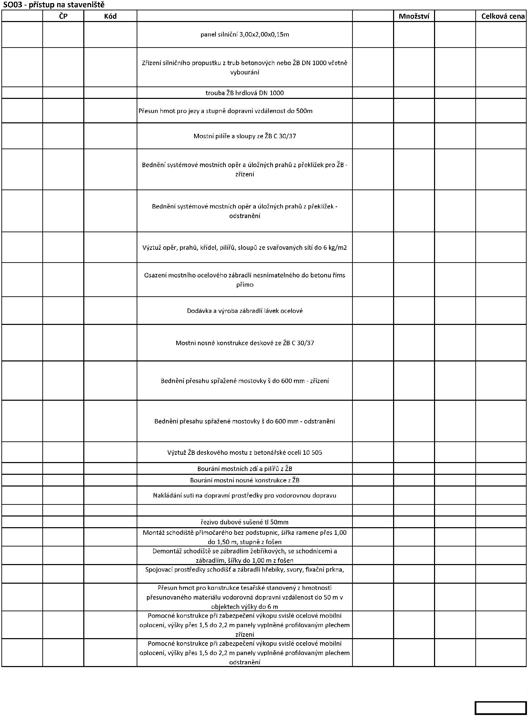

TV
Popis
MJ
J. cena
K
2 11510121R
KPL
0,6
220000
132 000,00
K
K
K
6 17110001R
36 462511270
23 291111111
M3
M3
M3
100
80
660
1990
1300
66 000,00
159 200,00
104 000,00
80
6
3 mm
K
5 164203101
45 99701369R
M3
T
100
160
202
600
20 200,00
K
96 000,00
celkem
577 400,00
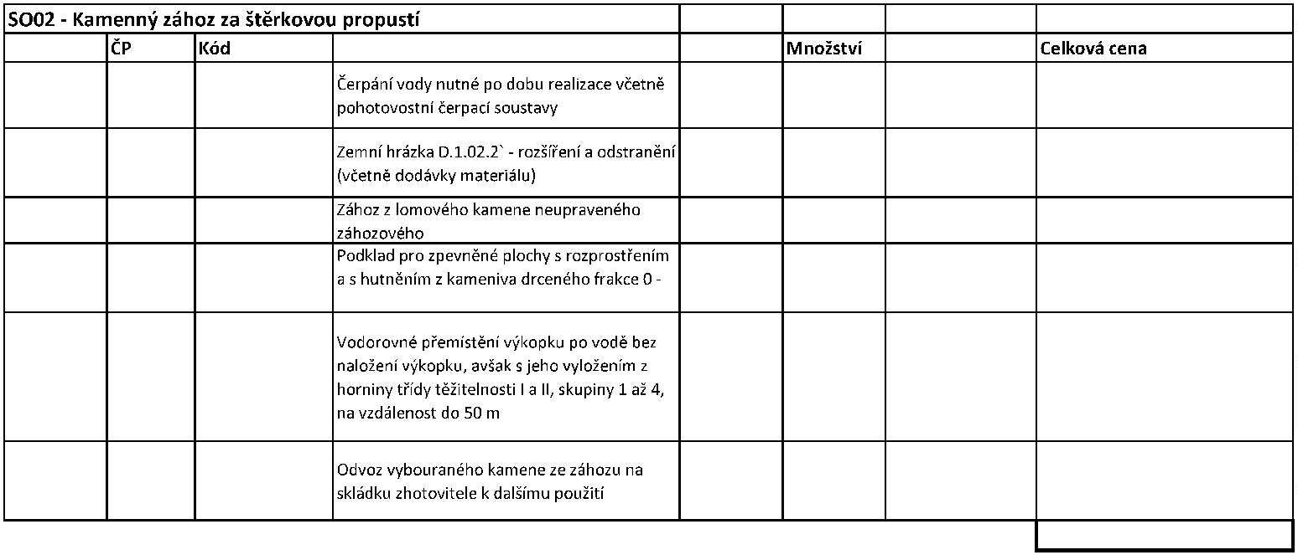

K
1
1
592031R2
T
43,867
1
1123,00
49 262,64
53112115R
KPL
378 000,00
378 000,00
K
K
KG
23473,00
1
5,50
129 101,50
60 000,00
KPL
60 000,00
1
31,4 km
K
K
063203000R1
063203000R2
KPL
KPL
1
1
27 552,00
861664
27 552,00
K
K
881 664,00
KPL
1
153440
153 440,00
M
M
M
13010974
13011021
t
t
t
1,66
1,07
0,4
38000
40600
38000
63 080,00
43 442,00
15 200,00
1
40
(IPN) 360
HEB 140
13010974
K
063203000R3
KPL
1
125952
125 952,00
KPL
1
21920
40600
21 920,00
26 390,00
M
13011021
t
0,65
M
M
60516102
28322004
m3
M2
2,352
39,2
13100
276
30 811,20
10 819,20
1
,5mm
K
KPL
1
50000
50 000,00
K
063203000R4
KPL
1
440832
440 832,00
KPL
1
35920
35 920,00
K
KPL
m3
1
35 400,00
2 430,00
35 400,00
36 450,00
1
55135111
15
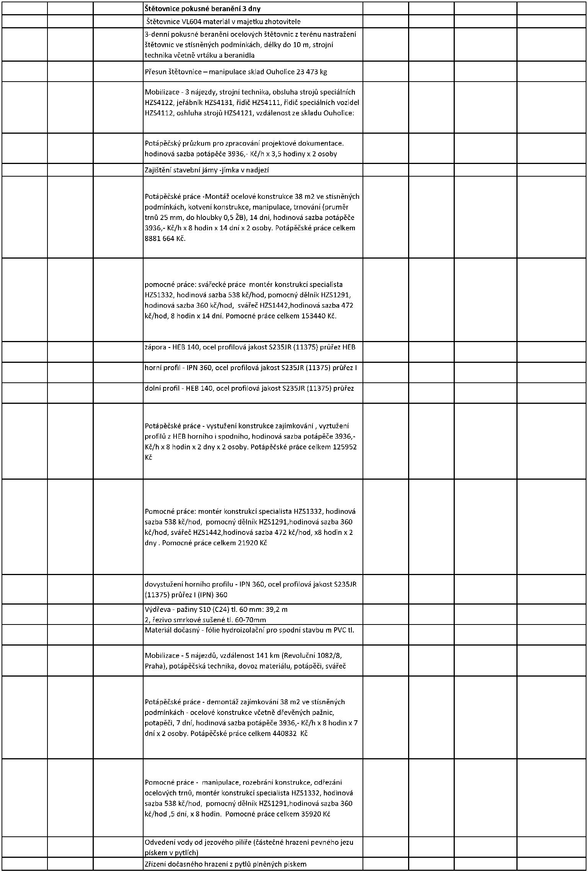

1
1
55135112
55135125
m3
m3
15
1 150,00
27,10
17 250,00
27 642,00
1020
K
K
063203000R5
KPL
1
1
314880
314 880,00
KPL
57600
57 600,00
M
K
58933332 beton
M3
m2
8,4
4 070,00
1827
34 188,00
13 592,88
533900R
7,44
K
18 1401108R
M
-44,85
-4,541
2 578,56
-115 648,42
K
21
22
23
24
321321116
M3
6 682,61
-30 345,73
K
K
K
321351010
321352010
321366112
M2
M2
T
-8,36
-8,36
1 515,64
491,11
-12 670,75
-4 105,68
-26 045,26
-0,506
51 472,84
K
K
36
40
961055111
985311114
M3
M2
T
-4,541
-6,8
6 712,14
4 586,30
377,93
-30 479,83
-31 186,84
-9 060,29
9
98323011
-23,97345
K
K
K
21
22
23
321321116
321351010
321352010
M3
M2
M2
1,666
7,35
7,35
6 682,61
1 515,64
491,11
11 133,23
11 139,95
3 609,66
K
K
36
40
961055111
985311114
M3
M2
1,666
7,35
6 712,14
4 586,30
11 182,43
33 709,31
K
K
966071133
T
15
5 393,33
80 899,95
35034022R2
KUS
T
1
59 000,00
377,93
59 000,00
9
0t
9
98323011
981,411
370 904,66
Celkem
-489 007,33
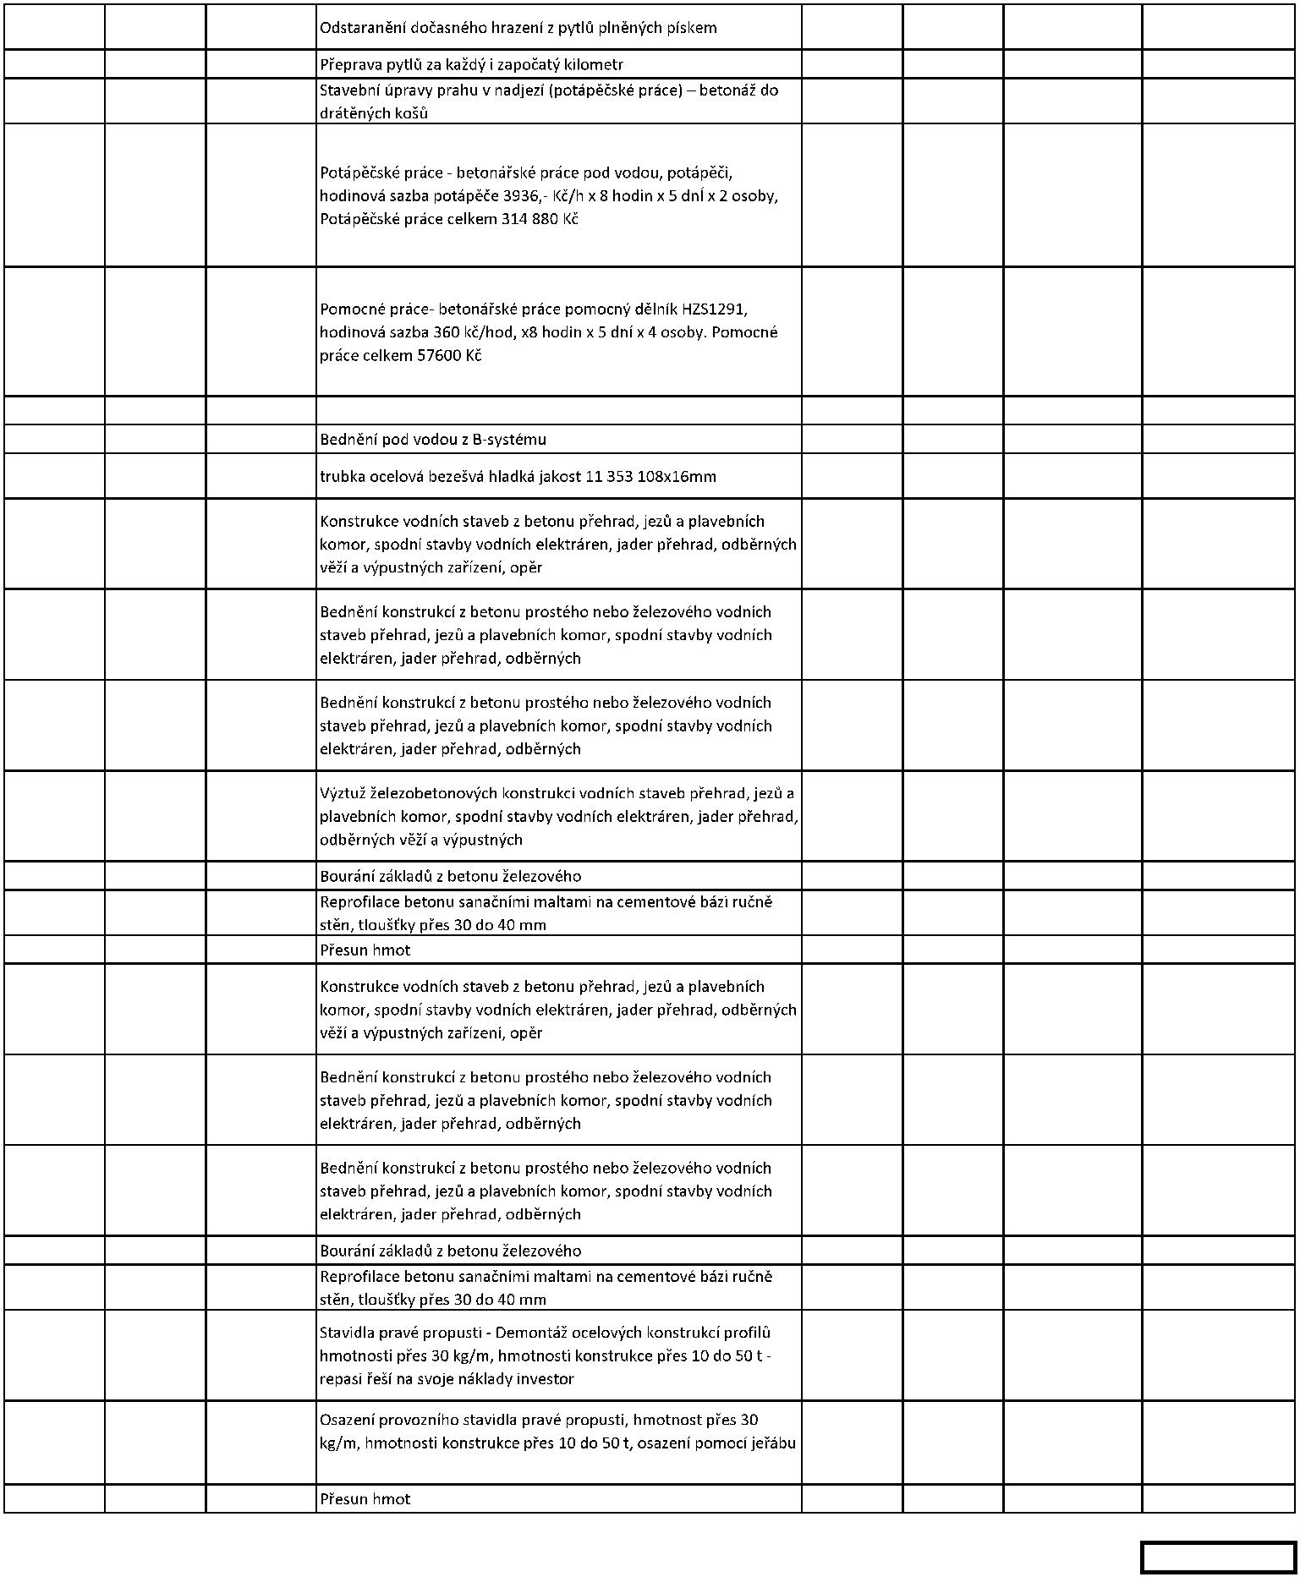

TV
Popis
MJ
J. cena
cena
ks
1
1
115 637,00 115 637,00
KPL
60 240,00
60 240,00
Celkem
175 877,00
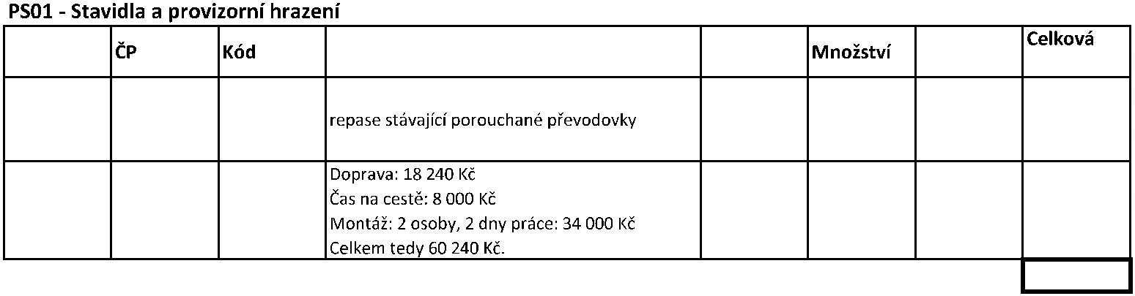

VON
TV
Popis
MJ
J. cena
cena
mostek
K
K
21
20
11002000
12002000
kpl
kpl
1
1
4 000,00
4 000,00
6 500,00
6 500,00
K
K
18
19
01300200R1
01300200R2
kpl
kpl
1
1
5 000,00
5 000,00
5 000,00
5 000,00
K
K
01300200R3
kpl
kpl
1
1
52 000,00
52 000,00
01300200R2
projektovou dokumentaci
projektant
27 400,00
27 400,00
99 900,00
Celkem
