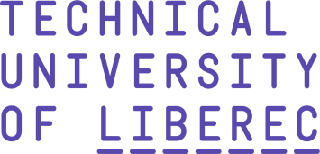
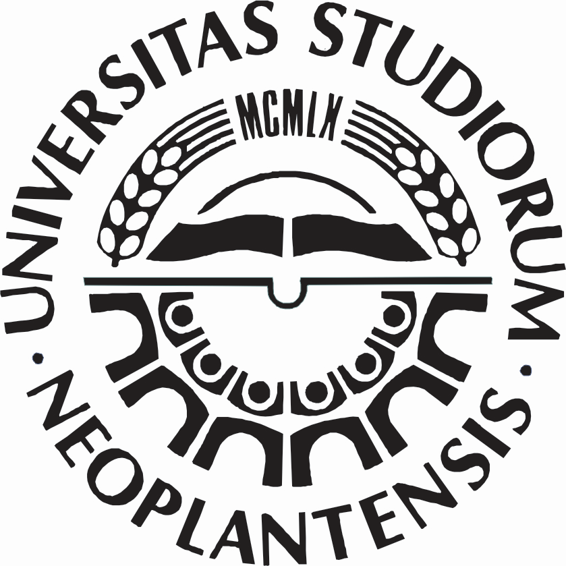

AGREEMENT
between
TECHNICAL UNIVERSITY OF LIBEREC – FACULTY OF MECHANICAL ENGINEERING
and
FACULTY OF TECHNICAL SCIENCES IN NOVI SAD

WITHIN THE FRAME OF CEEPUS NETWORK
RS-0304 - Technical Characteristics Researching of Modern Products in Machine Industry with the Purpose of Improvement Their Market Characteristics and Better Placement on the Market

Technical University of Liberec – Faculty of Mechanical Engineering and Faculty of Technical Sciences in Novi Sad, agree to develop academic exchange and cooperation in education and research, as follow:

- Based upon the principles of respect for each other’s independence and of mutual benefit, the two universities will carry out the following activities:
- exchange of students and PhD students
- exchange of academic members and staff
- exchange of scientific, technical and pedagogical information
- creation opportunities for students to prepare PhD/MSc Thesis based on the “These en cotutelle” agreement between at least two PhD/MSc coordinators, one at each university
- creation opportunities for the “visiting professors” of each institution to enhance their didactical and pedagogical skills.

- Both institutions shall receive the number of students, master students, PhD students and teachers according to the CEEPUS III Network Traffic Sheet.

- Each institution will inform the other institution about plans for sending or accepting students/teachers before the agreed due date by it.

- Further details of the specific conditions other than hereby described shall be worked out through mutual consultation.

- This agreement does not entail financial obligations for any of the universities.

- This agreement is valid for a period of 5 (five) years from the date of signature and will be renewed before the expiration date by mutual consent of the two universities.

For For
TUL – Faculty of Mechanical Engineering Faculty of Technical Sciences

Dean, Acting dean,
Doc. Ing. Jaromír Moravec, Ph.D. Prof. Dr. Boris Dumnić

…….……………………………………….……………… .…………………………………….…….………………

Date: December, 2023 Date: December, 2023

