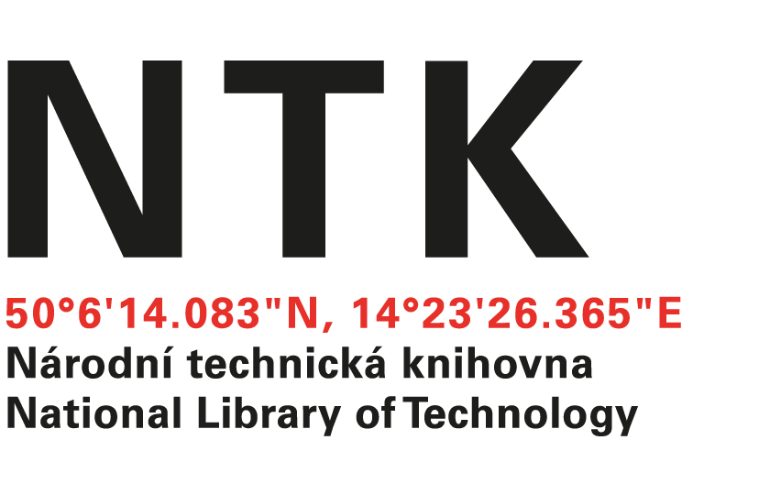
Order

No. 161/EIZ/2023

Customer: | Supplier:
National Library of Technology | McGraw-Hill  xxxxxxxxxxxx
Technická 6/2710 | 104 Windsor Center Drive, Suite 400
160 80 Prague 6 - Dejvice | East Windsor
Czech Republic | NY 08520
ID: 61387142
VAT: CZ61387142

Dear Raquel,

based on your offer from 11. 12. 2023 we order unlimited access to AccessScience for the price $ 16,067.12 Term: from December 31, 2023 to December 30, 2024.

Kind regards

xxxxxxxxxxxxx
electronic resources librarian

Order accepted by:
Date of issue: 13.12.2023
Issued:
xxxxxxxxxxxxxxx
email: eiz@techlib.cz
tel.: +420 232 002 409

