Annex No. 6 - Postal and Business Terms and Conditions – Other Services - Business Letter

Opening provisions

1. “Business Letter” (in Czech: “Firemní psaní”) is a postal service other than basic services provided by Česká pošta, s.p. (hereinafter referred to as “the Company”) under the Act No. 29/2000 Coll., on postal services and on amendment to certain related acts (“the Postal Service Act”). The Postal Terms and Conditions of Česká pošta, s.p. – Basic Postal Services (hereinafter referred to as “the Postal Terms and Conditions”) apply accordingly to matters which are not regulated by these Terms and Conditions.
2. Unless it is stipulated otherwise by the Company in certain circumstances, the Company accepts Business Letter consignments (hereinafter referred to as “consignment(s)”) under a written Agreement on the Conditions for Posting Business Letter Consignments (hereinafter referred to as “the Agreement”) at the designated post offices marked with the Company logo (hereinafter referred to as “post office”) or through its authorised employees at the place agreed in writing with the sender (hereinafter referred to as “pickup”).
3. Consignments will be posted without confirmation by the Company. Consignments will be delivered by the Company without any confirmation of receipt. The Company does not provide any compensation for damage caused by the loss, damage or part loss of the content of the consignment. No additional services are available for Business Letter consignments.

Service description

1. The minimum consignment dimensions are 9 x 14 cm. The maximum dimensions of a consignment including inserted small things are 35.3 cm (length) x 25 cm (width) x 2 cm (thickness). Consignments with irregular shapes will be assessed accordingly.
2. The weight of a consignment may not exceed 1,000 g.
3. Consignments with parameters suitable for machine processing (see Annex No. 2) must be prepared for such machine processing.

Content of consignments

1. Consignments may contain any things other than those specified in Art. 2(2), (3) and (4) of the Basic Postal Terms and Conditions. An unfolded postcard cardboard sheet may also constitute a consignment.

Postal address

1. The consignor must write the addresses of the addressee and the sender on the address side of the consignment. The address must correspond with Art. 4 of the Basic Postal Terms and Conditions.

Packaging of consignments

1. Consignments must be packed in the manner specified in Art. 3 of the Basic Postal Terms and Conditions.

Posting of consignments

1. Unless it is stipulated otherwise by the Company in certain circumstances, the Company accepts Business Letter consignments only under a written agreement. The agreement must specify the post office where the consignor will hand over the Commercial Letter consignments. A consignment is deemed posted as of the moment the Company accepts the consignment from the sender.
2. The address side format must comply with the instructions included in Annex No. 2. A specimen address side format is attached as Annex No. 2.
3. The consignor must submit any posted consignments together with a “Soupis zásilek Firemní psaní” (in English: List of Business Letter Consignments); the post office personnel will confirm the number of posted consignments according to the conditions agreed in the Agreement.
4. The consignments must be pre-sorted in the manner agreed in the Agreement.

Withdrawal from the Agreement

1. If the Company finds out that an accepted postal consignment contains objects that are not allowed, that its packaging does not comply with Art. 9, or that other agreed duties have not been observed, the Company may withdraw from the concluded Agreement and return the consignment back to the sender, or ask the sender to take over the consignment at a place specified by the Company. Additional costs covering any necessary related actions will be paid by the sender.

Labelling of consignments

1. The consignments must be clearly labelled as Business Letter consignments. The labelling must comply with the specimen contained in Annex No. 1 including the logo of Česká pošta, s.p.; the code assigned by the Company to Business Letter; the assigned User’s ID (CČK file ID); and the “D+1” note in case of priority consignments. If Credit is the selected payment method, the User’s ID (CČK file ID) is the number of the Credit used to pay for the consignment.

Price and manner of payment

1. The method of calculation of prices for which the service is provided is described in a separate part of the [Postal Terms and Condition of Česká pošta, s.p. – Pricelist](https://www.ceskaposta.cz/ke-stazeni/cenik-sluzeb-ceske-posty) (hereinafter referred to as “the [Pricelist](https://www.postaonline.cz/documents/10180/282441/kompletni_cenik.pdf)”). Unless it is stipulated otherwise by the Company in certain circumstances, the manner of payment of the price will be agreed in the Agreement. Neither postage stamps nor cash may be used to pay for the service.
2. The price of the service will not be refunded by the Company if a consignment is lost, damaged, or partly lost.

Delivery of consignments

1. Business Letter consignments may be sent by priority or economy mail. Consignments that are to be sent by priority mail must be labelled in a special manner agreed in Annex No. 1; otherwise, they will be sent by economy mail. Business Letter consignments sent by economy mail will not be transported by the fastest method used for Business Letter consignments.
2. The Company will deliver or deal with undeliverable consignments in compliance with the relevant provisions of the Basic Postal Terms and Conditions. The Company may deliver the consignment at a place other than the one specified in the postal address if it has learnt of the new place of residence or registered office of the addressee from the addressee or by other reliable means.
3. The Company will hand over the consignment deposited at a post office to an individual who has proven, in the manner specified in the Basic Postal Terms and Conditions, that he is the addressee of the consignment or person authorised to accept the consignment; the consignment will be handed over against his signature confirming its acceptance.
4. If the Company fails to deliver the consignment in accordance with the preceding provisions, it will return the consignment back to the specified sender’s address, without undue delay.

Resolution of disputes concerning the subject-matter of the postal contract

1. If the Company rejects or fails to settle a complaint concerning any defect of the provided postal service, the sender or the addressee has the right to appeal to the Czech Telecommunication Office ([www.ctu.cz](https://www.ctu.cz/)) against the decision in the claim procedure; the appeal must be made without undue delay, at the latest 1 month from the date of delivery of the claim decision or from the vain expiry of the time limit for the settlement of the complaint, otherwise the right to appeal terminates. The appeal is subject to an administrative fee. The Czech Telecommunication Office will decide in the appellate procedure about the rights and duties of the parties resulting from the postal contract or the Act No. 29/2000 Coll., on postal services, as amended.

Unalterable provisions

1. With the exception of Art. 1 to 3 and 7, these Postal Terms and Conditions may be altered by an agreement.

Transitional and final provisions

1. The current version of these Postal Terms and Conditions becomes effective on 01 May 2023 and is available at any post office as well as on the website [www.ceskaposta.cz](https://www.ceskaposta.cz/ke-stazeni/postovni-podminky). The Company reserves the right to amend or modify the present Postal Terms and Conditions or cancel the same by issuing new Postal Terms and Conditions.

List of annexes:

**Annex No. 1** Recommended address side formats.

**Annex No. 2** Definition of parameters of consignments suitable for machine processing.

Annex No. 1 Recommended address side formats

1. **Specimen address side format**
2. **Priority consignments**

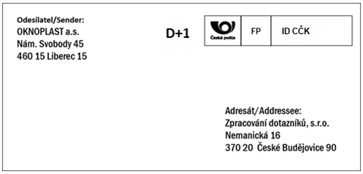

1. **Economy consignments**

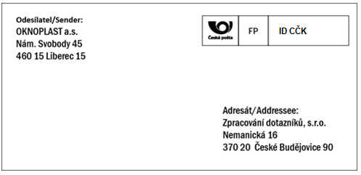

If Credit is the selected payment method, the User’s ID (CČK file ID) is the number of the Credit used to pay for the consignment.

Annex No. 2

**Definition of parameters of consignments suitable for machine processing**

1. **Basic description**

Consignments must comply with several parameters to be suitable for machine processing:

* 1. Size
  + Width: 90 mm to 162 mm;
  + Length: 140 mm to 235 mm;
  + Thickness: up to 5 mm.
  1. Weight
  + max. 100 g
  1. Content
  + Ideal content for machine sorting passes smoothly through the sorting machine; It includes but is not limited to documents, such as letters, invoices, bills;
  + Small things, such as coins, merchandise, keys, scissors, payment cards, must not be inserted in sorted consignments because they can damage or even destroy the consignment when passing through the sorting machine.
  1. Address

The address must be sufficiently legible, full, written by suitable means, positioned at a suitable place, and the letters must be sufficiently large so that the sorting machine can recognise each character and sort the consignment correctly.

1. **Detailed description**
   1. Recommended address side format

The address should be positioned on the largest surface of the consignment.

The address should:

1. be written in Latin script;

2. contain sufficiently large letters;

3. be legible;

4. be full;

5. be clear;

6. be accurate;

7. not contain any corrections;

8. not exceed the postcode boxes preprinted on the consignment.

The minimum size of typed or printed letters is 0.25 cm. Handwritten addressee’s name must be written in capital letters. The address has to be written using writing material which would prevent its deletion, alteration, or loss of legibility. In particular, it may not be written by a pencil or as a typed or handwritten carbon copy (this does not apply to address labels and envelopes made of carbonless copy paper). The addressee’s postal address must not be written in red ink or by a luminescent pen. The postcode and name of the destination post office on domestic consignments should not be underlined. The addresses have to be written lengthwise on the side of the consignment whose dimensions, format etc. are most suitable for this purpose. The minimum acceptable dimensions of such side are 14 x 9 cm. Addresses must not be written on the side of the envelope with flaps.

* 1. Recommended weight of envelopes for sorting machines

Only consignments weighing up to 100 g may be sorted by machines.

* 1. Recommended size of envelopes for sorting machines
  2. Recommended address side formats

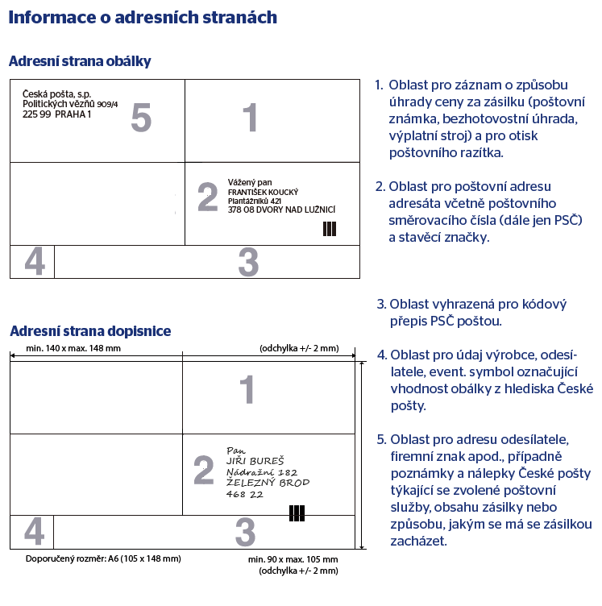

* 1. Recommended format of window envelopes: printing on the address side and position of the window (especially for business purposes)

Envelopes less than 105 mm wide should not contain any outside printing. The location of areas on the address side of envelopes depends on their use. Printing on envelopes must be done in one way, without blurring, smudging, splashing or ink splatter. Luminescent inks should not be used for printing or other surface treatment. Guide marks should be printed in black. Printing with light shades of reddish brown or of blue is acceptable.

Printing or additional printing on the address sides by the envelope manufacturer or user (company logo, advertisement) may only be position in the left part of the envelope, i.e. to the left of the addressee’s address, and must not preclude the placement of Czech Post’s business notes or stickers. No printing is allowed in the area designated as No. 3 in the picture along the entire lower edge with a minimum height of 16 mm, which is reserved for printing the postcode transcript by Czech Post’s sorting machine. No printing or additional printing is allowed to the right of the window. If the envelope has a print in the upper right-hand corner replacing the postage stamp, e.g. the assigned User’s ID (CČK file ID), the area for affixing the postage stamp may be omitted. The window must be positioned in the lower right- or left-hand quarter of the address side of the envelope and may display only the addressee’s postal address.

Window envelopes must contain a correctly positioned guide mark. With the exception of a guide mark, envelopes with a window positioned on the left may not contain any printing on the right-hand side of the window. The transparent window foil must be colourless, glued on all sides of the window inside the envelope, and clear (preferably with a glossy surface). Coloured stripes or frame around the window in window envelopes are not acceptable.

**Further parameters**

* + Envelopes and labels in the address zone and in windows must not bear any background print;
  + Only the addressee’s postal address may be visible in the envelope window, and the entire address must always be visible when moving the contents of the envelope;
  + The envelopes must be sealed along the entire length of the flap;
  + Postcards must be printed in accordance with the applicable standard.

**Recommended postal address format on envelopes for typed addresses (with preprinted guide marks and orientation marks)**

The postcode and the name of the destination post office should be typed on the last line of the address. Approximately the same spacing should be used between the lines of the address (min. 1 mm, max. 5 mm). No background printing is permitted in the address block!

**Recommended format for postcode and name of destination post office:**



* 1. Recommended fonts for addresses

Computer printing:

* + Arial CE, point size 12−14 (i.e. 2.5−4 mm), normal or bold, normal spacing;
  + Verdana, point size 12−14 (i.e. 2.5−3.5 mm), normal or bold, normal spacing;
  + Courier New CE, point size 12−14 (i.e. 2.5−3.5 mm), normal or bold, spacing expanded by 1 point.

Classic printing:

* + Helvetica, point size 3−5 mm, medium ductus, medium width.

Typing:

* + Touching characters must be divided by a space.
  1. Parameters of letters unsuitable for machine processing
  + Size larger than recommended;
  + Thicker than 5 mm;
  + Inflexible, damaged, or wrinkled;
  + Containing any numerical, written or graphical data under the postcode;
  + Having the address side printed on a paper with other than white or light yellow colour;
  + With address printed in a low contrast or a colour other than black and blue;
  + Having an uneven thickness or containing things, such as films, rolls, cassettes, keys, diskettes, CDs;
  + With corrected or amended address, forwarder, returned or already barcoded;
  + Made of thin paper;
  + Consisting of Return Receipt slips torn off from the original envelopes;
  + Mail for the blind;
  + Letters stuck together;

With address written in a grid.