Amendment No 1
to Partnership Agreement, in the framework of the LIFE project
“Innovative Technology based on Constructed Wetlands
for Treatment of Pesticide Contaminated Waters“
(LIFEPOPWAT/LIFE Grant Agreement Reference No LIFE18 ENV/CZ/000374)

entered into by and between
Coordinating Beneficiary
Technická univerzita v Liberci - Technical University of Liberec (TUL)
Institute for Nanomaterials, Advanced Technologies and Innovation
Studentská 1402/2, 46117 Liberec, Czech Republic
represented by doc. RNDr. Miroslav Brzezina, CSc., Rector

and

Associated Beneficiary 1
Aarhus University (AU)
Nordre Ringgade 1, Aarhus, 8000, Denmark
represented by Brian Bech Nielsen, Rector

Associated Beneficiary 2
DIAMO, státní podnik, odštěpný závod Správa uranových ložisek Příbram (DIAMO)
Máchova 201. Stráž pod Ralskem, 47217, Czech Republic
represented by Zbyněk Skála, Director

Associated Beneficiary 3
Główny Instytut Górnictwa - Central Mining Institute (GIG)
Plac Gwarków 1, Katowice, 40-166, Poland
represented by Stanislaw Prusek, Director

Associated Beneficiary 4
Urząd Miejski w Jaworznie - City of Jaworzno (Jaworzno)
ulica Grunwaldzka 33, Jaworzno, 43600, Poland
represented by Pawel Silbert, Mayor

Associated Beneficiary 5
Photon Water Technology (PWT)
Generála Svobody 25/108, Liberec 460 01, Czech Republic
represented by Petr Kvapil, Director

Associated Beneficiary 6
SERPOL (SERPOL)
2, chemin du Génie – BP 80, Vénissieux Cedex, 69633, France
represented by Alain Dumestre, Chief executive officer

(together the ‘Contracting Parties’)

This Ammendment modifies the Partnership Agreement between the above Contracting Parties and the Coordinating Beneficiary, which was concluded on 20 October, 2020 (“Agreement”):

1)
Beneficiary DIAMO is responsible for the investment – construction of the wetland system at the Hájek site. Due to price changes and additional work, the cost of this investment has increased by 12,602 EUR. DIAMO no longer has the fin. means to cover this increased investment and request a fund transfer from the Coordinating beneficiary (TUL). In the Czech Republic, the project is co-financed by Czech entities with 17.5 % of the Czech funds, which cannot be used for investments. The coordinating beneficiary, TUL, agrees to exchange 12,602 EUR between the sources, i.e. transfer of 12,602 EUR from the EU LIFE grant from TUL to DIAMO and from the national co-financing source transfer of 12,602 EUR from DIAMO to TUL.

DIAMO's overall budget will remain unchanged. Also, DIAMO's own funding under the Partnership Agreement Article 6.2 of EUR 247 290 will be maintained.

The final distribution of financial resources will therefore be as follows, and the above change will be reflected in the transfers of final payment funds from the Coordinating Beneficiary TUL to the Beneficiary DIAMO, s.p:
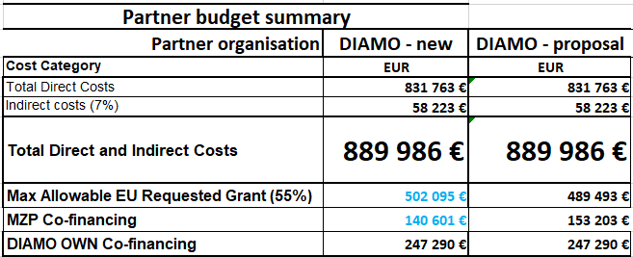

2)
Associated Beneficiary 6 (SERPOL) shifted 35,000 EUR of Direct costs and 2,450 EUR of Indirect costs to Coordinating Beneficiary (TUL), i. e. within GA rules (20 % of the budget). Therefore the Own co-financing of SERPOL will be lower (proposal: 71,454 EUR, new: 58,647 EUR).

Original text:

6.2 Budgeting
The total costs of the Project are estimated to be 3,167,290 EUR, out of which:
- 1,727,833 EUR –contribution from the EU
- 236,715 EUR – contribution from the Coordinating Beneficiary
- 247,290 EUR – contribution from Associated Beneficiary 2
- 75,499 EUR – contribution from Associated Beneficiary 6
- 336,091 EUR – contribution from the Ministry of Environment of the Czech Republic as co-financer for the Czech project participants
The total eligible costs of the Project are estimated to be 3,141,515 EUR.

New text:

6.2 Budgeting
The total costs of the Project are estimated to be 3,167,290 EUR, out of which:
- 1,727,833 EUR –contribution from the EU
- 243,568 EUR – contribution from the Coordinating Beneficiary
- 247,290 EUR – contribution from Associated Beneficiary 2
- 58,647 EUR – contribution from Associated Beneficiary 6
- 336,091 EUR – contribution from the Ministry of Environment of the Czech Republic as co-financer for the Czech project participants
The total eligible costs of the Project are estimated to be 3,141,515 EUR.

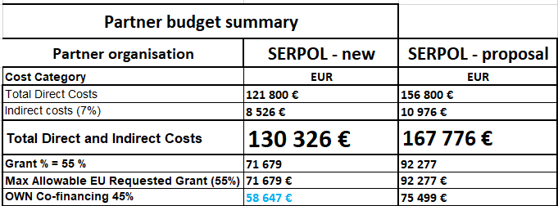

3)
After these two shifts, the TUL final budget and LIFEPOPWAT Project budget look like this:

TUL:
+12,602 EUR within EU donation (from DIAMO),
+35,000 EUR of Direct costs, and +2,450 EUR of Indirect costs (from SERPOL), i.e. 20,598 EUR within EU donation (55%) and 16,853 EUR within Own co-financing (45%)

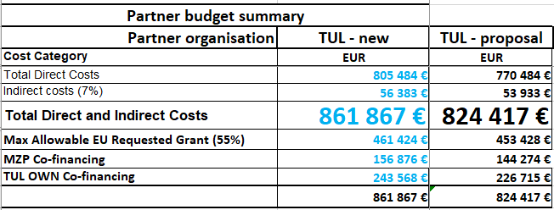

LIFEPOPWAT Project budget – NEW:

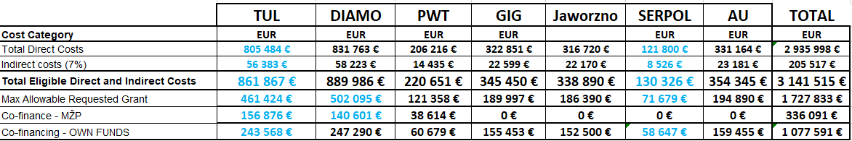

LIFEPOPWAT Project budget – Proposal:

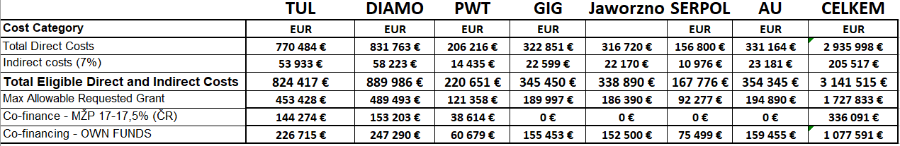

The other parts of the Agreement remain unchanged.

On behalf of the Coordinating Beneficiary

Technická univerzita v Liberci - Technical University of Liberec (TUL)

Done in Liberec on _09__/__06__/2023

Signature M. Brzezina

On behalf of the Associated Beneficiary 1

Aarhus University (AU)

Done in Aarhus on __06_/__06__/2023

Signature Hans Brix

On behalf of the Associated Beneficiary 2

DIAMO, státní podnik, odštěpný závod Správa uranových ložisek Příbram (DIAMO)

Done in Příbram on _04__/_05___/2023

Signature Z. Skála

On behalf of Associated Beneficiary 3

Główny Instytut Górnictwa - Central Mining Institute (GIG)

Done in Katowice on _04__/_05___/2023

Signature S. Prusek

On behalf of Associated Beneficiary 4

Urząd Miejski w Jaworznie - City of Jaworzno (Jaworzno)

Done in Jaworzno on _05__/__05__/2023

Signature P. Silbert

On behalf of Associated Beneficiary 5

Photon Water Technology (PWT)

Done in Liberec on _24__/_04___/2023

Signature P. Kvapil

On behalf of Associated Beneficiary 6

SERPOL (SERPOL)

Done in Vénissieux on _25__/_04___/2023

Signature A. Dumestre

