AS R2 PLUS Analytical Balances
Innovative design and system solutions for standard-class products
AS R2 PLUS, d = 0,1 mg
Communication interfaces
Large LCD display with text
information section
AS R2 PLUS, d = 0,01 mg
Functions
Parts
counting
Density
determination
Alibi
memory
Statistics
Totalizing
Animal
weighing
Under hook
weighing
GLP
procedures
Replaceable
unit
Dosing
Ambient conditions
measurement
Multilingual
menu
Checkweighing
Percent Weighing
Autotest
Peak hold
Features
Ergonomic Mechanical Design
Uncomplicated and Intuitive Operation
Spacious weighing chamber and large open-door clearance allow easy
access to the weighing pan and facilitate use of laboratory glassware
of various sizes and dimensions. Improved aluminium base of the
balance guarantees stability of the weihging system. DUAL-CLICK
system facilitates tool-free disassembly and assembly of the weighing
chamber. Locating the USB interface at the balance front makes it
easier to communicate with peripherals.
Large, easy-to-read LCD display oﬀers not only a clear presentation
of the weighing result, but also enables displaying messages related
to the drying process as well as pictograms of active functions and
working modes. Quick access keys located on the operation panel
enable you to run a given function with just one click.
Data Management
AS R2 PLUS information system is based on operators, products,
weighings and tares databases. All saved data can be analysed,
exported, imported or exchanged between weighing instruments.
Levelling System
Clearly visible levelling device located at the front of the weighing
chamber facilitates level control.
ALIBI Memory
Antistatic Weighing Chamber
Internal ALIBI memory guarantees safety and automatic record of
measurements copies, it also oﬀers possibility to preview, copy and
archive data.
Weighing chamber panes feature antistatic coating compensating
electrostatic charges on the sample and accessories used for mass
measurement.
Kensington Lock
*
Antistatic coating has been applied in balances with the readability of
AS R2 PLUS balances are equipped with Kensington Lock, which allows
to secure the device against theft.
d=0.01mg
Page 1 of 6
|
Date: 27.02.2020
www.radwag.com
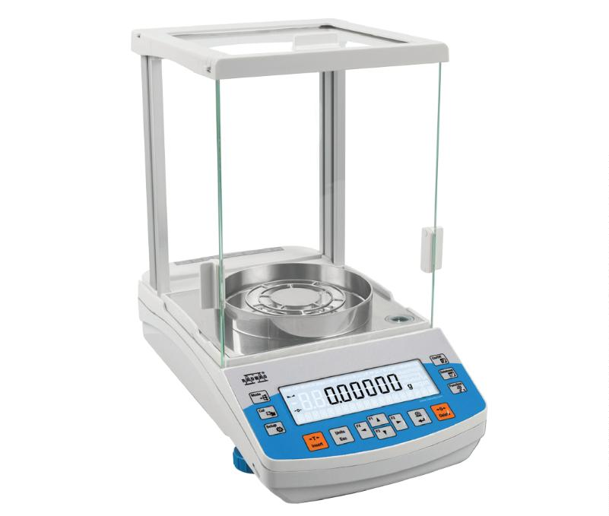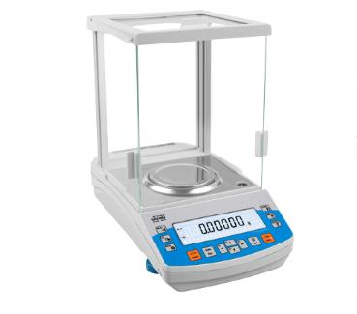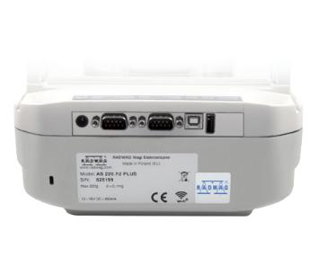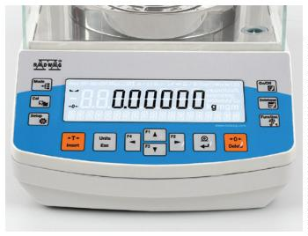

Technical Speciﬁcations
AS 60/220.R2 PLUS
60 g / 220 g
1 mg
AS 62.R2 PLUS
62 g
AS 82/220.R2 PLUS
82 g / 220 g
1 mg
AS 120.R2 PLUS
120 g
Maximum capacity [Max]
Minimum load
1 mg
1 mg
Readability [d]
0.01 mg / 0.1 mg
1 mg
0.01 mg
1 mg
0.01 mg / 0.1 mg
1 mg
0,01 mg
1 mg
Veriﬁcation scale interval [e]
Tare range
–220 g
–62 g
–220 g
–120 g
Standard values
Repeatability(5% Max)*
Repeatability(Max)*
Minimum weight (USP)
Minimum weight (U=1%, k=2)
Permissible values
Repeatability(5% Max)*
Repeatability(Max)*
Linearity
0.015 mg
0.08 mg
30 mg
0.012 mg
0.02 mg
24 mg
0.015 mg
0.08 mg
30 mg
0.015 mg
0.04 mg
30 mg
3.0 mg
2.4 mg
3.0 mg
3.0 mg
0.02 mg
0.018 mg
0.02 mg
0.02 mg
0.1 mg
0.03 mg
0.1 mg
0.05 mg
± 0.05 mg / ±0.2 mg
± 0.05 mg
± 0.05 mg / ±0.2 mg
± 0,05 mg
Stabilization time***
Adjustment
2 s
2 s
2 s
2 s
internal
internal
internal
internal
Veriﬁcation
Yes
Yes
Yes
Yes
OIML Class
I
I
I
I
Display
LCD (with backlight)
LCD (with backlight)
LCD (with backlight)
LCD (with backlight)
Keypad
14 keys
14 keys
14 keys
14 keys
Protection class
Databases
IP 43
IP 43
IP 43
IP 43
5
5
5
5
USB-A
1
1
1
1
USB-B
1
1
1
1
RS 232
2
2
2
2
Wi-Fi® ****
802.11 b/g/n
12 ÷ 16 V DC
3 W
802.11 b/g/n
12 ÷ 16 V DC
3 W
802.11 b/g/n
12 ÷ 16 V DC
3 W
802.11 b/g/n
12 ÷ 16 V DC
3 W
Power supply
Power consumption
Operating temperature
Atmospheric humidity*****
+10 ÷ +40 °C
40% ÷ 80%
–20 ÷ +50 °C
+10 ÷ +40 °C
40% ÷ 80%
–20 ÷ +50 °C
+10 ÷ +40 °C
40% ÷ 80%
–20 ÷ +50 °C
+10 ÷ +40 °C
40% ÷ 80%
–20 ÷ +50 °C
Transport and storage
temperature
Weighing pan dimensions
ø 90 mm open-work
ø 85 mm standard
(option)******
ø 90 mm open-work
ø 85 mm standard
(option)******
ø 90 mm open-work
ø 85 mm standard
(option)******
ø 90 mm open-work
ø 85 mm standard
(option)******
Weighing chamber dimensions
Weighing device dimensions
Net weight
160 × 168 × 227 mm
333 × 206 × 325 mm
5.3 kg
160 × 168 × 227 mm
333 × 206 × 325 mm
5.3 kg
160 × 168 × 227 mm
333 × 206 × 325 mm
5.3 kg
160 × 168 × 227 mm
333 × 206 × 325 mm
5.3 kg
Gross weight
7.3 kg
7.3 kg
7.3 kg
7.3 kg
Packaging dimensions
495 × 400 × 515 mm
495 × 400 × 515 mm
495 × 400 × 515 mm
495 × 400 × 515 mm
*
*
*
*
*
*
repeatability is expressed as a standard deviation from 10 weighing cycles
parameter determined in the following temperature range: +15 ÷ +35 °C
stabilization time depends on external conditions and dynamics of placing loads on a pan, determined for FAST proﬁle
optional solution on purchase order
non-condensing conditions
ø 85 mm standard weighing pan on purchase order
*
**
***
****
*****
Values of parameters provided in Technical Speciﬁcations table, have been determined under stable laboratory conditions. Due to ambient conditions impact or/and balance setup, the
above parameters may vary for environments other than laboratory.
Wi-Fi® is a registered trademark of Wi-Fi® Alliance.
Page 2 of 6
|
Date: 27.02.2020
www.radwag.com

Technical Speciﬁcations
AS 110.R2 PLUS
110 g
AS 160.R2 PLUS
160 g
AS 220.R2 PLUS
220 g
AS 310.R2 PLUS
310 g
Maximum capacity [Max]
Minimum load
10 mg
10 mg
10 mg
10 mg
Readability [d]
0.1 mg
0.1 mg
0.1 mg
0.1 mg
Veriﬁcation scale interval [e]
Tare range
1 mg
1 mg
1 mg
1 mg
–110 g
–160 g
–220 g
–310 g
Standard values
Repeatability(5% Max)*
Repeatability(Max)*
Minimum weight (USP)
Minimum weight (U=1%, k=2)
Permissible values
Repeatability(5% Max)*
Repeatability(Max)*
Linearity
0.06 mg
0.08 mg
120 mg
12 mg
0.07mg
0.08 mg
140 mg
14 mg
0.07 mg
0.08 mg
140 mg
14 mg
0.08 mg
0.12 mg
160 mg
16 mg
0.09 mg
0.09 mg
0.09 mg
0.12 mg
0.1 mg
0.1 mg
0.1 mg
0.15 mg
± 0.2 mg
± 0.2 mg
± 0.2 mg
± 0.3 mg
Stabilization time***
Adjustment
2 s
2 s
2 s
2.5 s
internal
internal
internal
internal
Veriﬁcation
Yes
Yes
Yes
Yes
OIML Class
I
I
I
I
Display
LCD (with backlight)
LCD (with backlight)
LCD (with backlight)
LCD (with backlight)
Keypad
14 keys
14 keys
14 keys
14 keys
Protection class
Databases
IP 43
IP 43
IP 43
IP 43
5
5
5
5
USB-A
1
1
1
1
USB-B
1
1
1
1
RS 232
2
2
2
2
Wi-Fi® ****
802.11 b/g/n
12 ÷ 16 V DC
3 W
802.11 b/g/n
12 ÷ 16 V DC
3 W
802.11 b/g/n
12 ÷ 16 V DC
3 W
802.11 b/g/n
12 ÷ 16 V DC
3 W
Power supply
Power consumption
Operating temperature
Atmospheric humidity*****
+10 ÷ +40 °C
40 ÷ 80%
–20 ÷ +50 °C
+10 ÷ +40 °C
40 ÷ 80%
–20 ÷ +50 °C
+10 ÷ +40 °C
40 ÷ 80%
–20 ÷ +50 °C
+10 ÷ +40 °C
40 ÷ 80%
–20 ÷ +50 °C
Transport and storage
temperature
Weighing pan dimensions
Weighing chamber dimensions
Weighing device dimensions
Net weight
ø 100 mm
ø 100 mm
ø 100 mm
ø 100 mm
160 × 168 × 227 mm
333 × 206 × 355 mm
5.3 kg
160 × 168 × 227 mm
333 × 206 × 355 mm
5.3 kg
160 × 168 × 227 mm
333 × 206 × 355 mm
5.3 kg
160 × 168 × 227 mm
333 × 206 × 355 mm
5.3 kg
Gross weight
7.3 kg
7.3 kg
7.3 kg
7.3 kg
Packaging dimensions
495 × 400 × 515 mm
495 × 400 × 515 mm
495 × 400 × 515 mm
495 × 400 × 515 mm
*
*
*
*
*
repeatability is expressed as a standard deviation from 10 weighing cycles
parameter determined in the following temperature range: +15 ÷ +35 °C
Stabilization time depends on external conditions and dynamics of placing loads on a pan, determined for FAST proﬁle
optional solution on purchase order
non-condensing conditions
*
**
***
****
Values of parameters provided in Technical Speciﬁcations table, have been determined under stable laboratory conditions. Due to ambient conditions impact or/and balance setup, the
above parameters may vary for environments other than laboratory.
Wi-Fi® is a registered trademark of Wi-Fi® Alliance.
Page 3 of 6
|
Date: 27.02.2020
www.radwag.com

Technical Speciﬁcations
AS 520.R2 PLUS
Maximum capacity [Max]
Minimum load
520 g
—
Readability [d]
0.1 mg
—
Veriﬁcation scale interval [e]
Tare range
–520 g
Standard values
Repeatability(5% Max)*
Repeatability(Max)*
Minimum weight (USP)
Minimum weight (U=1%, k=2)
Permissible values
Repeatability(5% Max)*
Repeatability(Max)*
Linearity
0.08 mg
0.25 mg
160 mg
16 mg
0.12 mg
0.4 mg
± 0.4 mg
Stabilization time***
Adjustment
2.5 s
internal
Veriﬁcation
—
OIML Class
—
Display
LCD (with backlight)
Keypad
14 keys
Protection class
IP 43
Databases
5
USB-A
1
USB-B
1
RS 232
2
Wi-Fi® ****
802.11 b/g/n
12 ÷ 16 V DC
3 W
Power supply
Power consumption
Operating temperature
Atmospheric humidity*****
Transport and storage temperature
Weighing pan dimensions
Weighing chamber dimensions
Weighing device dimensions
Net weight
+10 ÷ +40 °C
40 ÷ 80%
–20 ÷ +50 °C
ø 100 mm
160 × 168 × 227 mm
333 × 206 × 355 mm
5.3 kg
Gross weight
7.3 kg
Packaging dimensions
495 × 400 × 515 mm
*
*
*
*
*
repeatability is expressed as a standard deviation from 10 weighing cycles
parameter determined in the following temperature range: +15 ÷ +35 °C
Stabilization time depends on external conditions and dynamics of placing loads on a pan, determined for FAST proﬁle
optional solution on purchase order
non-condensing conditions
*
**
***
****
Values of parameters provided in Technical Speciﬁcations table, have been determined under stable laboratory conditions. Due to ambient conditions impact or/and balance setup, the
above parameters may vary for environments other than laboratory.
Wi-Fi® is a registered trademark of Wi-Fi® Alliance.
Page 4 of 6
|
Date: 27.02.2020
www.radwag.com

Dimensions
1
89,8
168,6
2
05,5
351
AS R2, d = 0.01 mg
1
89,8
168,6
2
05,5
351
AS R2, d = 0.1 mg
Accessories
Weighing Tables
Cables, Converters
•
•
•
granite antivibration table
antivibration tables for laboratory balances
professional weighing table
• P0108: RS 232 cable (balance-computer)
• P0151: RS 232 cable (balance - Epson printer)
• USB cable type A-B
•
AP2-1 power loop output
Professional Weighing
•
•
•
laboratory ware holders
KIT 85 density determination kit
under-hook weighing rack
Draft shields and anti-draft chambers
• protective cover for R series indicator
Electrical accessories
• ZR-02 power supply with battery
• panel box
Ambient Conditions
DJ-04 anti-static ioniser
Peripheral Devices
•
•
•
•
•
•
label printer
receipt printer
Epson dot matrix printer
barcode scanners
WD-6 LCD display
Page 5 of 6
|
Date: 27.02.2020
www.radwag.com
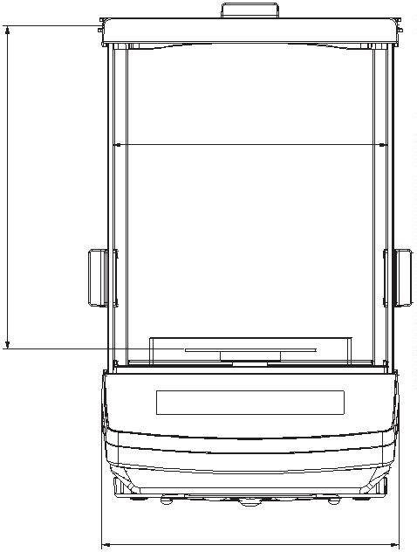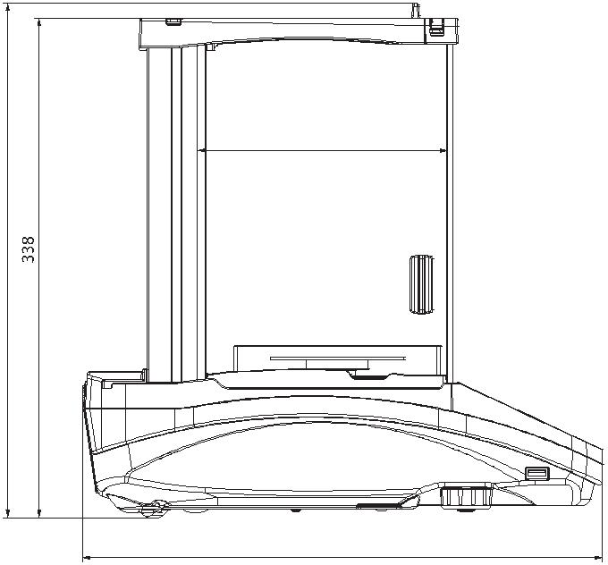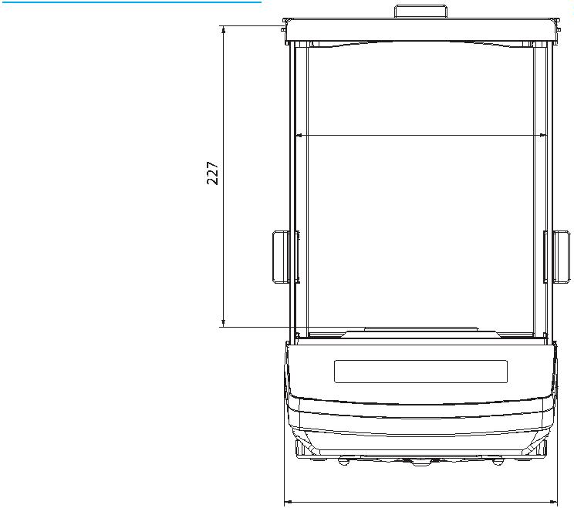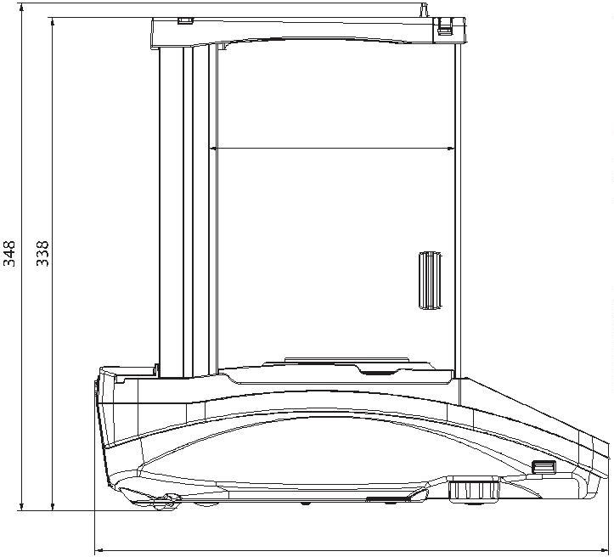

Dedicated Software
R-LAB
RADWAG Connect
•
•
•
collecting measurements
carrying out statistical analysis of measurements
customized graphs and reports
• establishing communication with all balances, scales and weighing
modules using Common Communication Protocol
• communication via local network,
•
•
•
support of basic functions
auto searching for devices
connecting with few devices simultaneously, swapping
between them
clear list of connected platforms
record of measurements in the program,
export of carried out measurements to CSV ﬁle,
work performed using freely selected device with Windows 10
operating system
E2R Weighing Records
•
•
•
•
complete, automated databases synchronization
fully supported processes of labelling and parts counting
record of weighings, weighings archiving
•
•
•
•
basic and advanced (with graphs) reports
Alibi Reader
•
•
•
•
readout of data saved to Alibi memory
export of data saved to Alibi memory
data ﬁltering and reports generating
saving ALIBI database to CSV ﬁle
LabView Driver
operation of RADWAG balances in LabView environment
R Panel
•
RAD KEY
•
Establishing cooperation between a weighing instrument and
•
operator access to all keys and functions that are to be found on an
operation panel
communication via COM1, COM2 or USB,
a computer
R.Barcode
•
•
•
The basic function software is presentation of the data sent by
compatible with: Windows Vista, 7, 8, 8.1, 10, Server 2008R2, 2012,
barcode scanners connected to PC via USB or RS232
2
016.
Radwag Development Studio
•
•
•
presentation of functions (and subfunctions) of communication
protocol (Common Communication Protocol)
possibility of connection with weighing equipment on which each
function is carried out,
library with mass control, contained within the development
environment
•
•
complete documentation of the communication protocol
set of user manuals for diﬀerent solutions addressed for programmers
employed in companies using RADWAG-manufactured
weighing equipment
Page 6 of 6
|
Date: 27.02.2020
www.radwag.com

