Frontier™ 5306
Mini Centrifuge
Powerful and Convenient Mini Centrifuge for Simple and Rapid Life Science
Separation Applications!
The OHAUS Frontier 5306 is a powerful mini centrifuge for simple and rapid liquid separation. The
Frontier 5306 includes an 8-position 1.5/2 mL tube rotor as well as a 4-position 8-strip PCR tube rotor
that can accommodate 32 individual PCR tubes or 0.2mL strip tubes. With the included adapters,
0
.2 mL and 0.5 mL strip tubes can also be accommodated in the 8 position tube rotor, further increasing
its versatility. Frontier 5306 also has a quick release design in which the rotors can be removed and
installed without the use of any tools. This centrifuge provides quiet, safe, and easy operation for your
everyday quick spin-down applications.
Standard Features Include:
•
•
A Quiet Motor and Rubber Base Assure Quiet Operation—With a low voltage power
input, quiet motor, and rubber base that absorbs vibrations, Frontier 5306 keeps operational
noise to a minimum and reduces disruptions in the laboratory.
Multiple Protective Features Ensure the Safety of Centrifuge Operator—Frontier
5306 has many safety attributes, including a low voltage power input, sturdy lid, and two
safety switches which immediately stop the rotors should the lid open while in rotation. An
imbalance sensor also stops the centrifuge if the rotors become imbalanced or sudden shock
occurs, protecting the operator from being injured by the high-speed spinning rotors.
•
Simple One-Step Operation—Frontier 5306 takes simple operation to a new level. Once
the device is powered on, simply place your sample in the centrifuge, close the lid, and it
will begin to rotate. Not even one button press is needed in order to separate your
sample.
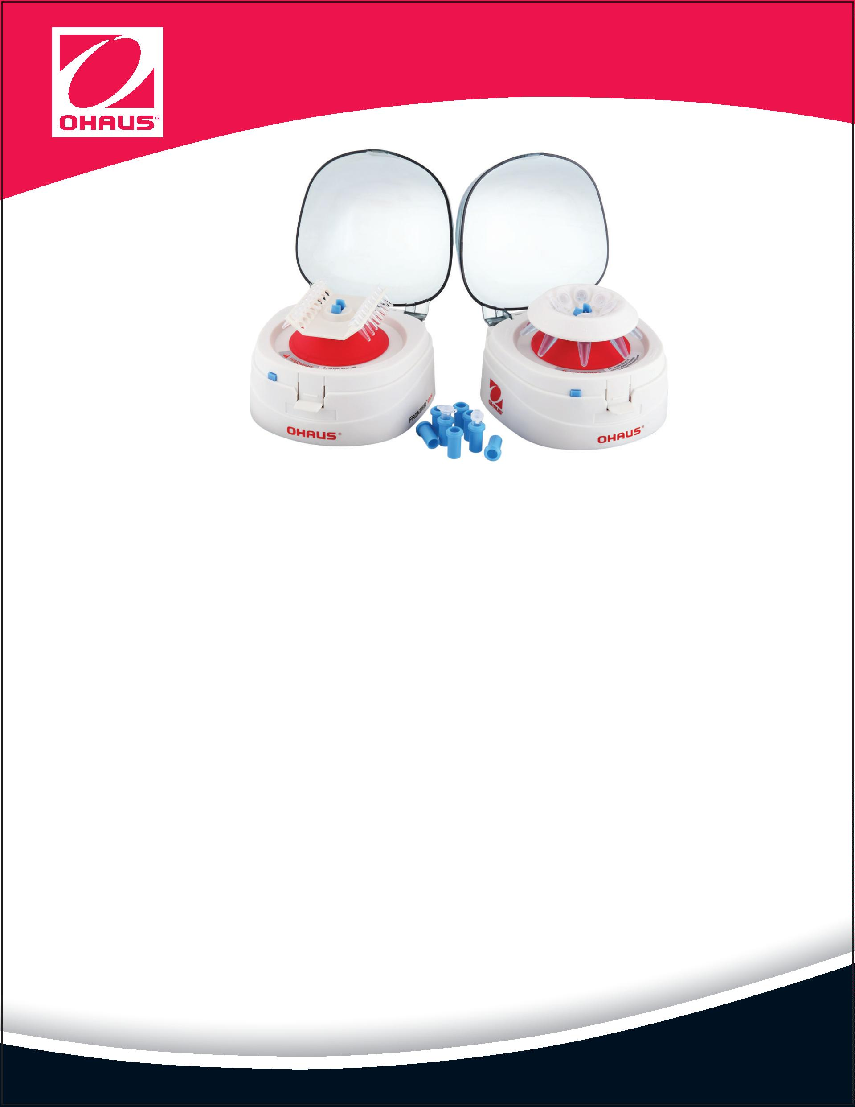

Frontier™ 5306 Mini Centrifuge
Model
FC5306
Rotor
Angle Rotor
Tube Bank Rotor
Rotating Speed Scope
Centrifugal Force
Rotating Direction
6000 rpm
2000 g
Counterclockwise
4
× 0.2 ml-PCR 8-tube bank
Maximum Capacity
8 × 1.5 ml /2 ml
0.2 ml / 0.5ml
or 32 × 0.2 ml single centrifugal tube
—
Adapter
Accelerating Time
Decelerating Time
Drive Mode and Motor
≤2 s
≤3 s
Direct drive, with low noise attributable to rolling bearing
Input: 100-240V ~ 50/60Hz 1.5A
Power Supply
Output: 24V
2.0A
Dimensions (W × D × H)
Net Weight
5.9 × 6.6 × 5.0 in. / 150 × 168 × 128 mm
2.3 lb / 1.1 Kg (including free-load angle rotor)
8.5 × 12.0 × 7.6 in. / 216 × 305 × 194 mm
4.1 lb / 1.9 Kg
Shipping Dimensions (W × D × H)
Shipping Weight
Standard Equipment
Mini Centrifuge , AC adapter, Angle rotor (8 × 1.5 ml / 2 ml), 0.2 ml tube bank rotor for PCR 8-tube bank,
Eight 0.5 ml adapters and eight 0.2 ml adapters, Manual
Approvals
•
•
Product Safety: IEC/EN 61010-1:2010, IEC/EN 61010-2-020:2006
Electromagnetic Compatibility: FCC Part 15 Class B, ICES-001 Class B, EN 61326-1:2013, Class B, Basic
environments, IEC 61326-1:2012, Class B, Basic environments
Rotors
Angle Rotor, 8 x 1.5 ml /2 ml . . . . . . . . . . . . . . . . . . . . . . . . . . 30129559
Angle Rotor, 4 x 0.2 ml PCR8 . . . . . . . . . . . . . . . . . . . . . . . . . . 30129560
Accessories
Adapter for 0.2 ml Tube (8PCS/Package) . . . . . . . . . . . . . . 30129561
Adapter for 0.5 ml Tube (8PCS/Package) . . . . . . . . . . . . . . 30129562
OHAUS CORPORATION
7 Campus Drive
*
Dimensions
Suite 310
Parsippany, NJ 07054 USA
Tel: 800.672.7722
9
73.377.9000
Fax:973.944.7177
www.ohaus.com
With offices throughout
Europe, Asia, and
Latin America
*
ISO 9001:2008
Registered Quality
Management System
5
6
.98 in/152 mm
.61 in/168 mm
5
.91 in/150 mm
