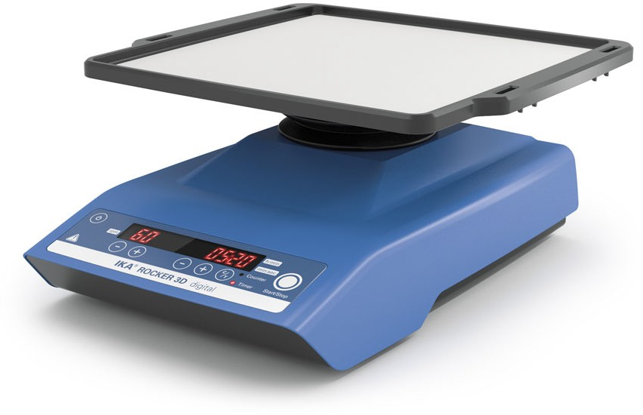

ROCKER 3D digital
/// Data Sheet

Digital shaker with three-dimensional tumbling motion and adjustable speed for smooth mixing tasks. Used for homogeneous mixing in flasks, culture flasks, Petri dishes and tubes. Ideal for e.g. the cultivation of cell cultures, DNA extractions, distributing of cells and staining and destaining of cells. Even with load and voltage fluctuations, shaking speed remains constant. An adjustable angle ensures optimum adaption to the particular experimental conditions.

- Timer: Countdown, adjustable from 1 s to 99h 59min
- Counter: Display of shaking time
- Error Code Display

- Different attachments enable use for a variety of applications
- Usable at 4 to 50 °C in incubators
- Easy operation with touch keypad
- Anti-slip rubber mat included
- Suitable for continuous operation
- Shaking diameter: 0 - 15° (angle)
- Speed range: 5 - 80 rpm

Technical Data
Type of movement tumbling
Permissible shaking weight (incl. attachment) [kg] 2
Permissible ON time [%] 100
Speed min (adjustable) [rpm] 5
Speed range [rpm] 0 - 80
Speed display 7 segment LED
Speed adjustment 1 RPM steps
Timer yes
Timer display 7 segment LED
Time setting min. [s] 1
Time setting max. [min] 5999
Operating mode timer and continuous operation
Tumbling angle adjustable [°] 0 - 15
Shaking platform stackable yes
Altitude (when shaking platform stacked) [mm] 30
Dimensions (W x H x D) [mm] 280 x 185 x 330
Weight [kg] 2.3
Permissible ambient temperature [°C] 4 - 50
Permissible relative humidity [%] 80
Protection class according to DIN EN 60529 IP 21
Voltage [V] 100 - 240
Frequency [Hz] 50/60
Power input [W] 24
DC Voltage [V=] 24
Current consumption [mA] 1000

