Ultrazvuková vodní lázeň
Typ: SONOREX Digitec DT 31 H
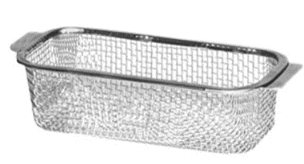
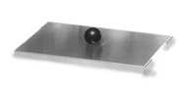
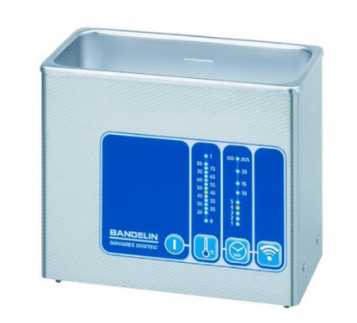
- 4-step operation as "plug and clean"
- Timer with countdown and continuous operation
- Degas - Freely selectable pulse sound - visible on the LED display
- Stainless steel case against spray, degree of protection IP 33
- SweepTec for permanent sound field
- Heating
dimensions:
Internal tank: 190 x 85 x 60 Outside: 205 x 100 x 170 mm LxWxH
Content: 0.9 liters
Filling volume 0.6 liters
Packaging: 320 × 235 × 190 mm, L × W × H
Features: Internal tank: Stainless steel 1.4301
Housing stainless steel 1.4301
against spray
Degree of protection: IP 33
Timer: 1, 2, 3, 4, 5, 10, 15, 30 min and 8
Heating 65 ° C fixed 70 Watt
Technical specifications:
Transducers: 1 PZT broad beam transducers System
HF generator: overload protected, constant power
Modes: Easy half-wave
Operating frequency: 35 kHz, automatic frequency control
Ultrasonic peak output: 240 W *
RF power: 30 watts rms
Current consumption: - 0.2 A
Power supply: 230 V ~ 50/60 Hz
Leakage current: <0.5 mA
Power cable: fixed to the device, 2 meters long
Koš K 08 stainless steel
170 x 65 x 50 mm, mesh size 4 x 4
Víko D 08
stainless steel

