Premium Laboratory Equipment
Reax top
P/N: 541-10000-00
The standard model
The strong 5-mm vibration orbit yields the best results even with high viscosity media or
solids out of solution and quickly gives a smooth and even dispersion
Switch to continuous mode – the unit performs a permanent vibration motion
Switch to automatic mode - the unit will start once a vessel is pressed to the plate and will
stop automatically once this pressure is released
Fast and dependable mixing results due to high vibration frequency rates up to 2,500 rpm
Plate for 20-mm diameter test tubes is included as a standard. Test tube tray for flasks up
to 50-mm diameter is optionally available in the accessory section
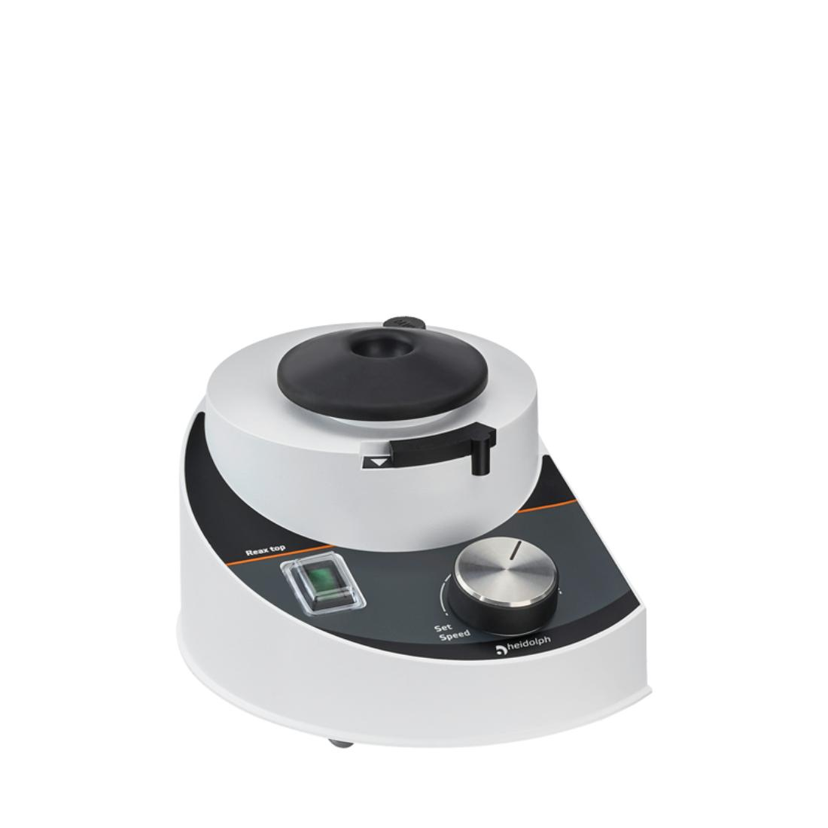

Premium Laboratory Equipment
Reax top - Technical Data
Overheat protection
self-resetting
Permissible ambient conditions
5 - 31 °C at 80 % rel. humidity 32 - 40 °C
decreasing linearly up to max. 50 % rel.
humidity
Weight
2.8 kg
Protection class DIN EN 60529
Timer
IP 22
-
Rotation speed range
Power input
0 - 2,500 rpm
51 W
Dimensions (w/d/h)
Max. Load
134 x 172 x 105 mm
-
Operating Mode
Rotation speed setting
Orbit / Stroke
automatic or continous
analog
5 mm
Platform size
-
Accessories included
Angle
-
-
Motion
vibrating

