Compact laboratory balance KERN 440
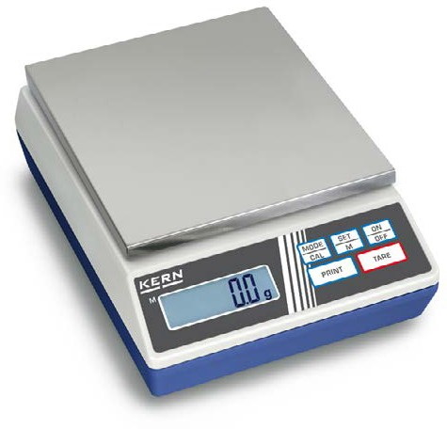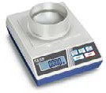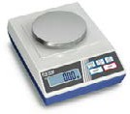

A

B

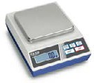
The classic balance in the laboratory

C

Accessories
- Protective working cover, scope of delivery: 5 items, for models with weighing plate size

Features
- Compact size, practical for small spaces
- Percentage determination: makes it possible to store a given weight value (100 %) and to determine deviations from this target value
- Ring-shaped draught shield standard, only for models with weighing plate size A
∅ 81 mm, weighing space ∅×H 90×40 mm
- Protective working cover included with delivery
Technical data
- Backlit LCD display, digit height 15 mm
- Dimensions weighing surface, weighing plate material
A ∅ 81 mm, plastic, with conductive lacquer
B ∅ 105 mm, stainless steel
C W×D 130×130 mm, stainless steel
D W×D 150×170 mm, stainless steel, see larger picture
- Overall dimensions W×D×H 165×230×80 mm (without draught shield)
- Optional battery operation, 9 V block not included in scope of delivery, operating time up to 20 h, AUTO-OFF function to preserve the battery
- Net weight approx. 0,95 kg
- Permissible ambient temperature 5 °C/35 °C
A KERN 440-210-002S05
B KERN 440-330-002S05
C KERN 440-450-002S05
D KERN 440-530-002S05
- Internal rechargable battery pack, operating time up to 20 h without backlight, charging time approx. 10 h, KERN FCB-A01
- Hook for underfloor weighing, KERN 440-A01
- RS-232/Ethernet adapter for connection to an IP-based Ethernet network,
KERN YKI-01
- Individual header data: the free software SHM-01 can be used to print 4 header lines on the printout when using printers 911-013,
YKN-01, YKB-01N, YKE-01 and YKC-01
(in combination with YKI-02)
- Further details, plenty of further accessories and suitable printers see Accessories

BALANCES & TEST SERVICE 2023
PRECISION BALANCES

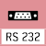
STANDARD OPTION
MULTI

Model Weighing capacity Readability Reproducibility Linearity Weighing plate Option
DAkkS Calibr. Certificate
[Max] [d]
KERN | g | g | g | g | KERN
440-21A | 60 | 0,001 | 0,001 | ± 0,003 | A | 963-127
440-33N | 200 | 0,01 | 0,01 | ± 0,02 | B | 963-127
440-35N | 400 | 0,01 | 0,01 | ± 0,03 | B | 963-127
440-35A | 600 | 0,01 | 0,01 | ± 0,03 | B | 963-127
440-43N | 400 | 0,1 | 0,1 | ± 0,2 | C | 963-127
440-45N | 1000 | 0,1 | 0,1 | ± 0,2 | C | 963-127
440-47N | 2000 | 0,1 | 0,1 | ± 0,2 | C | 963-127
440-49N | 4000 | 0,1 | 0,1 | ± 0,3 | D | 963-127
440-49A | 6000 | 0,1 | 0,1 | ± 0,3 | D | 963-128
440-51N | 4000 | 1 | 1 | ± 2 | D | 963-127
440-53N | 6000 | 1 | 1 | ± 2 | D | 963-128

Internal adjusting:
Quick setting up of the balance‘s accuracy with internal adjusting weight (motordriven)
Adjusting program CAL:
For quick setting up of the balance‘s accuracy. External adjusting weight required
Easy Touch:
Suitable for the connection, data transmission and control through PC or tablet.

Memory:
Balance memory capacity, e.g. for article data, weighing data, tare weights, PLU etc.

Alibi memory:

ALIBI
Secure, electronic archiving of weighing results, complying with the 2014/31/EU standard.
KERN Universal Port (KUP):
allows the connection of external KUP interface adapters, e.g. RS-232, RS-485, SB, Bluetooth, WLAN, Analogue, Ethernet etc. for the exchange of data and control commands, without installation effort
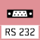
Data interface RS-232:
To connect the balance to a printer, PC or network

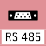
RS-485 data interface:
To connect the balance to a printer, PC or other peripherals. Suitable for data transfer over large distances. Network in bus topology is possible
USB data interface:
To connect the balance to a printer, PC or other peripherals

Bluetooth* data interface:
To transfer data from the balance to a printer, PC or other peripherals

WiFi data interface:
To transfer data from the balance to a printer, PC or other peripherals

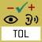
Control outputs (optocoupler, digital I/O):
To connect relays, signal lamps, valves, etc.

Analogue interface:
to connect a suitable peripheral device for analogue processing of the measurements

Interface for second balance: For direct connection of a second balance
Network interface:
For connecting the scale to an Ethernet network

KERN Communication Protocol (KCP):
It is a standardized interface command
set for KERN balances and other instruments, which allows retrieving and controlling all relevant parameters and functions of the device. KERN devices
featuring KCP are thus easily integrated with computers, industrial controllers and other digital systems
GLP/ISO log:
The balance displays weight, date and time, independent of a printer connection

GLP/ISO log:
With weight, date and time. Only with KERN printers.

Piece counting:
Reference quantities selectable. Display can be switched from piece to weight

Recipe level A:
The weights of the recipe ingredients can be added together and the total weight of the recipe can be printed out
Recipe level B:
Internal memory for complete recipes with name and target value of the recipe ingredients. User guidance through display
Totalising level A:
The weights of similar items can be added together and the total can be printed out
Percentage determination: Determining the deviation in % from the target value (100 %)

Weighing units:
Can be switched to e.g. nonmetric units. See balance model. Please refer to KERN‘s website for more details

Weighing with tolerance range: (Checkweighing) Upper and lower limiting can be programmed individually, e.g.
for sorting and dosing. The process is supported by an audible or visual signal, see the relevant model

Hold function:
(Animal weighing program) When the weighing conditions are unstable, a stable weight is calculated as an average value

Protection against dust and water splashes IPxx:
The type of protection is shown in the
Suspended weighing:
Load support with hook on the underside of the balance

Battery operation:
Ready for battery operation. The battery type is specified for each device

Rechargeable battery pack:
Rechargeable set

Universal plug-in power supply:

MULTI
with universal input and optional input socket adapters for
- EU, CH, GB
- EU, CH, GB, USA
- EU, CH, GB, USA, AUS
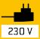
Plug-in power supply:
230V/50Hz in standard version for EU, CH. On request GB, USA or AUS version available

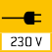
Integrated power supply unit: Integrated in balance. 230V/50Hz standard EU. More standards e.g. GB, USA or AUS on request

Weighing principle: Strain gauges Electrical resistor on an elastic deforming body

Weighing principle: Tuning fork
A resonating body is electromagnetically excited, causing it to oscillate

Weighing principle: Electromagnetic force compensation
Coil inside a permanent magnet. For the most accurate weighings
Weighing principle: Single cell technology:
Advanced version of the force compensation principle with the highest level of precision
Verification possible:
The time required for verification is specified in the pictogram

DAkkS calibration possible (DKD): The time required for DAkkS calibration is shown in days in the pictogram

Factory calibration (ISO):
The time required for Factory calibration is shown in days in the pictogram

Package shipment:
The time required for internal shipping prepa- rations is shown in days in the pictogram

pictogram. Pallet shipment:
BALANCES & TEST SERVICE 2023
KERN PICTOGRAMS
The time required for internal shipping prepa- rations is shown in days in the pictogram
*The Bluetooth® word mark and logos are registered trademarks owned by Bluetooth SIG, Inc. and any use of such marks by KERN & SOHN GmbH is under license. Other trademarks and trade names are those of their respective owners.

