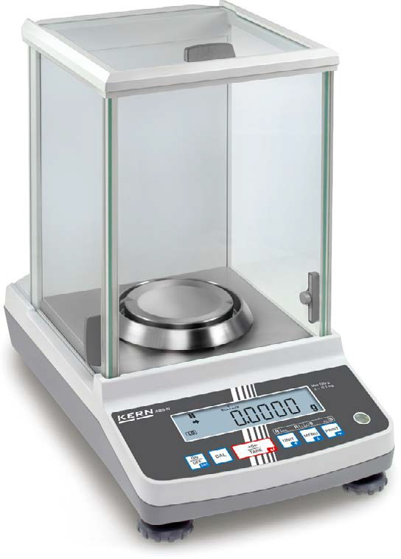
Analytical balances KERN ABS-N · ABJ-NM · ACS · ACJ

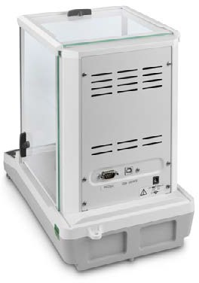
KERN ACS/ACJ with standard data interface RS-232 and USB data interface

The bestseller in analytical balances, with high-quality single-cell weighing system, also with EC type approval [M]

Features
- KERN ABJ-NM, ACJ: Automatic internal adjustment in the case of a change in temperature ≥ 2 °C or timecontrolled every 4 h, guarantees high degree of accuracy and makes the balance independent of its location of use
- KERN ABS-N, ACS: Adjusting program CAL for quick setting of the balance accuracy using an external test weight at an additional price, see test weights
- Dosage aid: High stability mode and other filter settings can be selected
- Simple recipe weighing and documenting with a combined tare/print function.
In addition, the ingredients for the recipe are numbered automatically and printed out with their corresponding number and nominal weight
- Automatic data output to the PC/printer each time the balance is steady
- Identification number: 4 digits, printed on calibration protocol freely programmable
- Protective working cover included with delivery

Analytical balances KERN ABS-N · ABJ-NM · ACS · ACJ
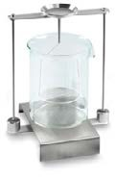
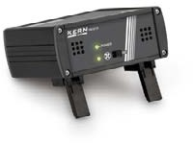
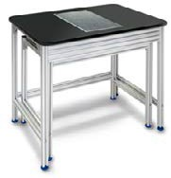

1

2

3

Technical data
- Large LCD display, digit height 14 mm
- Dimensions weighing surface, stainless steel, ∅ 91 mm
- Weighing space W×D×H 174×162×227 mm
- Overall dimensions (incl. draught shield) W×D×H 213×333×338 mm
- Net weight approx. 6 kg
- Permissible ambient temperature 10 °C/30 °C
Accessories
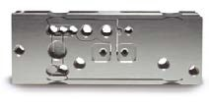
- Protective working cover, scope of delivery 5 items, KERN ACS-A02S05
Single-cell advanced technology:
- Fully automatic manufactured weighing cell from one piece of material
- Stable temperature behaviour
- Short stabilisation time: steady weight values within approx. 3 s under laboratory conditions
- Shock proof construction
- High corner load performance
- 1 Set for density determination of liquids and solids with density ≤/≥ 1, the density is indicated directly on the display,
KERN YDB-03
- 2 Ioniser to neutralise electrostatic charge, KERN YBI-01A
- KERN ABS-N/ABJ-NM: Data interface RS-232, interface cable included, approx. 1,5 m, KERN ACS-A01
- 3 Weighing table to absorb vibrations and oscillations, which would otherwise distort the weighing result, KERN YPS-03
- Minimum weight of sample, smallest weight to be weighed, depending on the required process accuracy, only in combination with a DAkkS calibration certificate,
KERN 969-103
- Equipment qualification: compliant qualifi- cation concept which includes the following validation services, Installation Qualification (IQ), Operating Qualification (OQ)
see page 216
· Further details, plenty of further accessories and suitable printers see Accessories
, for details

STANDARD OPTION FACTORY
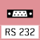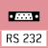
MULTI

ABJ-NM/ ABS-N/
ACS/ACJ ACS/ACJ ABS-N/
ACJ

ACJ
ACS
ABJ-NM

Model Weighing
KERN | capacity [Max]  g | [d] mg | value [e] mg | [Min] mg | bility  mg | mg | Verification  KERN | DAkkS Calibr. Certificate  KERN
ABS 80-4N | 82 | 0,1 | - - |  | 0,2 | ± 0,3 | - | 963-101
ABS 120-4N | 120 | 0,1 | - - |  | 0,2 | ± 0,3 | - | 963-101
ABS 220-4N | 220 | 0,1 | - - |  | 0,2 | ± 0,3 | - | 963-101
ABS 320-4N | 320 | 0,1 | - - |  | 0,2 | ± 0,3 | - | 963-101
ACS 80-4 | 82 | 0,1 | - - |  | 0,2 | ± 0,3 | - | 963-101
ACS 100-4 | 120 | 0,1 | - - |  | 0,2 | ± 0,3 | - | 963-101
ACS 200-4 | 220 | 0,1 | - - |  | 0,2 | ± 0,3 | - | 963-101
ACS 300-4 | 320 | 0,1 | - - |  | 0,2 | ± 0,3 | - | 963-101
ABJ 80-4NM | 82 | 0,1 | - - |  | 0,2 | ± 0,3 | - | 963-101
ABJ 120-4NM | 120 | 0,1 | - - |  | 0,2 | ± 0,3 | - | 963-101
ABJ 220-4NM | 220 | 0,1 | - - |  | 0,2 | ± 0,3 | - | 963-101
ABJ 320-4NM | 320 | 0,1 | - - |  | 0,2 | ± 0,3 | - | 963-101
Note: For applications that require verification, please order verification at the same time, initial verification at a later date is not possible.
Verification at the factory, we need to know the full address of the location of use.
ACJ 80-4M | 82 | 0,1 | 1 | 10 | 0,2 | ± 0,3 | 965-201 | 963-101
ACJ 100-4M | 120 | 0,1 | 1 | 10 | 0,2 | ± 0,3 | 965-201 | 963-101
ACJ 200-4M | 220 | 0,1 | 1 | 10 | 0,2 | ± 0,3 | 965-201 | 963-101
ACJ 300-4M | 320 | 0,1 | 1 | 10 | 0,2 | ± 0,3 | 965-201 | 963-101

Readability Verification
Minimal load Reproduci-
Linearity Option

Internal adjusting:
Quick setting up of the balance‘s accuracy with internal adjusting weight (motordriven)
Adjusting program CAL:
For quick setting up of the balance‘s accuracy. External adjusting weight required
Easy Touch:
Suitable for the connection, data transmission and control through PC or tablet.

Memory:
Balance memory capacity, e.g. for article data, weighing data, tare weights, PLU etc.

Alibi memory:

ALIBI
Secure, electronic archiving of weighing results, complying with the 2014/31/EU standard.
KERN Universal Port (KUP):
allows the connection of external KUP interface adapters, e.g. RS-232, RS-485, SB, Bluetooth, WLAN, Analogue, Ethernet etc. for the exchange of data and control commands, without installation effort
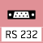
Data interface RS-232:
To connect the balance to a printer, PC or network

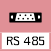
RS-485 data interface:
To connect the balance to a printer, PC or other peripherals. Suitable for data transfer over large distances. Network in bus topology is possible
USB data interface:
To connect the balance to a printer, PC or other peripherals

Bluetooth* data interface:
To transfer data from the balance to a printer, PC or other peripherals

WiFi data interface:
To transfer data from the balance to a printer, PC or other peripherals

Control outputs (optocoupler, digital I/O):
To connect relays, signal lamps, valves, etc.

Analogue interface:
to connect a suitable peripheral device for analogue processing of the measurements

Interface for second balance: For direct connection of a second balance
Network interface:
For connecting the scale to an Ethernet network

KERN Communication Protocol (KCP):
It is a standardized interface command
set for KERN balances and other instruments, which allows retrieving and controlling all relevant parameters and functions of the device. KERN devices
featuring KCP are thus easily integrated with computers, industrial controllers and other digital systems
GLP/ISO log:
The balance displays weight, date and time, independent of a printer connection

GLP/ISO log:
With weight, date and time. Only with KERN printers.

Piece counting:
Reference quantities selectable. Display can be switched from piece to weight

Recipe level A:
The weights of the recipe ingredients can be added together and the total weight of the recipe can be printed out
Recipe level B:
Internal memory for complete recipes with name and target value of the recipe ingredients. User guidance through display
Totalising level A:
The weights of similar items can be added together and the total can be printed out
Percentage determination: Determining the deviation in % from the target value (100 %)

Weighing units:
Can be switched to e.g. nonmetric units. See balance model. Please refer to KERN‘s website for more details

Weighing with tolerance range: (Checkweighing) Upper and lower limiting can be programmed individually, e.g.
for sorting and dosing. The process is supported by an audible or visual signal, see the relevant model

Hold function:
(Animal weighing program) When the weighing conditions are unstable, a stable weight is calculated as an average value

Protection against dust and water splashes IPxx:
The type of protection is shown in the
Suspended weighing:
Load support with hook on the underside of the balance

Battery operation:
Ready for battery operation. The battery type is specified for each device

Rechargeable battery pack:
Rechargeable set

Universal plug-in power supply:

MULTI
with universal input and optional input socket adapters for
- EU, CH, GB
- EU, CH, GB, USA
- EU, CH, GB, USA, AUS
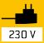
Plug-in power supply:
230V/50Hz in standard version for EU, CH. On request GB, USA or AUS version available

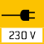
Integrated power supply unit: Integrated in balance. 230V/50Hz standard EU. More standards e.g. GB, USA or AUS on request

Weighing principle: Strain gauges Electrical resistor on an elastic deforming body

Weighing principle: Tuning fork
A resonating body is electromagnetically excited, causing it to oscillate

Weighing principle: Electromagnetic force compensation
Coil inside a permanent magnet. For the most accurate weighings
Weighing principle: Single cell technology:
Advanced version of the force compensation principle with the highest level of precision
Verification possible:
The time required for verification is specified in the pictogram

DAkkS calibration possible (DKD): The time required for DAkkS calibration is shown in days in the pictogram

Factory calibration (ISO):
The time required for Factory calibration is shown in days in the pictogram

Package shipment:
The time required for internal shipping prepa- rations is shown in days in the pictogram

pictogram. Pallet shipment:
BALANCES & TEST SERVICE 2023
KERN PICTOGRAMS
The time required for internal shipping prepa- rations is shown in days in the pictogram
*The Bluetooth® word mark and logos are registered trademarks owned by Bluetooth SIG, Inc. and any use of such marks by KERN & SOHN GmbH is under license. Other trademarks and trade names are those of their respective owners.

