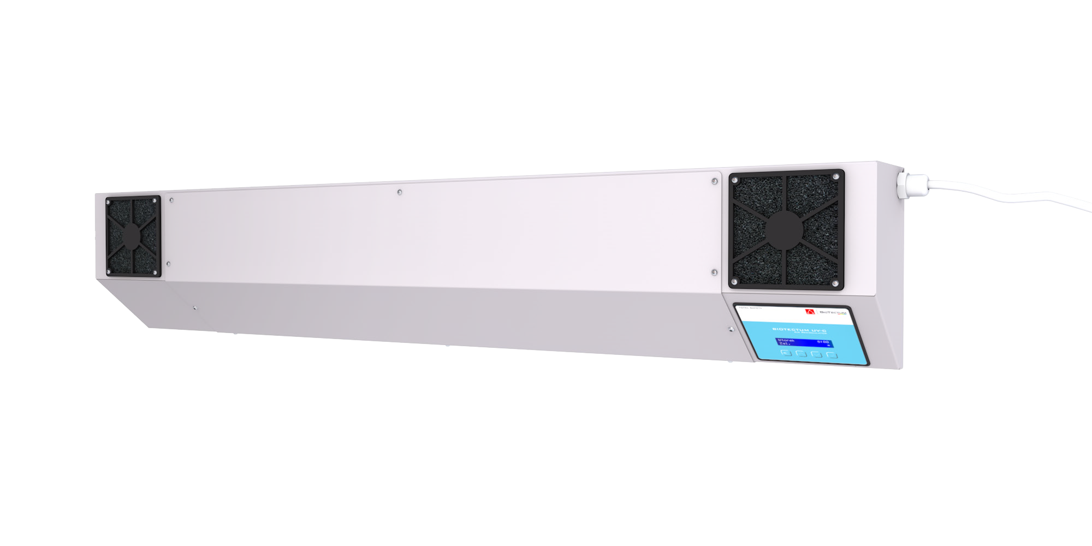BIOTECTUM UV-C
ANTI-BACTERIAL
AIR FLOW
LAMP

FEATURES & BENEFITS

UV-C light. Is it our ally in the fight against coronavirus?

In the statement of the Chief Sanitary Inspector of Poland of March 4, 2020 we read that:

„The virus is shielded by a thin lipid layer, which is destroyed by detergents, soap, disinfectants, UV rays.”
Forced air flow through the anti-bacterial cham- ber allows the device to be used safely indoors in the presence of people. The device housing is covered with a bacteriostatic IGP-DURA® coating with silver ions, color RAL 7047. IGP-DURA® co- atings show high chemical resistance to most known disinfectants.

The built-in controller with the programmer is designed to control the UV lamp - turn it on
and off according to the set program.

There are 4 possible modes available:
▶ work based on the hourly schedule on working days (Monday - Friday)
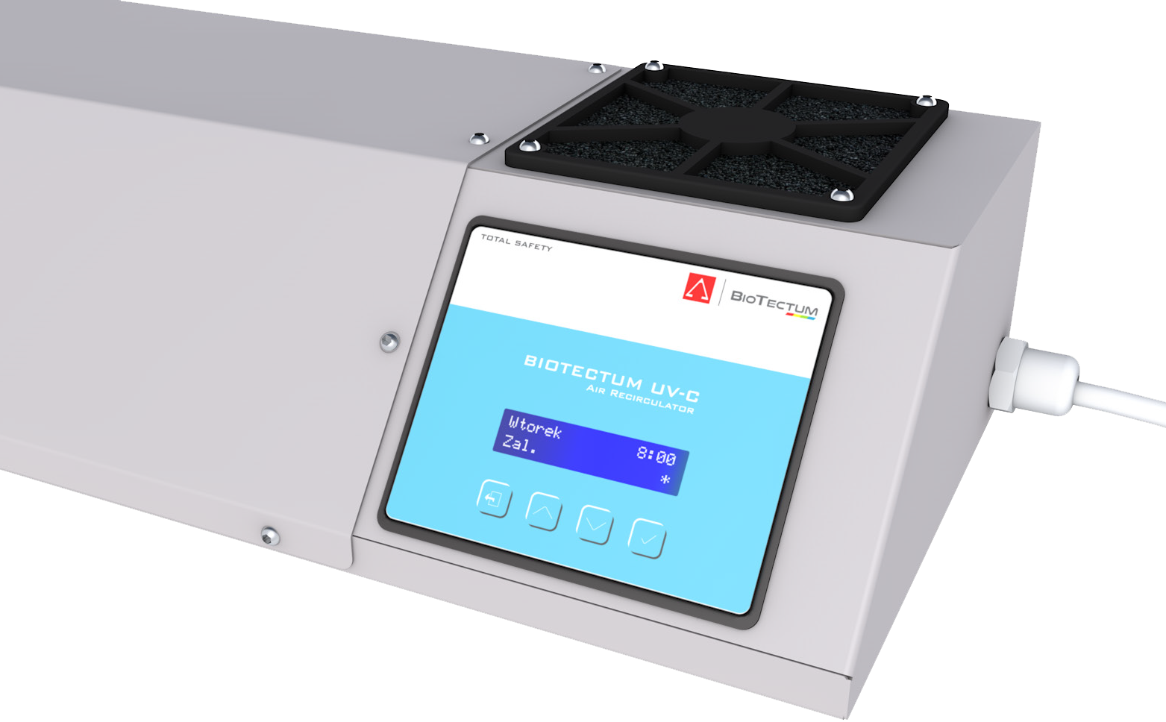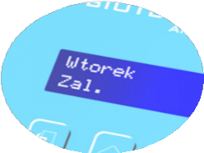▶ work based on the hourly schedule every day;

Readable display for the current day of the week, current time, mode of operation and status of the UV-radiator.
▶ continuous on,
▶ work based on timer (in timer mode - after a single countdown of the user-set time the lamp switches off).

The schedule means two freely user-configurable time intervals when the lamp is to be switched on during the day (e.g. lamp switched on from 4:00 AM to 10:00 AM and 12:00 AM to 6:00 PM)

The controller counts the time of operation of the UV radiator and after exceeding the time when its efficiency drops, it signals this fact in order to replace the UV radiator with a new one. The message „UV radiator working time expired” appears and a 2 sec beep is generated when it appears. The acoustic signal is repeated every 30 minutes.

1/2

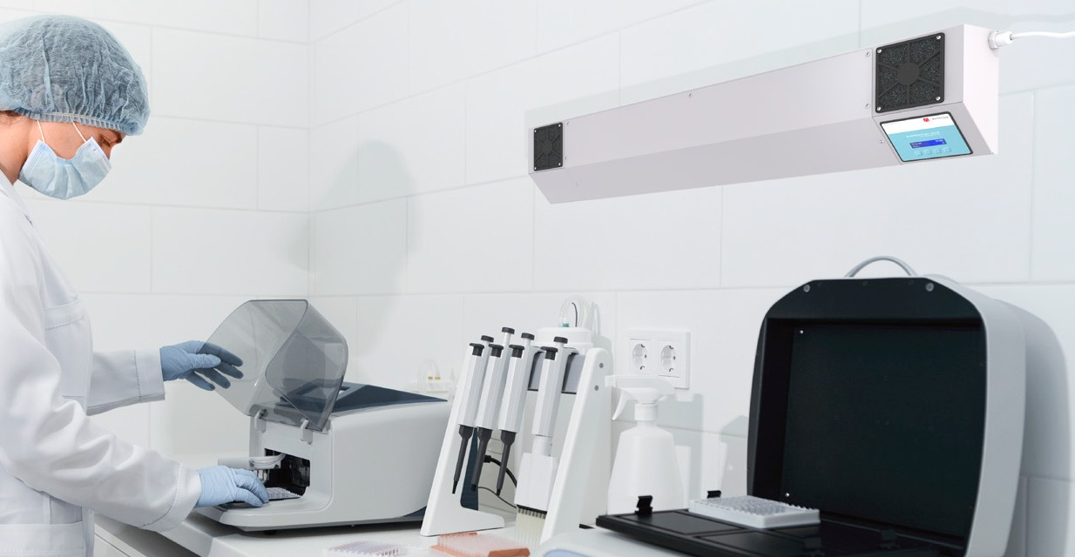
BIOTECTUM UV-C
ANTI-BACTERIAL
AIR FLOW
LAMP

BASIC TECHNICAL DATA OF BIOTECTUM UV-C

 | BioTectum UV-C 50 | BioTectum UV-C 100
Power supply [V/Hz] | 230/50 | 230/50
Power [VA] | 75 | 115
Element emitting UV-C radiation [W] | 2 x TUV 30 | 2 x TUV 55
Fan performance [m3/h] | 135 | 135
Disinfected cubature [m3] | 25-50 | 45-100
Lamp operating surface [m2] | 10-20 | 20-40
Radiator life [h] | 9000 | 9000
Enclosure type | IP 20 | IP 20
Installation | wall / ceiling or on a mobile tripod | wall / ceiling or on a mobile tripod
Dimensions LxHxD [mm] | 1180x210x114 | 1180x210x114
Catalog number | 955-0600-0050 | 955-0600-0100

2/2

