**Technical Specifiations**

_______________________________________________________________

|  |  |  |
| --- | --- | --- |
| SpO 2 |  | Display |
| Technique: Dual-wavelength LED |  | 3,5“ color TFT display with rotation |
| Display range: 0%-100% |  |  |
| Measuring accuracy: ±3%(range from 70% to 100%) |  | Power Supply |
|  |  | 2000mAh lithium battery |
| Pulse Rate |  |  |
| Measuring range: 30-250bpm |  | Charging |
| Measuring accuracy: ±2bpm or ±2% |  | Charging stand or USB cable |
|  |  |  |
| Temperature(option) |  | Dimension |
| Measuring range: 32C – 43C |  | 158mm x 73mm x 25mm |
| Measurnig accuracy: ±0.2C |  |  |
| Measuring time: 5 seconds |  | Net Weight |
| Measuring probe: Infrared ear probe |  | 230g |
|  |  |  |
| Perfusion Index |  | Data Upload |
| Pl display range: 0.2%-20% |  | USB cable or wireless |
|  |  |  |
| Measuring Mode |  | Operating Environment |
| Continuous or Spot check |  | Operating Temperature: 5C–40C |
|  |  | Operating Humidity: 15%-93% |
| Data Storage |  |  |
| Up to 500 hours |  |  |

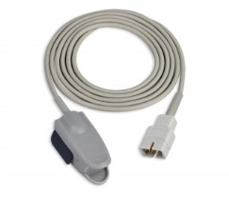 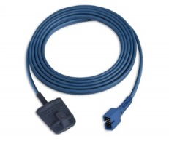 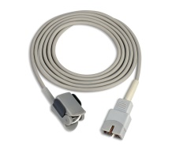

Adult clip sensor Adult soft sensor Pediatric clip sensor

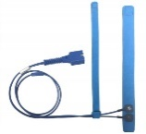 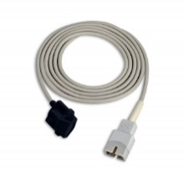

Pediatric soft sensor Neonate wrap sensor Infrared ear thermometer



CE 0123 FDA 510(k)

**Shenzhen Creative Industry Co.,Ltd**

2/F, Block 3, Nanyou Tian'an Industry Town,518054 Shenzhen,GD, P.R.China

Tel: +86 755 26433514 Fax: : +86 755 26430930

[www.creative-sz.com](http://www.creative-sz.com) info@creative-sz.com