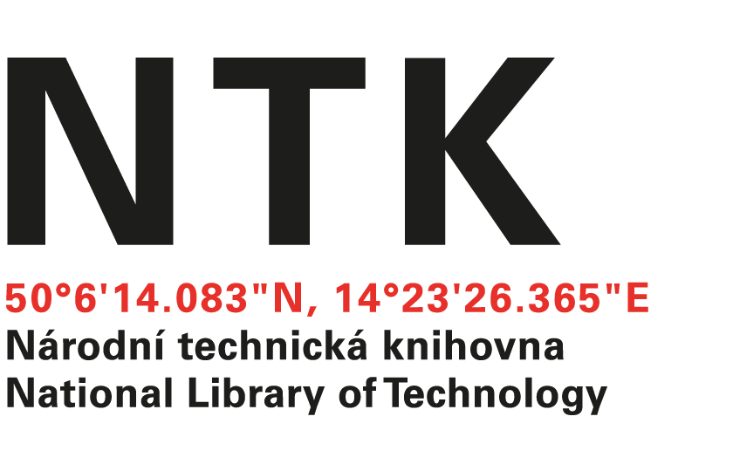
Order

No. 147/EIZ/2022

Customer: | Supplier:
National Library of Technology | Encyclopaedia Britannica (UK) Ltd.
Technická 6/2710 | 2nd Floor, Unity Wharf
160 80 Prague 6 - Dejvice | Mill Street
Czech Republic | London  SE1 2BH  UK
ID: 61387142
VAT: CZ61387142

Dear Deborah,

based on your renewal quote from 7.12.2022 we order:
Britannica Academic 1.1.2023 - 31.12.2023 - £3,195
ImageQuest 1.1.2023 - 31.12.2023 - £1,859

Total : £5,054

Kind regards

xxxxxxxxxxxxx
electronic resources librarian

Order accepted by:
Date of issue: 15. 12. 2022
Issued:
xxxxxxxxxxxxxxxx
email: eiz@techlib.cz

