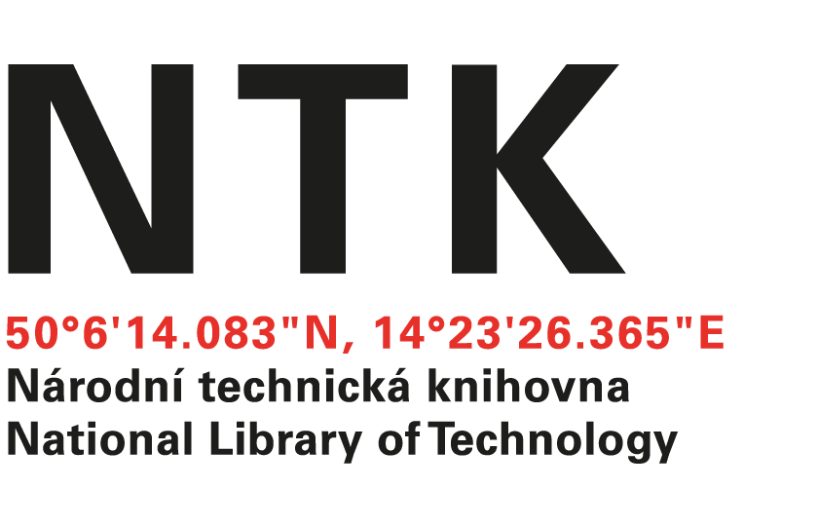
Order

No. 123/EIZ/2022

Customer: | Supplier:
National Library of Technology | McGraw-Hill  Ingrid Chavez
Technická 6/2710 | 104 Windsor Center Drive, Suite 400
160 80 Prague 6 - Dejvice | East Windsor
Czech Republic | NY 08520
ID: 61387142
VAT: CZ61387142

Dear Ingrid,

based on your offer from 31. 10. 2022 we order unlimited access to AccessScience for the price $ 15.016.00. Term: from December 31, 2022 to December 30, 2023.

Kind regards

xxxxxxxxxxxxxxx
electronic resources librarian

Order accepted by:
Date of issue: 15. 11. 2022
Issued:
xxxxxxxxxxxxx
email: eiz@techlib.cz
tel.: +420 232 002 409

