Supplier:
Department of Electronics and Information Technology University of West Bohemia in Pilsen Univerzitní 8
306 14 Pilsen
Czech Republic
Customer:
Institute of Experimental and Applied Physics Czech Technical University in Prague Husova 240/5
110 00 Prague 1

Czech Republic

ID: 49777513, Tax number: CZ49777513

Pilsen, 8th November 2022
Quotation: Katherine readout for Timepix3 Generation 2,
Katherine readout for Timepix3 (Telescope edition)
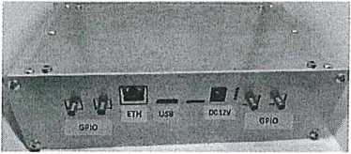
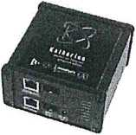

Subject of delivery:
- Katherine readout system for Timepix3 Generation2. The device for control and reading Timepix3 readout chips (up to 8 chips). The power supply is included in the delivery.
- Katherine readout for Timepix3 - telescope edition - supporting connection of two sensors with synchronization ensuring uniform timing. The item contains the readout device and the 5V power supply unit.
Subject | unit price | pcs | final price
Katherine readout for Timepix3 Generation 2 | 68 000,- Kč | 1 | 68 000,- Kč
Katherine readout for Timepix3 (Telescope edition) | 44 000,- Kč | 1 | 44 000,- Kč
Total |  |  | 112 OOO,- Kč
Delivery anf financial conditions:
The price does not include VAT. Timepix3 detectors are not included.
Shipping costs are not included.
Expected delivery time is 120 days from receipt of the order.
This quotation is valid until 30^{,h} November 2022. Payment: within 30 days from invoice receiving date.

