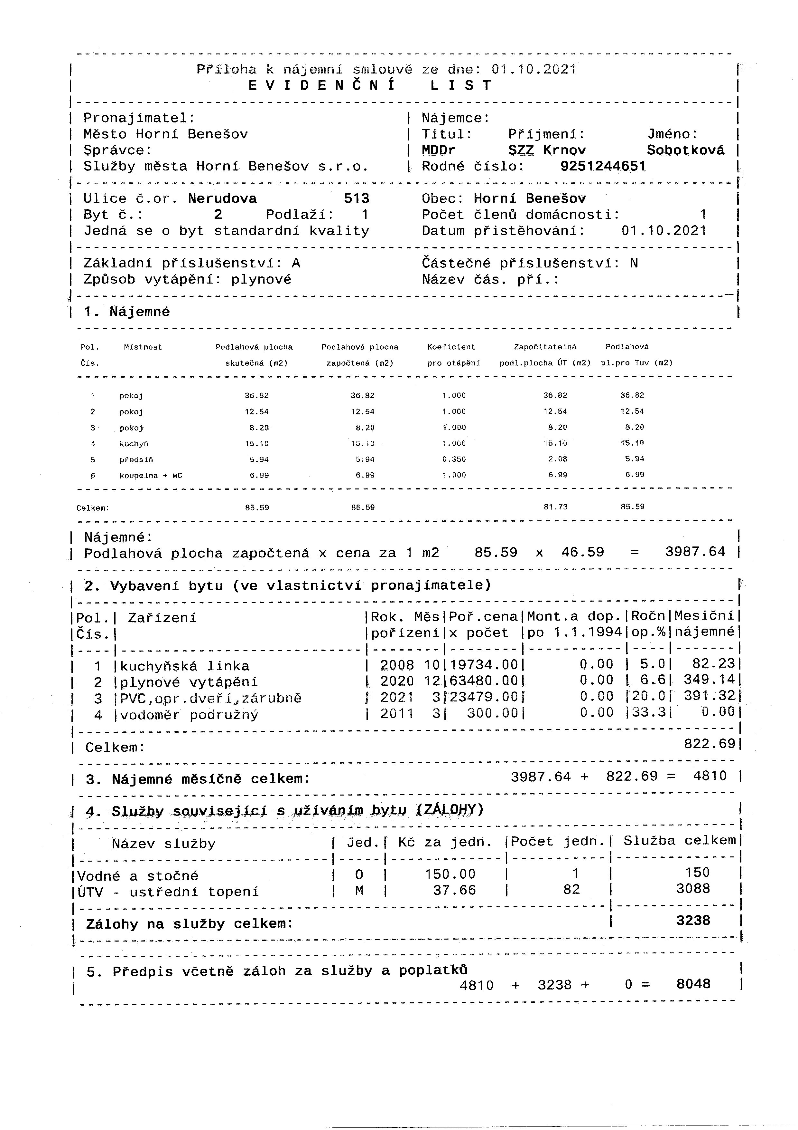

PDF-XChange Editor DEMO

PDF-XChange Editor DEMO

PDF-XChange Editor DEMO

PDF-XChange Editor DEMO

PDF-XChange Editor DEMO

PDF-XChange Editor DEMO

PDF-XChange Editor DEMO

PDF-XChange Editor DEMO

PDF-XChange Editor DEMO

PDF-XChange Editor DEMO

PDF-XChange Editor DEMO

PDF-XChange Editor DEMO



PDF-XChange Editor DEMO

PDF-XChange Editor DEMO

PDF-XChange Editor DEMO

PDF-XChange Editor DEMO

PDF-XChange Editor DEMO

PDF-XChange Editor DEMO

PDF-XChange Editor DEMO

PDF-XChange Editor DEMO

PDF-XChange Editor DEMO

PDF-XChange Editor DEMO

PDF-XChange Editor DEMO

PDF-XChange Editor DEMO



PDF-XChange Editor DEMO

PDF-XChange Editor DEMO

PDF-XChange Editor DEMO

PDF-XChange Editor DEMO

PDF-XChange Editor DEMO

PDF-XChange Editor DEMO

PDF-XChange Editor DEMO

PDF-XChange Editor DEMO

PDF-XChange Editor DEMO

PDF-XChange Editor DEMO

PDF-XChange Editor DEMO

PDF-XChange Editor DEMO



PDF-XChange Editor DEMO

PDF-XChange Editor DEMO

PDF-XChange Editor DEMO

PDF-XChange Editor DEMO

PDF-XChange Editor DEMO

PDF-XChange Editor DEMO

PDF-XChange Editor DEMO

PDF-XChange Editor DEMO

PDF-XChange Editor DEMO

PDF-XChange Editor DEMO

PDF-XChange Editor DEMO

PDF-XChange Editor DEMO