**Hei-VAP Core**

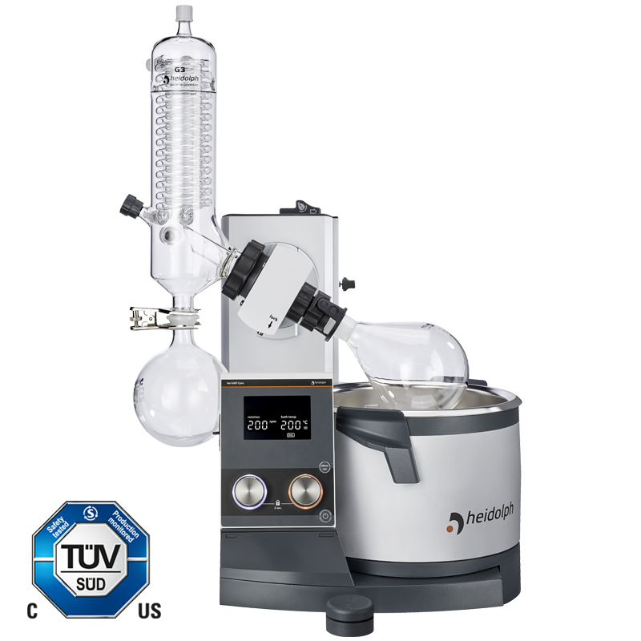

An operating concept that is focused on the essentials: clear and with access to the basic parameters rotation speed and heating bath temperature at any time.

Clear digital display showing actual and set values

Two separate knobs with dynamic control for setting the rotation speed and heating bath temperature: fast turning for large jumps, slow turning for precise setting of the set values Accidental changing of the values can be prevented by the lock function

Intuitive LED ring light system makes activated functions clearly visible even from a distance

Easy adjustment of the immersion depth up to 155 mm and the inclination angle from 20° to 80°

Standby function and residual heat warning at heating bath temperatures above 50 °C Available as hand or motor lift models

The standby button stops all functions and, when using a motor lift model, lifts the evaporating flask from the heating bath.

**Hei-VAP Core - Technical Data**

Rotation speed indicator 3.5" LCD Display

Permissible ambient conditions 5 – 31 °C at 80 % rel. humidity

32 – 40 °C decreasing lineary up to max 50% rel. humidity

Protection class DIN EN 60529 IP 20

Lift Hand lift or Motor lift

Height adjustment speed

Hand lift models: manual Motor lift models: 25 mm/s

Height adjustment 155 mm

Drive

brushless DC motor with electronic speed control

Heating capacity 1,300 W

Temp. range heating bath 20 – 210 °C

Temperature accuracy bath ±1K

Overheat protection bath

cut-off at 5 °C over set temperature via separate PT 1000

Bath temperature setting 3.5" LCD Display

Heating bath temperature control electronic / digital

Secondary overtemp. cut off 250 °C

Material heating bath stainless steel AISI 316L

Diameter heating bath 255 mm

Volume heating bath 4.5 l

Display vapor temperature -

Required accessories for display vapor temperature

-

Integrated vacuum controller -

Timer -

Programmable ramps -

Supply Power 1,400 W

Weight without glassware assembly 15 kg

Dimensions with glassware set G3 (w/d/h)

HL: 739 x 487 x 845 mm

ML: 739 x 432 x 845 mm

Dimensions with glassware set G3 XL (w/d/h) HL: 739 x 487 x 920 mm

ML: 739 x 432 x 920 mm

Condensing surface 1,400 cm²

Condensing surface XL condenser 2,200 cm²

Max. size evaporating flask 5 l

Rotation speed range 10 - 280 rpm

Integrated Hei-CHILL controller -

Vacuum program Dynamic AUTOaccurate - requires AUTOaccurate sensor

Solvent libary -