Product specification

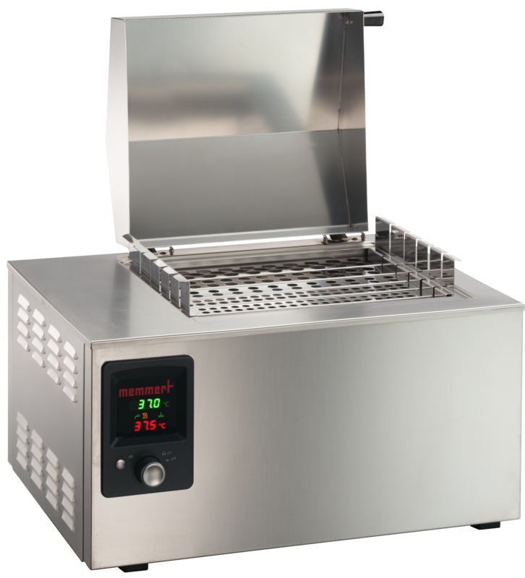
Waterbath

WNB 22

The combination of corrosion-resistant stainless steel, precise electronics and multiple temperature protection guarantees the highest level of safety in the laboratory.

On this page, you can find all the essential technical data on the Memmert water bath. Our customer relations team will be pleased to help if you want further information. If you should require a customised special solution, please contact our technical specialists at sales@memmert.com.
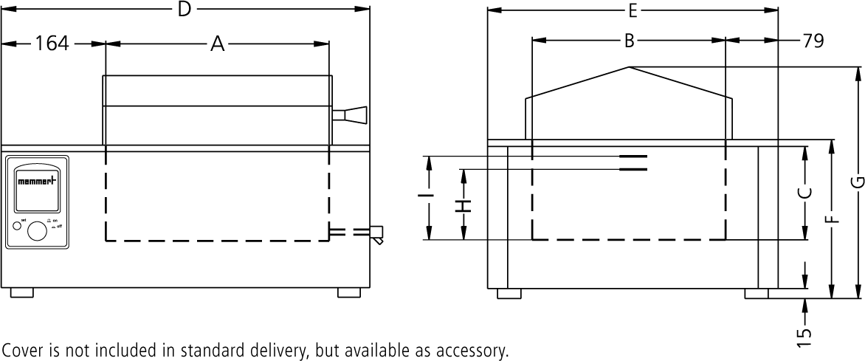

Temperature
Setting temperature range +10 to +95 °C and boiling stage

Working temperature range in °C
min. 5 above ambient up to +95 °C with additional boiling mode

Control of standard components
Temperature sensor 1 Pt100 sensor class A in 4-wire-circuit
Timer integrated digital timer from 1 min. to 99,59 hours for:ON continuous operationWAIT (delayed on for continuous andlimited timed operation)HOLD

Control technology
Controller digital display of set and actual temperature and of (remaining) programme time

Safety
Temperature control mechanical temperature limiter TB protectionclass 1 switching the heating off at approx. 30°Cabove max. temperature of the bath
Temperature control in case of overtemperature due to failure,the heating is switched off at approx. 10°Cabove the set temperature (fixed value)

Autodiagnostic system microprocessor PID-temperature controllerwith integrated autodiagnostic system withfault indicator

Heating concept
Heating Baths corrosion-proof large-area heating onthree sides

Stainless steel interior

Dimensions W x H x D in mm

w(A) x h(C) x d(B): 350 x 220 x 290 mm

Interior easy-to-clean interior, made of stainlesssteel, reinforced by deep drawn ribbing,material no. 1.4301 (ASTM 304), laser-welded
Volume 22 l

Liquid level min. 177 mm
Liquid level max. 200 mm

Textured stainless steel casing
Dimensions w(D) x h(G) x d(E): 578 x 405 x 436 mm

Electrical data
Voltage 230 V, 50/60 Hz
Electrical load approx. 2000 W (during heating)

Ambient conditions
Installation The vent openings in the left and back side must remain unobstructed. Minimum wall spacing on all sides is 80 mm. The minimum spacing from the top of the bath to the next ceiling is 750 mm.
Ambient temperature +5 °C to +40 °C

Humidity rh max. 80 %, non-condensing
Overvoltage category II
Pollution degree 2

Packing/shipping data
Transport information The appliances must be transported upright
Customs tariff number 8419 8998

Country of origin Federal Republic of Germany
WEEE-Reg.-No. DE 66812464

Dimensions approx incl. carton
w x h x d: 670 x 530 x 460 mm

Net weight approx. 16 kg
Gross weight carton approx. 23 kg

Standard units are safety-approved and bear the test marks

