Product specification

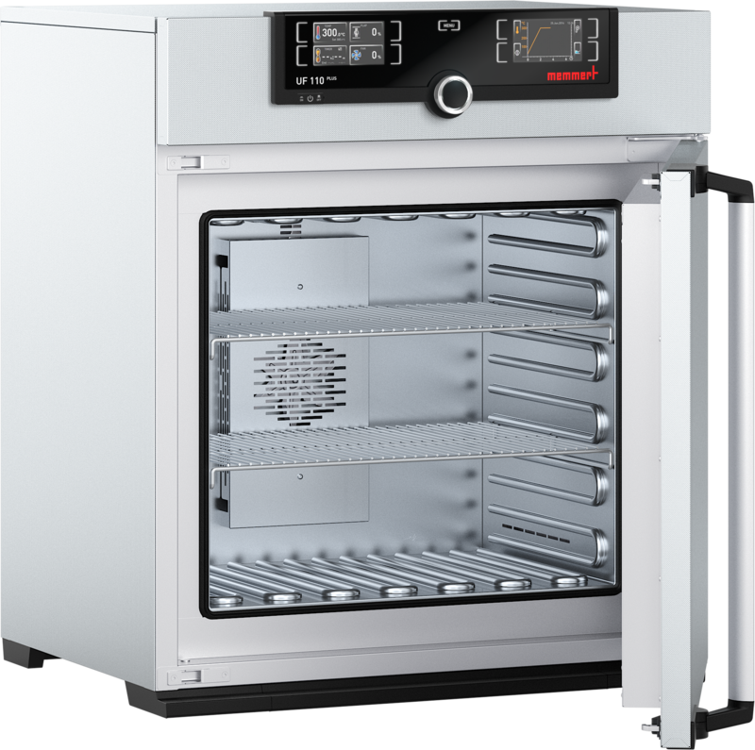
Universal Oven Um

UF110mplus

The heating oven Um is a Class I medical device.

This universal oven made of high-quality hygienic, easy to clean stainless steel leaves nothing to be desired in terms of ventilation technology, control technology, overtemperature protection and perfectly tuned heating technology.
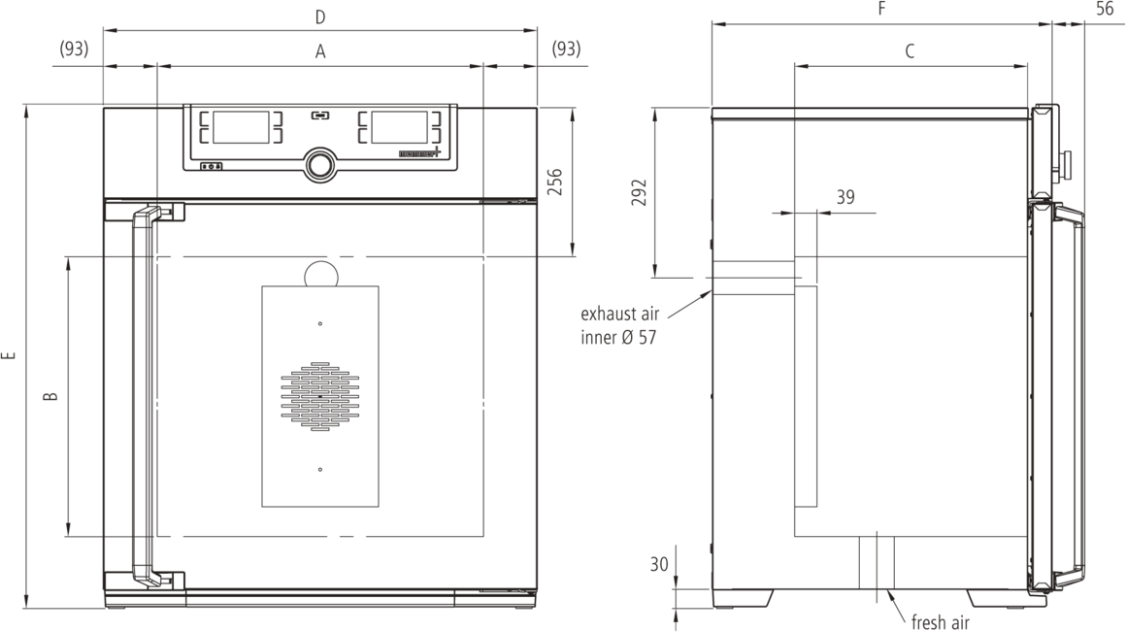

Temperature
Working temperature range at least 5 (UN/UNplus/UNm/UNmplus) or 10 (UF/UFplus/UFm/UFmplus) above ambient temperature to +300 °C

Setting accuracy temperature
up to 99.9 °C: 0.1 / from 100 °C: 0.5

Setting temperature range +20 to +300 °C
Temperature sensor 2 Pt100 sensors DIN Class A in 4-wire-circuit for mutual monitoring, taking over functions in case of an error

Control technology
ControlCOCKPIT TwinDISPLAY. Adaptive multifunctional digital PID-microprocessor controller with 2 high-definition TFT-colour displays.
Language setting German, English, Spanish, French, Polish, Czech, Hungarian

Timer Digital backwards counter with target time setting, adjustable from 1 minute to 99 days
Function HeatBALANCE adapting the distribution of the heating performance of the upper and lower heating circuit from -50 % to +50 %

Function SetpointWAIT the process time does not start until the set temperature is reached
Calibration three freely selectable temperature values

adjustable parameters temperature (Celsius or Fahrenheit), fan speed, air flap position, programme time, time zones, summertime/wintertime

Ventilation
Fan forced air circulation by quite air turbine, adjustable in 10 % steps for each segment individually
Fresh air admixture adjustment of pre-heated fresh air admixture by air flap control in 10 % steps for each segment individually

Vent vent connection with restrictor flap

Communication
Documentation programme stored in case of power failure
Programming AtmoCONTROL software on a USB stick for programming, managing and transferring programmes via Ethernet interface or USB port

Safety
Temperature control mechanical temperature limiter TB, protection class 1 according to DIN 12880 to switch off the heating approx. 20°C above nominal temperature
Temperature control overtemperature monitor TWW, protection class 3.1 or adjustable temperature limiter TWB, protection class 2, selectable on display

AutoSAFETY additionally integrated over- and undertemperature monitor "ASF", automatically following the setpoint value at a preset tolerance range, alarm in case of over- or undertemperature, heating is switched off in case of overtemperature
Autodiagnostic system for fault analysis

Alarm visual and acoustic

Standard equipment
Door fully insulated stainless steel door with 2-point locking (compression door lock)
Internals 2 stainless steel grid(s), electropolished

Works calibration certificate Calibration at +160°C

Stainless steel interior
Dimensions w(A) x h(B) x d(C): 560 x 480 x 400 mm (d less 39 mm for fan)
Interior easy-to-clean interior,made of stainless steel, reinforced by deep drawn ribbing with integrated and protected large-area heating on four sides

Volume 108 l
Max. number of internals 5
Max. loading of chamber 175 kg
Max. loading per internal 20 kg

Textured stainless steel casing
Dimensions w(D) x h(E) x d(F): 745 x 864 x 584 mm (d +56mm door handle)
Housing rear zinc-plated steel

Electrical data
Voltage Electrical load
Voltage Electrical load

230 V, 50/60 Hz
approx. 2800 W
115 V, 50/60 Hz
approx. 1800 W

Ambient conditions
Set Up The distance between the wall and the rear of the appliance must be at least 15 cm. The clearance from the ceiling must not be less than 20 cm and the side clearance from walls or nearby appliances must not be less than 5 cm.
Altitude of installation max. 2,000 m above sea level

Ambient temperature +5 °C to +40 °C
Humidity rh max. 80 %, non-condensing
Overvoltage category II
Pollution degree 2

Packing/shipping data
Transport information The appliances must be transported upright
Customs tariff number 8419 8998

Country of origin Federal Republic of Germany
WEEE-Reg.-No. DE 66812464

Dimensions approx incl. carton
w x h x d: 830 x 1050 x 800 mm

Net weight approx. 74 kg
Gross weight carton approx. 99 kg

Standard units are safety-approved and bear the test marks

