Pilsen, 6th October 2022
FACULTY OftlíCTMCM
F' «siiuíim
OMvmiw’ or v,rí i eühruu
Supplier:
Department of Electronics and Information Technology University of West Bohemia in Pilsen
xxx
xxx
xxx
ID: xxx, Tax number: xxx
Contact person:
xxx
Tel.: xxx
Email: burianp@fel.zcu.cz
Customer:
xxx
Institute of Experimental and Applied Physics
Czech Technical University in Prague
xxx
xxx
xxx
Email: xxx

Quotation: Katherine readout for Timepix3 Generation 2
Subject of delivery:
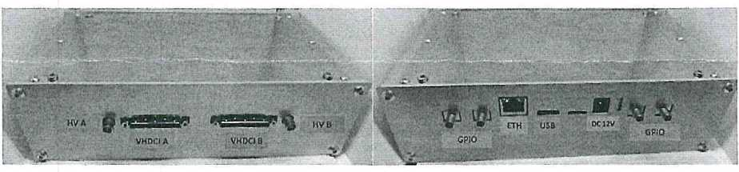

Katherine readout system for Timepix3 Generation2. The device for control and reading
Timepix3 readout chips. The.power supply is included in the delivery.
Subject | unit price | pcs | final price
Katherine readout for Timepix3 Gen2 | 60 000,- CZK | 1 | 60 000,- CZK
Total |  |  | 60 000,- CZK
Delivery anf financial conditions:
The price does not include VAT. Timepix3 detectors are not included.
Shipping costs are not included.
Expected delivery time is 120 days from receipt of the order.
This quotation is valid until 10^{lh} November 2022. Payment: within 30 days from invoice receiving date. /

doc. xxx<Ph.D. Head of department, FEE

