acuiTvof utcîÂJUt i*’“ ÎKCiNtCCWC UMVUSttf * onvcst ooicîuu

Pilsen, 6th October 2022
Supplier:
Department of Electronics and Information Technology University of West Bohemia in Pilsen
xxx
xxx
xxx
ID: xxx, Tax number: xxx
Contact person:
xxx
Tel.: xxx
Email: xxx
Customer:
xxx
Institute of Experimental and Applied Physics Czech Technical University in Prague
xxx
xxx
Czech Republic
Email: xxx

Quotation: Katherine readout for Timepix3 Generation 2
Subject of delivery:
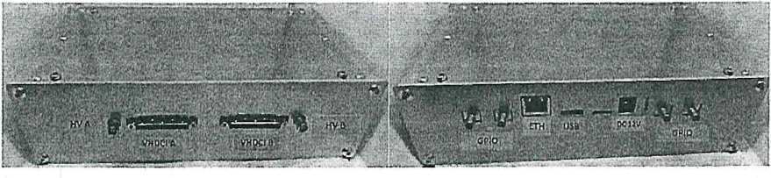

Pair of Katherine readout system for Timepix3 Generation 2. The power supplies are included in the delivery. ’
Subject | unit price | pcs | final price
Katherine readout forTimepix3 Gen2* | 44 000,-CZK | 2 | 88 000,- CZK
Total ' |  |  | 88 000,-CZK
Delivery anf financial conditions:
*FPGA modules and housings are not Included In cost
The price does not Include VAT. Tlmeplx3 detectors are not included. Shipping costs are not .included.
Expected delivery time Is 120 days from receipt of the order.
This quotation is valid until 10th November 2022.
Payment: within 30 days from invoice receiving date.

