Annex 2

Project Agreement(s)

21.26.MAG_v2: “Study of Progressive Longitudinal Compression of GI Tract Anastomotic Stricture in Swine”

Scope of the study
The scope of the study and the detailed protocol are described in the study plan related to study code 21.26.MAG_v2.

Planning
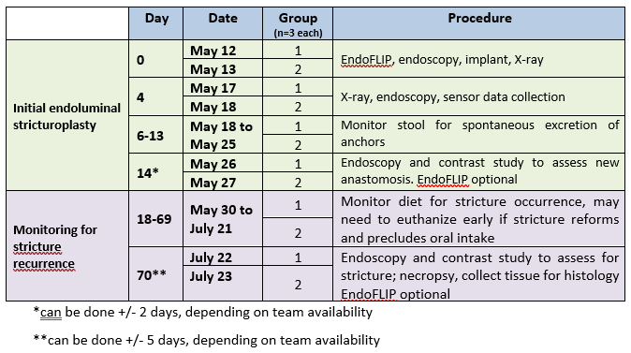

Fees

Fees of anastomotic stricture model creation in pigs
Cost entries | Event budget  (CZK) | Note - specification of planned costs
Lease
Theatre | 528.0 | 66 CZK * 8 hours
Theatre equipment | 10,878.7 | 1,359.84CZK * 8 hrs
Material
Pig | 9,701.0 | 1 * 9 701 CZK
Anesthesia | 10,983.04 | 1,372.88 CZK * 8 hrs
Chemicals - consumables | 1,875.0
Injector - consumables | 5,000.0
Services
Other direct costs:
Feeding days | 5,328.0 | 48 CZK * 111 days
Personal costs | 57,076.13
Total cost per animal | 101,369.87
Total cost per animal including VAT (21%) | 122,657.54
Total cost for 6 pigs including VAT (21%) | 735,945.24

Fees of placement, post-operative care, monitoring, sigmoidoscopy, euthanasia and tissue collection
Cost entries | Event budget  (CZK) | Note - specification of planned costs
Lease
Theatre | 528.0 | 66 CZK * 8 hours
Theatre equipment | 16,585.3 | 2073.16 CZK * 8 hrs
Material
Pig | 0 | 0 * 9 701 CZK
Anesthesia | 10,983.04 | 1,372.88 CZK * 8 hrs
Services
Other direct costs:
Feeding days | 3,360.0 | 48 CZK * 70 days
Project of experiment charges | 1,250.0
Personal costs | 80,412.63
Total cost per animal | 113,118.97
Total cost per animal including VAT (21%) | 136,873.95
Total cost for 6 pigs including VAT (21%) | 821,243.7

Total cost (3.1. + 3.2.) for 6 pigs including VAT: 1,557,187.2 CZK

