Příloha nájemní smlouvy Č.98N03/44

Variabilní symbol: 9810344 Uzavřeno; 30.09.2003

Datum tisku: 23.05.2022 Účinná od: 01.10.2003

Roční nájem: 24 263 Kč



Nájemci:

Název

Adresa

Staré Hradiště 490, 53352 Staré Hradiště

ZEAS, a.s. Pod Kunětickou horou

Nemovitostí:

|  |  |  |  |  |  |  |  |  |  |
| --- | --- | --- | --- | --- | --- | --- | --- | --- | --- |
| Pozn. | Parcela | / DM | Skp. | Kult. Číslo LV | Typ  sazby | Cena  [Kč] | Výměra  [m^j | % Inflace | Nájem  [Kč] |
| Katastr: Brozany nad Labem | | | | | | | | | |
|  | 1 | 4 | 2 | 2 10002 | pc/ha | 91 700,00 | 14 | 2,2 | 2,82 |
|  | 230 | 2 | 2 | 2 10002 | pc/ha | 91 700,00 | 261 | 2,2 | 52,65 |
|  | 231 | 3 | 2 | 2 10002 | pc/ha | 91 700,00 | 493 | 2,2 | 99,46 |
| PFČR1/2=3182m2 | 251 | 1 | 2 | 2 401 | pc/ha | 91 700,00 | 3 182 | 2,2 | 641,94 |
|  | 256 | 22 | 2 | 11 10002 | pc/ha | 91 700,00 | 147 | 2,2 | 29,66 |
|  | 256 | 24 | 2 | 11 10002 | pc/ha | 91 700,00 | 67 | 2,2 | 13,52 |
|  | 259 | 7 | 2 | 2 10002 | pc/ha | 91 700,00 | 928 | 2,2 | 187,21 |
| PFČR1/2=55m2 | 267 | 11 | 2 | 7 401 | pc/ha | 91 700,00 | 55 | 2,2 | 11,10 |
|  | 284 | 9 | 2 | 14 10002 | pc/ha | 91 700,00 | 396 | 2,2 | 79,89 |
|  | 428 |  | 2 | 2 10002 | pc/ha | 91 700,00 | 200 | 2,2 | 40,35 |
|  | 485 | 3 | 2 | 5 10002 | pc/ha | 91 700,00 | 246 | 2,2 | 49,63 |
|  | 573 | 6 | 2 | 7 10002 | pc/ha | 91 700,00 | 190 | 2,2 | 38,33 |
|  | 601 | 2 | 2 | 2 10002 | pc/ha | 91 700,00 | 580 | 2,2 | 117,01 |
| PFČR1/3=142m2 | 601 | 6 | 2 | 2 344 | pc/ha | 91 700,00 | 142 | 2,2 | 28,65 |
|  | 618 | 13 | 2 | 2 10002 | pc/ha | 91 700,00 | 252 | 2,2 | 50,84 |
| PFČR2/54=6m2 | 670 | 1 | 2 | 2 186 | pc/ha | 91 700,00 | 6 | 2,2 | 1,21 |
| PFČR2/54=8m2 | 670 | 2 | 2 | 7 186 | pc/ha | 91 700,00 | 8 | 2,2 | 1,61 |
| PFČR2/54=2 m2 | 670 | 3 | 2 | 7 186 | pc/ha | 91 700,00 | 2 | 2,2 | 0,40 |
| PFČR2/54=5m2 | 670 | 4 | 2 | 2 186 | pc/ha | 91 700,00 | 5 | 2,2 | 1,01 |
| PFČR2/54=18m2 | 670 | 5 | 2 | 2 186 | pc/ha | 91 700,00 | 18 | 2,2 | 3,63 |
|  | 672 | 5 | 2 | 14 10002 | pc/ha | 91 700,00 | 318 | 2,2 | 64,15 |
| PFČR4/30=143m2 | 679 | 1 | 2 | 2 345 | pc/ha | 91 700,00 | 143 | 2,2 | 28,85 |
|  | 688 | 9 | 2 | 7 10002 | pc/ha | 91 700,00 | 11 | 2,2 | 2,22 |
|  | 775 |  | 2 | 2 10002 | pc/ha | 91 700,00 | 384 | 2,2 | 77,47 |
| Celkem za katastr |  |  |  |  |  |  | 8 048 |  | 1 623,61 |
| Katastr: Časy |  |  |  |  |  |  |  |  |  |
|  | 1049 |  | 2 | 14 10002 | pc/ha | 52 400,00 | 3 151 | 2,2 | 363,25 |
|  | 1079 |  | 2 | 14 10002 | pc/ha | 52 400,00 | 1 619 | 2,2 | 186,64 |

**Příloha nájemní smlouvy Č.98N03/44**

Variabilní symbol; 9810344 Uzavřeno: 30.09.2003

Datum tisku; 23.05.2022 Účinná od: 01.10.2003

Roční nájem: 24 263 Kč

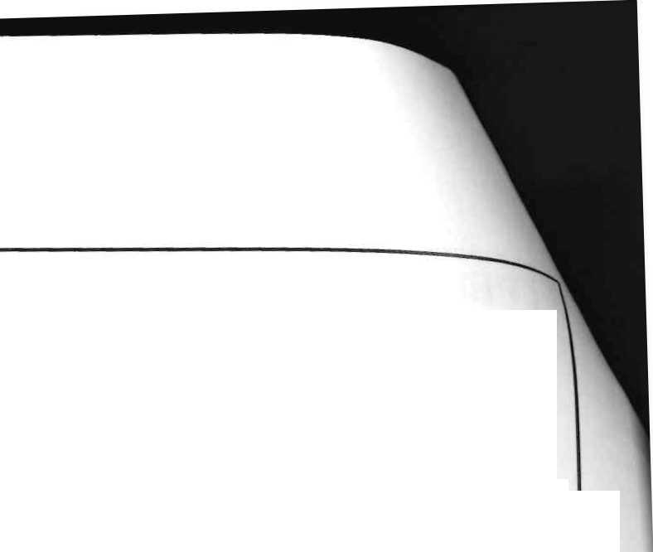

|  |  |  |  |  |  |  |  |  |  |
| --- | --- | --- | --- | --- | --- | --- | --- | --- | --- |
| Pozn. Parcela | | / | Díl Skp. | Kult. Číslo | Typ | Cena | Výměra | % Infla | ce Nájem |
|  |  |  |  | LV | sazby | [Kč] | [m^] |  | [Kč] |
| Celkem za katastr |  |  |  |  |  |  | 4 770 |  | 549,89 |
| Katastr: Hrádek u Pardubic | |  |  |  |  |  |  |  |  |
|  | 119 | 2 | 2 | 210002 | pc/ha | 65 200,00 | 230 | 2,2 | 32,99 |
|  | 121 | 7 | 2 | 14 10002 | pc/ha | 65 200,00 | 217 | 2,2 | 31,13 |
|  | 129 | 2 | 2 | 2 10002 | pc/ha | 65 200,00 | 99 | 2,2 | 14,20 |
|  | 151 | 3 | 2 | 7 10002 | pc/ha | 65 200,00 | 124 | 2,2 | 17,79 |
|  | 327 | 6 | 2 | 7 10002 | pc/ha | 65 200,00 | 1 881 | 2,2 | 269,81 |
| Celkem za katastr |  |  |  |  |  |  | 2 551 |  | 365,92 |
| Katastr: Hrobice |  |  |  |  |  |  |  |  | 4 |
|  | 2009 |  | 2 | 7 10002 | pc/ha | 89 700,00 | 128 | 2.2 | 25,26 |
|  | 2142 |  | 2 | 14 10002 | pc/ha | 89 700,00 | 688 | 2,2 | 135,77 |
|  | 2299 |  | 2 | 7 10002 | pc/ha | 89 700,00 | 332 | 2.2 | 65,52 |
| Celkem za katastr |  |  |  |  |  |  | 1 148 |  | 226,55 |
| Katastr: Kunětice |  |  |  |  |  |  |  |  |  |
| pfčr | 94 |  | 1 | 13 10002 | pc/ha | 1 000 000,00 | 1 555 | 1 | 1 555,00 |
| pfčr | 138 |  | 1 | 13 10002 | pc/ha | 1 000 000,00 | 28 | 1 | 28,00 |
|  | 367 | 5 | 2 | 2 10002 | pc/ha | 95 900,00 | 29 | 2,2 | 6,12 |
| pfčr | 461 | 6 | 2 | 14 10002 | pc/ha | 500 000,00 | 4 048 | 1 | 2 024,00 |
| pfčr | 461 | 12 | 2 | 14 10002 | pc/ha | 500 000,00 | 345 | 1 | 172,50 |
|  | 653 | 1 | 2 | 2 10002 | pc/ha | 95 900,00 | 2 832 | 2,2 | 597,50 |
|  | 740 | 61 | 2 | 11 10002 | pc/ha | 95 900,00 | 349 | 2,2 | 73,63 |
| Celkem za katastr |  |  |  |  |  |  | 9 186 |  | 4 456,75 |
| Katastr: Lukovna |  |  |  |  |  |  |  |  | • |
|  | 219 | 12 | 2 | 2 10002 | pc/ha | 86 899,99 | 5 | 2,2 | 0,96 |
|  | 219 | 13 | 2 | 2 10002 | pc/ha | 86 899,99 | 361 | 2,2 | 69,02 |
|  | 289 | 2 | 2 | 7 10002 | pc/ha | 86 899,99 | 717 | 2,2 | 137,08 |
|  | 289 | 13 | 2 | 210002 | pc/ha | 86 899,99 | 49 | 2,2 | 9,37 |
|  | 444 | 2 | 2 | 14 10002 | pc/ha | 86 899,99 | 472 | 2,2 | 90,24 |
|  | 444 | 13 | 2 | 2 10002 | pc/ha | 86 899,99 | 612 | 2,2 | 117,00 |
|  | 448 | 2 | 2 | 7 10002 | pc/ha | 86 899,99 | 342 | 2,2 | 65,38 |
|  | 450 | 3 | 2 | 7 10002 | pc/ha | 86 899,99 | 31 | 2,2 | 5,93 |
|  | 479 | 21 | 2 | 2 10002 | pc/ha | 86 899,99 | 128 | 2,2 | 24,47 |
|  | 479 | 25 | 2 | 2 10002 | pc/ha | 86 899,99 | 29 | 2,2 | 5,54 |
|  | 479 | 26 | 2 | 2 10002 | pc/ha | 86 899,99 | 48 | 2.2 | 9,18 |
|  | 479 | 27 | 2 | 2 10002 | pc/ha | 86 899,99 | 137 | 2,2 | 26,19 |
|  | 479 | 36 | 2 | 2 10002 | pc/ha | 86 899,99 | 180 | 2,2 | 34,41 |

2/6

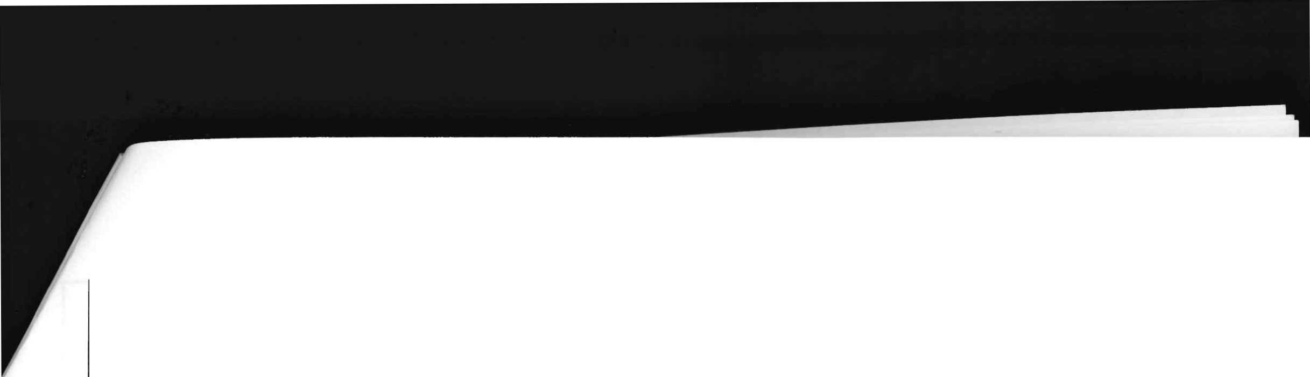

|  |  |  |  |  |  |  |  |  |  |
| --- | --- | --- | --- | --- | --- | --- | --- | --- | --- |
| Příloha nájemní smlouvy Č.98N03/44  Variabilní symbol: 9810344 Uzavřeno:  Datum tisku: 23.05.2022 Účinná od: | | | | | 1. Roční nájem:   01.10.2003 | | | 24 263 Kč |  |
| Pozn. Parcela | | / | DM Skp. | Kult. Číslo | Typ | Cena | Výměra | % Inflace | Nájem |
|  |  |  |  | LV | sazby | [Kč] | [mT |  | [Kč] |
| Katastr: Lukovna | | | | | | | | | |
|  | 479 | 39 | 2 | 2 10002 | pc/ha | 86 899,99 | 179 | 2,2 | 34,22 |
|  | 500 | 12 | 2 | 14 10002 | pc/ha | 86 899,99 | 14 | 2,2 | 2,68 |
|  | 507 | 1 | 2 | 2 10002 | pc/ha | 86 899,99 | 433 | 2,2 | 82,78 |
|  | 527 |  | 2 | 2 10002 | pc/ha | 86 899,99 | 442 | 2,2 | 84,50 |
| Celkem za katastr |  |  |  |  |  |  | 4 179 |  | 798,95 |
| Katastr: Němčíce nad Labem | | |  |  |  |  |  |  |  |
|  | 320 | 35 | 2 | 2 10002 | pc/ha | 85 300,00 | 243 | 2,2 | 45,60 |
| Celkem za katastr |  |  |  |  |  |  | 243 |  | 45,60 |
| Katastr: Pardubice |  |  |  |  |  |  |  |  |  |
|  | 1534 | 3 | 2 | 2 10002 | pc/ha | 107 300,00 | 359 | 2,2 | 84,75 |
|  | 1548 | 5 | 2 | 2 10002 | pc/ha | 107 300,00 | 11 342 | 2,2 | 2 677,39 |
|  | 1584 | 9 | 2 | 7 10002 | pc/ha | 107 300,00 | 1 803 | 2,2 | 425,62 |
|  | 1616 | 21 | 2 | 7 10002 | pc/ha | 107 300,00 | 141 | 2,2 | 33,28 |
| Celkem za katastr |  |  |  |  |  |  | 13 645 |  | 3 221,04 |
| Katastr: Počaply nad Loučnou | | |  |  |  |  |  |  |  |
|  | 108 | 8 | 2 | 2 10002 | pc/ha | 107 900,00 | 35 | 2,2 | 8,31 |
|  | 136 | 4 | 2 | 2 10002 | pc/ha | 107 900,00 | 541 | 2,2 | 128,42 |
|  | 296 | 12 | 2 | 2 10002 | pc/ha | 107 900,00 | 1 694 | 2,2 | 402,12 |
|  | 296 | 13 | 2 | 2 10002 | pc/ha | 107 900,00 | 54 | 2,2 | 12,82 |
|  | 296 | 15 | 2 | 2 10002 | pc/ha | 107 900,00 | 59 | 2,2 | 14,01 |
|  | 296 | 17 | 2 | 2 10002 | pc/ha | 107 900,00 | 7 | 2,2 | 1,66 |
|  | 303 | 27 | 2 | 2 10002 | pc/ha | 107 900,00 | 767 | 2,2 | 182,07 |
| Celkem za katastr |  |  |  |  |  |  | 3 157 |  | 749,41 |
| Katastr: Pohránov |  |  |  |  |  |  |  |  |  |
|  | 55 | 31 | 2 | 14 10002 | pc/ha | 65 300,00 | 541 | 2,2 | 77,72 |
|  | 55 | 40 | 2 | 2 10002 | pc/ha | 65 300,00 | 960 | 2,2 | 137,91 |
|  | 55 | 42 | 2 | 2 10002 | pc/ha | 65 300,00 | 1 026 | 2,2 | 147,40 |
|  | 58 | 64 | 2 | 7 10002 | pc/ha | 65 300,00 | 953 | 2,2 | 136,91 |
|  | 58 | 71 | 2 | 7 10002 | pc/ha | 65 300,00 | 543 | 2,2 | 78,01 |
|  | 83 | 14 | 2 | 210002 | pc/ha | 65 300,00 | 523 | 2,2 | 75,13 |
|  | 256 |  | 2 | 210002 | pc/ha | 65 300,00 | 602 | 2,2 | 86,48 |
| Celkem za katastr |  |  |  |  |  |  | 5 148 |  | 739,56 |
| Katastr: Ráby |  |  |  |  |  |  |  |  |  |
|  | 163 | 1 | 2 | 7 10002 | pc/ha | 79 800,00 | 84 | 2,2 | 14,75 |
|  | 200 | 64 | 2 | 2 10002 | pc/ha | 79 800,00 | 712 | 2,2 | 125,00 |

Příloha nájemní smlouvy Č.98N03/44

Variabilní symbol; 9810344 Uzavřeno: 30.09.2003

Roční nájem: 24 263 Kč

Datum tisku: 23.05.2022 Účinná od; 01.10.2003

|  |  |  |  |  |  |  |  |  |  |
| --- | --- | --- | --- | --- | --- | --- | --- | --- | --- |
| Pozn. Parcela | | / | Díl Skp. | Kult. Číslo LV | Typ  sazby | Cena  [Kč] | Výměra  [m^] | % Inflace | Nájem  [Kč] |
| Katastr; Ráby | | | | | | | | | |
|  | 207 | 1 | 2 | 2 10002 | pc/ha | 79 800,00 | 308 | 2,2 | 54,07 |
|  | 207 | 2 | 2 | 2 10002 | pc/ha | 79 800,00 | 81 | 2,2 | 14,22 |
|  | 233 | 2 | 2 | 2 10002 | pc/ha | 79 800,00 | 718 | 2,2 | 126,05 |
|  | 260 | 27 | 2 | 2 10002 | pc/ha | 79 800,00 | 411 | 2,2 | 72,16 |
|  | 296 | 6 | 2 | 2 10002 | pc/ha | 79 800,00 | 586 | 2,2 | 102,88 |
|  | 296 | 7 | 2 | 2 10002 | pc/ha | 79 800,00 | 513 | 2,2 | 90,06 |
|  | 298 | 7 | 2 | 7 10002 | pc/ha | 79 800,00 | 29 | 2,2 | 5,09 |
| pfčr | 356 | 2 | 2 | 2 10002 | pc/ha | 79 800,00 | 262 | 2,2 | 46,00^ |
|  | 358 | 10 | 2 | 14 10002 | pc/ha | 79 800,00 | 78 | 2,2 | 13,69 |
|  | 366 |  | 2 | 2 10002 | pc/ha | 79 800,00 | 640 | 2,2 | 112,36 |
|  | 376 | 2 | 2 | 14 10002 | pc/ha | 79 800,00 | 395 | 2,2 | 69,35 |
|  | 376 | 13 | 2 | 14 10002 | pc/ha | 79 800,00 | 77 | 2,2 | 13,52 |
|  | 377 | 3 | 2 | 14 10002 | pc/ha | 79 800,00 | 135 | 2,2 | 23,70 |
|  | 504 | 8 | 2 | 2 10002 | pc/ha | 79 800,00 | 16 | 2,2 | 2,81 |
| Celkem za katastr |  |  |  |  |  |  | 5 045 |  | 885,71 |
| Katastr: Sezemice nad Loučnou | | | |  |  |  |  |  |  |
|  | 638 | 28 | 2 | 2 10002 | pc/ha | 77 100,00 | 20 | 2.2 | 3,39 |
|  | 638 | 29 | 2 | 2 10002 | pc/ha | 77 100,00 | 8 | 2,2 | 1,36 |
| PFČR1/2=2887  m2 | 842 |  | 2 | 2 728 | pc/ha | 77 100,00 | 2 887 | 2,2 | 489,69 |
|  | 1595 | 3 | 2 | 2 10002 | pc/ha | 77 100,00 | 1 047 | 2,2 | 177,59 |
|  | 1640 | 9 | 2 | 710002 | pc/ha | 77 100,00 | 197 | 2,2 | 33,42 |
|  | 1644 | 12 | 2 | 2 10002 | pc/ha | 77 100,00 | 510 | 2,2 | 86,51 |
| PFČR1/2=749m2 | 1719 |  | 2 | 2 828 | pc/ha | 77 100,00 | 749 | 2,2 | 127,05 |
| PFČR1/2=56m2 | 1720 | 1 | 2 | 2 828 | pc/ha | 77 100,00 | 56 | 2,2 | 9,50 |
| Celkem za katastr |  |  |  |  |  |  | 5 474 |  | 928,51 |
| Katastr: Srch |  |  |  |  |  |  |  |  |  |
|  | 148 | 6 | 2 | 210002 | pc/ha | 58 800,00 | 86 | 2.2 | 11,12 |
|  | 148 | 10 | 2 | 2 10002 | pc/ha | 58 800,00 | 10 | 2,2 | 1,29 |
|  | 392 | 2 | 2 | 2 10002 | pc/ha | 58 800,00 | 71 | 2,2 | 9,18 |
|  | 524 | 7 | 2 | 2 10002 | pc/ha | 58 800,00 | 22 | 2,2 | 2,85 |
|  | 527 | 3 | 2 | 2 10002 | pc/ha | 58 800,00 | 24 | 2,2 | 3,10 |
|  | 543 | 1 | 2 | 2 10002 | pc/ha | 58 800,00 | 546 | 2,2 | 70,63 |
| Celkem za katastr |  |  |  |  |  |  | 759 |  | 98,17 |
| Katastr; Staré Hradiště | |  |  |  |  |  |  |  |  |
|  | 44 | 1 | 1 | 13 10002 | pc/ha | 1 000 000,00 | 3 516 | 1 | 3 516,00 |

4 / R

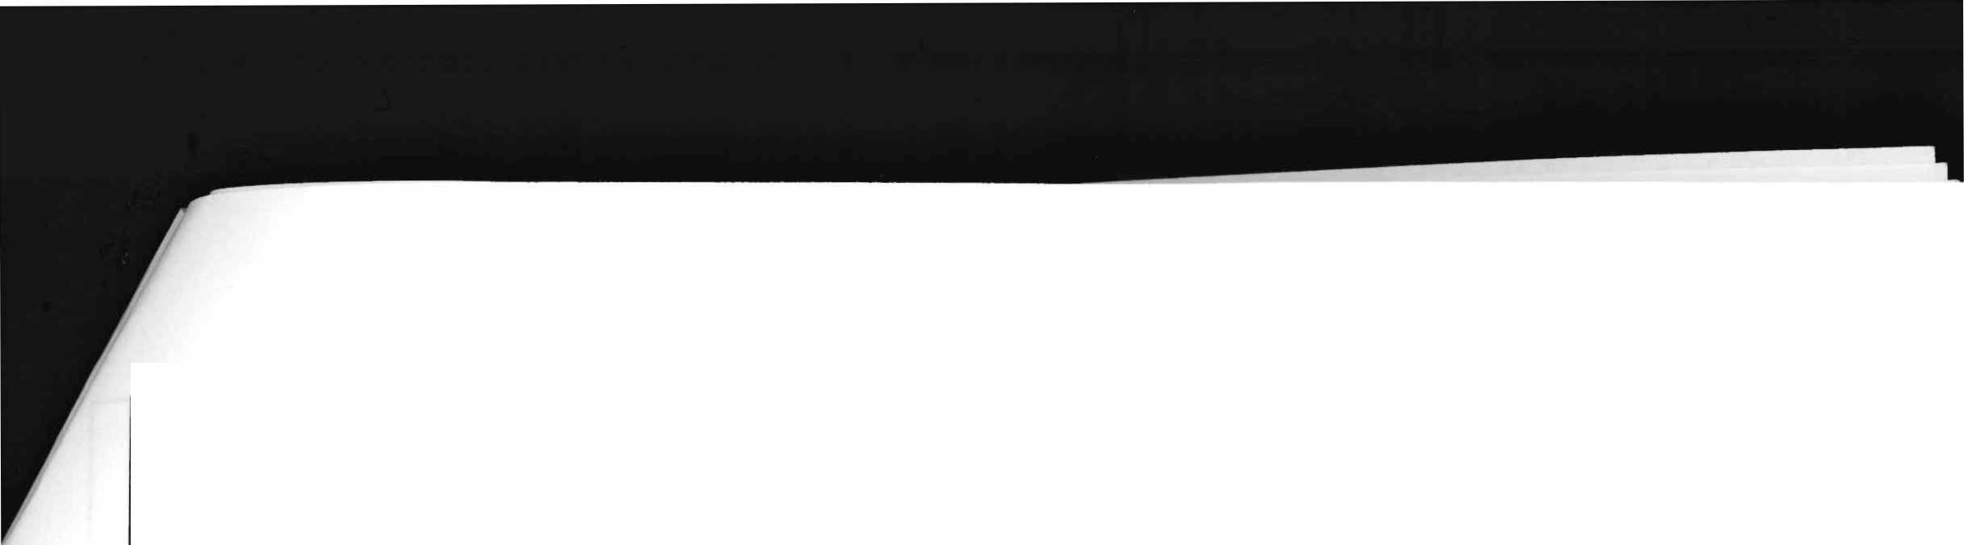

|  |  |  |  |  |  |  |  |  |  |
| --- | --- | --- | --- | --- | --- | --- | --- | --- | --- |
| Příloha nájemní smlouvy Č.98N03/44 | | | | |  |  |  |  |  |
| Variabilní symbol: | 9810344 | |  | Uzavřeno: | 30.09.2003 Roční nájem: | | | 24 263 Kč |  |
| Datum tisku: | 23.05.2022 | |  | Účinná od: | 01.10.2003 | |  |  |  |
| Pozn. Parcela | | / Díl | Skp. | Kult. Číslo | Typ | Cena | Výměra | % Inflace | Nájem |
|  |  |  |  | LV | sazby | [Kč] | [m^l |  | [Kč] |
| Katastr: Staré Hradiště | | | | | | | | | |
|  | 44 | 2 | 1 | 13 10002 | pc/ha | 1 000 000,00 | 442 | 1 | 442,00 |
|  | 44 | 3 | 1 | 13 10002 | pc/ha | 1 000 000,00 | 15 | 1 | 15,00 |
|  | 322 |  | 1 | 13 10002 | pc/ha | 1 000 000,00 | 454 | 1 | 454,00 |
|  | 330 | 2 | 2 | 2 10002 | pc/ha | 91 200,00 | 247 | 2,2 | 49,56 |
|  | 349 | 3 | 2 | 2 10002 | pc/ha | 91 200,00 | 262 | 2,2 | 52,57 |
|  | 354 |  | 2 | 2 10002 | pc/ha | 91 200,00 | 53 | 2,2 | 10,63 |
|  | 966 | 11 | 2 | 14 10002 | pc/ha | 91 200,00 | 216 | 2,2 | 43,34 |
|  | 966 | 14 | 2 | 14 10002 | pc/ha | 91 200,00 | 159 | 2,2 | 31,90 |
| Celkem za katastr |  |  |  |  |  |  | 5 364 |  | 4 615,00 |
| Katastr: Stéblová |  |  |  |  |  |  |  |  |  |
|  | 164 | 2 | 2 | 7 10002 | pc/ha | 51 000,00 | 6 063 | 2,2 | 680,27 |
| část 18325 m2 | 287 | 1 | 2 | 2 10002 | pc/ha | 51 000,00 | 18 325 | 2.2 | 2 056,07 |
|  | 287 | 13 | 2 | 2 10002 | pc/ha | 51 000,00 | 38 v | 2,2 | 4,26 |
|  | 287 | 14 | 2 | 2 10002 | pc/ha | 51 000,00 | 606 | 2,2 | 67,99 |
|  | 287 | 18 | 2 | 2 10002 | pc/ha | 51 000,00 | 130 | 2,2 | 14,59 |
|  | 310 |  | 2 | 2 10002 | pc/ha | 51 000,00 | 1 604 | 2,2 | 179,97 |
|  | 316 | 3 | 2 | 2 10002 | pc/ha | 51 000,00 | 2 | 2.2 | 0,22 |
|  | 319 | 4 | 2 | 14 10002 | pc/ha | 51 000,00 | 88 | 2,2 | 9,87 |
|  | 345 | 83 | 2 | 7 10002 | pc/ha | 51 000,00 | 6 | 2,2 | 0,67 |
|  | 348 | 1 | 2 | 7 10002 | pc/ha | 51 000,00 | 4 632 | 2,2 | 519,71 |
|  | 487 | 144 | 2 | 7 10002 | pc/ha | 51 000,00 | 72 | 2,2 | 8,08 |
|  | 487 | 169 | 2 | 2 10002 | pc/ha | 51 000,00 | 267 | 2,2 | 29,96 |
| část 3977 m2 | 560 | 41 | 2 | 2 10002 | pc/ha | 51 000,00 | 3 977 | 2,2 | 446,22 |
|  | 560 | 52 | 2 | 2 10002 | pc/ha | 51 000,00 | 6 490 | 2,2 | 728,18 |
|  | 560 | 61 | 2 | 2 10002 | pc/ha | 51 000,00 | 67 | 2.2 | 7,52 |
|  | 632 | 10 | 2 | 2 10002 | pc/ha | 51 000,00 | 30 | 2,2 | 3,37 |
|  | 632 | 12 | 2 | 2 10002 | pc/ha | 51 000,00 | 36 | 2,2 | 4,04 |
| Celkem za katastr |  |  |  |  |  |  | 42 433 |  | 4 760,99 |
| Katastr: Trnová |  |  |  |  |  |  |  |  |  |
|  | 632 | 2 | 2 | 2 10002 | pc/ha | 100 100,00 | 895 | 2,2 | 197,10 |
| Celkem za katastr |  |  |  |  |  |  | 895 |  | 197,10 |

**Celkem**

**112 045**

**24 263**