PURCHASE CONTRACT
Nr. 063/2022/02-IN

Date of birth:
With seat:
Bank details: ING
IBAN: NL97INGB0003889041
BIC/SWIFT: INGBNL2A
hereinafter also "seller"

and

Muzeum středního Pootaví Strakonice
With seat: Zámek 1, 386 01 Strakonice
IČ (IDN): 00072150
DIČ (VAT): no VAT payer
Bank details: Komerční banka, a. s., Strakonice
Account number: 115-3431200227/0100
Represented by:

hereinafter also „customer“

together also "contracting parties"

conclude on the day, month and year below in the sense of the provisions of § 2079 et seq. Act No. 89/2012 Coll., Civil Code, as amended, this purchase contract (hereinafter also "contract")

Art. I.
Introductory provisions

1.1. The contracting parties declare that they are competent to conclude this contract.
1.2. The seller declares that he is the sole owner of the movable item: gajdy from Oravská Polhora (Slovakia); threevoiced gajdy (Slovakia); torupill - Estonia (with a white leather storage bag); torupill – Estonia (with a grey textile cover); tulum – Turkey (with a white leather storage bag); tulum – Turkey (with a blue textile cover), hereinafter referred to as "the item".
1.3. The customer declares that he has the item before concluding this contract inspected, and understands its condition.

Art. II.
Object of the contract

2.1. On the basis of this contract, the seller hands over the item referred in Article I, and allows the buyer to acquire ownership of it, at the agreed purchase price specified in Article III of this contract and the customer takes delivery this item from the seller for this purchase price and becomes their property.
2.2. The item will be hand to the buyer after the signing of the contract by both parties.

Art. III.
Purchase price

3.1. The purchase price is 4 650 euro (in words: fourthousandsixhundredandfifty euro).

Name | Price without VAT in euro | VAT | Price with VAT in euro
gajdy from Oravská Polhora (Slovakia) | 1 000,- | 0,- | 1 000,-
threevoiced gajdy (Slovakia) | 1 000,- | 0,- | 1 000,-
torupill - Estonia (with a white leather storage bag) | 1 000,- | 0,- | 1 000,-
torupill – Estonia (with a grey textile cover) | 750,- | 0,- | 750,-
tulum – Turkey (with a white leather storage bag) | 400,- | 0,- | 400,-
tulum – Turkey (with a blue textile cover) | 500,- | 0,- | 500,-
total | 4 650,- | 0,- | 4 650,-

3.2. Payment of the purchase price will be done after the handover of the item by bank transfer to the seller's bank account; IBAN: NL97INGB0003889041 as agreed with a protocol on taking over the subject of the order within 14 days.

Art. IV.
Final Arrangements

4.1. The contract is made in three originals, from that the seller receives one and the customer two.
4.2. Amendments of this contract may only be made by means of written and ascending numbered amendments signed by both parties.
4.3. The contract is a manifestation of the serious and free will of the contracting parties, and was not signed in distress or under noticeably unfavorable conditions. In witness whereof, the parties attach their signatures.
4.4. The contract is effective from the date of signing this contract.
4.5. Muzeum středního Pootaví Strakonice processes personal data specified in this contract on the basis of fulfilling of a legal obligation in accordance with Regulation 2016/679 of the European Parliament and of the Council of the EU. The above personal data will be processed for the statutory deadline.

Art. V.
Contractual clause

5.1. The Contracting Parties take into account that this contract will be published in the Register of
Contracts pursuant to Act No. 340/2015 Coll., on Special Conditions for the Effectiveness of
Certain Contracts, the Publication of These Contracts and on the Register of Contracts (Act on
the Register of Contracts), as last amended.
5.2. The contracting parties declare that the contract does not contain any trade secrets.

In Strakonice on May 27, 2022 In Strakonice on May 27, 2022

…………………………………………………… ……………………………………………………
(seller) (customer)

TERMS AND CONDITIONS - CONTRACTUAL REQUIREMENTS
The Customer acquainted the seller with the fact that the financing of the subject of the work will be part of the project implementation through the Program Framework of the Integrated Regional Operational Program (IROP). As a grant recipient, the customer is obliged to bind all sellers in accordance with the rules and methodological instructions of the IROP (hereinafter "Conditions"), which include in particular:
- Archival obligation, the supplier/maker is obliged to properly keep all documentation related to the implementation of the delivery within the project, including accounting until 2028.
- Obligation to provide co-operation to control authorities, the Contractor is obliged to provide the required information and documentation to employees or agents of authorized authorities for a period of ten years from the end of project implementation in order to verify compliance with obligations arising from the Conditions implementation of the project and provide them with cooperation in carrying out the inspection.
- CZ.06.3.33/0.0/0.0/16_059/0004547, name of the project „Renewal of Selected Objects in the Strakonice Castle National Cultural Monument“

Confirmation from the seller (signature, stamp):

In Strakonice on May 27, 2022

………………………………………………………………
(seller)

Protocol on taking over the subject of the order

Muzeum středního Pootaví Strakonice
With seat: Zámek 1, 386 01 Strakonice, Czech Republic
IČO: 00072150
person authorized to sign the handover protocol

and

Date of birth:
With seat:
person authorized to sign the handover protocol:
hereinafter also "seller"

Concluded on May 27, 2022 purchase contract Nr. 063/2022/02-IN in the sense of the provisions of § 2079 et seq. Act No. 89/2012 Coll., Civil Code, as amended. An integral part of this is this handover protocol.

Name and description of of the subject of the contract:
Number | Name | Price in euro | Accession number
1 | gajdy from Oravská Polhora (Slovakia) | 1 000,- | 35/2022
1 | threevoiced gajdy (Slovakia) | 1 000,- | 36/2022
1 | torupill - Estonia (with a white leather storage bag) | 1 000,- | 37/2022
1 | torupill – Estonia (with a grey textile cover) | 750,- | 38/2022
1 | tulum – Turkey (with a white leather storage bag) | 400,- | 39/2022
1 | tulum – Turkey (with a blue textile cover) | 500,- | 40/2022

The subject of the order was taken over by the customer on May 27, 2022.

Takeover: the subject of the order has been taken over, as it meets the requirements of the customer

…………………………………………………….. ……………….……………………………………….

handed over from the seller took over for the customer

illustrativ Fotodocumentation
gajdy from Oravská Polhora (Slovakia) | 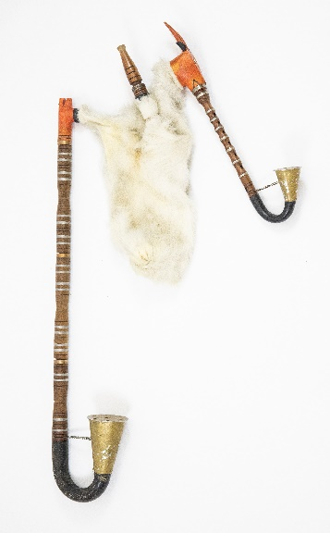
threevoiced gajdy (Slovakia) | 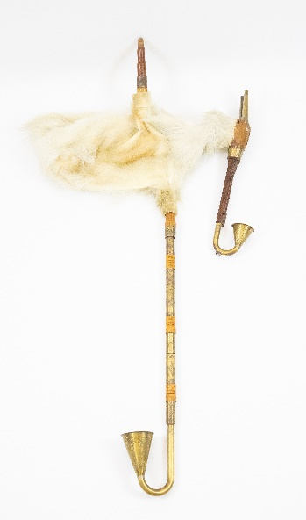
torupill - Estonia (with a white leather storage bag) | 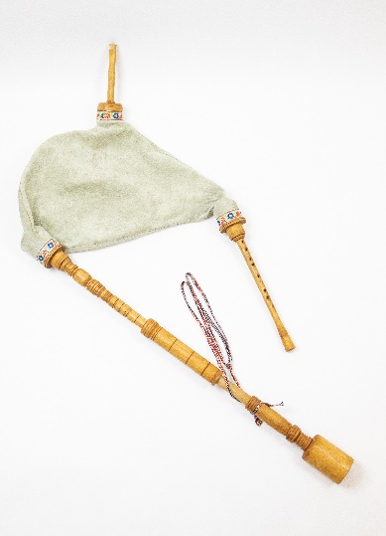
torupill – Estonia (with a grey textile cover) | 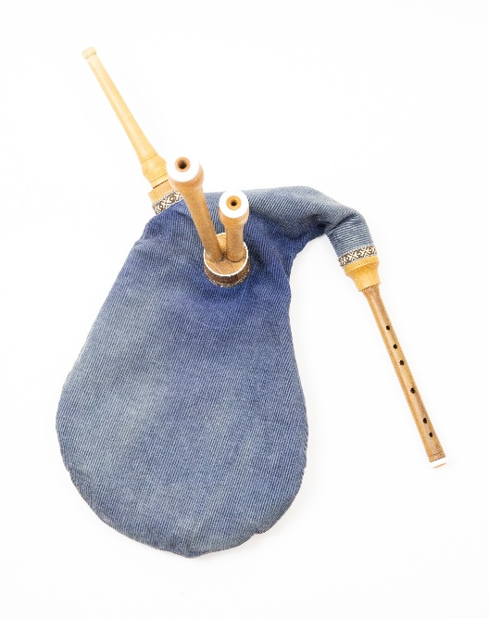
tulum – Turkey (with a white leather storage bag) | 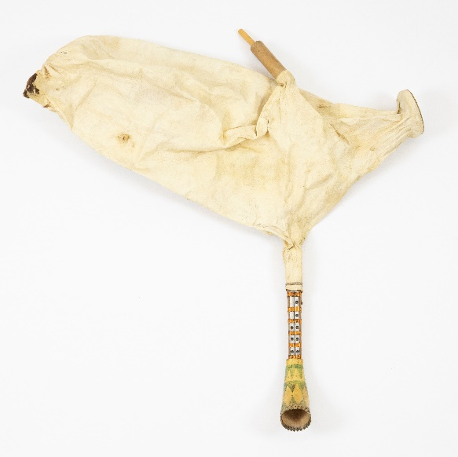
tulum – Turkey (with a blue textile cover) | 