BOSQUE / WOODS

Catarina Saraiva PT
Clarice Lima BR
Nina Fajdiga SL
Aline Bonamin BR

TECHNICAL RIDER & EXTRA INFOS

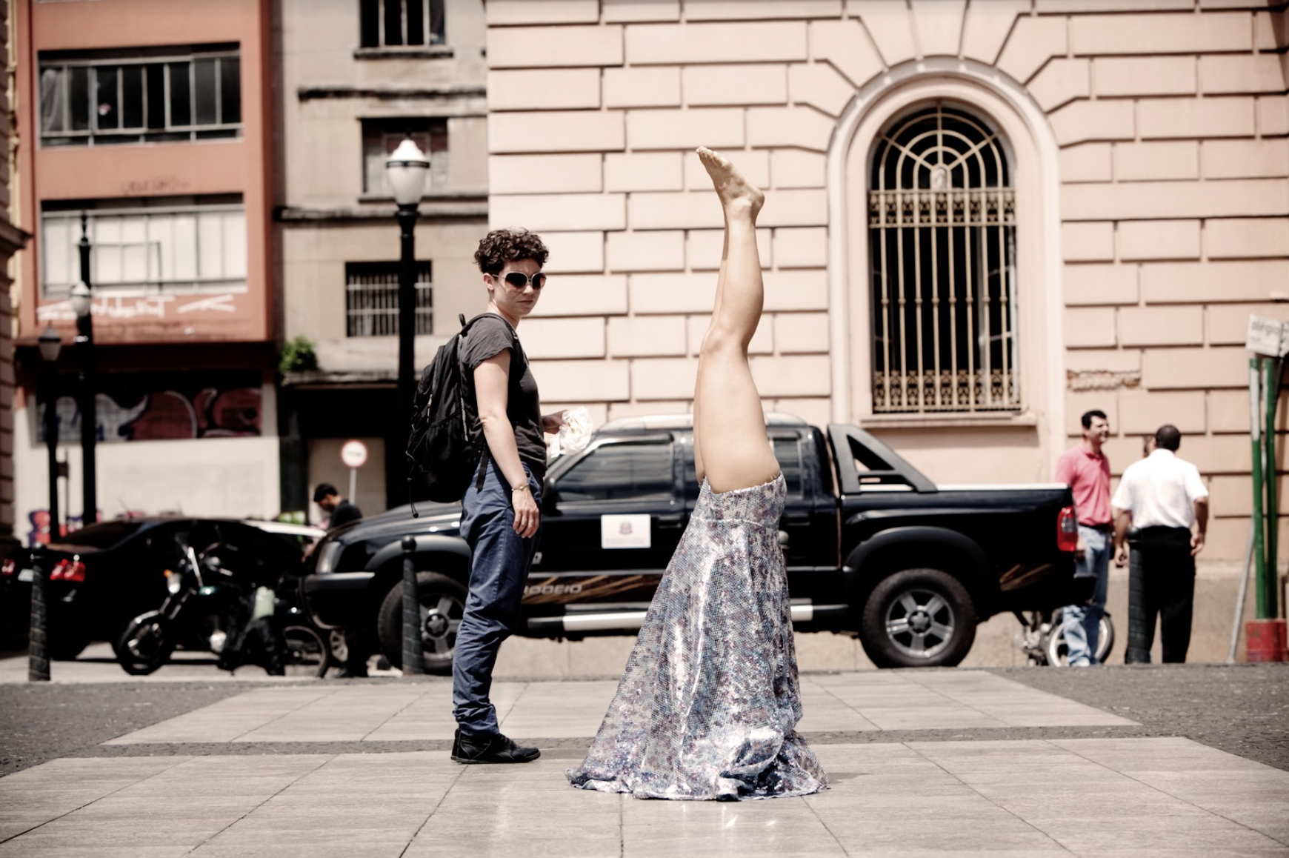
Árvores/ Trees, Clarice Lima © Patrícia Araujo

PERFORMANCE
For the performance the only thing we need is a large place with flat floor without any inclination, preferably smooth, but can be done in any kind of floor such as connect, wood, medium or large stone floor, sand, grass and similar. The size of the space must be decided according to the number of participants.

We don't use stage lights or sound systems and we don't have any fixed set to be placed on the space before the performance and don't leave anything on the space after the performance. We need a place nearby to the performative space to change costumes and get ready.

To help to understand the performance area we did some drawings that you can see below.

1. ILHA A: Performance with 40 participants (maximum) in a square space
Performance area: 25m x 20m

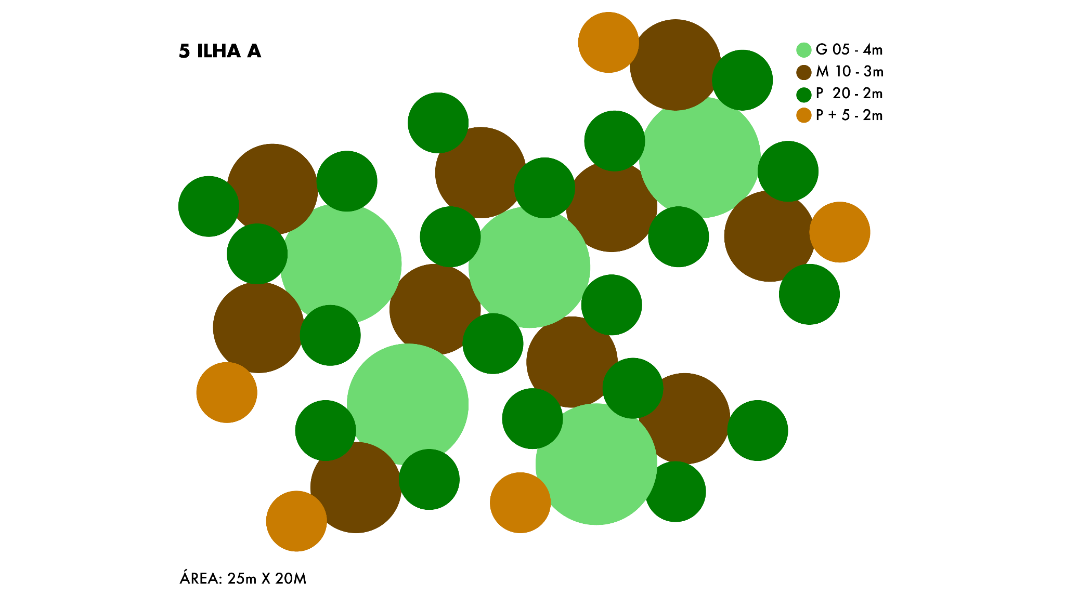

2. ILHA B: Performance with 40 participants (maximum) in a narrow space
Performance area: 35m x 15m
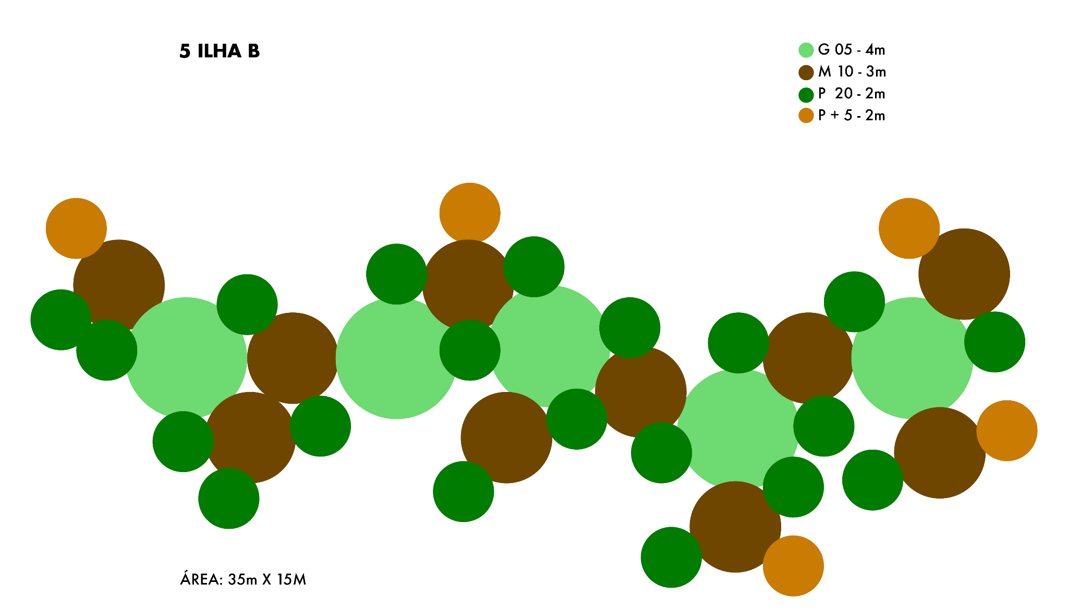

3. ILHA C: Performance with 15 participants (minimum) in a square space
Performance area: 13m x 10m
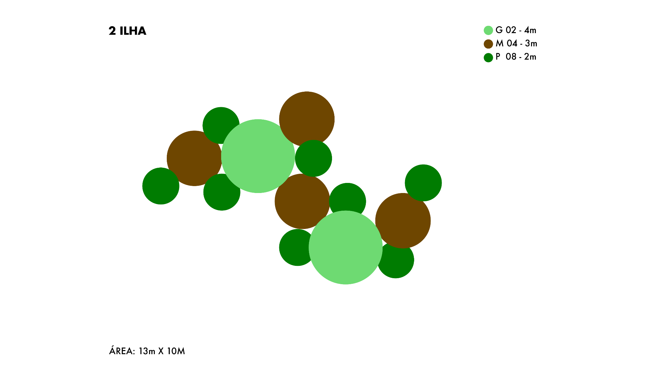

WORKSHOP
The workshop can be done in any kind of room with a flat and smooth floor that can accommodate up to 40 people. We need a sound system.

EXTRA INFORMATION

Space
Bosque/ Woods is a performance for open air but can be done indoors, in a place where people naturally pass by, a place in between places. This is to say that it can be done in interior patios but also - in case of rain - closed/indoor space such as museus ou cultural centers as long as they are passageways. This is a piece for contemplation, where the public can be called to a place, but also wants to take the audience by surprise, people who pass by and who risk stopping for a moment and looking at the forest. The performance can be done each time in the same location or in different locations. We always must have a second location/ plan B in case of rain.

With all this information in mind, the host must suggest the location of the performance, take pictures and discuss it with the Choreographer remotely so we can decide it in advance.

What kind of space and methodology to locate it
- We need a large space with a flat floor and natural light.
- If we do it in the open air, in the city, we look for a place where we have a big flux of people passing by and not so much nature in it.
- If we have to do it in interior patios or indoors spaces we look for places where people naturally pass by, a place in between places such as the atrium of museus or cultural centers.

What kind of public space permissions do we foresee needed
- It depends on the city laws and we must check together with the venue if it's needed or not.
- The performance can last 30 minutes maximum.
- We don't have a fixed set to be placed on the space before the performance.
- We don't leave a fixed set on the space after the performance.

Will there be the need for hiring security
- No need for hiring security.

Open Call
In order to bring local people to join the performance an open call must be launched by the host. The workshop isn't aimed at professional dancers but to people that know how to do a headstand, this is the only prerequisite to participate.

The open call must be widely publicized in order to reach different people, with different experiences such as dance, yoga, hiphop, capoeira, circus, gymnastics and so on. It's important to have diversity of people doing the performance as we have diversity of plants in a forest. We know that it's not a easy task to gather 30 to 40 people that already know how to do a headstand so there is also the possibility of partnerships with Dance Schools, Yoga Studios and or other local organizations that practice the head stand to be sure we have enough participants and still be open to whoever wants to mix and join the experience.

We believe that these people should be compensated for their participation but if it is not possible to pay a symbolic fee for each, we ask for them to have access to the meeting point, meal per each day of work, transport subsidy if they need to move and insurance, taken care by each venue.

Open Call example
Let's turn the city upside down!!
We want you to join the performance Woods, an artistic call for environmental awareness, a research that brings together dance, live performance and visual arts to create unique and powerful landscapes in the cities, pursuing the idea of impermanence and instability of the body, nature, climate and collective practices. While upside down, the body inverts space and questions time. For how long can the body resist? For how long can the forest resist?

This open call is addressed to non-professional that practice headstand such as students of dance, yoga, hiphop, capoeira, circus and gymnastics, including all genders, colors and ages, to make this a vast forest. Together in a two day workshop we'll talk about the concepts of the piece, practice the upside down posture and rehearse the choreography structure. We'll exchange strategies, helping and supporting each other in order to engage all the participants in this project as a collective act against the city concrete, the lack of nature, the climate changes, the missing trees and the forgotten woods.

Workshop

The preparation and participation of the participants is done in a two days workshop, working 4 hours per day where we talk about the concepts of the piece, practice the upside down posture and rehearse with the costume the choreography structure and composition. During the workshop we exchange strategies, helping and supporting each other in order to engage all the participants in this project as a collective act, managing the diversity and desires of the group of local people.

The headstand posture can be done in two ways: with the top of the head and the hands (1) or with the top of the head and the forearm (2).

1. 2.

Duration: 2 days / 4 hours per day
Minimal participants: 15
Maximal participants: 40

