Pilsen, 26th April 2022

ÍMulWOl ÍLÍČUtCll

Ï* uiímtiiuMi

VMUtttn «/

**Supplier:**

Department of Electronics and Technology

University of West Bohemia

ID: xxx, Tax number: xxx

**Contact person:**

xxxxx

Tel.: xxxxx

Email: [xxxx](mailto:burianp@fel.zcu.cz)x

**Customer:**

Ing. xxx

Institute of Experimental and Applied Physics **Czech Technical University in Prague** xxxxx

**Quotation: Quad Timepix3 chipboards**

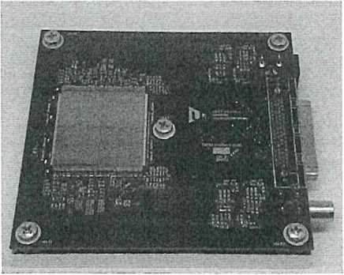

The price does not include VAT. Timepix3 detectors are not included.

**Subject of delivery:**

Quad Chipboard for quaternion of Timepix3 detectors: PCB, aluminum holder, plastic sensor protection.

|  |  |  |  |
| --- | --- | --- | --- |
| *Subject* | *unit price* | *pcs* | *final price* |
| Quad chipboard forTimepix3 | 24 875,-Kč | 4 | 99 500,-Kč |

**Delivery anf financial conditions:**

Delivery costs are not included and will be invoiced separately. Delivery time is 90 days from receipt of the order.

This quotation is valid until 30th May 2022.