|  |  |  |  |
| --- | --- | --- | --- |
| Name/Firm | Inducon BV  Swimming pool technology | Name/Firm | ICSS Odlochovice |
| Address | Bathoorn 3  NL-9411 SE Beilen | Address | Odlochovice 1  25703 Jankov (CZ) |
| Contact person | Service Department  Tessa Hammingh | Contact person | Jana Petranova |
| E-mail | Service@inducon.nl | E-mail | [petranova@icsso.cz](mailto:petranova@icsso.cz)  [saturka@icsso.cz](mailto:saturka@icsso.cz)  IČ 70875324  VAT CZ70875324 |
| Telephone | +31 593 745 041 | Telephone | +420 777 981 491 |
| Chamber of Commerce | North Netherlands 0402 5356 |  |  |
|  |  |  |  |
| Subject | Maintenance contract moveable floor | | |
| Offer number | 07649 | | |
| Your reference | ICSS Odlochovice | | |
|  |  |  | Beilen, 18-02-2022 |

## General

The maintenance of the movable floor takes place once a year. The price offered concerns the total annual amount for regular maintenance. If an installation is not maintained annually by Inducon, the costs for overdue maintenance are not included in the maintenance costs offered.

Maintenance can be carried out in a dry pool or in a filled pool with warm pool water. If the work is carried out with pool water in the pool, we are obliged to do this with professional divers and according to the applicable rules.

## Duration of contract

The contract has a term of five years, but the customer is free to choose whether the contract should last longer or shorter. This is laid down when the contract is concluded.

If it is desired to enter into a contract longer than three years, the contract will be indexed as of the second year. This takes place annually on the basis of the DBD index

## Diving

Inducon employs professional divers and cooperates with certified diving companies. During wet maintenance or repairs, there must be water in the pool (minimum water temperature 23 0C) and comply with the pool water that’s on quality for swimming.

During diving, at least one diver, one dive team leader and a third person (dive guard) must be present. The dive guard is needed in the event of an emergency to direct the rescue services. The third person must be in contact with the diving team leader. This can be done by being present in the same room or by using a walkie-talkie. In principle, the client is responsible for providing a third person (dive guard). If the client does not provide the dive guard, this must be known in advance. In such cases, Inducon will supply this person itself, for which additional costs will be charged.

## Maintenance and cleaning of movable floors

The maintenance includes the use of small materials (lubricants, fasteners, etc.). Small repairs and/or adjustments during the maintenance are included in the price. Any larger necessary repairs or the replacement of (worn) parts will be discussed with you beforehand and, if necessary, offered separately. After the maintenance, a report is made with the state of the installation and recommendations for the coming years. Cleaning under the moveable pool floor is only done when the maintenance is done with pool water in the pool.

During the maintenance, the following items are carried out:

* Checking the drive components, main structure and deck;
* Check for leakage in the air system;
* Checking the wear of the movable parts;
* Checking and, if necessary, adjusting of the depth display;
* Control of operating program including any updates;
* Check for rust and clean up.
* Cleaning underneath the moveable floor

The annual cost for carrying out dry maintenance*: € **2.705,00**

The annual cost for cleaning underneath the movable floor**: € **412,50**

*The amount offered includes travel and accommodation costs. The calculated travel and accommodation costs are for a combined visit in the vicinity. If the maintenance cannot be combined in the vicinity another €**1.960,00** will be charged.

**Solely in combination with wet maintenance (in a filled pool).

The annual cost if Inducon provides the third man*: € **1.650,00**

*This cost is only charged if Inducon supplies the third man.

## Additional work during maintenance

During maintenance, it may be necessary to carry out additional work offered. This could be revision work or recommended replacements from previous maintenance or residual work from service work. The costs of this are offered separately.

## Planning of the work

The work of wet maintenance (maintenance/cleaning the floor) will take an estimated 3 to 4 hours. This depends on the size of the pool and the degree of soiling during the wet maintenance. Dry maintenance will take an estimated 3 to 4 hours. Ask the Inducon service department in advance to avoid problems.

In most cases, the pool cannot be used during maintenance.

In order to be able to carry out maintenance properly and completely, we recommend reserving sufficient time for this. Incomplete maintenance carried out in one job could lead to a necessary second visit with additional costs.

## Working outside office hours

If work has to be done outside office hours, we charge the following surcharges according to the table below. This surcharge also applies to travel outside office hours.

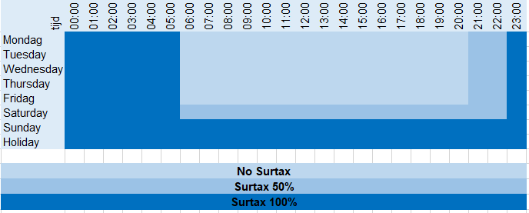

## Delivery terms

Prices: Net excluding VAT;

Delivery includes;

Assembly : Included;

Payment: 100% net at the latest 30 days after execution of the work.

Our general terms and conditions and our general guarantee conditions, filed with the Chamber of Commerce in the north of the Netherlands (Groningen) under no. 1086, apply.

|  |  |  |  |  |  |  |
| --- | --- | --- | --- | --- | --- | --- |
| Odlochovice | , | 22.2.2022 |  | Beilen | , | 18-02-2022 |
| (place) |  | (Date) |  | (place) |  | (Date) |
|  | | |  | **Inducon B.V. Swimming pool technology**  Fabian van Dorland  Bathoorn 3, 9411SE BEILEN  Phone : +31-593-332181  E-mail : [service@inducon.nl](mailto:service@inducon.nl) | | |
| (Signature of the commissioner with stamp) | | |  | (contractor) | | |