CONTRACT
Between
Agency:
Keltit Music Management
Viale Berrini, 7
28041 Arona (NO)
Italy
Representing the band: The SIDH hereinafter referred to as the ARTIST and
Promoter:

Městské kulturní středisko Strakonice
Zastoupené ředitelem Františkem Christelbauerem
Mírová 831
38601 Strakonice
Česká republika
Tel. +420 383 311 530 ,IČO 00367869
Kontaktní osoba Ladislav Řanda te. +420 601560953
hereinafter referred to as the PROMOTER.

Mutually recognising themselves full legal capacity to perform the agreement hereof WITNESS Article 1: THE PROMOTER hereby engages the ARTIST to perform in 1 musical live shows.
Article 2: The show will be held on:
Dates: 27th of August 2022
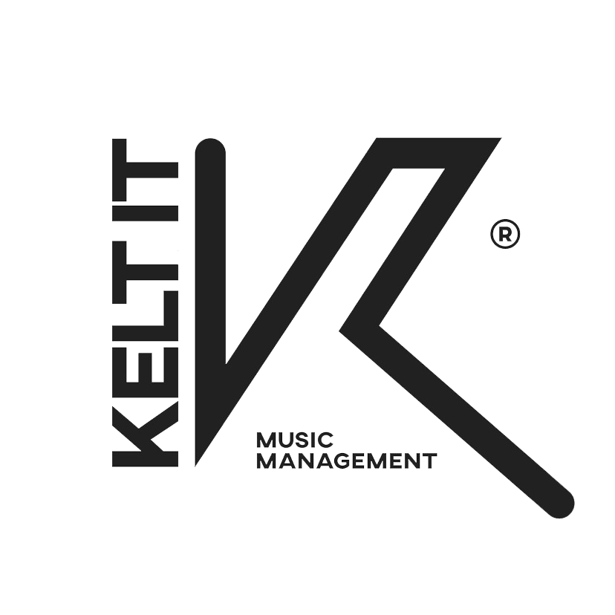
Venue: 24th International Bagpipe Festival Strakonice Adress: in CZ-386 01 STRAKONICE, U Sv. Markéty, Parkoviště u OD Baťa
(49.2604597N, 13.9034564E):
Capacity: 1500
Load In: 21:00
Sound check: 21:30
Concert starting at: 22:00
Hotel: until konw

THE ARTIST will not start performing after midnight without previous agreements. THE ARTIST is to receive star billing on all publicity releases and paid advertisements. It is also indispensable that THE ARTIST and its technical staff shall have at least 75 minutes after load in and set up to carry out Soundcheck.
Article 3: THE PROMOTER will pay the ARTIST as a compensation a fee of 5 .000 (FIVE THOUSAND) €
It is agreed and understood: that the salary to be paid to the ARTIST shall be net and free of all taxes. That all taxes have to be paid by THE PROMOTER.
THE PROMOTER will provide PA & Lights requested into the TECHNICAL RIDER + Backline (if requested by the ARTIST).
THE PROMOTER will provide a Dressing Room with specifications included into the DRESSING ROOM RIDER. THE PROMOTER will provide Accommodations for 9 People during the stay, breakfast included.
For 2 Nights: the Band is arriving one day before (26th of August 2022) and will leave on the 28th of August 2022
ROOMING LIST: 1 Singles + 4 Double (King Size bed)
Accommodations: Is required a minimum quality of 3 Stars
THE PROMOTER will provide Food for 9 People during the full stay.
Article 4: THE ARTISTS has permission to sell his merchandise (Cds, T-Shirsts, etc). THE PROMOTER will provide a Location with Table sufficiently close to the stage with enough light. THE PROMOTER doesn't require percentages on the sale.
Article 5: THE PROMOTER undertakes to comply and fulfill all regulamentation with respect to concert promotion, public performances, author’s rights and/or any other laws that might affect the agreement herein. THE PROMOTER shall -at his own cost- obtain all licences, work permits and special Sunday driving permits for commercial vehicles. Any violation or unfilfillment of the above shall be the sole responsibility of THE PROMOTER.

Article 6: This contract consists of 3 Pages. THE ARTIST shall not be responsible of any obligation whatsoever as long as this agreement hasn’t been signed in full by THE PROMOTER and has been received in THE ARTIST´s office. No provision in this agreement (including THE RIDER) can be erased, altered or by any means modified by THE PROMOTER. In the case that any alteration is agreed by both parties hereto, it shall not have any legal effect till it is properly signed in writing by the parties hereto. In the case that this agreement is returned to THE ARTIST´s office with any alterations, modifications or amendments in its original content, the agreement hereto shall be deemed null and void and THE ARTIST shall be deemed free of any obligations. Every additional clause included in the following appendix “RIDER” will constitute an integral part of this agreement. In the case that the aforementioned RIDER is not included here, the ARTISTS´s office will send it in the following days an this is assumed and acknowledged by THE PROMOTER accepting and assuming the costs of the technical requirements needed to undertake the performance by THE ARTIST hereunder.
Article 7: Any non-fulfilment of the provisions of this contract by THE PROMOTER will enable THE ARTIST to cancel THE ARTIST´s performance hereunder and to claim the full salary greed on Article 3 above and a compensations for any damage, harm or loss that might be caused to THE ARTIST.
Article 8: THE PROMOTER will pay the fee of 5.000 (FIVE THOUSAND) € to be paid in TWO payments behalf of invoice from artist:
- 50% of the total amount, within 15 days from the day of signing the contract; – - 50% on the first working day after the performance.
THE PROMOTER WILL BE RESPONSIBLE FOR THIS END PAYMENT.
THE PROMOTER acknowledges that the PAYMENT MUST BE EUROS, in the date and time that have been agreed with no kind of delay whatsoever and, if any delay occurs, THE ARTIST shall have the right to cancel THE ARTIST´s performance hereunder without damage of any of the rights THE ARTIST is entitled, too.
Article 9: Any VISA, airport tax, tax on with holding will be provided by and taken care by THE PROMOTER.
Article 10: THE PROMOTER agrees to hire at his own cost, enough security personnel to guarantee the safety of ARTIST against loss or injury due to lack of protection backstage, onstage and in the auditorium. Promoter is also responsible for all security with respect to onstage equipment, trucks and others vehicles belonging to THE ARTIST, with enough parking facilities always available. The PROMOTER shall be held responsible, before, after and during the show, for any damage or theft caused to the ARTIST's equipment and caused, even by unknown persons, within the Venue/Festival.
Article 12: In the event of any radio or TV broadcast related to THE ARTIST or its performance prior written consent from THE ARTIST ´s office will be needed. Interviews are welcome, but the ARTIST´s office will be informed in writing prior to the concert date.
Article 13: THE PROMOTER acknowledges and understands that, in case could not be undertaken by the following causes:
- - The Stage floor being wet or very humid.
- - Heavy Rain, Snow or Water snow precipitation
- - Unalterable bad conditions of accesses to the stage (mud, puddle) so it prevents from loading and/or unloading.
- - Considerable Delay or Cancellation of Flights/Trains necessary to arrive at the venue.
THE ARTIST will have the full right to cancel its performance and, notwithstanding, receive a percentage or the full salary agreed in Article 3.
Above considering the PROMOTER is able to establish whatever technical mediums he might consider appropriate, agreed with the ARTIST, in order to prevent the above happening. The aforementioned situations do not enable THE PROMOTER to propose an alternative venue due to technical reasons.
Percentages due to the artist in case of cancellation:
- 50% of the entire fee previously agreed in Article 3, in case the exhibition is canceled after the contract has been signed.
- 70% of the entire fee previously agreed in Article 3, in case the ARTIST has arrived to the Location of the exhibition but could not be able in doing the SOUND CHECK.
- 100% of the entire fee previously agreed in Article 3, with SOUNDCHECK concluded.
Article 13/bis: Force Majeure (COVID - 19)
If, after the conclusion of this contract, circumstances of force majeure occur, the deadlines for the fullfillment of obligations will, if possible, be moved to a date when it suits all actors.
Force majeure means extraordinary and extreme events that cannot be foreseen, which happened without the will and influence of the contracting parties and which could not be prevented.
The contracting party affected by force majeure will promptly notify the other party to the Contract in writing about the circumstances caused by force majeure and provide the appropriate proof.
If, in case of a worsening of the epidemiological situation and introducing special measures due to the Covid-19 pandemic, the implementation of the artistic event is prevented, the contracting parties will make efforts to reach an agreement for the performance to be moved to a time when it suits all actors, which will be regulated by a special contract or annex to the contract.
If it is not possible to reach an agreement on the subsequent performance, the ARTIST undertakes to refund the amount paid so far to the Contracting Entity, with the exception of any expenses advanced by the artist, such as: Taxes, Flight tickets, any vehicle for rent, etc which THE PROMOTER must already be aware of, within 7 days from the date of receipt of the written notice by the Contracting Entity. The contracting parties agree that after the payment of the refund, there will be no further mutual requests and/or claims under this contract.
The fee for the service performed by the Tenderer in case of postponement remains unchanged, and the Contracting Entity is responsible for any additional costs that may arise due to postponement.
In case of postponement of the performance referred to in the previous paragraph of this Article, the contracting parties shall conclude an annex to the contract.
Article 14: THE PROMOTER will provide THE ARTIST, when he requires it and free of any charge, 10 tickets or invitations or FreeEnterPass with seats in preferred locations to attend each of the performances hereunder. The tickets are meant to be exclusively used by THE ARTIST and/or THE ARTIST´s office. THE ARTIST agrees to give back to THE PROMOTER all the invitation tickets unused (if any) before the time scheduled for the performance to begin.
Article 15: THE PROMOTER shall not, by any means, negotiate any support from a Sponsor with Political / Religious purposes regarding THE ARTIST or the performance herein without previous written consent from THE ARTIST.
Article 16: This contract can be unilaterally terminated in case the obligations of this contract were not fulfilled, as well as in other cases prescribed by law.
This Contract can be terminated by mutual consent.
In case of termination of the Contract by mutual agreement, the Contract will define mutual rights and obligations, regarding the unfulfilled obligations under this Contract.
The laws of Italy shall apply to this agreement and all its terms shall be construed in accordance herewith. If, by any means, any of provisions in this agreement was deemed null or void, all other provisions herein shall be deemed valid an the aforementioned null provision shall be re-written by agreement of the parties hereto. For any dispute the competent court is the one in: Milan.
KELTIT MUSIC MANAGEMENT THE PROMOTER
DATE DATE 22.02. 2022

