Attachment No. 1 – Specifications of the System

Contents
1 Introduction 3
1.1 Definition of Abbreviations and Terms 3
1.2 Situation Description 6
1.3 The Objective of Implementing BIM in the Czech Republic 8
1.4 Subject of Tender 8
2 requirements for the ISDSBIM system and the Administration Module of the ISDSBIM 10
2.1 General system requirements for the ISDSBIM and the Administration Module of the ISDSBIM 10
2.2 Creation and Administration of Property requirements 13
3 requirements for the Publicly Accessible Module with the Last approved Published Version of the DSBIM 16
4 requirements for the API ISDSBIM Module 16
5 Non-Functional requirements 17
6 CBT Data Model 21
6.1 IFC_Class 21
6.2 IFC_Property_Set 22
6.3 Generic_Property 23
6.4 IFC_Property 23
6.5 X_Property_Set_Class 24
6.6 X_Property_Set_Property 24
6.7 POSV_System 24
6.8 X_Property_POSV 25
6.9 Document_Type 25
6.10 Document_State 25
6.11 Document_TNK 25
6.12 STD_Document 25
6.13 X_Property_Document 26
6.14 STD_PRJ_Phase 26
6.15 STD_Repres 26
6.16 STD_BIM_Use 27
6.17 STD_Phase_Use 27
6.18 STD_Property_Set_Index 27
6.19 STD_Data_Needed 27
6.20 BIM_User 27
requirementrequirementrequirementrequirement

Introduction

Definition of Abbreviations and Terms
This item defines the abbreviations and terms used in this Attachment No. 2 of the Contract for the purpose of specifying their use in this Attachment No. 2 of the Contract.
Agency/Contract Owner/CSA – Czech Standardization Agency, state-funded institution
Biskupský dvůr 1148/5, 110 00 Prague 1, Company Identification No.: 06578705
API – (Application Programming Interface) – the interface for programming applications for accessing the DSBIM.
“BIM” - BIM (Building Information Management) - The standard Czech equivalent is “Informační management staveb”. This designates the management of the design, construction, and management of buildings, which uses electronic object-oriented information.
bsDD – buildingSMART data dictionary.
buildingSMART - This organisation was established in October 1995 in the USA, originally under the name IAI (International Alliance for Interoperability). It is an alliance of organisations dealing with the construction of buildings and with facility management. The main objective is to define shared information about a building throughout its entire life cycle. The organisation brings together architects, engineers, contractors, investors, building owners, SW producers, state institutions, research laboratories, universities, and other members. It contributes to the creation of ISO standards for “BIM”, and its local chambers often collaborate with governments when creating policies and plans. The Czech Republic does not have its own representation within this organisation; however, many “BIM” experts are in contact with the members of this organisation.
CBT – the CSA BIM tool - the tool that the Agency is temporarily using for recording properties, property sets and data templates formed form property sets. Contractual delivery also includes the data transfer from this temporary tool to the System.
CPR – Construction Products Regulation – Regulation (EU) of the European Parliament and of the Council 305/2011
ČSN - a protected designation of Czech technical standards. The creation and issuance of ČSN is currently provided by the Czech Office for Standards, Metrology, and Testing (OSMT).
–building information model - is a structured and object-oriented representation of a building or its part, containing representations of individual building elements with their properties and graphic form required for the required display. It is usually formed as an output from software tools designed for the design phase of a building.
ISDSBIM – The Information System of the Data Standard for Building Information Model, which manages the property requirements of data objects of the Building Information Management system, and ensures the presentation of data templates of property requirements for individual types of data objects of the building information model (e.g. building entity, premises, physical object, abstract elements).
DS - data standard (general term) - a set of requirements for data.
DSBIM – The data standard of the Building Information Model - a set of property requirements, their groups, and other related data of Building Information Model. The DSBIM is comprised with data templates for the necessary data objects of the building information model requirement.
Phases of the Construction Project - the parts of the work resulting from dividing the construction project according to a certain programme or agreement; the division may also stem, for instance, from legal requirements.
Geometric Data - data that determines the spatial information (placement, shape, and relation) of a building in relation to other buildings. They can be in the form of a vector or of a raster data model.
3D model – see the term Geometric Data.
GUID – A unique identifier generated to identify a specific property, property sets, or a data template. The identifier is generated by an algorithm in accordance with the ISO/IEC 9834-8:2014 standard.
IFC - IFC (Industry Foundation Classes) - the data format for data sharing in the construction sector and in facility management. The IFC format is used to exchange and share data about a building between applications developed by various software manufacturers. IFC specifications are focused on supporting the various fields that contribute to the construction project during the entire life cycle of the building. The definition of IFC is given in ČSN EN ISO 16739:2017
Classification system - The systematic organisation of classes and sub-classes for building entities and complexes, construction premises, technical and functional systems, including classes of individual types of construction elements and products.
MIT - Ministry of Industry and Trade of the Czech Republic, Na Františku 32, 110 15 Prague 1, Company Registration No. 47609109.
Non-geometric data - descriptive information, properties, and attributes or time data describing the qualitative and quantitative characteristics of the building.
Area – defines the area of expertise for which always one group of experts is nominated to approve the property requirements of said area within the course of the approval process.
Provider – the party entitled to the property rights to the System; the party that provides the System to the Agency based on the Contract.
r/o – read only – meant solely for reading.
r/w – read write – meant for reading and recording / amendments.
Contract – the contract for services rendered, based on which the Provider provides the System to the Agency under the conditions given in these technical specifications.
Property Set – The list of separate properties for the given building.
Construction Element (the element) - part of the construction that has a characteristic function, whether by shape or location, e.g. floor constructions, wall constructions, road constructions, etc. (source: ČSN ISO 12006-2) that is comprised of one or more construction products and that is usually designed by a project architect uniquely for each given project.
Construction Product - a product meant for permanent installation into a building, e.g. products of support and division, for technical equipment, etc.
System – the computer programme, the acquisition of which is the subject of performance of the Contract. The system consists of
- the administration module of the ISDSBIM,
- the publicly accessible module with the last approved published version of the DSBIM,
- the API ISDSBIM Module.
Use - The act of creating a Building Information Model for a specific purpose (for example, visualisation, technical analyses, collision control, checking legislative requirements, pricing, recording the actual realisation, making budgets).
Data template – Set of properties defined either directly by a list of properties or by including property sets.
Property – non-geometric information (attribute).
Administration Module of the ISDSBIM – the module of the System that makes up the work environment for administrating the DSBIM. This module is the primary work environment for users editing data and approving the proposed changes.
Publicly Accessible Module with the Last approved Published Version of the DSBIM - the module of the system enabling the presentation of the approved and published DSBIM.
The API ISDSBIM Module - the module of the System that provides the computer interface for r/o access to the ISDSBIM.
Source – designates the document from which the element was created.

Situation Description
On September 25th 2017, the Czech Government passed its Resolution No. 682, approving the Policy for Introducing the “BIM” Methodology in the Czech Republic.
The resolution was prepared by the Ministry of Industry and Trade, which is the guarantor for implementing BIM in the Czech Republic in cooperation with the Expert Council for BIM and the State Fund of Traffic Infrastructure. The document was presented based on Government Resolution No. 958 on the Significance of “BIM” for Construction Work in the Czech Republic and Proposal for Further Steps in its Implementation of 2 November 2016.
The Policy outlines the state of implementing “BIM” in Europe and in the Czech environment, it delineates key issues associated with “BIM” that we must deal with, and it contains the Plan of Gradual Implementation of “BIM” in the Czech Republic for the years 2018 - 2027, including the recommended measures to be taken so that this method can be commonly and effectively used.
On 25 September 2017, the Government of the Czech Republic adopted Resolution No. 682 on the Policy of Implementing the “BIM” Methodology in the Czech Republic. Based on this resolution, the development of “BIM” in the Czech Republic is in the competence of the Ministry of Industry and Trade. The Ministry of Industry and Trade, as the administrator of the implementation of “BIM” in the construction practice of the Czech Republic, needed a partner to ensure such a far-reaching expert task that touches upon many sectors, one that will assume the role of an independent, expert guarantor throughout the course of the “BIM” Policy realisation. For these reasons, the partnership between the MIT,UNMZ and the Agency was established.
One of the basic components for the implementation of “BIM” in the Czech construction sector is the specification of data requirements for entering and delivering building information modelling, especially in terms of the public contracting authority, yet also with a serviceability for other buildings outside of the public sector. Thanks to the standardisation of the shared information, this shall contribute to a greater degree of automatization in all processes related to the whole life cycle of the building. The creation of the DSBIM is in the competence of the Agency.
The following text describes in what way the specification of property requirements of the data object of building information model.
The creation of the DSDBIM is one of the key tasks of the Policy of Implementing the “BIM” Methodology in the Czech Republic (hereinafter the “BIM Policy”), adopted by Government Resolution No. 682 of 25 September 2017. The realisation of this project meets Action No. 9 - Creating a Standard of LOI and LOD extent for Each Phase of Building Documentation Creation and Action No. 11 - Creating Databases for the Property requirements of Construction Work, of which the MIT is the administrator, in accordance with the Annex to Government Resolution No. 682/17.
Governance system maintaining the property requirements of data object of the building information model requirement shall serve as a tool for the digitalisation of the required information about construction products and construction elements and shall create suitable conditions for the widespread use of the BIM methodology in practice. The resulting DSBIM shall contain both the graphic design requirements of model elements (the graphic part of the DSBIM), as well as the non-graphic lists of properties (the non-graphic part of the DSBIM) necessary for assigning data to each role of participants involved in the construction process throughout the entire life cycle of the building. They, in turn, will have the data and information they need for their tasks at their disposal. The periodically published outcomes of the ISDSBIM will be the DSBIM (the Data Standard for Building Information Model - the set of property requirements, their groups of designated types of data objects of building information modelling, and related information for use in the construction sector). The ISDSBIM will only administrate the non-graphic requirements of the DSBIM.
Since one of the sources of requirements will be harmonised standards according to the CPR, the ISDSBIM will be a fundamental platform for the management of information necessary for creating implementing regulation stemming from the Act on Construction Products and their use in buildings. Therefore there is the requirement of database processing, which is a safe and effective solution for meeting the task in the desired time period and with a minimum level of error in terms of the complexities of connections, the extent of the designs, and the need for future continuous updates. This objective also meets the requirements of the digitalisation of the state administration. Once the regulations for creating Czech legislation shall allow it, the legislation for construction products will contain direct links to the pertinent sections of the database administrating product properties.
The primary target group of ISDSBIM is the public administration, primarily in the role of contractors, users, and facility managers. The system will allow them to specify the digital, structured requirements for the contents of information models. Thanks to this, they will have the opportunity of monitoring the entire process in a better quality and standardised manner, thus gleaning information from it for future, more effective facility management.
In general, the target group that will use the ISDSBIM is the entire Czech construction sector - from the producers of construction products, to the project contractors, project architects, building constructors, all the way to facility managers. The expert public requires a uniform data standard and access to it so that the participants of the construction process can share data reliably and rapidly. Launching operations of the ISDSBIM will also be a fundamental source and impulse for the providers of software to adjust their software layouts and to work with data in an identical structure.
The DSBIM will determine the basic requirements for the preparation of building information models. At the same time, it will determine the specifications of model contents to a greater extent, necessary when preparing each phase of a building’s life cycle, while providing the required levels of detail and meta-data.
Furthermore, the DSBIM specifies the requirements for the structures of models, data, their extent and quality, and the level of detail for each of the phases of a building’s life cycle and for each separate application. The data standard allows data sharing between each individual participant.
The general architecture of the DSBIM is in accordance with the prepared European standard, the Level of Information Need (prEN 17412:2019). This is a standard that is being elaborated by work group CEN/TC 442 WG2. This prepared standard defines the basic principles for the creation of data standards and their contexts.
The requested ISDSBIM should serve the purpose of creating, administrating, and purposefully sharing data templates, not for the purpose of sharing information on individual commercial products.
Because of the project schedule and the necessity of working on the DSBIM prior to having the ISDSBIM available, the Agency is currently using the temporary “CSA BIM tool” (the CBT) to create the DSBIM. Therefore, part of the system requirements for the ISDSBIM is the data transfer from the CBT.

The Objective of Implementing BIM in the Czech Republic
The system will serve as a basic building block in the development of the “BIM” methodology in the Czech Republic, and should meet the following objectives:
- In a managed manner, allow the agreement of all participants of construction projects as to the extent of the data object of building information model depending on the role, phase, use, and classification.
- In a digital form, procure and further manage the definition of construction products and element properties determined by valid international and national standards and legislation valid within the territory of the Czech Republic.
- Ensure interactive access to the DSBIM using web services, both using a user environment in a browser, as well as directly using software tools with the help of the API ISDSBIM Module.
As a part of the implementation of the system, the Agency requires the following tasks to be met:
- Implementation and launching (making accessible) of the ISDSBIM System (the following modules).
- Data transfer from the CBT.
- Support of making local versions of the user interface of the System by translating it into Czech language in case it is a foreign System; the translation will be carried out by the Agency itself, while the Provider shall ensure the technical solutions enabling the translation. If the technical solutions shall not enable the Agency to enter the translation directly into the System, that is, if the cooperation of the Provider is necessary to enter the translations, the Agency requires that the Provider enter the translations, even repeatedly, without entitlement to remuneration (see the Contract).
- Settings of the necessary codebooks.
- Settings of the safety model and the needed workflow.

Subject of Tender
The objective of the tender is to ensure the purchase, implementation, and ensuing operations of the ISDSBIM.
The requested ISDSBIM shall consist of the following three modules, where the term “module” means a set of requirements for functionality; the term “module” is used as the terminological designation without any binding character for the System architecture. The modules in question are:
- Administration Module of the ISDSBIM – the System module that provides the work environment for administrating the ISDSBIM. This module represents the main work environment for users that propose changes, edit data, and approve the proposed changes.
The Administration Module of the ISDSBIM is an integral part of the System. Therefore, the description of the requirements for the Administration Module of the ISDSBIM also includes the general requirements for the system.
The requirements for the general functionality of the System and the functionality of the Administration Module of the ISDSBIM are described in Chapter 2.
- Publicly Accessible Module with the last approved Last approved Published Version of the DSBIM - the module of the system enabling the presentation of the approved and published DSBIM.
The requirements for the functionality of the Publicly Accessible Module with the Last approved Published Version of the DSBIM are described in Chapter 3.
- The API ISDSBIM Module - the module of the System that provides the computer interface for r/o access to the ISDSBIM.
The requirements for the functionality of the API ISDSBIM Module are described in Chapter 4.
The relation of the aforementioned requirements to the subject of performance and the required modules are shown in Figure No. 1.

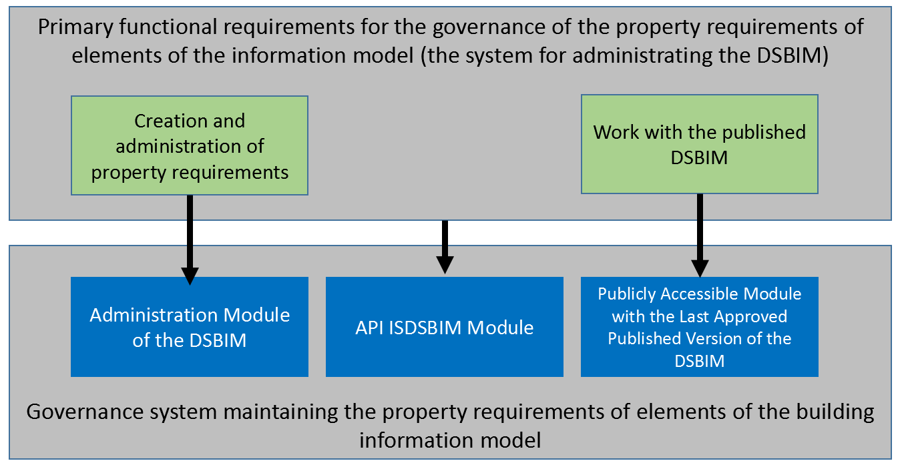
Fig. 1: Relation of tasks and System modules
Figure No. 1 describes the relation of the main functional requirements for the governance of the property requirements of data objects of building information model (the system for administrating the DSBIM)requirement, which are depicted as rectangles with green backgrounds, and the main modules of the System, which are depicted as rectangles with blue backgrounds.
The subject of performance of the Provider is:
- Delivery of the Administration Module of the DSBIM.
- Delivery of the Publicly Accessible Module with the Last approved Published Version of the DSBIM.
- Delivery of the API ISDSBIM Module.
- Data transfer from the CBT, training, and initial settings.
- Implementation and operations of the System as given by the Contract.
- Cooperation in data transfer to any eventual providers of similar services.

Requirements for the ISDSBIM system and the Administration Module of the ISDSBIM

General system requirements for the ISDSBIM and the Administration Module of the ISDSBIM
- Data transfer from the CBT. During the transfer, the data integrity of the original data must be maintained, including integrity of codebooks.
- The system must allow the creation and administration of the DSBIM, and then publish it separate consecutive versions. The Agency shall accept the fact if the only version made publicly available will be the last approved and publishable version.
- Every data entity must exist in the System in all its versions. This functionality is key in terms of creating links while working with the DSBIM. Links must be targeted between each version. The DSBIM will evolve and develop. An overview of each of the versions will be key for the reliable provision of information about the changes.
- The data of each version must meet the conditions of referential data integrity, where the published version is guaranteed to be stable and unchanging so that it is possible to cite it in contractual and other documents.
- The System enables all texts in the DSBIM to be multilingual. To enter the text in another language, the System allows the user to select the language from the language code and enter the text in the language selected. The language codebook must be modifiable by the System administrator.
- The System must enable the proposal of changes to the draft version of the DSBIM. The Systems saves all information and can show individually proposed past changes. More authors can suggest changes in parallel.
- For the main data entities (the property requirements, property requirement sets, and data templates), the System must record at least the following attributes:
  - short title (multilingual),
  - full title (multilingual),
  - technical definition - technical description from the binding document, e.g. a standardstandard,
  - user description - text in the form of commentary in the user’s own words,
  - examples of values – examples of the values that the entity can have,
  - documents - the System enables attaching any documents to the data entity, whether by selecting them and saving them to a server (uploading them), or by links,
  - unique identifiers (GUID)
    - of the entity no matter its version,
    - its concrete version,
    - of the entity in the data dictionary service (for example, bsDD).
- The System must entail the following data entities:
  - Property requirements: Represents the requirement of the existences of properties or even concrete allowable value (or a list or interval of allowable values) for the construction element (for example, window, wall, room). Aside from the attributes mentioned above, the System must also record at least the following
    - data type (e.g. number, text, date),
    - value type (e.g. length, weight, electricity),
    - measurement units (e.g. m², kg·m·s⁻² etc.),
    - related documents and type of relation,
    - measurement method,
    - example of value,
    - list of allowable values (if it is a list),
    - associated examples of use,
    - relevant data objects categories,
    - source determination (standard, legal regulation, etc.)
    - GUID for binding to data dictionaries.
The option of attaching relevant documents must exist.
  - Set of Property requirements: Logical groupings of property requirements according to their functions or other relationship. The system must ensure the option of assigning one property to any number of property sets.
  - Data template: requirement data templates shall group the aggregate property sets so that it is possible to work with them further when approving proposed changes and when publishing each version. Data templates can be classified in any number of classification systems saved in the System. At the same time, it is possible to assign any number of documents from their codebooks to them. The option of attaching relevant documents must exist.
  - Property requirement in requirement Templates bound to a milestone: The System must enable property requirements in each of the data templates to be bound to definable milestones in the building life cycle.
  - Property requirement in requirement Templates bound to a classification: The System must enable property requirements in each of the data templates to be bound to items of one or more classification that will be used in the system, and that on any of the hierarchy levels.
  - Property requirement in requirement Templates bound to an actor: The System must enable property requirements in each of the data templates to be bound to individual actors of the process, whether in the role of the party requiring the data or the role of the party supplying the data. The basic implicit actor is the public contractor, who creates the demand for the data that are to be supplied to them.
  - Property requirement in requirement Templates bound to data use: Using the same principle as with milestones, the specification of requirements in data templates using another codebook consisting of data use must be enabled.
  - Property requirement in requirement Templates mapped to the property of an IFC-format data entity: The System must enable property requirements in each of the data templates to be mapped to the pertinent IFC format of the property, and in the case of their absence, to enter them into the IFC chart in the System in accordance with its definition by ČSN ISO 16 379.
  - Milestones of the Building Life Cycle: The System must enable the Administrator to define individual milestones during implementation.
  - Data use (usecase): The System must enable the Administrator to define individual cases of data use during implementation.
  - Classification Systems: The System must enable the use of more than one classification system at once. The property requirements, as well as their sets and templates, can be classified. Each class of the classification system must be represented in the hierarchical structure. The Agency must have the option of creating and administrating classifications.
  - Documents: To ensure adherence to the legislation, technical standards, and other documents, the System must allow documents to be entered into the System and to assign documents to the property requirements and the data template. When assigning, there must be the option of specify a specific place (chapter, item) in the document. The System will include a document codebook, in which every document will be recorded by describing its attributes and with the option of saving and downloading the full version of the document. The documents will be assigned from this codebook.
- The System must enable the administration of authorisations bound to the roles listed below, and not to the person of the user:
  - DSBIM User - e.g. the expert public, public contractors. Based on the requirement Template, they create their own sets of property requirements, which they can use to communicate with sub-contractors, or in contractual relations.
  - Draftsman - proposes new property requirements or their adjustments.
  - Member of the Expert Committee - checks the element’s conformity with the real world. In general, the role of the Expert Committee is one of supervision (material relevancy, aspect of non-discrimination, duplicity, conformity with standards).
  - Member of the Supervisory Committee - as a member of the Expert Committee + decides about disputable proposals if the Expert Committee should not come to an agreement.
  - Administrator of the DSBIM Versions - administrates and creates expert groups for each of the expert fields, publishes each individual version of the DSBIM
  - User Administrator - can create, delete, and edit users of the System. Assigns roles to others, can reset passwords.
  - User Administrator - can limit (e.g. block) access to users who use the System in an unauthorised manner, or in a manner that encroaches the other users.
- In all places that any sort of codes will be used, the Agency must be able to adjust said codes. These adjustments must be part of the version control so that the data integrity is not affected also for the administrative processes of the DSBIM, nor shall the data integrity published in any previous DSBIM version be affected.
- The System will implement methods to prevent the creation of duplicate versions; furthermore, it must implement a mechanism for identifying and solving any eventual duplicates (for example by merging and adjusting the pertinent references).
- The System shall enable the monitoring of relations between items in the codebook and the data that use it.
- The System must meet the requirements of EN ISO 23386:2020 and EN ISO 23387:2020.
- The System must be interoperable with data and services in accordance with ČSN EN ISO 12006-3.
- To ensure interoperability and the option of adhering to the European and international standards and expertise, the System must enable the use of data from data dictionaries in accordance with ČSN EN ISO 12006-3 for the presentation to users and for creating any eventual structured reports. As of the date of the Contract signature, the Agency requests the use of the dictionary buildingSMART Data Dictionary (bSDD), including interactive links from relevant data entities. The Agency accepts the fact of possibly changing the data dictionary used during the period that the System is being operated.
- The System must enable the existence of a complete DSBIM in the following states:
  - An unlimited amount (history) of approved versions - the moment it is approved, the given DSBIM version becomes invariable and available on the Publicly Accessible Module with the Last approved Published Version of the DSBIM and on the API ISDSBIM Module.
  - Draft versions - The System saves one draft version that is open for editing; within this version, the approval process (workflow) of the elements occurs.
- The System must enable the Administrator of the DSBIM versions to display the DSBIM versions history, to compare versions, and to show the comparison results.

Creation and Administration of Property Requisites
- The System should enable the settings of a security model for methods of creating and administrating requirement definitions.
- For all key data entities (property requirements, property requirement sets, classifications and classification items, documents, data templates, and others), the System must enable the:
  - Displaying and editing of details
  - Browsing and searching the defined occurrences in the System
  - Comparison of two occurrences, displaying differences
  - Displaying entities that link to the given data entity
- Creating data templates by copying existing data templates.
- The property requirement can be defined as a simple value, or as the specification of intervals, enumeration types, etc.
- Property requirement sets may be assigned to data templates.
- To display the data templates in which the given property requirement set is being used.
- To display the data templates and property requirement sets in which the given property can be found.
- The export of selected property requirements, property requirement sets, and data templates to
  - regular users in a human readable format, for example, XLSX (standard created according to ISO/IEC 29500 standard)
  - the machine-readable XMLformat ,
  - and the format IFC (ČSN EN ISO 16739) by using the data infrastructure for data templates and their sets, classifications, documents, and other relevant types of data entities. If a new European technical standard applicable to the data templates is adopted while the Contract is in effect, the System must enable the export of selected property requirements, property requirement sets, and data templates according to the new European technical standard by no later than six (6) months from the beginning of the validity of this new European standard.
  - The Agency reserves the right to define the structure of all the exports mentioned above based on the data structure of the selected ISDSBIM. The Provider takes into account that a standard with the English name “Building Information Modelling – Exchange structure for product data templates and product data based on ifcXML” is being prepared by the CEN/TC 442 WG 2, which is not yet published and which shall define the format and structure of the transfer of data templates.
- The System must offer support for the automatization and formalisation of workflows for creating and administrating definitions of property requirements and all related data entities.
- Within the framework of the ISDSBIM Licence (according to the Contract), the System must enable the registration of an unlimited number of third parties, users, in the role of Draftsman. To avoid any doubt, it is hereby determined that the Provider is not entitled to any reimbursement or bonuses for making the System accessible in the necessary extent to users in the role of Draftsman.
- System must offer effective methods for discovering possible duplicate designs from registered users to the Members of the Expert Committee and members of the Supervisory Committee.
- The System must enable the creation and administration of expert groups for each of the areas of expertise, as well as the assignment of System users to these groups.
- The System must allow the creation and administration of just one Supervisory committee, as well as the assignment of System users to this committee.
- The System must enable the assignment of individual data templates to the expert committees according to their area of expertise.
- The Expert Committee will be a part of the automatic processes (workflows) for the administration of property requirements.
- The automated workflows must also consider time and must escalate requirements depending on the time in case of inactivity.
- The System must enable the System administrator to display and administrate all ongoing processes (instances of workflows), monitor their developments, and eventually change them.
- To deal with design proposals, all participants of the process must have the option of communicating with each other in a discussion forum, or in another similar manner that at least allows the sharing text messages, links, and attached documents.
- The communication that takes place while dealing with proposals for changes to designs must be a permanent part of the history of each data entity.
- The possibility or impossibility of changing each data entity must be given by a security model that must, among other functions, take into account the state of the given data entity (in the approval process, rejected, approved, published).
- The transition between states of data entities must adhere to the following process bound to each role:

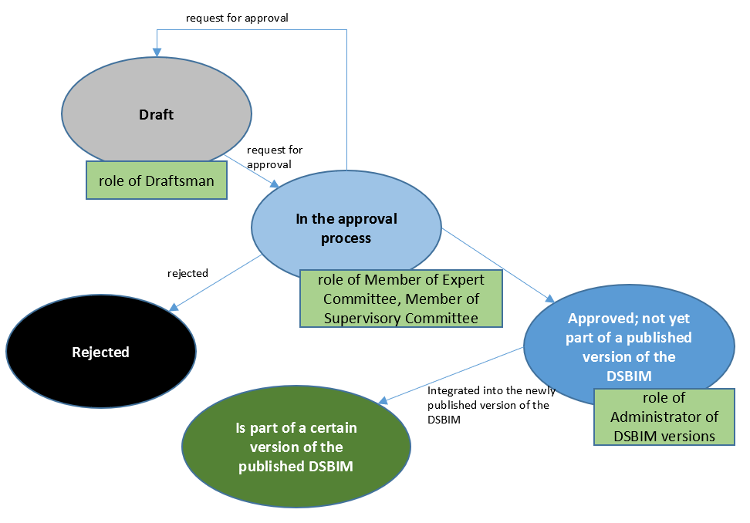
Fig. 2: The transition between states of data entities
- The System must provide the option of providing automatic notifications if the user expresses interest in monitoring changes to property requirements, sets of property requirements, or data templates. Changes to property requirement sets also include changes or additions to property requirements. Changes to the data templates also include changes or additions to property requirement sets.
- Notifications of changes are sent when the state of the data entity changes (proposal for change, proposal for approval, approval, rejection). Notifications must be sent by e-mail (with the possibility of aggregations - daily, weekly, monthly) and displayed in the user interface.
- The System must enable the interactive navigation to data dictionary services (see to buildingSMART Data Dictionary – bSDD in this Attachment No. 2 of the Contract) for the relevant data entities.
- The System must enable the graphic browsing, filtering, and exporting of the change history of individual data entities and published versions.
- When creating property requirements, the System must offer allowable values for the measurement unit types, related documents, and other aspects so that the creation will be time effective and the data integrity of all properties will be guaranteed.
- The System must enable displaying the entire communication and history related to dealing with proposals for changes within the automated work processes, including the history of decisions and the responsible parties.

Requirements for the Publicly Accessible Module with the Last approved Published Version of the DSBIM
- The System makes the last published version of the DSBIM accessible to users.
- A user must have the option of selecting individual sections of the DSBIM according to the intended use of the BIM, phase of the construction project, sector of building according to the classification system, and their role within the project, and based on this, create their own set of requirements. The user must have the option of saving this set of requirements to their own data warehouse in the formats specified above.
- The user must have the option of browsing, displaying, exporting, searching, and filtering the contents of the current published version of the DSBIM.

Requirements for the API ISDSBIM Module
- The API ISDSBIM Module will be available to third party software applications.
- The API ISDSBIM Module and its documentation are provided by the Provider to the Agency in either the Czech or English language.
- The documentation of the API ISDSBIM Module must be maintained and made accessible by the Provider to the Agency in its current state.
- The Agency itself must have free access to the API ISDSBIM Module for its own needs, i.e. it must have the option of the possible authorisation of unlimited access for reading all data that are the subject of the DSBIM.
- Access by third parties to the API ISDSBIM Module will only be for a limited time (typically, a year), except for the cases mentioned in the Contract, especially in Attachment No. 2 of the Contract. The System must enable the issuance of access data with a validity for a limited time.
- The Agency must have the option of blocking access to the API ISDSBIM Module for certain module users through the administration interface of the System.
- The System must enable the Agency to track the statistics of access to the API ISDSBIM Module overall and for individual module users.
- The API ISDSIMS Module must use web standards (SOAP or REST).
- The System must allow the limitation of the number of queries of individual module users (units per hour, day, etc.).
- The communication of a third party’s software application with the API ISDSBIM Module must exclusively take place using the secured HTTPS protocol with a valid certificate.
- All changes to the API that the API ISDSBIM Module provide to users must be managed, open, documented, and be retrospectively compatible.

Non-Functional Requirements
User Interface
The Administration Module of the ISDSBIM will always be used on personal computers or laptop computers.
The web interface of the module for public access to the last approved published version of the DSBIM must always use the principles of responsive design for display also on tablets and on mobile devices. Module users may also access the System from mobile devices (Android, iOS), which requires a user-friendly display of the websites, including full functionality.
Language
The user interface for the Administration Module of the ISDSBIM is required to be in Czech.
The user interface for the module for public access to the last published version of the DSBIM is requested to be created so that the user can choose the presentation to be in Czech or in English.
The Agency requires the support of making the local version of the user interface of the System, translating it into Czech in the case that a foreign System is chosen; the Agency itself will carry out the translation, while the applicant ensures the technical solutions that the translation enables.
User Accessibility
The requirement for designing the user interface must take into account users with health disabilities, according to the provisions of Act No. 99/2019 Coll. (Act of Internet Site and Mobile Application Accessibility and on amendments to Act No. 365/2000 Coll., on public administration information systems and on changes to several other acts, as amended).
Adding Users to the System and Password Change
The System must enable users to log in to the System by at least using the method of entering a username and password (single factor).
Lost Password
In the case of lost passwords, the System will send a newly generated password to the user’s designated e-mail or will enable the user to change their own password on a one-time basis. The password must meet the requirements for complexity listed below and services for one time for the first log-in. If the password was sent by e-mail, the System then forces a password reset. The generated password must have an adequately short period of validity.
Checking the Correctness of Entered E-mail Addresses
Checking the correctness of entered e-mail addresses by sending a verification e-mail is required.
Cyber Security
The Provider takes into account that the System used by the Agency based on the Contract has the character of a significant information system according to Act No. 181/2014 Coll., and the Provider hereby commits to meet their contractual obligations with this fact in mind.
The Provider commits to adhere to the legislation of the Czech Republic. The Agency explicitly points out:
- Government Resolution No. 241 of 18 April 2018, “Methodological Support in the Field of Cyber Security for 2018”.
- Act No. 181/2014 Coll. on Cyber Security and on the amendment of related laws (Act on Cyber Security) as amended, and related ordinances, especially Ordinance No. 82/2018 Coll. (Ordinance on Security Measures, Cyber Security Incidents, Reactive Measures, Requirements for Submission in terms of Cyber Security, and Data Liquidation (Ordinance on Cyber Security))
- Act No. 110/2019 Coll. on Personal Data Processing.
- The General Data Processing Regulation - Regulation (EU) 2016/679 of the European Parliament and of the Council of 27 April 2016 on the protection of natural persons with regard to the processing of personal data and on the free movement of such data and repealing Directive 95/46/EC (General Data Protection Regulation).
Requirements for System Documentation
The documentation must contain at the minimum:
- Data model for data export to the XML format
- User documentation (including training)
- A template for an operations log (diary) for ensuring the documentation of operational interventions and adjustments that have or could have an effect on the Contractor - e.g. documentation of system shut downs and launchings, changes in settings, installations of infrastructure and application layer patches (including security patches). .
The Agency requests that the following documentation is delivered together with the System:
- Project documents
  - Methodology of Project Management of the System implementation
  - Project plan
  - Declaration of preparedness for trial operations
  - Report from the trial operations
  - Declaration of preparedness for production operations
  - Report on data migration into the production operations
- Training Guide - serves for training Agency users.
- User Guide - Serves as an aid when working with the System (including e.g. instructions, error messages); therefore, it is organised according to the activities that the System supports. The System must also contain user documentation, available on-line from the System screens.
- Administrator Guide - Based on this guide, the System Administration should be able to carry out all tasks that are necessary for ensuring the proper operations of the application, including the export of data to the XML format.
- The Provider shall propose the following processes:
  - change management,
  - incident management,
  - patch management, and release management,
Requirements for the Architecture and Operations of the System
- Ensuring protection from attacks of the DOS, DDOS type.
- System certificates and internet domains for operating the Administration Module of the ISDSBIM and the Publicly Accessible Module with the Last approved Published Version of the DSBIM shall be contractually ensured by the Agency.
- The System must ensure the secured division between isolated trial operations, where the Agency will test the functionality of the System, and the actual production operations. At the same time, it must provide a secure environment for the purposes of education and training, which shall also be safely isolated.
- To exclusively use the architecture of thin clients, i.e. to supply the System so that no specially created software must be installed at the user’s workstation. The user interface of the System will be realised using a thin client for all roles (web solution), supported by the current primary browsers (at the very least, Google Chrome, Mozilla FireFox, Microsoft Edge, and Safari for iOS users).
- All client-server communications will take place over a secured HTTPS.
- The System shall ensure the management of access according to a user’s role (that is, mapping role authorisations, and not individual user accounts). Not using shared accounts. Every user/role sees only the data they need to see for their work.
- The System shall not require higher user rights (e.g. administrator rights) for operating client station environments.
- The data model of the database export to the XML format must never be dynamically changed by the System, i.e. the System must not dynamically create or delete entities (tables), add or remove attributes, nor change their type. Changes to the data model are made possible only as a part of a properly documented update or upgrade of the System. All changes of user settings or settings of System parameters must be realised using means of configuration (with authentications, authorisations, and logging) without the need of changing System programming code.
- The System must enable communications with users using a proxy server.
- In error messages, the System will not display any data to users that could lead to a security breach (internal addresses, account data, data of other users, debugging information and tracking, etc.). Error messages must be written so that even the first level of the help desk can clearly recognise the specific circumstances of the error. The necessary details must then be referenced in the log.
- The System shall scan important files for harmful codes.
- The System will block unauthorised access to any functions that require authentication (e.g. the direct access upon entering the entire URL is not possible).
Logging
The System must enable all activities to be logged to the minimum extent determined by Act No. 181/2014 Coll., as amended. The System must enable the Agency both automated and manual access to these records for reading only, as well as a selective export to an open format.

CBT Data Model
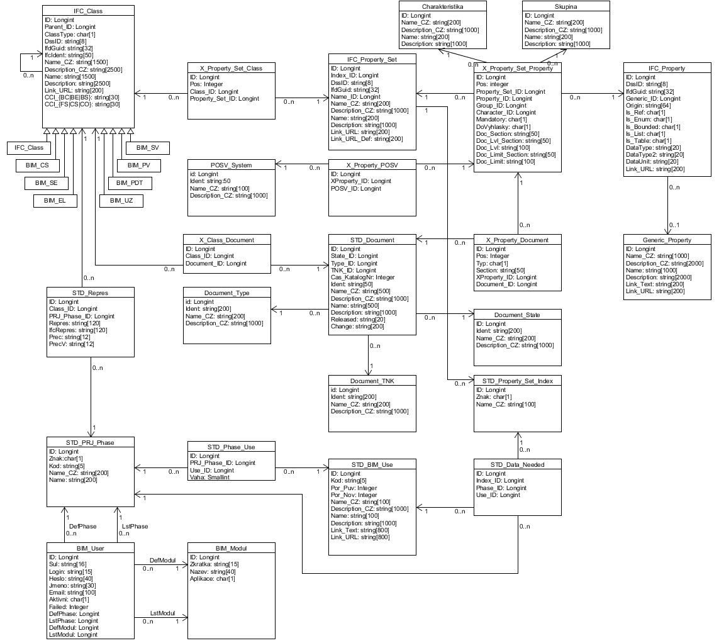
Fig. 3: CBT data scheme (Database of building standard data)
The above mentioned scheme and descriptions of tables is a conceptual and the final data model for import may differ slightly from it.

The descriptions of each chart scheme and their data fields are given below:

IFC_Class
The basic hierarchy of data standard objects.. Each level of the hierarchy has one type of node on the given level (see the attribute ClassType). Currently the data is divided into four applications - data sets. These correspond to the data templates for Building Constructions, Road Constructions, Railroad Constructions, and the data templates transferred from the standards and regulations for introducing products to the market. For the meantime, the data is divided into groups, but their future merger is expected. Every data set is currently recorded into a separate root instance with ClassType=NULL.
- ID … internal identifier
- Parent_ID … internal identifier of the parent building
- ClassType … designation of building type
Building, Road, and Railroad Constructions use a fixed three-level hierarchy with the ClassType values of:
“C” – Section of construction
“S” – Set of data objects
“E” – Data objects
All sections of the building for each type of construction has its own root class (with an empty type). The templates of products have a fixed four-level hierarch with the ClassType values of:
“1” – Group of products
“2” – Sub-group of products
“V” – Product
“P” – Product use
Again, all product groups have one common root class without a type.
- DssID … class identifier within the DBS standard
- ifdGuid … identifier (GUID) for identification in the export to the IFC
- ifcIdent … internal identifier of class in the IFC, if entered
- Name_CZ … The Czech name of the building. Must be unique within the parent
- Description_CZ … Description (notes on) the building in Czech
- Name … The eventual English name of the building. Must be unique within the parent
- Description … Eventual description (notes on) the building in English
- Link_URL … Link to a website, usually to the corresponding class definition according to the IFC
- CCI_BC, CCI_BE, CCI_BS, CCI_FS, CCI_CS, CCI_CO … classifications

IFC_Property_Set
A set of properties, through which properties are assigned (in sets) to classes. One property can be in more than one set, and can be assigned to classes multiple times. The multiplicity of assignments does not have any special significance. Names in English must be unique; Czech names can be repeated.
- ID … internal identifier
- Index_ID … link to index of property sets. Through the index of property sets, the set is bound to individual uses of the BIM. Thus, only some property sets of the given building can be considered for the selected use of BIM, while others cannot be considered. In the context of the various BIM uses, the building can have another property set requested (for example, for calculating amounts, for the purposes of fire safety, ...). The export of data to the IFC can be created simultaneously for several selected BIM uses. In such cases, the export contains a hierarchy several times for each use, and each includes only the required property sets, and thus only the properties required.
- DssID … identifier of property set within the DBS standard
- ifdGuid … identifier (GUID) for identification in the export to the IFC
- Name_ID … Auxiliary identifier of the set, contains (as a standard) NULL. In special cases, it contains a copy of the ID. This is enabled by the set name, allowing it to be repeated. It is used for the names of sets that represent properties in templates stemming from the requirements of the harmonisation standards.
- Name_CZ … The Czech name of the set. Must be unique, along with the Name_ID.
- Description_CZ … Description (notes on) the set/s in Czech
- Name … The eventual English name of the building.
- Description … Eventual description (notes on) the set/s in English
- Link_URL … Address of the link that further explains the property set, usually a link to the corresponding definition according to the IFC
- Link_URL_Def … Address of the link that further explains the property set, usually a link to the corresponding definition according to the DSS

Generic_Property
A property that is not directly assigned to a class. In contrast to the understanding of the IFC, the property is defined on two levels: The generic property is currently primarily defined by its title. The data type (number, physical quantity (e.g. “length” or “heat conductivity”); the measurement unit (for example, m, mm, J/m2/K, …) is given in the specific property.
- ID … internal identifier
- Name_CZ … Czech name of property. Must be unique.
- Description_CZ … Description (notes on) of the property in Czech
- Name … Eventual name of property in English. Must be unique.
- Description … Eventual description in English (notes on) of the property
- Link_URL … Address of the link that further explains the property.

IFC_Property
A property including the data type and eventual physical unit. One generic property can have more specific properties if its measurement is carried out in other units (m, km, mm, …) or if the data type differs.
Currently, a specific property is designated by both names, both descriptions, IS_* attributes, both data types, and unit. Therefore, two practically identical properties, differing only in their English description, can exist.
- ID … internal identifier
- Generic_ID … link to the generic property
- DssID … identifier of properties within the DSS standard
- Origin … information on the property origin. Data of building construction contains either the value “IFC4_ADD2_TC1” when the property stems from the IFC 4.2 standard, or “PS03” if it was drafted by this work group.
- ifcType … type designation in the IFC
- ifdGuid … identifier (GUID) for identification in the export to the IFC
- Is_Ref, Is_Enum, Is_Bounded, Is_List, Is_Table … Attributes showing whether it is a referential type, enumeration type, interval of values, list of values, or eventually a table.
- Data_Type … Identifier of data type (e.g. IfcPositiveLengthMeasure, IfcTimeMeasure, …)
- Data_Type2 … Identifier of data type (e.g. IfcPositiveLengthMeasure, IfcTimeMeasure, …) Used in tables. The first type designates the index type, and the second type designates values in tables. In all other cases, one type will suffice.
- DataUnit … unit in which the property is given when it is a physical quantity.

X_Property_Set_Class
Relation between classes and property sets. Shows what property sets each class includes
- ID … internal identifier
- Class_ID … link to class
- Property_Set_ID … link to property set
- Pos … Eventual position (rank) of property set within the class.

X_Property_Set_Property
Relation between the property sets and properties. Shows what properties are found in the given property set. Aside from this, also contains information that is specific for the given property within the property set. Used for properties required for products by the harmonised standards.
- ID … internal identifier
- Property_Set_ID … link to property set
- Property_ID … link to property
- Pos … Eventual position (rank) of the property within the property set.
Furthermore, includes these specific data for the properties stemming from the harmonised standards:
- Group_ID … link to the comprehensive property name within the framework of the harmonised standard
- Character_ID … link to characteristics of the property within the framework of the harmonised standard
- Mandatory … Information about whether the property is mandatory and required by the harmonised standards
- DoVyhlasky … Information about whether this property should be mentioned in an ordinance.
- Doc_Section … Information about the section of the harmonised standard that describes the given property for the product template
- Doc_Lvl_Section … Information about the section of the harmonised standard that describes the eventual level of property values (e.g. fire safety class)
- Doc_Lvl … If the eventual levels of property values (e.g. fire safety class) are easily enumerated, it is possible to enter them here
- Doc_Limit_Section … Information on the section of the harmonised standard that describes any eventual limit values permitted for the given property
- Doc_Limit … If the limit values permitted for the given property are easily described, it is possible to enter them here

POSV_System
Systems of assessing and verifying the invariability of the construction product property (1, 1+, 2, …)
- ID … internal identifier
- Ident … Identifier of system (1, 1+, 2, …)
- Name_CZ … Czech name of system. Momentarily, it is identical with the identifier
- Description_CZ … Description (notes on) the system in Czech

X_Property_POSV
Every property within the harmonised standard can have determined systems according to which the property is assessed. This is a binding table for these systems
- ID … internal identifier
- XProperty_ID … Identifier of bonds between the property set and property
- POSV_ID … Identifier of POSV system
- Pos … Position (rank) of the system in the list.

Document_Type
Documents can be assigned to a certain type of document (standard, ordinance, law).
- ID … internal identifier
- Ident … Identifier of document type (“standard”, “ordinance”, …)
- Name_CZ … Czech name for document type. Momentarily, it is identical with the identifier
- Description_CZ … Description (notes on) the document type in Czech

Document_State
State of document processing (“to be edited”, “reviewed”,...).
- ID … internal identifier
- Ident … Identifier of document state (“to be edited”, “reviewed”,...)
- Name_CZ … Czech name for document state. Momentarily, it is identical with the identifier
- Description_CZ … Description (notes on) the document state in Czech

Document_TNK
List of committees under which the products determined by the harmonised standard fall.
- ID … internal identifier
- Ident … Identifier TNK
- Name_CZ … Identical with the identifier
- Description_CZ … Description (notes on) the given committee in Czech

STD_Document
Documents (standards, ordinances, laws) that can be cited by both the buildings in the table IFC_Class and the individual properties of the harmonised standards.
- ID … internal identifier
- State_ID … Link to the state of implementation of the given standard in the list of product templates
- Type_ID … Link to the type of the given document (technical standard, trial standard, law, …)
- TNK_ID … Number of the technical standardalisation committee that is presenting the products described by the harmonised standard
- Cas_KatalogNr … Catalogue number of the standard
- Ident … Identifier of document, for example “ČSN EN 15804+A1”
- Name_CZ … Czech name of the standard
- Description_CZ … Description (notes on) the standard/s in Czech
- Name … Eventual name of the standard in English
- Description … Eventual description (notes on) the standard/s in English
- Released … Validity of the given standard in the form of YYYY, YYYY-MM, YYYY-MM-DD and similarly. Or eventually “null”.
- Change … designation of implemented changes and adjustments of the given standard.
This threesome (Ident, Released, Change) is definite, as is eventually (Name_CZ, Released, Change)

X_Property_Document
Every property within the harmonised standard can have further documents attached that require, describe the trials of the given property, etc.
- ID … internal identifier
- Pos … Position (rank) of documents in the list of cited documents.
- Typ … Type of list of cited documents. (‘Z’ = trial standard …)
- Section … Section within the document. Can specify the location in the document that is cited
- XProperty_ID … Identifier of bonds between the property set and property
- Document_ID … Identifier of the cited document

STD_PRJ_Phase
The project phase (e.g. “Introduction to market”, “Feasibility study, investment plan”). Each of the project phases are connected to only some of the BIM uses with the help of the binding table STD_Phase_Use. Furthermore, each pair of the project phase and BIM usage has specific indexes of property sets assigned to them. Thus, within the framework of each phase, building information models can have a different representation, dependent also on the specific BIM usage since each requires a different property (property set)
- ID … internal identifier
- Znak … Single-symbol identifier of the project phase
- Kod … The project phase code has up to five symbols
- Name_CZ … Czech name of the project phase
- Name … Eventual English name of project phase

STD_Repres
The representation of the given building within the framework of the given project phase. Different representations or differently detailed building representations may be required for various project phases.
- ID … internal identifier
- Class_ID … Link to the building
- Prj_Phase_ID … Link to project phase
- Repres … Czech name of building representation
- ifcRepres … Corresponding name of building representation in the IFC standard
- Prec … Accuracy of the representation
- PrecV … Vertical accuracy of the representation if different from horizontal accuracy

STD_BIM_Use
Intended BIM use (e.g. “3D model of the current state”, “Amount Statement”).
- ID … internal identifier
- Kod … Code of BIM use, must be unique
- Por_Puv, Por_Nov … Original and new rank
- Name_CZ … Czech name for usage
- Description_CZ … Description (notes on) the usage in Czech
- Name … Eventual English name for usage
- Description … Eventual description (notes on) the usage in English
- Link_Text, Link_URL … Text and address of link that further explains the usage

STD_Phase_Use
The relation between phases and the expected intended uses in the given project phase.
- ID … internal identifier
- Phase_ID … Link to phase
- Use_ID … Link to BIM use
- Vaha … Weight (importance) of the pertinent BIM use in the given project phase

STD_Property_Set_Index
Property Set Index. Within the property set for road, railroad, and building construction, the property sets are named so that the first symbol determines the corresponding index.
- ID … internal identifier
- Znak … Single-symbol code in the index
- Name_CZ … Czech name of item in index

STD_Data_Needed
Ternary bond between the BIM use, phases, and index items. Within the selected BIM use in the given project phase, one can then display / consider only those property sets that belong to the given index.
- ID … internal identifier
- Index_ID … Link to index
- Phase_ID … Link to project phase
- Use_ID … Link to BIM use

BIM_User
User of the application.
- ID … internal identifier
- Login … Username
- Sul … Salt for the hash function
- Heslo … Salted SHA256 hash of the user password
- Aktivni … is the user active and can they log in?
- Failed … Number of failed log-in attempts. After going over the limit, the user can no longer log in.
- DefPocRadek … Standard number of list rows that are displayed to the user
- DefModul, LstModul … Standard module and last module that the user worked in. LstModul has precedence
- DefPhase, LstPhase … Standard project phase and last project phase, the context of which the user worked in. LstPhase has precedence

