1)))))1
8.i
beamlines

Fyzikální ústav AV ČR, v. v. I., Na Slovance 2, 182 21 Praha 8
1nfo@elibeams eu I www.eli beams.eu

Confidentiality

BL - Restricted for

TC ID / TC Revision 00272188 / A
Level | interna/ use
Branch | M - Management | Document Status | Document Released
Level | Process ( M,Q,S) | Valid from (date) | 01.06.2020
Document Type | Directive
PBS Code | NOT RELEVANT

WBS /OBS Code 97 Technology Infrastructure and Services

D1R20
ELI na,ne convention and addressing for electrical co111ponents
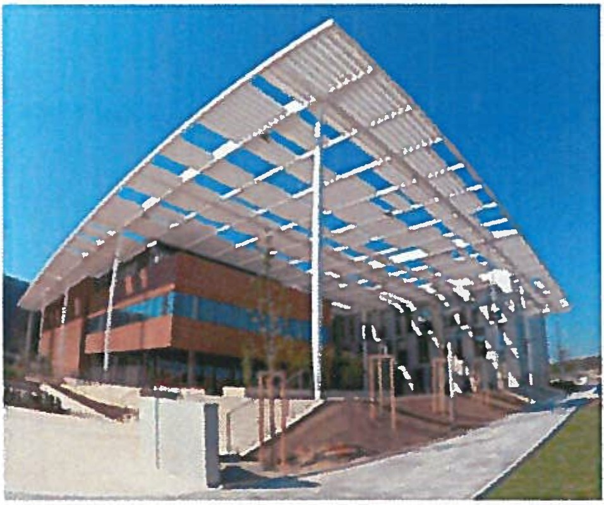

Keywords
Conductor, cabinet, UID

Position Name Signature Date

Prepared by Electrical Engineer Vojtěch Gaman
Quality Engineer Jan Černý 2 1. 5 . 20 20
Head of Electrical Engineering Luboš Nims /tf,j\
o

Agreed by

Assurance
Team Leader - Laser
beamlines control system
group Alexander Jack Nylon
v
Quality Quality Manager Viktor Fedosov

Approved Project Manager Roman Hvězda
by

t.S- 5"'_ w-i.,O

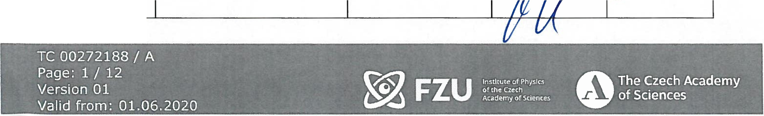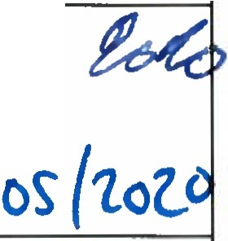

eii

1)))))1
beamlines

Fyzikální ústav AV ČR. v. v. i., Na Slovance 2, 182 21 Praha 8
1n fo@elibeams.eu I www e i beams.eu

Revision History I Change Log
Change No. | Made by | Date | - -  Change description, Pages, Chapters |  | TC  rev. | Ver.
 |  |  | -

Reviewed By
Name (Reviewer) | Position | Date | Signature
Roman Kuřátko | Facility Manager | J1...S. | ,.1.-r _
Birgit Plotzeneder | Control System Team Leader | .;i .i\· c.;. 2o ;ltJ | Í7iL
Pavel Bakule | Head of department 97 | z,..r, J. Z.o Le | /J J ---'2_
Veronika Olšov cová | Safety Team Manager | u.r:uw | /l
Ivo Konderla | Quality Engineer - | 11.r. 1-t>'t.o | I
Matyáš Žalud | Electrical Designer | 21. . lotO | Jíf\J))
Martin Nešpor | Control System Technician | t, 1 . f' . la 2e | .A-
Lukáš Mindl | Designer - Electrical | lz.s,Zozo
Michal Suchý | Electrician | )) , f.JOíL | t„0·
Karel Zíka | Technology Installation Engineer | 2 2 . r-..2..oz..o | /q

... ""'li•• • ,• .. \ ,_..." • .,. r-,. " '• ' .', 1'
\ I A · - ·.
I - • • -
<lt_-
6)
FZU | lnstltuteofPhysrcs
 | Academy of Scr | ences

T-C 002721 88

Pag : 2 / 12 , . . - .
Versron 01
oftheCzcch .
.
;,"'\
•.

The Czech Academ
of Sc1·ences

Valici from: 01.06.2020 .

Eii

1)))))1
beamlines

Fyzikální ústav AV ČR, v. v. i., Na Slovance 2, 182 21 Praha 8
1n fo@eli beams.eu I www eli beams.eu

Tahle of Content
- Purpose 4
- Scope 4
- Glossary of Abbreviations and Terms 4
- Related documents 4
- Naming convention 4
  - Components abbreviations 4
  - UIDs marking 5
5.3. Numbering systems for components .......................................................... S
5.3.1. PLCs................................................................................................. S
    - Connection terminals 7
    - Filters, Power supplies, Circuit breakers and Surge protectors connected to mains (230V/400V) 7
    - DIN rails 8
    - Relays, SPDs, Contactors and Fuses 9
  - Addressing 9
    - Printed labels 9
- Conductors requirements 11
  - Signal conductors (providing just information in 24V logic) + analogue conductors 11
  - Power conductors permanently energized with low voltage (up to SOV) 12
  - Power conductors - mains (230/400V) 12
- Database 12
- Attachments 12

.-• - "- r - -->,. • • • - _,- • - •
r.,_, • '- '
0
ge·
. .
- . ·
I
TC 0 2_72188 A .
FZU
..
· Pa 3 / 12 "
h
Institute of Physlcs
oftheCzech
T e Czech Academy
O CleOCeS
fs .
Vers1on 01
\

Valid from: 01.06.2020 ._, .
Acaderny of Sciences

Eii beamlines

Fyzikální ústav AV ČR, v. v. i., Na Slovance 2, 182 21 Praha 8

, nfo@eli beams eu I www eli beams.eu

1.Purpose
This directive sets standards for name convention, addressing and type of electrical components, cabinets, IT racks, conductors and similar devices used in EU Beamlines.

2.Scope
This document is valid for all EU Beamlines employees for installations in laser and experimental halls.
This document does not directly deal with mains installation (230/400V) as this is described by general electrical standards [1, 2].
This directive is not valid for cabinets installed prior to release of this directive and for these in scope of facility that follow general electrical standards [1, 2].

Glossary of Abbreviations and Terms

Abbr. | Term | Explanation
- | EU Beamlines employees | Employees of Fyzikální ústav AV ČR, v.v.i., organizationally assigned to section 9 - EU Beamlines
UID | Unique identification number | A unique identification code for all electrical devices in laser and experimental halls.
- Related documents
[1]. ČSN 332130:2014, ed.3 Low-voltage electrical installations - Interna! electric distribution lines
[2]. ČSN 332000:2009, ed. 2 Low-voltage electrical installations
[3]. ČSN EN 60445:2017, ed. 5 Basic and safety principles for man-machine interface, marking and identification - Identification of equipment terminals, conductor terminations and conductors

Naming convention

Components abbreviations
Ali components in cabinets have unique abbreviations and follow the convention below:
  - A= PLCs
  - D = DIN rails
  - F = Fuses
  - FA = Circuit breakers for mains (230/400V)
  - FLT = Filters for mains (230/400V)
  - FV = Surge protectors for mains (230/400V)
  - G = Power supplies
  - KA = Relays
  - KM = Contactors
  - R = Cabinets
  - SPD = Signal surge protectors for low voltage (up to SOV)

h ,,._ I • -; •1.:Jt• 1,.-,:' ; 41 • - - • - • CCf .. -- - • - .., .._' - .\I • • "': , 1 . U.• • .. 111 • • ,. i,.,, , • ,
" -·• , ;,
...._,,,.f'i.
. TC 00272188/ , A · _ _..... . . ··. .,+· . · ·.:. :.
'. ., . .
FZU
! ! ! e sc,ences _ ,....

. Page: 4 / 1. 2 , -, -:
V · 01
0
o ···,: , .
The Czech Academy
lnstltuteofPhyslcs

erls,.dofn . 01 06 2020 ·
V
of Sciences

a I rom. . . .
..-.:

eli
1)))))1
beamlines

Fyzikální ústav AV ČR. v. v. i., Na Slovance 2, 182 21 Praha 8
1n fo@eli beams eu I www eli beams.eu

- UPS = Uninterruptible power supplies
- X = Connection terminals
  - UIDs marking
The UID marking is preferably used for cabinets, PLCs and UPSs. The UID is generated according to the key ABnn where A stands for abbreviation (Chapter 5.1) /function of the device (Chapter 5.3.1 for PLCs), B stands for the system prefix defined in table (Tahle 1) and nn is a serial number in the system - examples:

- R801 - cabinet number 01 in experimental hall E3
- I0H501 - IOH is a function of PLC, 5 means that it is related to BT and 01 that it is the first PLC in the system
- RI0403 - RIO is a function of PLC, 4 means that it is related to L4 and 03 that it is the third PLC in the system

Tahle 1: System prefixes for generating UID

System | Ll | L2 | L3 | L4 | BT | El | E2 | E3 | E4 | ES | Plant rooms
System prefixes | 1 | 2 | 3 | 4 | s | 6 | 7 | 8 | 9 | 10 | 11

Other components inside cabinets that have some parameters have also a unique UID created using the same convention. Examples of such components: SDS and NSW.

Numbering systems for components

PLCs
PLC itself is marked by its label (UID) that typically starts with its function IOH, RIO, CRIO, PLC, etc. This label is directly attached to the device and it not used during addressing.
PLCs cards are marked nAm, where n is a serial number of PLC in a cabinet and m is a serial number of a card. The exception is the first power supply card that is an integral part of PLC.
For B&R components, this first power supply card is marked by nA.PS. The m = 1, 2, etc. is used for rest of the cards including further power supply cards.
Additionally, when PLC contains network module next to the cards, this network module is marked nA.BC or .HB. If there is more such modules then a serial number is added from left to right (example for first PLC in the cabinet - 1A.BC1, 1A.BC2, etc.). The network inputs of such modules if they do not have original marking are marked IFl, IF2, etc. (used only during addressing, not marked on the device itself). Example of such PLC, type from company B&R - Figure 1.

• .: • ... ,5" ... ,.., '
FZU

Institute of Physlcs oftheCzech Academy of Sciences
6)
2721
 | 5/ | 1
on 01

TC 0
0
ge:
.
- Pa
ers
88 / A .
2
he
Q
Czech Academy
T
CleOCeS

V . , O S
f
.
Valtd from: 01.06.2020 # .. -

1)))))1
Si
beamlines

Fyzikální ústav AV ČR, v. v. i., Na Slovance 2, 182 21 Praha 8
1nfo@eli beams.eu I www eli beams.eu

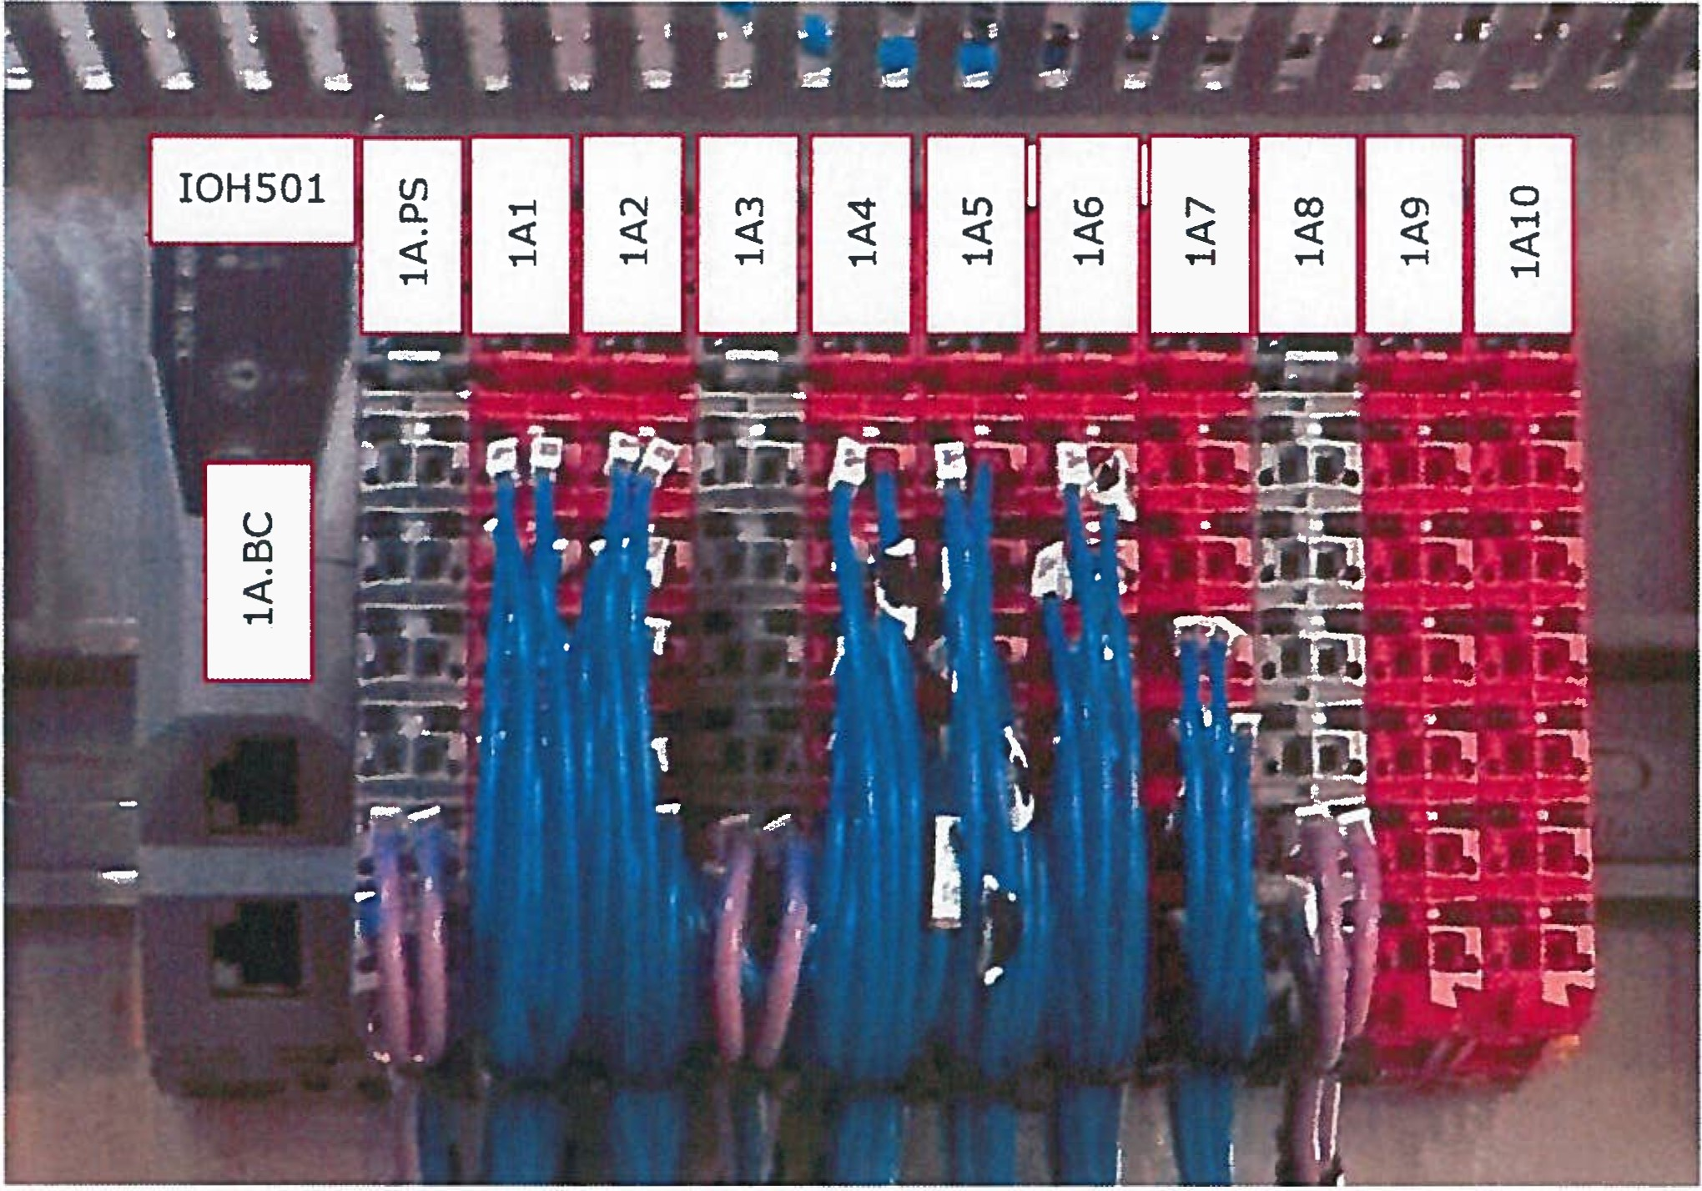
Figure 1: PLC IOH501 type B&R with 1 network module and 3 power supply cards

Other examples of PLCs, type from company PILZ - Figure 2 and type from company NI - Figure 3. (lA.*, * depends on exact marking on the device, e.g. 1A.X1).
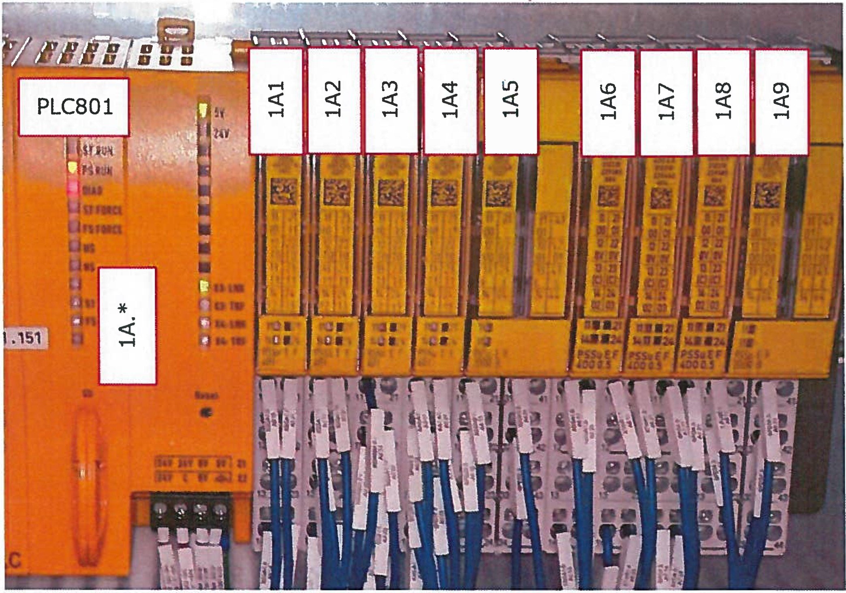

Figure 2: PLC801 type PILZ

::·} f t 002·i2iaa / Á
-. ,:. g :6 I 12 6)
..
J
FZU

lnstl tute of Phys lc Acaderny of sc1ences
The Czech Academy
of Sc1·ences
Q
. Vers,on 01
oftheCzech .
· ,
; • t t Valid from: 01.06.2020

Eii

1)))))1
beamlines

Fyzikální ústav AV ČR, v. v. I., Na Slovance 2, 182 21 Praha 8
1n fo@eli beams eu I www e i beams.eu

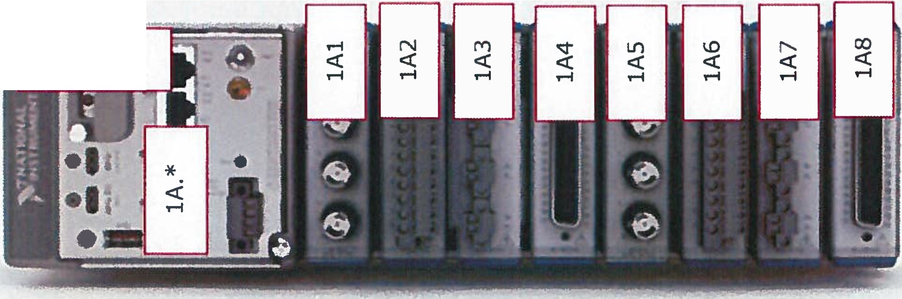
CRI0503

Figure 3: PLC CRI0503 type NI

Connection terminals
The function name of the connection terminal is preferable added after the marking X
- examples: XSACB, XDPWR.G52_24V, XDPWR.G52_COM, XTEMP, XTMPS, XSCON,
etc. When it is not required to add the specific function name these connection terminals are marked Xl, X2 ... Xn (n is a serial number in the cabinet).
When more of the same connection terminals are in the cabinet, then a serial number is added after the marking.
Inside a cabinet, it is possible to mark connection terminals by labels with or without DIN rail number, which they are mounted on - Figure 4. Both variants are allowed.

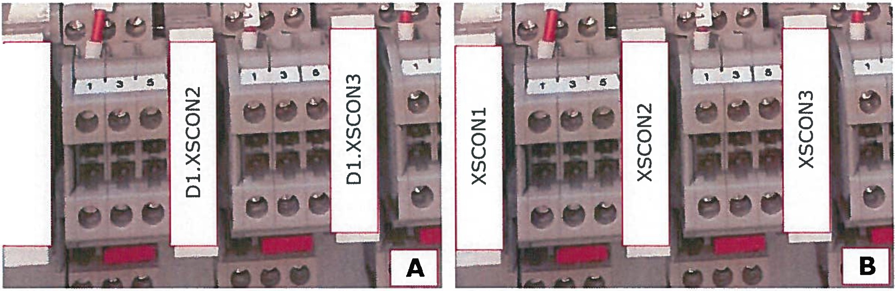
oz
,-i
(/)
u
X
o
,-i
Figure 4: 3 connection terminals XSCON on DIN rail Dl and two possible ways of marking - A) marking with DIN rail nr. B) marking without DIN rail nr.

Filters, Power supplies, Circuit breakers and Surge protectors connected to mains (230V/400V)
Components - circuit breakers (FA), power supplies (G), filters (FLT) and surge protectors (FV) connected to mains (230/400V) are numbered by the convention below to indicate which branches are powered based on various laser states (scenarios)

  - Numbering G/FA/FLT/FV101-199 for no emission laser state (scenario)
  - Numbering G/FA/FLT/FV201-299 for low power laser state (sce
nario)
d

- · ...·.Pa.g , : ,2 .
A,!f'7.' )
•t:
• .:.p..
·r-:,,.1
•
7
. o
e ers
1
1
A
1· -··
;
I
-·.
,
. :
TC | 00 |  | 2721 |  |  | 8, 8
 |  |  |  | /
V | ,o |  | n

"Th

· .·
o
s

czechAca emy

T' ...:', - ,;_...._-;:;. • - -;. ",. • • ._ • • • .; _,.- -...,; -"• -

.
---.: ·. · •.
e
lnstituteofPhyslcs ofthe Czech AcademyofSc1ence
.·... ..· .
FZ.U·
Valtd from. 01.06.2020

f S .
O ClenCeS
.

1)))))1

beamlines

Fyzikální ústav AV ČR. v. v. i., Na Slovance 2, 182 21 Praha 8
1n fo@eli beams eu I www e1i beams.eu

- Numbering G/FA/FLT/FV301-399 for high power laser state (scenario)
- Numbering G/FA/FLT/FVSOl-599 for powered by UPS laser state (scenario)

Designer can choose additional system (e.g. 401-499) for components operated in other laser states (scenarios) if he considers it as useful or better arranged. In that case, he must create a note describing his system on the electrical drawing.
Other components that refer to neither above-mentioned options have a serial number set by a designer; see the example of cabinet with UPS - Figure 5.

FAS - FVS ,- FASl | - UPS501 1- FASll - FLTSll | - G511
1 | 1- FA512 • FLT512 | - GS12
 | I- FA513 • FLT513 | - G513
 | I- FA514 • FLT514 | - G514
 | L FA515 • FLT515 | - GS15
L FA52 | - KMl 1 - FAS21 - FLT521  I- FA522 - FLT522 | - G521
 | 1- FA523 - FLT523
 | I- FA524 - FLT524
 | 1- FA525 - FLT525
 | 1- FAS26 - FLT526
 | L FA527 - FLT527

Figure 5: Part of circuit with UPS

DIN rails
DIN rails are marked Dl, D2 ... Dn (n is a serial number in a cabinet) in direction from up to down and subsequently from the left to right - Figure 6.
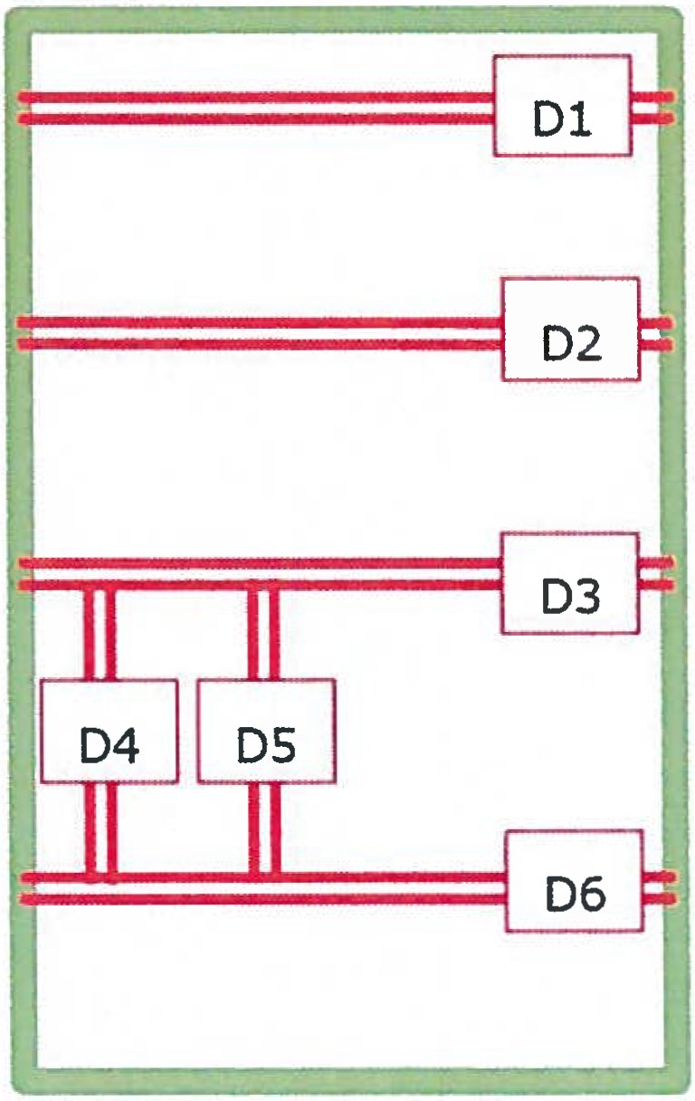

Figure 6: Example of cabinet with DIN rails

Eii

1)))))1
beamlines

Fyzikální ústav AV ČR. v. v. i., Na Slovance 2, 182 21 Praha 8
nfo@eli beams eu I www e i beams.eu

Relays, SPDs, Contactors and Fuses
These components are marked according to the convention that all components have a serial number starting from 1:
- Relays are numbered KA1, KA2 ... KAn (n is a serial number in a cabinet).
- Contactors are numbered KM1, KM2 ... KMn (n is a serial number in a cabinet).
- SPDs are numbered SPD1, SPD2 ... SPDn (n is a serial number in a cabinet).
- Fuses are numbered Fl, F2 ... Fn (n is a serial number in a cabinet).

  - Addressing
Conductors between components in cabinets are marked according the convention defined in Tahle 2.

Tahle 2: Addressing convention

Conductor start |  |  | Conductor end
Start Address | separator | End Address | End Address | separator | Start Address
Dn.Qn.x |  | Dm.Qm.y | Dm.Qm.y |  | Dn.Qn.x

Dn.Qn.x : Dm.Qm.y

- Dn - DIN rail with serial number n at conductor start
- Dm - DIN rail with serial number m at conductor end
- Qn - component Q with serial number n and pin x at conductor start
- Qm - component Q with serial number m and pin y at conductor end
- The marking is mirrored on each end
- If the conductor comes from different cabinet, the cabinets UIDs are added before both numbers RO.Dn.Qn.x : RP.Dm.Qm.y (RO is the UID of the first cabinet and RP is the UID of the second cabinet).
- Examples:
o D1.1A1.11: D1.2A3.1
o D1.XTEMP1.8:D2.KA1.1
o R510.D1.1A1.5:R513.D7.KA127.A1
o D10.XSACB13.20:D3.XDPWR.G51_24V
o D6.KA57.A1:D1.2A.X2.3

    - Printed labels
Conductors are preferably marked by printed plastic labels from the printing machine Weidmuller Printjet ADVANCED. The manual for this device is attached, see [AP02]. Experiment Control Systems dpt. is responsible for production of these printed labels

ge:
h
fs
.
Vers1on 01
·,-c 00272188 /
Pa . 9/ 12
oftheCmh
Acaderny of Sc1en
ces
.
FZU Institute of Physlcs
o
A
. . .
..
.
T e Czech Academy

Valid from: 01.06.2020 ._,
:.,"
\
. O ClenCeS

1)))))1
€li
beamlines

Fyzikální ústav AV ČR, v. v. i., Na Slovance 2, 182 21 Praha 8
1nfo@el1 beams.eu I www eli beams.eu

and define the suitable type of labels for components/conductors (examples of labels are on Figure 7).

Figure 7: Types of labels for Weidmuller Printjet ADVANCED

Printed labels are placed as close as possible to conductor terminals (must be still easily readable). The marking is printed on two lines, example on Figure 8 and Figure 9.
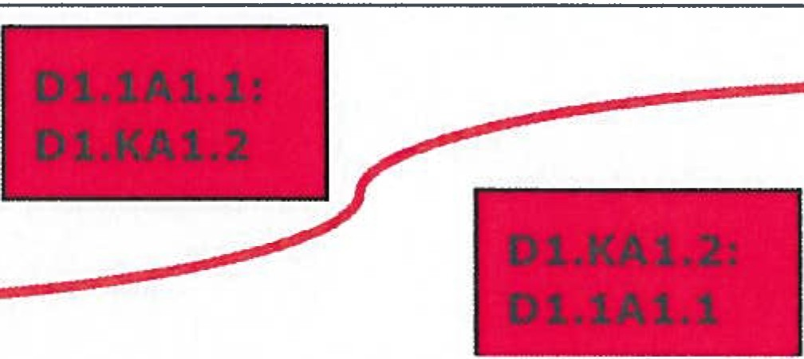
KA1
( pin 2)
Labe! on conductor start:
I
/
1A1
(pin 1)
I DI N fil l-
Dl I
Labe! on cond uct or end:

Figure 8: General scheme of printed labels from the printing machine Weidmuller
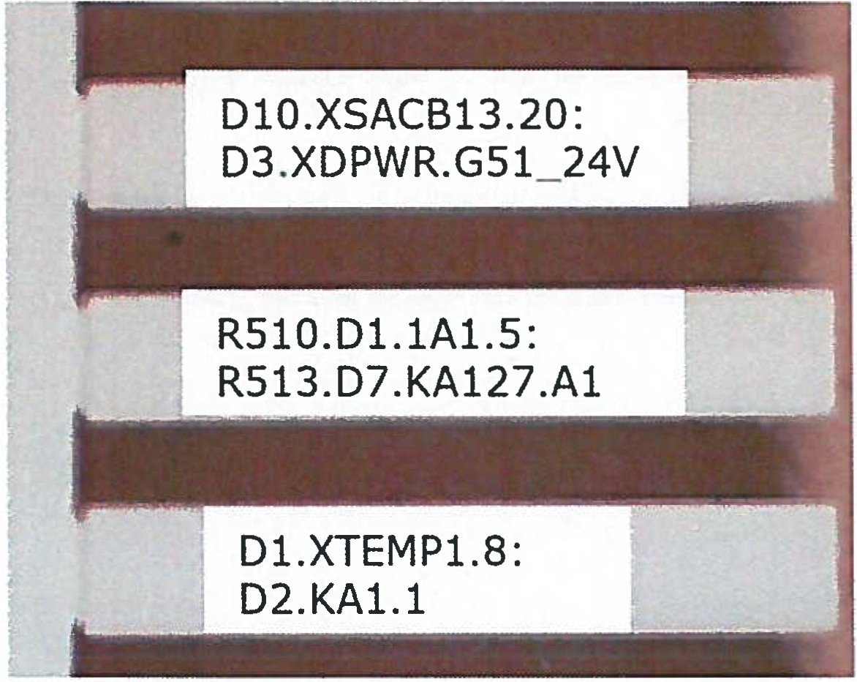

Figure 9: Example of printed labels from the printing machine Weidmuller

In case of additional changes/reworks in fieldworks or lack of space for two lines, it might be necessary to use shrink/sleeve tubes labels from the mobile printing device Brother that prints complete addressing label on only one line. These labels are placed again as close as possible to conductor terminals. On vertical components as relays
2
.
?,.
FZU

- I •
cr 00 7 218 8 / A
... . : . ' ;. . " '\ . .. '-" .

P'age:
·
o l / 12 ·
ofPhy s lcs 6)

Academy
The Czech

. Vers1on of Sť nces
10
Instit | ute
ofthe | C | zech

- Valid from: 01.06.2020 ,. :-. Q AcademyofSc1ences ,e

Eli

1)))))1
beamlines

Fyzikální ústav AV ČR. v. v. i., Na Slovance 2, 182 21 Praha 8
1nfo@el1 beams eu I w w w.eli beams.eu

and connection terminals the labels are placed on upper side from right direction and on down side from left direction, example on Figure 10.

.R_ea_d fro_m l_eft _side>
<--
Read from right side
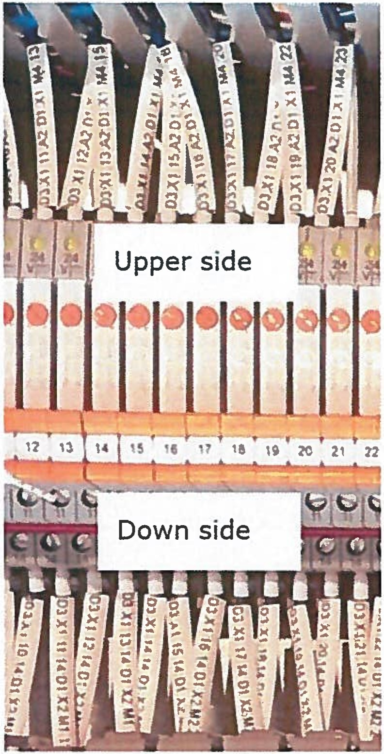

Figure 10: Example of shrink/sleeve tubes labels from the device Brother
- Conductors requirements
Conductors for cabinets and IT racks are divided into these three main categories:
  - Signal conductors (providing just information in 24V logic) + analogue conductors
  - Power conductors permanently energized with low voltage (up to SOV)
  - Power conductor - mains (230/400V)

The conductors colours are defined by this directive (mentioned RAL values are only informative). The cross sections are only recommended.

Signal conductors (providing just information in 24V logic) + analogue conductors
These conductors have different requirements than power conductors. The conductors have to be stranded, with crimped ferrule on both ends.
  - General digital signals
    - Colour - White (e.g. RAL 9010)
    - Cross section - O. 50 mm2
  - Personnel Safety signals
    - Colour - Yellow (e.g. RAL 1021)
    - Cross section - 0.50 mm2

'-f _-\ Te 00272188 / .A ,- .
The Czech
of Sciences
Academy
o

· V g e : 11 01 12
p a
/
·
Valici from: 01.06.2020
FZU lnstltuteofPhyslcs "
Academyofsc,ences
ers,on oftheCzech

1)))))1
eli
beamlines

Fyzikální ústav AV ČR. v. v. i., Na Slovance 2, 182 21 Praha 8
nfo@eli beams eu I www eli beams eu

  - Machine Safety signals
    - Colour - Orange (e.g. RAL 2003)
    - Cross section - 0.50 mm2
  - Analogue signals
    - Colour - Violet (e.g. RAL 4005)
    - Cross section - 0.50 mm2

  - Power conductors permanently energized with low voltage (up to SOV)
The cross section of conductors for low voltage (up to SOV) is selected by a designer and the cross section corresponds to relevant current flow. The conductors have to be stranded, with crimped ferrule on both ends.
  - Positive Voltage
    - Colour - Red - (e.g. RAL 3000)
    - Cross section - 0.50 / 0.75 / 1.50 mm2
  - Negative Voltage
    - Colour - Dark Blue - (e.g. RAL 5002)
    - Cross section - 0.50 / 0.75 / 1.50 mm2

Power conductors - mains (230/400V)
The conductors for mains (230/400 V) follow standard [3].

- Database
  - The Database of UID is shared at http://laser-interface.eli-beams.eu/.
- It serves for generating UID.
- The administration of the Database is the responsibility of the Laser dpt.
- The Database manual is attached, see [APOl].

Attachments
[APOl] Laser Interfaces Database Tutorial [AP02] Manual PrintJet ADVANCED

TC 00272 88./ A . . -'·' . y •• :'. • • •
V age:
V a' d f
erS10n
1 01
I rom.,
12
01 .06.2020
o
O ClenCeS
Tfs
e •zech Academy
P
2/
·
h
C
l

ln s t l tut e o f Phys l cs
ofthe Czech
AcademyofScience.s
FZU
. .....
6)

