SPEC SHEET

ULTRA UHD LED MONITORS

MODELS

WBXML4K43 43” (42.51” diagonal) WBXML4K55 55” (54.64” diagonal)
WBXML4K49 49” (48.5” diagonal) WBXML4K65 65” (64.53” diagonal)

PANEL SPECIFICATIONS 4K
43
”
49
”
55
”
65
”

ULTRA HD
Size | 43" diagonal | 49" diagonal | 55" diagonal | 65" diagonal
Panel | FPD panel(UHD) | FPD panel(UHD) | FPD panel(UHD) | FPD panel(UHD)
Display scale | 16:9 | 16:9 | 16:9 | 16:9
Backlight | DLED direct Type | DLED direct Type | DLED direct Type | DLED direct Type
Maximum resolution | 3840×2160 | 3840×2160 | 3840×2160 | 3840×2160
Best working resolution | 3840×2160@60Hz | 3840×2160@60Hz | 3840×2160@60Hz | 3840×2160@60Hz
Pixel Pitch | 0.2451mm×0.2451mm | 0.2797mm×0.2797mm | 0.3151mm×0.3151mm | 0.372mm×0.372mm
Active Area | 941.2mm×529.4mm | 1073.8mm×604mm | 1209.6mm×680.4mm | 1428.48mm×803.52mm
Viewing angle | H:178º,V:178º (CR>10) | H:178º,V:178º (CR>10) | H:178º,V:178º (CR>10) | H:178º,V:178º (CR>10)
Center Luminance of White | Min.:220cd/m2;Typ.:260cd/m2; Max.: 300cd/m2 | Min.:220cd/m2;Typ.:260cd/m2; Max.: 300cd/m2 | Min.:220cd/m2;Typ.:260cd/m2; Max.: 350cd/m2 | Min.:220cd/m2;Typ.:260cd/m2; Max.: 350cd/m2
Contrast ratio | Typ.:1000:1 | Typ.:1000:1 | Typ.:1000:1 | Typ.:1000:1
Response time | Typ.:8ms (GTG) | Typ.:8ms (GTG) | Typ.:8ms (GTG) | Typ.:8ms (GTG)
Display Colour | 1.073B | 1.073B | 1.073B | 1.073B
Colour Gamut | Typ.:70% NTSC | Typ.:70% NTSC | Typ.:70% NTSC | Typ.:70% NTSC

STRUCTURE SIZE
Model (all) | Plastic construction | Plastic construction | Plastic construction | Plastic construction
Size w×h×t (without base) | 38.2” x 22” x 3.3” (970.2×558.8×83.8mm) | 43.6" x 25.4" x 3.5" (1107.4×645.1×88.9mm) | 49” x 28.7” x 3.7” (1244.6×729×94mm) | 57.5” x 33.2” x 3.56” (1460.5×843.2×90.5mm)
Size w×h×t (with base) | 38.2” x 24.4” x 8.36” (970.2×619.7×212.3mm) | 43.6” x 28” x 10” (1107.4×711.2×254mm) | 49” x 31.4” x 10.2” (1244.6×797.5×259mm) | 57.5” x 35.6” x 10.2” (1460.5×904.2×259mm)
Size w×h×t Packing size (with base) | 41” x 25” x 5” (1043×647×133mm) | 47.4" x 29.3" x 5.5" (1205×745×140mm) | 53” x 33” x 5.9 ” (1350×845×150mm) | 62.2” x 37.9” x 6.9” (1580×965×175mm)
Weight (with base) | net weight 16.9 lbs (7.7 Kg) gross weight: 24.2 lbs (11 Kg) | net weight 22 lbs (10 Kg) gross weight 31.9 lbs (14.5 Kg) | net weight 30.6 lbs (13.9 Kg) gross weight 42.3 lbs (19.2 Kg) | net weight 39.2 lbs (17.8 Kg) gross weight 54.4 lbs (24.7 Kg)
Vesa | 200mm×200mm | 200mm×200mm | 400mm×200mm | 400mm×400mm

INTERFACE CONFIGURATION (ALL MODELS)
HDMI 1  DVI 1  VGA 1  Input Interface BNC (CVBS) In 2  BNC (CVBS) Out 1  Audio In 1  Audio Out 1 | USB 1  RS232 (RJ45) In 1  RS232 (RJ45) Out 1

SPEC SHEET

MODELS

WBXML4K43 43” (42.51” diagonal) WBXML4K55 55” (54.64” diagonal)
WBXML4K49 49” (48.5” diagonal) WBXML4K65 65” (64.53” diagonal)

FUNCTION PARAMETER (ALL MODELS) POWER MGT (ALL MODELS)
System | Menu Language | English/French/Spanish/Italian  Netherlands/Polish/Czech/Danish
 | Sleep time setting | Yes
 | Video format support | MJPEG,MPEG-1,MPEG-2, MPEG-4,H.264,FLV
 | Audio format support | MP3,WAV
 | Picture format support | JPG/JPEG,BMP,PNG
 | Text format support | TEXT
Picture | Picture mode | User/Dynamic/Standard
 | Colour temperature | User/Cool/Medium/Warm
 | Comb filtering | 3D
Sound | Sound mode | Standard/Music/Movie/Sports/User
 | Mute | Yes
 | Stereo Sound | Yes
Size | 43" | 49" | 55" | 65"
Power input | 100V-240VAC 60/50Hz
Working consumption | ≤83W | ≤94W | ≤165W | ≤189W
Standby consumption | ≤0.5W (auto wake up off model)
Audio power | 5W×2
Stands |  | 1PCS
Remote control |  | 1PCS
User's Manual |  | 1PCS
Hardware Pack (screws) |  | 1PCS
Power cord |  | 2PCS (EU & UK)
Display Port to HDMI Converter |  | 1PCS
VGA Cable |  | 1PCS
Audio Cable |  | 1PCS
Model | Left | Right | Top | Bottom
WBXML4K43 | 13.8 | 13.8 | 13.8 | 19.5
WBXML4K49 | 16.1 | 16.1 | 16.1 | 23.6
WBXML4K55 | 18.5 | 18.5 | 18.5 | 29.4
WBXML4K65 | 15.4 | 15.4 | 15.4 | 23.9
ACCESSORY (ALL MODELS)
BEZEL SIZE/MM

SAFETY & CERTIFICATION (ALL MODELS)
Safety (class I) | Withstand voltage strength | 2.5KV DC/60s
 | Leakage current | ≤3.5mA(264V AC/60s)
 | Earthing protective resistance | ≤100mΩ(25A DC/20s)
Authentication |  | CE, FCC, Reach, Weee
Remote control area |  | ≥8m straight line  ≥7m horizontal±30° and vertical±15°”
Environment | Working condition | Temperature: 0°C~40°C Humidity: 10%~90% Atmosphere: 86KPa~104KPa
 | Storage condition | Temperature: -20°C~50°C Humidity: 5%~95% Atmosphere: 86KPa~104KPa

SPEC SHEET

MODELS

WBXML4K43 43” (42.51” diagonal) WBXML4K55 55” (54.64” diagonal)
WBXML4K49 49” (48.5” diagonal) WBXML4K65 65” (64.53” diagonal)
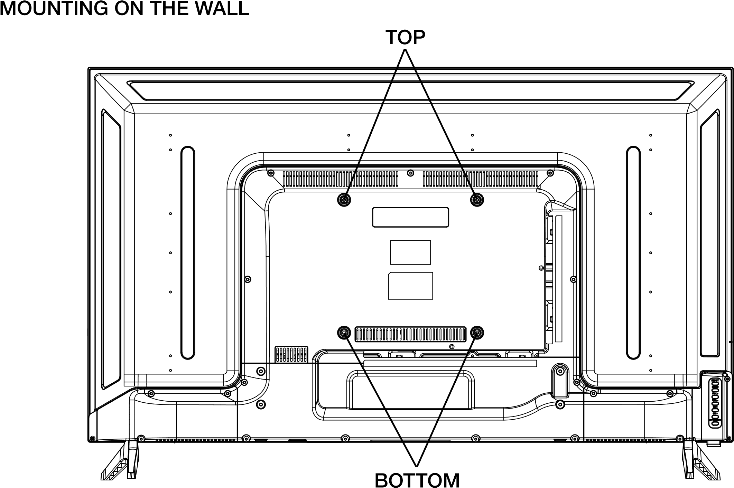

VESA MOUNTING
Model | Mounting Dimension | TOP | BOTTOM
WBXML4K43 | 200x200mm | BM5.0x8mm | BM5.0x8mm
WBXML4K49 | 200x200mm | BM6.0x10mm | BM6.0x10mm
WBXML4K55 | 400x200mm | BM6.0x10mm | BM6.0x10mm
WBXML4K65 | 400x400mm | BM6.0x10mm | BM6.0x10mm

* HARDWARE INCLUDED IN MONITOR BOX

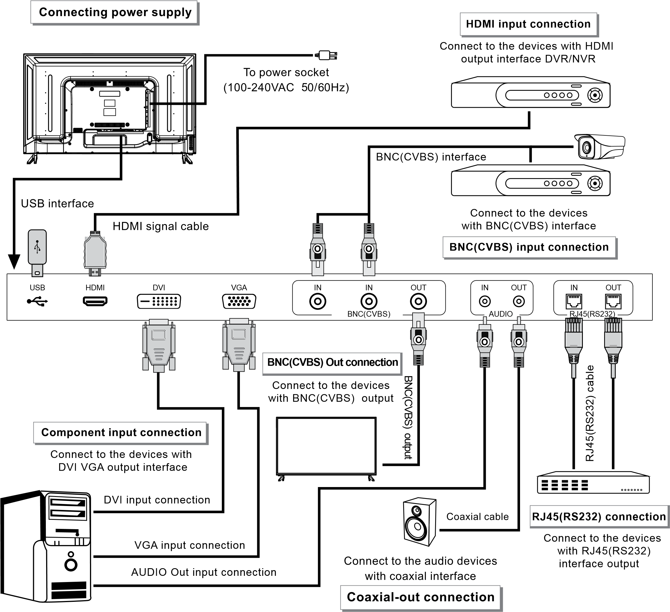

SPEC SHEET

