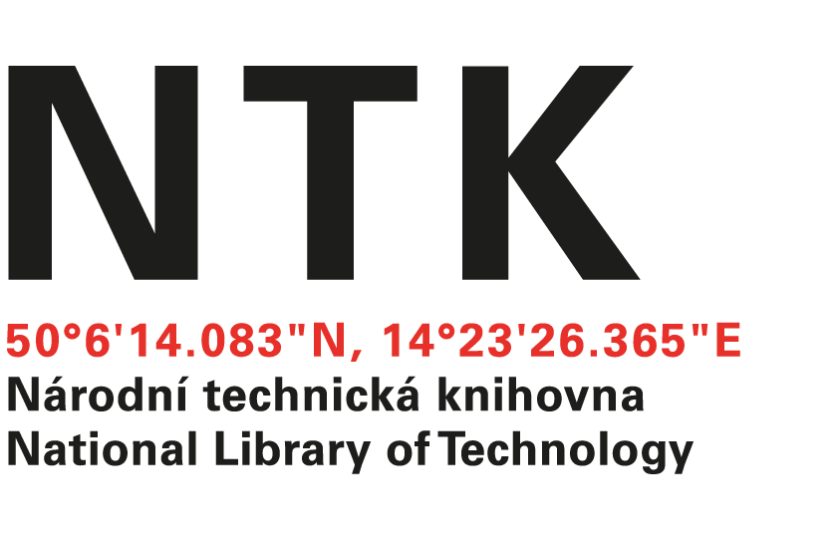
Order

No. 133/EIZ/2021

Customer: | Supplier:
National Library of Technology | Emerald Group Publishing
Technická 6/2710 | Howard House, Wagon Line
160 80 Prague 6 - Dejvice | Bingley, BD16 1WA
Czech Republic | United Kingdom
ID: 61387142
VAT: CZ61387142

Dear xxxxxx,

based on your offer from 9. 11. 2021 we order the Emerald eBooks Select 25 for the price 2 125 GBP.
+ Addendum: Emeral 25 eBooks List final

Kind regards

xxxxxxxxxxx
electronic resources librarian

Order accepted by:
Date of issue: 15. 12. 2021
Issued:
xxxxxxxxxxxxx
email: eiz@techlib.cz
tel.: +420 232 002 572

