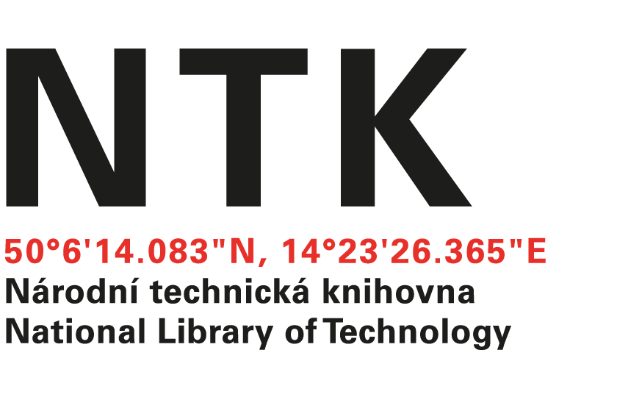
Order

No. 128/AČ/2021

Customer: | Supplier:
National Library of Technology | The Optical Society OSA  Elizabeth Nolan
Technická 6/2710 | 2010 Massachusetts Avenue, NW
160 80 Prague 6 - Dejvice | Washington DC 20036
Czech Republic | USA
ID: 61387142
VAT: CZ61387142

Dear xxxxxxxxxxx,

based on your offer (Pro Forma Invoice) from 13. 9. 2021 we order access to the collection e-journals OSA - Electronic Combination 1 for the price $ 14.778 USD started from 1 January 2022 ended 31 December 2022.

Kind regards

xxxxxxxxxxxxx
electronic resources librarian

Order accepted by:
Date of issue: 16. 12. 2021
Issued:
xxxxxxxxxxxxx
email: eiz@techlib.cz
tel.: +420 232 002 409

