From: czorders@thermofisher.com <czorders@thermofisher.com>
Sent: Thursday, November 4, 2021 2:50 PM
To:xxxxxxxxxxxxxxxxxx
Cc: czorders@thermofisher.com; xxxxxxxxxxxx; newaccounts@invitrogen.com
Subject: 266369 SO // OV1-2520/2021

Dobry den,

Potvrdzujeme Vasu objednavku c. OV1-2520/2021 zo dna 04.11.2021 v hodnote 50 492,00 CZK bez DPH. Vasa objednavka bude aktivovana po zverejneni v registri zmluv.

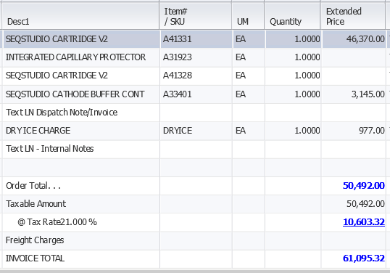

S pozdravom,

xxxxxxxxxxxxxxxxx
Customer Care – Zákaznické Centrum

Thermo Fisher Scientific
Life Technologies Czech Republic s.r.o.
V Celnici 1031/4
11000 Praha, Czech Republic
xxxxxxxxxxxxxxxxxxxxxxxxx
Fax: (+420) 227-204-750

