From: czorders@thermofisher.com <czorders@thermofisher.com>
Sent: Friday, October 15, 2021 4:30 PM
To: xxxxxxxxxxxxxxxxxxxxx

Cc: xxxxxxxxxxxxxxxxxxxxxxx
Subject: 260502 SO // OV1-2154/2021

Dobry den,

Potvrdzujeme Vasu objednavku c. OV1-2154/2021 zo dna 15.10.2021 v hodnote 88 833,92 CZK bez DPH. Objednvaka bude aktivovana po zverejneni v registri zmluv.

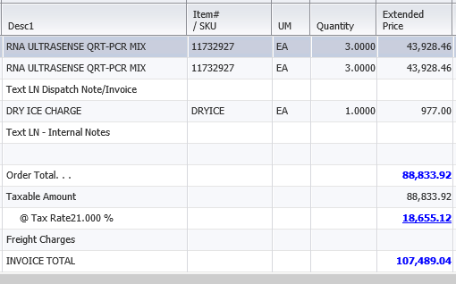

S pozdravom,

xxxxxxxxxxxx
Customer Care – Zákaznické Centrum

Thermo Fisher Scientific
Life Technologies Czech Republic s.r.o.
V Celnici 1031/4
11000 Praha, Czech Republic
Tel: (+420) 235-302-459
Fax: (+420) 227-204-750

czorders@thermofisher.com
www.lifetechnologies.com

